Microsoft Universal Foldable Keyboard
Fact Sheet
March 2015
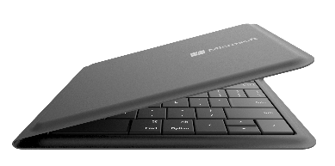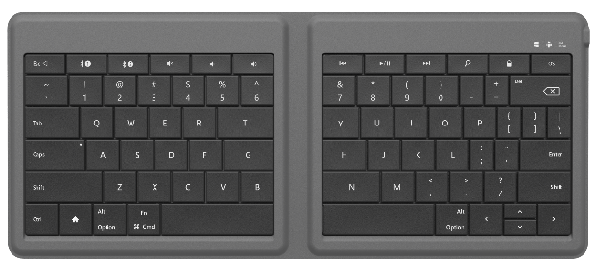
Designed for

The Microsoft Universal Foldable Keyboard is portable, packable and precise for your on-the-go lifestyle to help you get more done anywhere, anytime, on virtually any device.

The Universal Foldable Keyboard was designed to work with iPad®, iPhone® and Android™ devices and Windows tablets. Simultaneously pair it with any two supported mobile devices and switch between them with a single touch. Set up in seconds — just open it to turn it on and connect. Then you’ll enjoy fast, comfortable typing on a full-sized keyset. Power through emails, edit a proposal or instant message with friends. When you’re done, simply close it to turn it off and you’re ready to go.

Its ultrathin, lightweight, compact design lets you easily take it wherever you go so you can get more done on your tablet or smartphone no matter where you are. And its durable, spill-resistant keyset and fabric help protect against accidents.

Top Features and Benefits
- Works across devices: The Universal Foldable Keyboard was designed to work with iPad, iPhone, and Android devices and Windows tablets. Pair the keyboard with any combination of two compatible devices and quickly switch between them with one touch.
- Ultrathin and lightweight: Only 5mm thin, the innovative, foldable design easily fits into a purse, bag or jacket pocket.
- Full-size keyset: The full-size keyset provides fast, accurate typing.
- Easy on/easy off: Open the keyboard to connect to your tablet or smartphone. Simply close the keyboard to shut it down.
- Spill-resistant design: Water repellent keyset and fabric help protect against accidents.
- Rechargeable battery: The built-in rechargeable battery provides up to three months of usage on a single charge.
- Bluetooth Smart: Clutter-free and reliable experience utilizing the latest in Bluetooth 4.0 technology, consuming less power.

Read on for more information:
Top-Line System Requirements / Availability and Pricing / Contact Info

Top-Line System Requirements
To use the Universal Foldable Keyboard, customers need the following:
For Windows | For Macintosh | For Android
- Windows 8/8.1  - Compatible with Bluetooth® 4.0 hardware¹ | - Apple iOS7  - Compatible with Bluetooth 4.0 hardware¹ | - Android 4.3  - Compatible with Bluetooth 4.0 hardware¹

Availability and Pricing

The Universal Foldable Keyboard will be generally available in July 2015 for the estimated retail price of $99.95² at http://www.microsoftstore.com and various other retailers.

The Universal Foldable Keyboard is backed by a limited hardware warranty. The limited warranty and license agreement are available at http://www.microsoft.com/hardware/warranty.

¹ Works with tablets and smartphones that have Bluetooth HID (Human Interface Device) keyboard support. See compatibility information at http://microsoft.com/hardware/compatibility.
² Estimated retail price. Actual retail prices may vary.

The Bluetooth® word mark and logos are registered trademarks owned by Bluetooth SIG Inc., and any use of such marks by Microsoft Corp. is under license.

Android is a trademark of Google Inc. The Android robot is reproduced or modified from work created and shared by Google and used according to terms described in the Creative Commons 3.0 Attribution License.

iPad and iPhone are trademarks of Apple Inc., registered in the U.S. and other countries.

Contact Info

For more information, press only:
Rapid Response Team, Waggener Edstrom Communications, (503) 443-7070, rrt@waggeneredstrom.com

For more product information and images:
Visit the Microsoft News Center at http://news.microsoft.com/presskits/hardware.

For more information about Microsoft PC accessories:
Visit http://www.microsoft.com/hardware.

