MICROSOFT ARC TOUCH BLUETOOTH MOUSE
Fact Sheet
September 2014

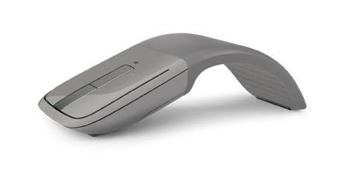

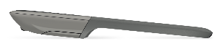
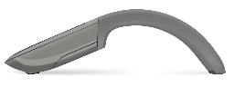

The Microsoft Arc Touch Bluetooth® Mouse is a modern take on our award-winning design of the Arc Touch Mouse, now with Bluetooth 4.0 Low-Energy technology for even more wireless freedom in an iconic design.
Behind the Scenes
Did you know?
The original Arc Mouse was released in 2008, followed by the Arc Touch Mouse in 2010 and the Arc Touch Mouse Surface Edition in 2013. The award-winning design of the Arc Touch Mouse continues to be a favorite of customers and reviewers around the world.

Comfortable and elegant, the Arc Touch Bluetooth Mouse smartly flattens for portability and pops up into an arc designed to match the natural curve of your hand when you need to use it. The touch strip in the center lets you swipe, tap and flick to intuitively navigate your screen with the power of your finger. ¹ It’s also outfitted with BlueTrack Technology so you can mouse on virtually any surface — even rough wood or carpet — while you’re on the go. Just flatten to turn off and slip into your pocket, purse or bag.

Top Features and Benefits
- Flexible design: Curved for comfort. Flatten to pack. A perfect fit for your hand and your mobile lifestyle.

Power on and off: Pop up to turn on. Flatten to turn off. No button to switch. A green light flashes to show the battery is working, and then turns off to save battery life.

Touch to scroll: Swipe. Tap. Flick. Control. Quickly brush up or down with your finger to flick into hyperfast vertical scrolling for smooth, intuitive navigation. Scroll slowly with a gentle swipe or quickly with a flick of the finger, then tap to stop.

BlueTrack Technology: Take advantage of BlueTrack Technology, which combines the power of optical with the precision of laser for remarkable tracking on virtually any surface.²

Bluetooth smart: Clutter-free and reliable experience that works from up to 30 feet away. Utilizing the latest in Bluetooth 4.0 technology, consuming less power.

Read on for more information:
Top-Line System Requirements / Availability and Pricing / Contact Info

Top-Line System Requirements
To use the Arc Touch Bluetooth Mouse, customers need the following:
For a Windows PC
- Windows 8.1, Windows 8, Windows RT 8.1 or Windows RT 8²
- Computer enabled with Bluetooth 4.0 Low-Energy wireless technology
- 2 AAA alkaline batteries (included)

Availability and Pricing

The Arc Touch Bluetooth Mouse will be generally available in September 2014 for the estimated retail price of $69.95³ at http://www.microsoftstore.com and various other retailers.

The Arc Touch Bluetooth Mouse is backed by a three-year limited hardware warranty. The limited warranty and license agreement are available at http://www.microsoft.com/hardware/warranty.

¹ Advanced functionality not available with all devices and/or operating systems. See compatibility information at http://microsoft.com/hardware/compatibility.
² BlueTrack Technology does not work on clear glass or mirrored surfaces.
³ Estimated retail price. Actual retail prices may vary.

Contact Info

For more information, press only:
Rapid Response Team, Waggener Edstrom Communications, (503) 443-7070,
rrt@waggeneredstrom.com

For more product information and images:
Visit the Microsoft News Center at http://www.microsoft.com/en-us/news/presskits/hardware.

For more information about Microsoft PC accessories:
Visit http://www.microsoft.com/hardware.

