Bluetooth® Mobile Mouse 3600
Fact Sheet
August 2015

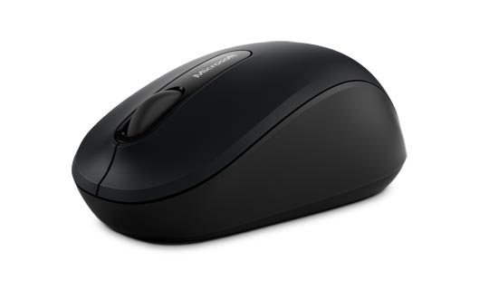

An update to the best-selling Wireless Mobile Mouse 3500, the Bluetooth® Mobile Mouse 3600 now features new Bluetooth®¹ 4.0 SMART technology² and Windows 10 compatibility. With its four-way scroll wheel for navigating up, down, left and right, and compact, comfortable design, this updated mouse is perfect for ultimate portability. It also offers up to six months of battery life and will be available in three colors: red, blue and black.

Top features and benefits
- Bluetooth® 4.0 SMART Technology gives you a modernized wireless connection.
- BlueTrack Technology allows people to ditch their mouse pad and use their mouse on virtually any surface,³ including granite, marble, carpet and wood.
- Ambidextrous design and rubber side grips give you comfort and durability anywhere it’s used.

Specs  Weight 0.139 lbs.  Dimensions 3.7496” x 2.2417” x 1.5941”  Compatibility⁴ Windows 10, Windows 8 Mac OS X 10.10.3 Android 4.4.2, 5.0  Warranty Three-year limited hardware warranty⁶  $29.95⁵  Available for purchase in stores Oct. 8, 2015  The Bluetooth® word mark is a registered trademark owned by Bluetooth SIG, Inc. and any use of such mark by Microsoft Corp. is under license.  ² Device must support Bluetooth® 4.0 (or higher). See compatibility information at http://microsoft.com/hardware/compatibility.  3 BlueTrack Technology does not work on clear glass or mirrored surfaces.  ⁴ Customizable features require Mouse and Keyboard Center (150MB software download) and the latest Windows update. Internet fees may apply. See compatibility information at http://microsoft.com/hardware/compatibility. You must accept the License Terms for software download at: microsoft.com/hardware/downloads.  5 U.S. only; varies by market.  6 Estimated retail price. Actual prices may vary.  Contact info  For more information, press only:  Rapid Response Team, Waggener Edstrom Communications, (503) 443-7070, rrt@waggeneredstrom.com  For more product information and images:  Visit Microsoft Hardware Newsroom at https://news.microsoft.com/presskits/hardware.  For more information about PC accessories:  Visit Microsoft Hardware at https://www.microsoft.com/hardware/en-us. | 