Microsoft Designer Bluetooth Desktop
Fact Sheet
May 2015
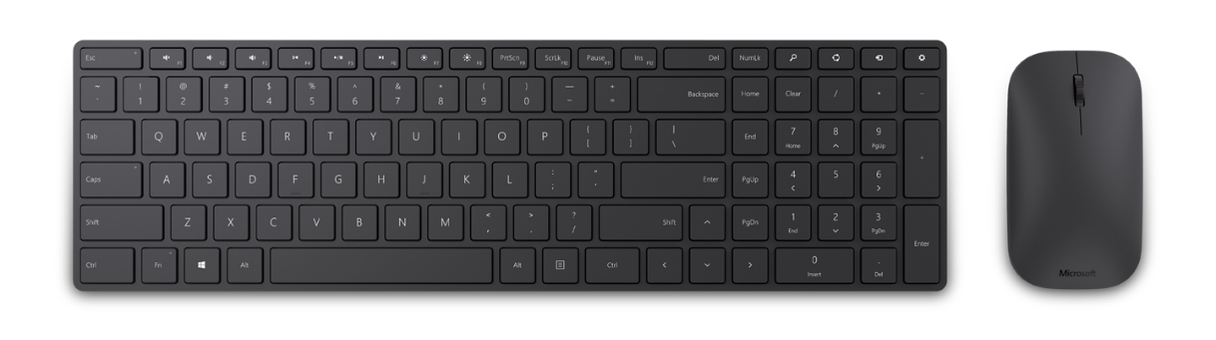
With its ultrathin and modern look, the Microsoft Designer Bluetooth® Desktop is a great addition to any desk, complementing the sleek and modern devices in your home workspace or office. The sleek and modern design keeps your desk looking its best while giving you what’s needed to keep you productive.

A full-size keyboard with built-in number pad and mouse is as beautiful as it is productive. Even with its minimalist design, this keyboard gives you a robust typing experience that comes with chiclet-style, soft touch keys. For those who work and play, media keys are included, so you can easily control music and videos. With Function Keys and quick access to Search and other features, the Designer Bluetooth Desktop is the envy of any PC or laptop.

With the latest Bluetooth® Smart technology,¹ the Designer Bluetooth® Desktop pairs wirelessly to your laptop or tablet to instantly connect without wires or dongles and remains constantly connected whenever you’re in range.

Top Features and Benefits
- Ultrathin and modern: The ultrathin and modern design complements your desk.
- Full-size keyboard: The full-size keyboard with built-in number pad and mouse will keep you productive at your desk.
- Bluetooth® Smart: A clutter-free and reliable experience, the Designer Bluetooth Desktop utilizes the latest in Bluetooth 4.0 technology,¹ consuming less power.
- BlueTrack Technology: Take advantage of Microsoft’s BlueTrack Technology, which combines the power of optical with the precision of laser for remarkable tracking on virtually any surface.²
- Comfortable in either hand: Use your mouse with your left or right hand. Ambidextrous design makes it comfortable either way.
- Up to six months of battery life: Use your mouse for up to six months without having to change batteries. An LED indicator tells you when battery power is low.

Read on for more information:
Top-Line System Requirements / Availability and Pricing / Contact Info

Top-Line System Requirements
To use the Designer Bluetooth Desktop, customers need the following:
For a Windows PC | For Macintosh⁴ | For Android⁴
- Windows 7, Windows 8.1, Windows 8, Windows RT 8.1 or Windows RT 8  - Compatible with Bluetooth 4.0-enabled devices  - 150 MB of available hard disk space  - 4 AAA alkaline batteries (included) | - Mac OS 10.10³  - Compatible with Bluetooth 4.0-enabled devices  - 150 MB of available hard disk space  - 4 AAA alkaline batteries (included) | - Android 4.4+³  - Compatible with Bluetooth 4.0-enabled devices  - 150 MB of available hard disk space  - 4 AAA alkaline batteries (included)

Availability and Pricing

The Designer Bluetooth Desktop will be generally available in May 2015 for the estimated retail price of $99.95⁴ at http://www.microsoftstore.com and various other retailers.

The Designer Bluetooth Desktop is backed by a three-year limited hardware warranty. The limited warranty and license agreement are available at http://www.microsoft.com/hardware/warranty.

¹ Works with Bluetooth Smart Ready devices with HID (Human Interface Device) support
² BlueTrack Technology does not work on clear glass or mirrored surfaces.
³ Some keys not available on Mac and Android: http://microsoft.com/hardware/compatibility
⁴ Estimated retail price. Actual retail prices may vary.

The Bluetooth® word mark and logos are registered trademarks owned by Bluetooth SIG Inc., and any use of such marks by Microsoft Corp. is under license.

Android is a trademark of Google Inc.

Mac and Macintosh are trademarks of Apple Inc., registered in the U.S. and other countries.

Contact Info

For more information, press only:
Rapid Response Team, Waggener Edstrom Communications, (503) 443-7070,
rrt@waggeneredstrom.com

For more product information and images:
Visit the Microsoft News Center at http://news.microsoft.com/presskits/hardware.

For more information about Microsoft PC accessories:
Visit http://www.microsoft.com/hardware.

