Microsoft Designer Bluetooth Mouse
Fact Sheet
March 2015

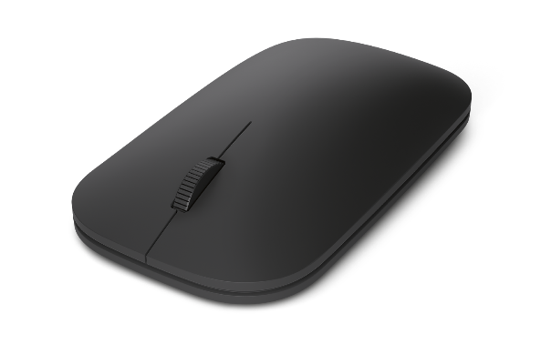

The contoured and modern Microsoft Designer Bluetooth® Mouse is a great addition to any desk, complementing the sleek and modern devices in our lives. And it’s easy on the eyes and on your hands, letting you keep focused on your task.

With the latest Bluetooth® Smart technology, the Designer Bluetooth® Mouse pairs wirelessly to your laptop or tablet to instantly connect without wires or dongles.

The compact form factor allows you to carry the mouse with you when you need more precision and accuracy in navigation while working on the go.

Top Features and Benefits
- Stylish and modern: The stylish, low-profile design complements today’s sleek and modern devices.
- Bluetooth® Smart: A clutter-free and reliable experience, the Designer Bluetooth Mouse utilizes the latest in Bluetooth 4.0 technology,¹ consuming less power.
- BlueTrack Technology: Take advantage of Microsoft’s BlueTrack Technology, which combines the power of optical with the precision of laser for remarkable tracking on virtually any surface.²
- Control in either hand: Use your mouse with your left or right hand. Ambidextrous design allows you to control your mouse in either hand.
- Up to six months of battery life: Use your mouse for up to six months without having to change batteries. An LED indicator tells you when battery power is low.

Read on for more information:
Top-Line System Requirements / Availability and Pricing / Contact Info

Top-Line System Requirements
To use the Designer Bluetooth Mouse, customers need the following:
For a Windows PC | For Macintosh | For Android
- Windows 8.1, Windows 8, Windows RT 8.1 or Windows RT 8  - Compatible with Bluetooth 4.0-enabled devices  - 150 MB of available hard disk space  - 2 AAA alkaline batteries (included) | - Mac OS 10.10  - Compatible with Bluetooth 4.0-enabled devices  - 150 MB of available hard disk space  - 2 AAA alkaline batteries (included) | - Android 4.4+  - Compatible with Bluetooth 4.0-enabled devices  - 150 MB of available hard disk space  - 2 AAA alkaline batteries (included)

Availability and Pricing

The Designer Bluetooth Mouse will be generally available in March 2015 for the estimated retail price of $29.95³ at http://www.microsoftstore.com and various other retailers.

The Designer Bluetooth Mouse is backed by a three-year limited hardware warranty. The limited warranty and license agreement are available at http://www.microsoft.com/hardware/warranty.

¹ Works with Bluetooth Smart Ready devices with HID (Human Interface Device) support
² BlueTrack Technology does not work on clear glass or mirrored surfaces.
³ Estimated retail price. Actual retail prices may vary.

The Bluetooth® word mark and logos are registered trademarks owned by Bluetooth SIG Inc., and any use of such marks by Microsoft Corp. is under license.

Android is a trademark of Google Inc.

Mac and Macintosh are trademarks of Apple Inc., registered in the U.S. and other countries.

Contact Info

For more information, press only:
Rapid Response Team, Waggener Edstrom Communications, (503) 443-7070,
rrt@waggeneredstrom.com

For more product information and images:
Visit the Microsoft News Center at http://news.microsoft.com/presskits/hardware.

For more information about Microsoft PC accessories:
Visit http://www.microsoft.com/hardware.

