New and updated PC accessories for Windows 10
Fact Sheet
August 2015

Wireless Desktop 900 — New  The newest addition to our desktop lineup, the Wireless Desktop 900 sports a simple, modern design and features quiet-touch keys and a full-size ambidextrous mouse. The Wireless Desktop 900 delivers a comfortable and responsive typing experience and precise navigation. Plus, it offers one-click shortcuts to take advantage of the best of Windows 10, including Cortana¹, OneNote and virtual desktops². The Wireless Desktop 900 also includes Advanced Encryption Standard (AES) encryption secured wireless connectivity and a simple plug-and-play wireless design that provides up to a 30-foot range. The mouse is also sold separately as a standalone device.  Specs  Keyboard weight 1.13 lbs.  Keyboard dimensions 16.77” x 6.08” x 1.11”  Mouse weight 0.16 lbs.  Mouse dimensions 4.45” x 2.48” x 1.73”  Compatibility Windows 10, Windows 8, Windows 7 Mac OS X 10.4–10.7  Warranty Three-year limited hardware warranty³  Wireless Desktop 900 – $49.95⁴  Available for purchase in stores Oct. 1, 2015  Wireless Mouse 900 – $29.95⁴  Available for purchase in stores Oct. 15, 2015 | 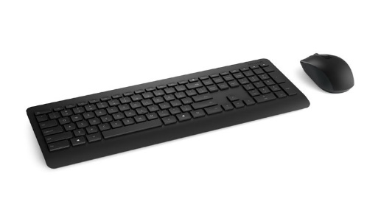
Sculpt Comfort Desktop  Our extremely comfortable and stylish Sculpt Comfort Desktop and Sculpt Comfort Mouse have been updated with Windows 10 functionality for easy access to new software features such as Cortana¹ and virtual desktops.² They boast a stylish, ergonomist-approved contoured design that has been shown to improve comfort. They also include unique, timesaving features such as the split spacebar with optional backspace functionality and the Windows touch tab to help you get more done.  Specs  Keyboard weight 1.74 lbs.  Keyboard dimensions 18.82” x 8.89” x 1.25”  Mouse weight 0.29 lbs.  Mouse dimensions 4.37” x 2.69” x 1.44”  Compatibility Windows 10, Windows 8, Windows 7 Mac OS X 10.4–10.7  Warranty Three-year limited hardware warranty³  Sculpt Comfort Desktop – $79.95⁴  Available for purchase in stores July 29, 2015  Sculpt Comfort Mouse – $39.95⁴  Available for purchase in stores July 29, 2015 | 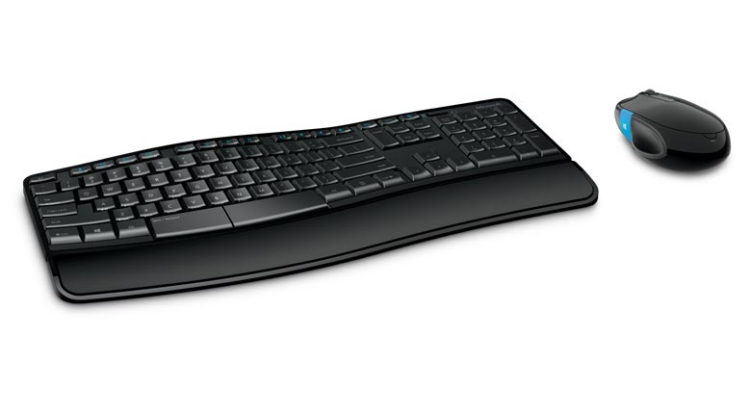
Wireless Desktop 850  The Wireless Desktop 850 is an update to the Wireless Desktop 800, and now features AES encryption and Windows 10 compatibility. The Wireless Desktop 850 offers a traditional straight keyboard layout and ambidextrous mouse design. It’s easy to set up and is a perfect complement to Windows 10. The keyboard is also sold separately as a standalone device.  Specs  Keyboard weight 1.22 lbs.  Keyboard dimensions 17.94” x 6.24” x 1.06”  Mouse weight 0.14 lbs.  Mouse dimensions 4.47” x 2.27” x 1.55”  Compatibility Windows 10, Windows 8, Windows 7 Mac OS X 10.4–10.7  Warranty Three-year limited hardware warranty3  Wireless Desktop 850 – $39.95⁴  Wireless Keyboard 850 – $25.95⁴  Available for purchase in stores Sept. 23, 2015 | 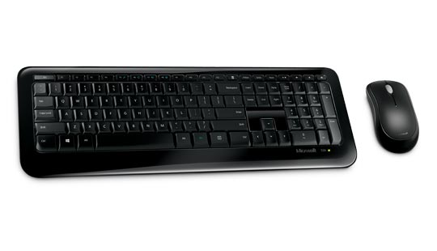
Wireless Desktop 3050  The Wireless Desktop 3050 is an update to the Wireless Desktop 3000, and now features AES encryption and Windows 10 compatibility.² This premium desktop set offers a traditional straight keyboard layout and ambidextrous mouse, and also incorporates a variety of convenient, timesaving hot keys² to help you navigate Windows faster and easier.  Specs  Keyboard weight 1.71 lbs. (with 2 AA batteries)  Keyboard dimensions 17.55” x 7.83” 1.04”  Mouse weight 0.22 lbs.  Mouse dimensions 4.59” x 2.76” x 1.66”  Compatibility Windows 10, Windows 8, Windows 7 Mac OS X 10.4–10.7  Warranty Three-year limited hardware warranty³  $59.95⁴  Available for purchase in stores Oct. 7, 2015 | 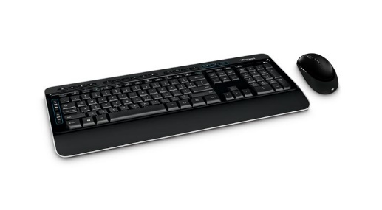
Wireless Comfort Desktop 5050  The Wireless Comfort Desktop 5050 is an update to the Wireless Comfort Desktop 5000, and now features AES encryption and Windows 10 compatibility. This desktop set offers a curved keyboard layout and a full-size mouse for added comfort. The Wireless Comfort Desktop also incorporates a variety of convenient, time-saving hot keys² to help you navigate Windows faster and easier. The Wireless Comfort Desktop is perfect for use at the office or at home.  Specs  Keyboard weight 1.83 lbs. (with 2 AA batteries)  Keyboard dimensions 18.82” x 6.89” x 1.22”  Mouse weight 0.23 lbs.  Mouse dimensions 4.59” x 2.77” x 1.66”  Compatibility Windows 10, Windows 8, Windows 7 Mac OS X 10.4–10.7  Warranty Three-year limited hardware warranty3  $69.95⁴  Available for purchase in stores Oct. 7, 2015  Cortana available in select global markets at launch; experience may vary by region and device.  ² Customizable features require Mouse and Keyboard Center (150MB software download) and the latest Windows update. Internet fees may apply. See compatibility information at http://microsoft.com/hardware/compatibility. You must accept the License Terms for software download at http://microsoft.com/hardware/downloads.  ³ U.S. only; varies by market  4 Estimated retail price. Actual retailer prices may vary.  Contact info  For more information, press only:  Rapid Response Team, Waggener Edstrom Communications, (503) 443-7070, rrt@waggeneredstrom.com  For more product information and images:  Visit Microsoft Hardware Newsroom at https://news.microsoft.com/presskits/hardware.  For more information about PC accessories:  Visit Microsoft Hardware at https://www.microsoft.com/hardware/en-us. | 