MICROSOFT WIRELESS DISPLAY ADAPTER
Fact Sheet
February 2016

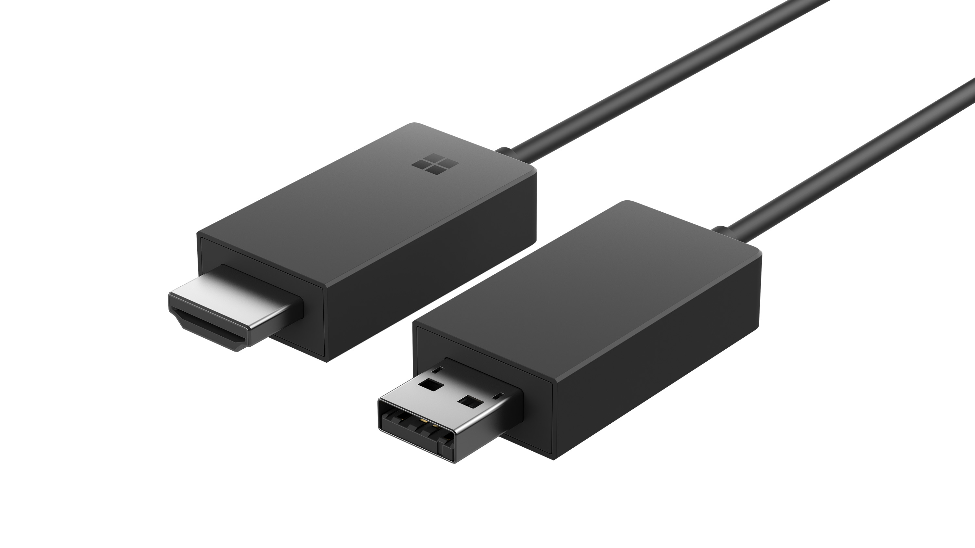

Wirelessly display any and all content on your Miracast®-enabled Windows 10 phone, tablet or laptop — including the Surface lineup¹ — onto your HDTV or monitor with the next generation of Microsoft Wireless Display Adapter. Go beyond just streaming apps — the Wireless Display Adapter allows you to quickly mirror or extend videos, photos and anything else on your screen with ease.

Just plug the Wireless Display Adapter into the HDMI and powered USB ports on your TV or monitor, find the Wireless Display Adapter from the menu on your device and connect, then wirelessly mirror or extend your screen to bring your content to life in new ways.

With the Wireless Display Adapter, you have more freedom to use your primary device while projecting content to a larger screen, completely untethered. Beam a movie to a TV from your tablet while still sending emails on the couch, or plug the Wireless Display Adapter into a conference room projector to share a presentation from a Miracast-enabled tablet or laptop. Those using Miracast-enabled Windows 10 phones, tablets and laptops — including the Surface lineup — can easily show friends and family their latest vacation videos without being tied down to a small mobile screen.

The newest Wireless Display Adapter incorporates everything people loved about the first generation, and improves on it with less latency and a new form factor. The new Microsoft Wireless Display Adapter App also allows users to change security settings and keep firmware updated. It’s perfect for students, mobile professionals, or anyone else who wants the freedom of displaying content with no wired constraints.

Top Features and Benefits
- See it all on your big screen: Share what’s on your Miracast-enabled Windows 10 smartphone, tablet or laptop onto an HDTV or monitor with Microsoft Wireless Display Adapter. Stream movies, view personal photos or display a presentation on a big screen — all wirelessly.
- Modernize your meetings: Project your ideas and collaborate in real time by plugging the Microsoft Wireless Display Adapter into a conference room projector or monitor. You can even ink in PowerPoint to emphasize a point and make that big screen your collective workspace.
- Miracast technology: The Wireless Display Adapter uses Miracast technology, so you’re not limited to certain apps or content streaming; you can display everything from your device on an HDTV or monitor.
- Easily connect: Just plug the USB and HDMI from the Wireless Display Adapter into your HDTV or monitor, connect, then mirror or extend your screen and enjoy. The Wireless Display Adapter delivers a reliable connection with up to a 20-foot range.
- Wireless Display Adapter App: Available from the Windows store for Windows PCs and Windows Phones, the Wireless Display Adapter App lets you customize your adapter’s security settings and keep up to date with the latest firmware.

Read on for more information:
Top-Line System Requirements / Availability and Pricing / Contact Info

Top-Line System Requirements
To use the Microsoft Wireless Display Adapter, customers need the following:
For a Windows PC
- Any Miracast-enabled Windows 10 tablet, laptop or phone, including the Surface lineup¹

Availability and Pricing

The Microsoft Wireless Display Adapter will be available in the U.S. and Canada on March 1, 2016, for the estimated retail price of $49.95 at http://www.microsoftstore.com, Best Buy and Amazon.

The Microsoft Wireless Display Adapter will be backed by a one-year limited hardware warranty. The limited warranty and license agreement are available at http://www.microsoft.com/hardware/warranty.

¹ The Microsoft Wireless Display Adapter is compatible with Surface Pro, Surface Pro 2, Surface Pro 3, Surface Pro 4, Surface Book and Surface 3.

Contact Info

For more information, press only:
Microsoft Media Relations, WE Communications, (425) 638-7777, rrt@we-worldwide.com

For more product information and images:
Visit the Microsoft News Center at http://www.microsoft.com/en-us/news/presskits/hardware.

For more information about Microsoft PC Accessories:
Visit http://www.microsoft.com/hardware.

