Lumia 950
Fact Sheet
October 2015
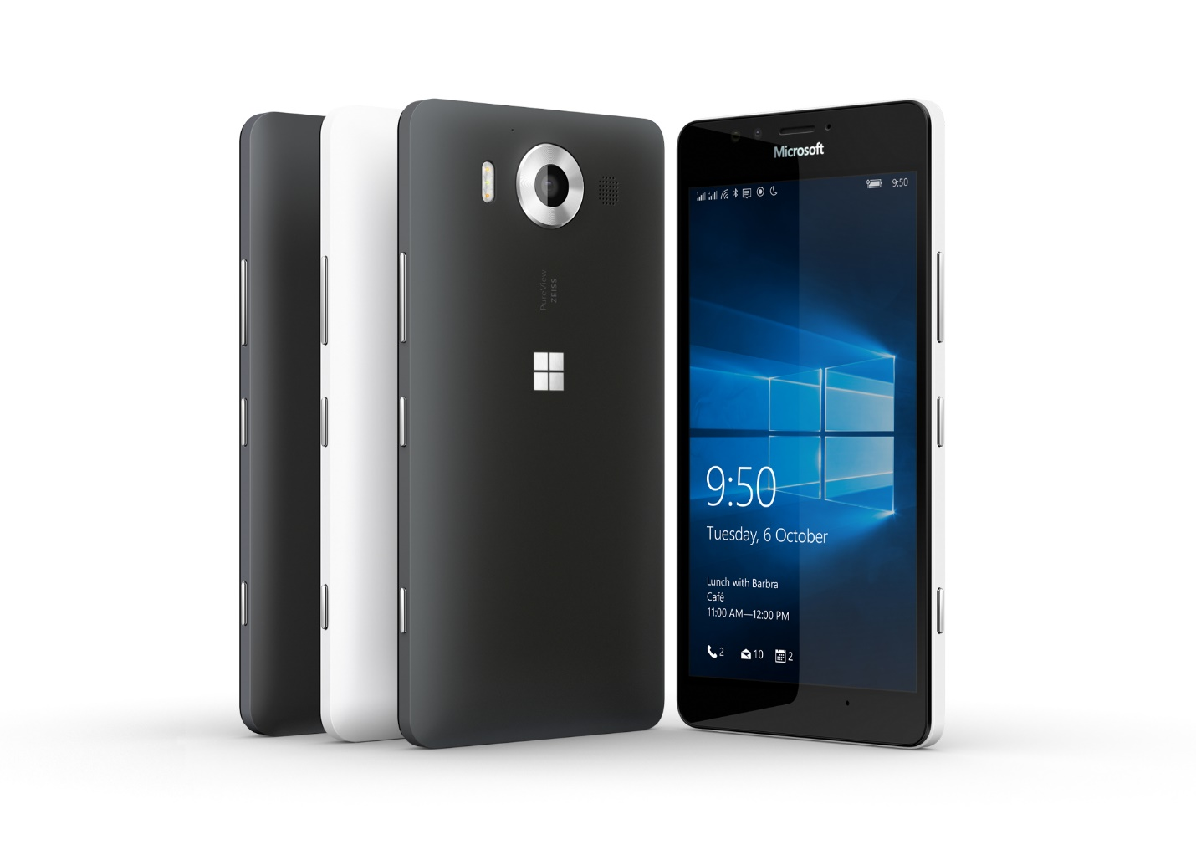
Meet Lumia 950, the phone that works like your PC. Running Windows 10 and featuring a 5.2-inch Quad HD display in a package that’s just 8.25mm thin, Lumia 950 is designed to give you the best Windows experience in the palm of your hand.

Top Features and Benefits
- The best of Windows 10. Thanks to Windows 10 and programs and features such as Cortana, Microsoft Office and the Windows Store, Lumia 950 delivers a personal yet productive experience¹.
- Continuum and Microsoft Display Dock. Use your Lumia 950 like a PC by connecting it to a bigger screen, keyboard and mouse with Microsoft Display Dock, an optional accessory that enhances the new Windows 10 Continuum experience for phones — and simultaneously charges your device. Scale and display Windows apps beautifully on the bigger screen when connected, or work on a Microsoft Office document, browse the Internet and stream movies for your kids. Plus, you’ll be able to use your phone independently to take a call or send a text message while you continue to enjoy apps on the bigger screen².
- Capture stellar images. The PureView camera captures beautiful photos thanks to its 20MP sensor and triple LED natural flash, which adapts to any scene. Rich Capture automatically chooses the best camera mode, allowing you to take crisp images even in challenging conditions. 4K video capture helps ensure you never miss a detail.

Technical Specifications
Operating  system | Windows 10
Exterior | Dimensions: 145 x 73.2 x 8.25 mm  Weight: 150 g  Casing: polycarbonate  Colors: black, white³  Physical buttons: power, volume, camera
Storage | 32 GB4 and up to 200 GB of expandable storage5  OneDrive storage
Display | Screen: 5.2-inch Quad HD AMOLED Corning® Gorilla® Glass 3 display  Resolution: 2560x1440 (564 ppi)  Aspect ratio: 16:9  Touch: Multitouch
CPU | Qualcomm® Snapdragon™ 808 processor featuring Hexa-core CPUs and 64-bit support
Network | Wi-Fi: MIMO, WLAN IEEE 802.11 a/b/g/n/ac  Bluetooth 4.1
Battery | Removable 3000mAh battery, USB-C fast charging, wireless charging⁶  Battery life7  Standby 275  Wi-Fi browsing 9.5  2G talk 23.0  3G talk 18.0  MP3 playback 67.0  Video playback 1080p 10.0
Cameras | Rear-facing PureView camera with 20MP sensor, Zeiss optics, OIS, triple LED natural flash, and 4K video recording  5MP wide-angle 1080p front-facing camera
Ports | microSD™ slot, supports up to 200 GB of expandable storage⁴  USB-C charging port for data, AV connectivity and charging  3.5mm stereo headset connector  Available in single-SIM and dual-SIM variants
Sensors | Accelerometer  Ambient light sensor  Barometer  Gyroscope  Magnetometer  Proximity sensor
Power supply | Microsoft USB-C Fast Charger (AC-100)
Location | A-GLONASS  A-GPS  Barometer  Cellular  Wi-Fi network positioning  Gyroscope
In the box | Lumia 950  3000 mAh battery  Microsoft USB-C Fast Charger (AC-100)  Microsoft USB-C Cable (CA-232CD)  Quick Guide
Preloaded | Creative Studio  Gadgets  Lumia Help+Tips  MixRadio8  Photos plug-ins9  Transfer my Data
Warranty | One-year limited hardware warranty¹⁰

Pricing
32 GB³ | $549 ERP

¹ Features may vary by device and market. Cortana available in select markets at launch.

² External display with DisplayPort, HDMI connector or compatible adapter required. Office 365 subscription required for some Office features. Microsoft Display Dock, accessories and Office 365 all sold separately.
³ Device color availability may vary.
⁴ Preinstalled system software and apps use a significant amount of internal memory space. See http://www.microsoft.com/mobile/lumia-storage for more details.
⁵ Supports SDXC 3.01 standard-compliant cards. 200 GB cards currently available.
⁶ Requires wireless charging accessory, sold separately.
⁷ Talk, standby and playback times are estimates only. Actual times are affected by, for example, network conditions, device settings, features being used, battery condition and temperature. Battery has limited recharge cycles and battery capacity reduces over time. Eventually the battery may need to be replaced.
⁸ Where supported
⁹ Accessible directly from imaging apps
¹⁰ In the U.S.; warranty terms vary by market.

Contact Information
For more information, press only:
Rapid Response Team, WE Communications, (503) 443-7070, rrt@we-worldwide.com

For more product information and images:
Visit the Lumia Newsroom at https://news.microsoft.com/presskits/lumia/.

For more information about Lumia:
Visit Lumia at http://www.microsoft.com/en/mobile/phones/lumia/.

