Lumia 950 XL
Fact Sheet
October 2015
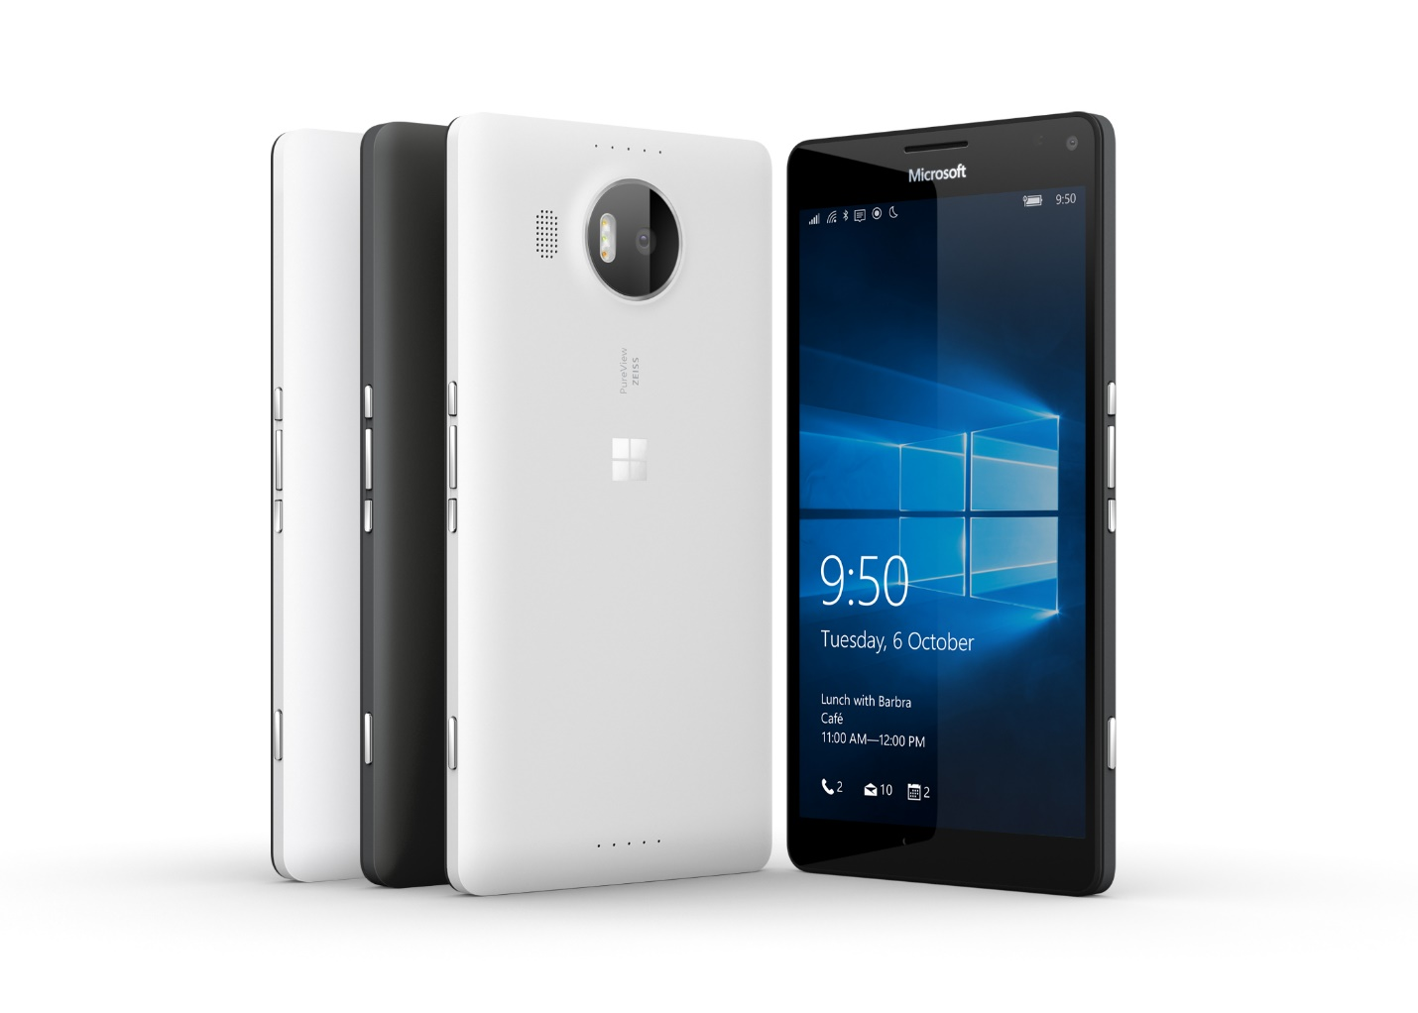
Meet Lumia 950 XL, the phone that works like your PC. Super sleek at just 8.1mm thin, Lumia 950 XL runs Windows 10 and packs Continuum capabilities and a 5.7-inch Quad HD display. It’s large enough to be productive, yet mobile enough to meet your daily phone needs.

Top Features and Benefits
- Windows 10 experiences. With one seamless experience across your phone, PC and tablet, Windows 10 gives you access to its Windows Store, OneDrive, Cortana, and Microsoft Office Mobile and Outlook — your truly personal and productive experience. Lumia 950 XL brings this Windows 10 experience to life¹.
- Continuum for phones. Use your Lumia 950 XL like a PC by connecting it to a bigger screen, keyboard and mouse with Microsoft Display Dock, an optional accessory that enhances the new Windows 10 Continuum experience — and concurrently charges your device. When you’re connected, Windows apps can scale smoothly and display beautifully on the bigger screen, helping you to get things done. Work on a Microsoft Office document, browse the Internet or stream movies for your kids. Plus, you can use your phone independently to take a call or send a text message while you continue to work on the bigger screen. Get the Microsoft Office and Outlook experiences on your mobile device, or use Office 365 with Microsoft Display Dock to unleash the power of editing features on a bigger screen for a PC-like experience².
- Superior performance. Alleviate fear of a dying phone thanks to Lumia 950 XL’s 3340 mAh battery³. And now featuring USB-C fast charging, Lumia 950 XL charges your battery half full in half an hour⁴. For those who want to eliminate cables, utilize the wireless charging⁵.

Technical Specifications
Operating  system | Windows 10
Exterior | Dimensions: 151.9 x 78.4 x 8.1 mm  Weight: 165 g  Casing: polycarbonate  Colors: black, white⁶  Physical buttons: power, volume, camera
Storage | 32 GB⁷ and up to 200 GB of expandable storage⁸  OneDrive storage
Display | Screen: 5.7-inch Quad HD AMOLED Corning® Gorilla® Glass 4 display  Resolution: 2560x1440 (518 ppi)  Aspect ratio: 16:9  Touch: Multitouch
CPU | Qualcomm® Snapdragon™ 810 processor featuring Octa-core CPUs and 64-bit capabilities
Network | Wi-Fi: MIMO, WLAN IEEE 802.11 a/b/g/n/ac  Bluetooth 4.1
Battery | Removable 3340mAh battery, USB-C fast charging, wireless charging⁴  Battery life3:  Standby 300  Wi-Fi browsing 25.0  2G talk 19.0  3G talk 11.0  MP3 playback 75.0  Video playback 1080p 11.0
Cameras | Rear-facing PureView camera with a 20-megapixel sensor, Zeiss optics, OIS, triple LED natural flash, and 4K video recording  5MP wide-angle 1080p front-facing camera
Ports | microSD™ slot, supports up to 200 GB of expandable storage7  USB-C charging port for data, AV connectivity and charging  3.5mm stereo headset  Available in single-SIM and dual-SIM variants
Sensors | Accelerometer  Ambient light sensor  Barometer  Gyroscope  Magnetometer  Proximity sensor
Power supply | Microsoft USB-C Fast Charger (AC-100)
Location | A-GLONASS  A-GPS  Barometer  Cellular  Wi-Fi network positioning  Gyroscope
In the box | Lumia 950 XL  3340mAh battery  Microsoft USB-C Fast Charger (AC-100)  Microsoft USB-C Cable (CA-232CD)  Quick Guide
Pre-loaded | Creative Studio  Gadgets  Lumia Help+Tips  MixRadio⁹  Photos plug-ins¹⁰  Transfer my Data
Warranty | One-year limited hardware warranty¹¹

Pricing
32 GB⁵ | $649 ERP

¹ Features may vary by device and market. Cortana available in select markets at launch.
² External display with DisplayPort, HDMI connector or compatible adapter required. Microsoft Display Dock, accessories, and Office 365 all sold separately.
³ Talk, standby and playback times are estimates only. Actual times are affected by, for example, network conditions, device settings, features being used, battery condition, and temperature. Battery has limited recharge cycles and battery capacity reduces over time. Eventually the battery may need to be replaced.
⁴ Requires wireless charging accessory, sold separately.
⁵ Applies when charging from 10 percent capacity (battery critically low) with Microsoft USB-C Fast Charger (included); actual results will vary based on usage.
⁶ Device color availability may vary.
⁷ Pre-installed system software and apps use a significant amount of internal memory space. See http://www.microsoft.com/mobile/lumia-storage for more details.
⁸ Supports SDXC 3.01 standard-compliant cards. 200GB cards currently available.
⁹ Where supported
¹⁰ Accessible directly from imaging apps
¹¹In the U.S.; warranty terms vary by market.

Contact Information
For more information, press only:
Rapid Response Team, WE Communications, (503) 443-7070, rrt@we-worldwide.com

For more product information and images:
Visit the Lumia Newsroom at https://news.microsoft.com/presskits/lumia/.

For more information about Lumia:
Visit Lumia at http://www.microsoft.com/en/mobile/phones/lumia/.

