Your Complete Office in the Cloud
A Reviewers Guide to Office 365 Home Premium

Contents
Welcome to Office 365 Home Premium 1
The latest Office across your devices 2
Easy to manage 2
Settings move with you 2
Stream Office to any Windows 7 or Windows 8 PC with Office on Demand 2
Connect to social networks easily 2
Make calls with Skype 2
Easier than ever 3
Experience Office at its best on Windows 8 devices 3
Office on your phone, tablet, and PC 4
Office 365 Home Premium and SkyDrive: Any file, anywhere 5
Create beautiful documents, and enjoy the read 7
Enjoy 7
Work together 9
Polish 11
Discover and share insights from your data 14
Discover 14
Visualize 16
Share 17
Design and deliver beautiful presentations with ease and confidence 19
Design 19
Impress 21
Work together 22
Manage your email, schedules, contacts, and to-do lists 24
Communicate 24
Manage 26
Find 27
Take notes, and have them where you want, when you need them 29
Capture 29
Find 31
Go 32
Create professional and impactful publications 35
Impact 35
Personalize 36
Share 37
Organize data in your life and business 40
Create 40
Experience 41
Get started with Office 365 Home Premium 43
Managing your Office 365 subscription:
Frequently Asked Questions 45

Welcome to Office 365 Home Premium
Today, people want to be able to create, use, and share documents wherever they go, on a wide variety of devices. Families sharing computers and mobile devices need solutions that work for a wide variety of needs with simple licensing and simpler installation.
That’s what the next generation of Office delivers. It’s a powerful service that that keeps you connected whether you’re at home or on the go. For families and individuals with multiple devices, Office 365 Home Premium delivers incredible value with the ability to install Office on up to five PCs, Macs, and Windows tablets. With Office connected to the cloud, your documents and personal settings roam with you. Simply sign into My Office on Office.com to access your Office applications, documents, and personal settings, just the way you left them. Store and share your documents online in SkyDrive to collaborate with friends, family, and co-workers. Stream a full-featured version of Office to any Windows 7 or Windows 8 PC with an Internet connection (fees may apply)—with your personal settings intact. You have the freedom to work the way you want with Office.
Office includes powerful new versions of your favorite applications including Word, Excel, PowerPoint, OneNote, Outlook, Access, and Publisher. The new Office lets you create documents using a pen, touch, or keyboard. Intuitive touch features work with how you use devices—flip through PowerPoint slides, read documents, and check email—and let you go from consuming content to composing it.
With Office 365 Home Premium, you can easily make documents look their best. Benefit from smarter Office applications that anticipate and recommend the most appropriate charts, tables, and graphs. Adding pictures, videos, links, and more media is as easy as dragging and dropping them into your document.

The latest Office across your devices
Office 365 Home Premium is a subscription that is constantly updated and connected to Microsoft cloud offerings. You have the latest Office as soon as it is available, automatically downloaded and synched with Office on your desktop—no need to buy a new edition or upgrade.

Easy to manage
The My Account page is your all-in-one destination for managing your Office 365 Home Premium subscription. In one place, you can register and unregister your devices, check your Skype minutes and SkyDrive storage, and access support. Installing Office 365 on your devices is fast and easy—you can even start using it on your PC before all the features are downloaded.

Settings move with you
If you use Office a lot, you probably have your ribbon, styles, and other default settings set up the way you like them. Even if you sign in to Office 365 on a different PC or stream it to another computer using Office On Demand, everything will be personalized and ready for you to get to work right away.

Stream Office to any Windows 7 or Windows 8 PC with Office on Demand
Ever wanted to get something done on a PC that’s not your own? With an Office 365 subscription, you can, and you don’t even have to have Office installed on the PC. Stream a full-featured Office application to any Internet-connected PC running Windows 7 or Windows 8 using Office on Demand. When you’re done, close the application and it will be removed from the PC.

Connect to social networks easily
Bring your online social networks to Office, complete with pictures, contact information, and status updates. Rekindle old connections, ask questions, and boost your business. It’s all possible with the latest version of Office, which includes built-in connectors that bring LinkedIn and Facebook into more of your Office experience.

Make calls with Skype
Talk with family, friends, and co-workers easily with Skype. Every Office 365 Home Premium subscription includes 60 minutes of international calls every month to landlines in more than 40 countries and to mobile phones in 7 countries.

Easier everywhere
Office 365 Home Premium is more than just another pretty face. It’s designed to get out of the way and help you get things done. It’s sleek, streamlined, and easy on the eyes with crisp animation and vivid colors, and it is easy to navigate with a mouse or touch. With a familiar, highly intuitive user experience, it’s easy to get up and running whether you’re an Office power user or first-time user.

Experience Office at its best on Windows 8 devices
Office was made for Windows 8 on PCs and tablets, as well as Windows Phone 8. Try them together for the ultimate productivity experience. The beautiful design is optimized for a range of hardware from compact, touch-enabled tablets and lightweight laptops to powerful all-in-ones with big, high-definition screens. It’s smooth, intuitive, and gives you instant access to your people, apps, and documents. You spend less time searching and more time doing.

Fresh, fast, and fluid user interface
Windows 8 and Office 365 Home Premium both have a bold, beautifully designed style that’s sleek and simple. From the clean look of the words on your screen to the way the applications animate, the experience is fresh and the way it works is intuitive. The streamlined, user-focused design creates a productivity experience that is functional and gorgeous.

Use touch, pen, or keyboard
Office is optimized for different experiences. When you’re on the go with your tablet, PC or mobile phone, the Office 365 Home Premium touch experience makes it easy to communicate, consume content, and perform lightweight editing with a flick of your finger or stroke of a pen. When you are at your desk with a keyboard and mouse, you have the full range of fine-tuned Office controls at your command for the most demanding content creation tasks.

Type naturally and accurately with the Windows 8 touch keyboard
The touch keyboard in Windows 8 helps you type more quickly and accurately. If you misspell a word, Windows will suggest words as you type so you can correct with a single tap. Two keyboard modes—a full-sized touch keyboard and a thumb keyboard—help keep you productive anywhere. On touch-enabled PCs, the keyboard layout automatically adjusts to the language you choose for Windows.

Leading touch experience with OneNote
Ready for a reimagined touch experience when brainstorming and taking notes? The OneNote Windows Store App delivers touch-and-hold radial menus that put useful commands at your fingertips, one-tap search and sharing, and finger-friendly zooming and panning through pictures.
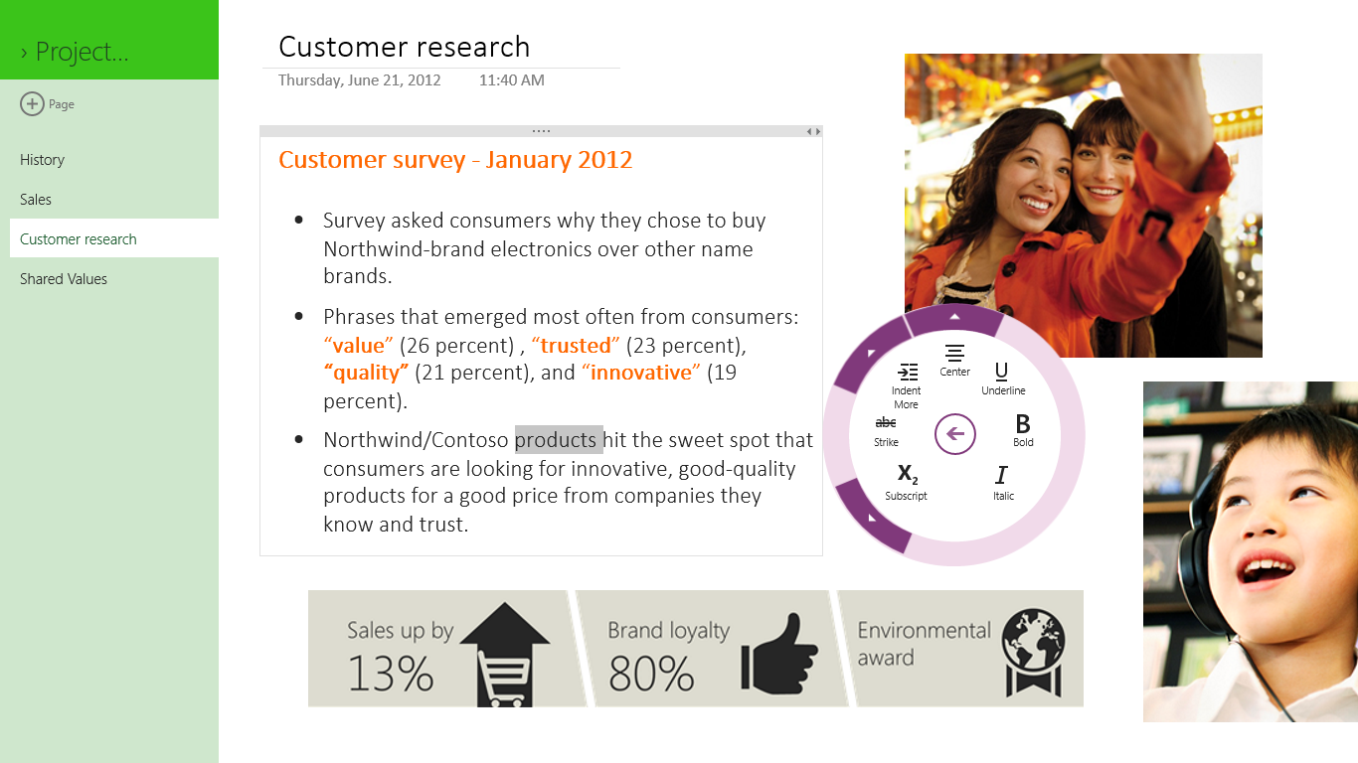

Office on your phone, tablet, and PC
Use Windows 8 across your devices, and get a full-featured Office experience anywhere. Each experience is tailored for the way you work, whether at your desk or on the go.

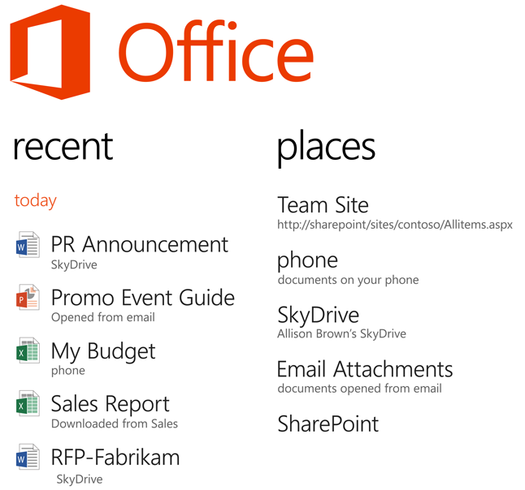
Edit across devices while preserving formatting
When you use Office on a Windows 8 PC or tablet or a Windows Phone 8, formatting and styles remain intact no matter where you work. You can create a document on your desktop and make edits to it on your tablet, and the formatting will remain the same. All the hard work you put into making your document look its best will be preserved.

Office 365 Home Premium and SkyDrive: Any file, anywhere
You want to access and share your documents and other files, but you don’t always have your PC with you. No problem—when you are signed in, Office 365 Home Premium saves your documents to SkyDrive by default. You can access them from any Internet-connected device. Want to save them to your local drive? You can do that, too.
With your documents stored on SkyDrive, you have what you need wherever you go—whether it’s a home to-do list or the latest version of a sales presentation. Your SkyDrive files aren’t stored on a PC hard drive with a limited lifespan. If your computer goes down, your files stay up. If you’re collaborating with other people, you keep track of one version instead of sending revisions back and forth by email. Going mobile? Access your SkyDrive files quickly and easily from your smartphone. Use the SkyDrive apps for Windows Phone 8 and other compatible mobile phones, or sign in from your browser. Either way, you’ll get your docs to go.
Accelerate your creative process with collaboration built in. With Office 365 Home Premium and SkyDrive, people can work together even when they’re not together. Work on a vacation plan in OneNote with a family member. Post it on SkyDrive, and invite others to review it and do basic editing in their browser with the free Office Web Apps. They don’t have to have Office installed to get a great experience.
Word

Create beautiful documents, and enjoy the read
The new Word gives you a clean view so you can enjoy the read from your screen. You still get powerful tools for creating beautiful documents and working together. Stay on top of the latest changes to a shared document and all the conversations in it. Have your documents saved and stored online so you know you're using the right version. Add polish and style with new, compelling templates, tools, and support for online videos and photos.

Enjoy
Get absorbed in Word documents with the new, on-screen read mode. It looks great and gives you tools to enhance your reading experience.
Read mode: Enjoy easy and pleasant reading with text reflowing automatically in columns to fit the screen. Distractions are removed, providing you with only the tools that add value to your reading such as Define, Translate, and Search with Bing.
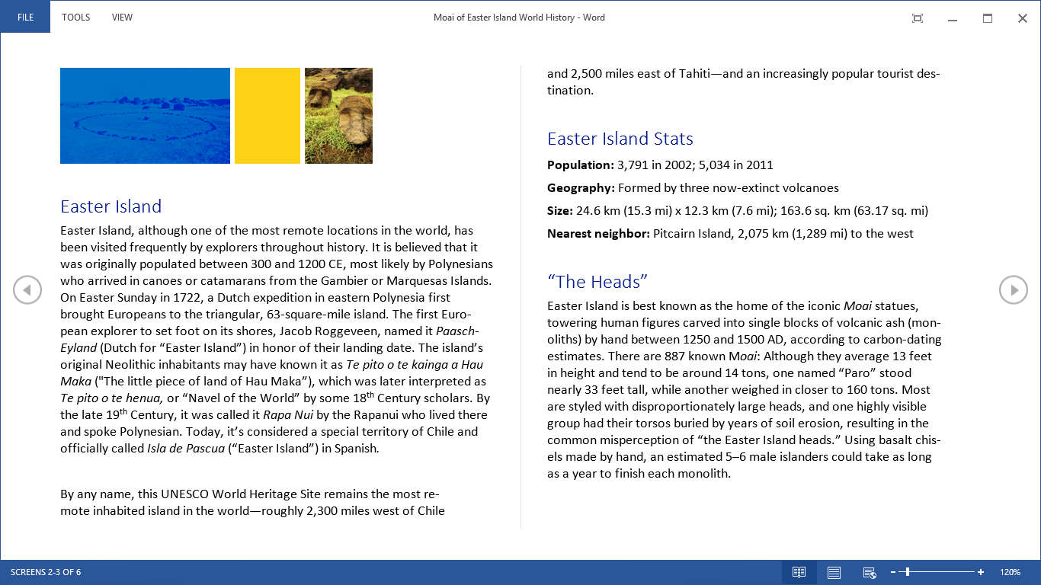
Object zoom: Tap your finger or click your mouse to zoom in and make tables, charts, and images in your document fill the screen. Focus on and take in the information, and tap again to zoom out and continue reading.
Resume reading: Word automatically bookmarks your last position in a document. Take a break from reading, and when you reopen your document, you can pick up where you left off, even on a different PC or tablet when signed into your SkyDrive account.
Online video: When you have an Internet connection, you can watch online videos in Word without having to leave the document, so you can stay focused on the content.
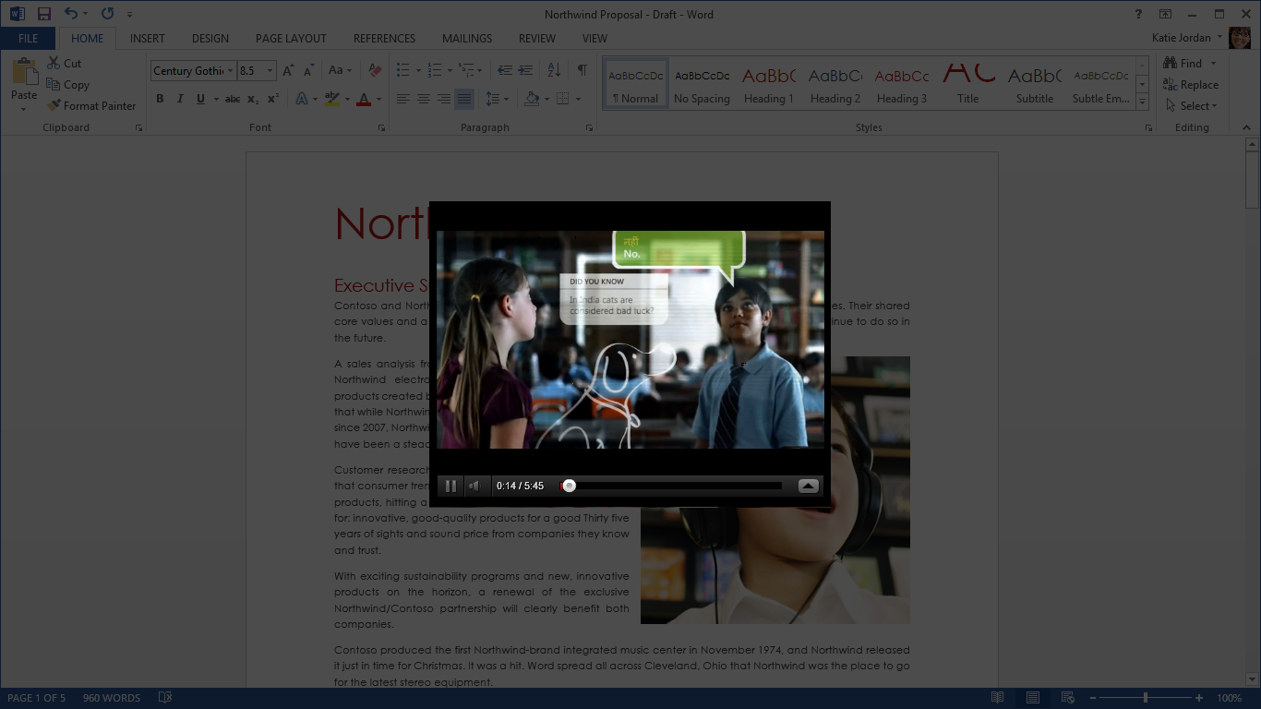
Expand and collapse: You can collapse and expand sections of your document with a tap or click. Easily manage large documents by collapsing paragraphs you are not working with, or expand them to explore more.
Navigation pane: Know at a glance where you are in your document. You can see the contents, search the document, and track your place by heading all from the navigation pane.

Work together
Share and work with others using improved reviewing and online presentation tools.
Simplified sharing: When you are online and signed in with your Microsoft account or organizational or school ID, your documents are saved to the cloud by default. You can share and collaborate by sending a link. Manage and track only one version of your document.
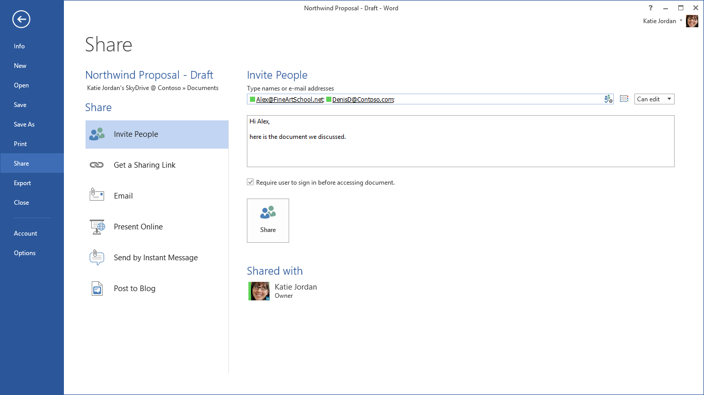
Reply comment: Debate and easily track comments next to the relevant text. You can see who replied to whom and when, so you can have helpful conversations where they matter.
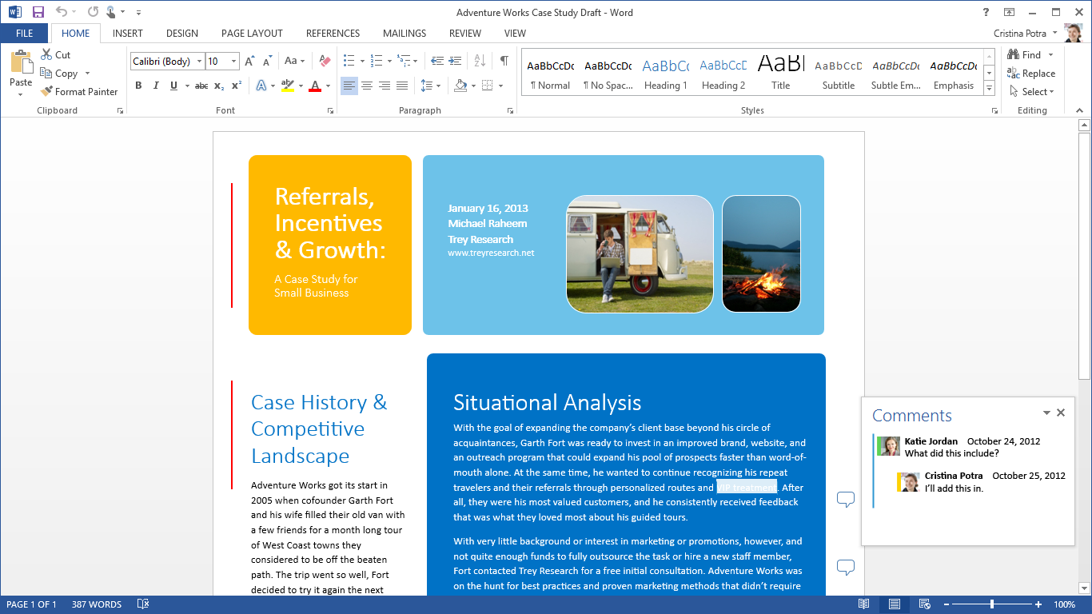
Present online: When you're online, you can share the document on your screen with others, even if they don't have Word. Send them a link, and they can follow you in their browser as you scroll through the document on your screen.
Simple markup: See a clean version of documents that have been marked up, with subtle hints that indicate changes and comments. With one click, you can see the changes and then hide them for easy reading and tracking.
Lock tracking: Add a password to prevent others from turning off change tracking so you see every edit.
Mark comment as done: When a comment or a conversation has been addressed, mark it as "done" to collapse and gray it out. It will be out of your way but easily accessible for future reference.

Polish
Add flair to your documents with online photos and videos.
PDF Reflow: Use content from PDFs easily, and make it look great. Word now opens PDFs and makes content such as paragraphs, lists, and tables act like Word documents.
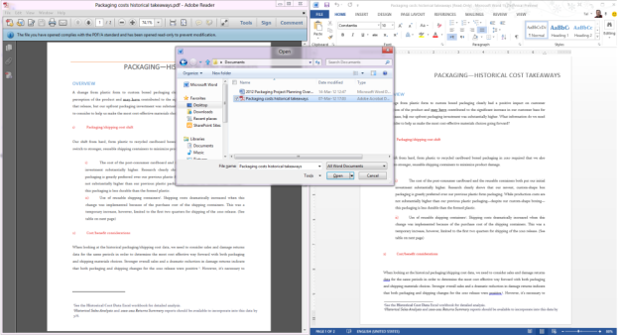
Automatically reflow PDF content into an editable Word document.
Alignment guides: New alignment guides make it easy to align charts, photos, and diagrams with your text for a polished and professional look. Guides pop into place when you need them and disappear when you're done using them.
Live layout: Watch photos, videos, and shapes move through the text as you drag them in your document. Release the mouse button, and your object and the text around it are in their final place—no need to guess the result.
Start: The new Start experience gives you easy access to new, inspiring templates as well as a list of your recently viewed documents. You can get back to where you were in no time.
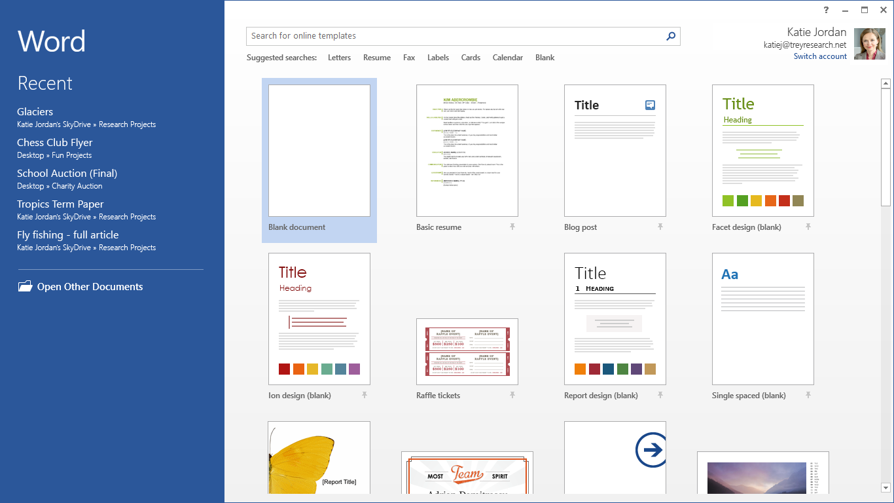
Design tab: The new Design tab helps you make your design changes from one place, so you spend less time searching for what you need.
New building blocks: Choose from a new set of cover page, header, and footer styles to give your document polish.
Online pictures: When you're online, you can use Word to search your albums on Facebook, Flickr, and other online services. Add pictures directly to the document without having to first save them to your desktop, laptop, or tablet.

For information about Word, visit the Get started with Word 2013 website.

Excel

Discover and share insights from your data
The new Excel gives you intuitive ways to explore your data, inspiring you to new insights. In one click, discover new ways to visualize your data, and see your information with new depth. Enjoy working with and analyzing your data—the new Excel guides you with charts and tables based on your data and helps you get the job done faster. A new, clean view made as much for the touch of your finger as the click of your mouse or keyboard means you can move naturally through your information.

Discover
Unleash the insights hidden in your data with new tools that make it easy to extract what you need from imported information and quickly perform complex analyses.
Flash Fill: Reformatting and rearranging your data just got easier. Watch Excel recognize and learn your pattern and autocomplete the remaining data, with no formulas or macros required.
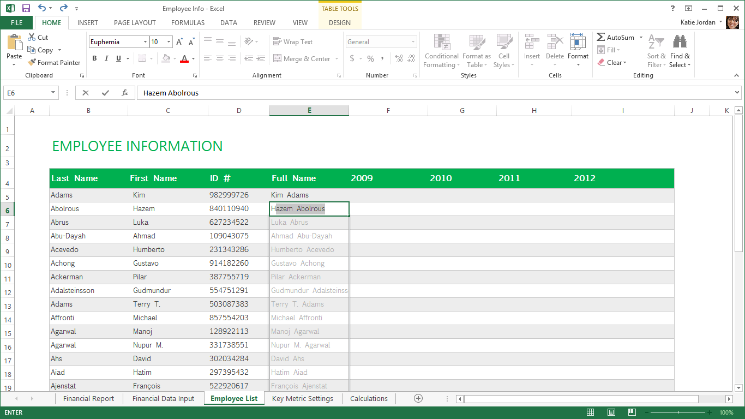
Recommended PivotTable: Find the best summary for your data. Excel suggests options for summarizing your data into a PivotTable. Get a quick look at your data in tables that use different pivots, and pick the one that lets the insights flow.
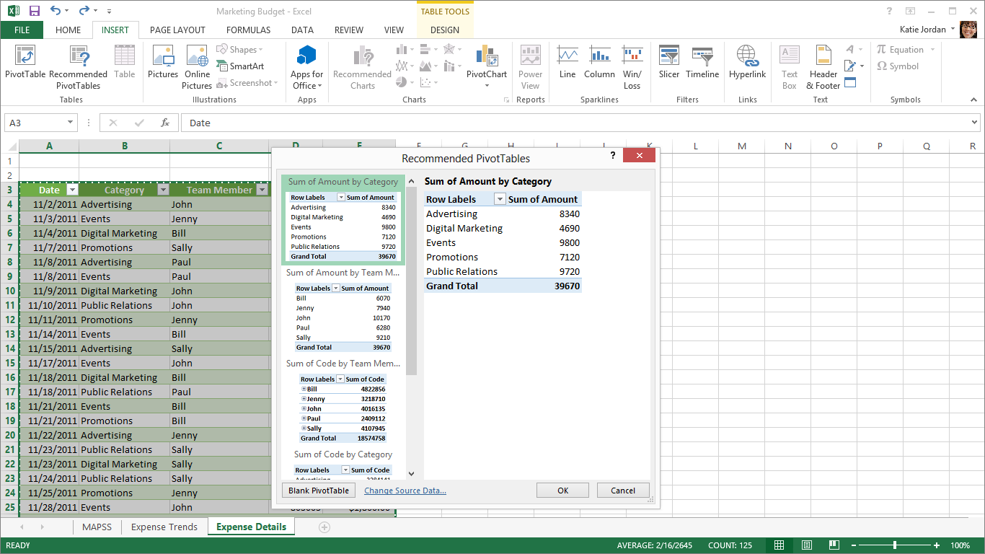
Add Custom Tools: The new Office Store offers a range of apps to help you represent and interpret your data. From a heat map to a radial bar chart, you can choose the best way to share your insights with colleagues.

Visualize
Bring your analysis to life with a click of the mouse and new, easy-to-use visualization tools that make your data look great.
Quick Analysis Lens: With one click, discover different ways to visually represent your data. Love what you see? Apply formatting, Sparklines, a chart, or a table with one more click.
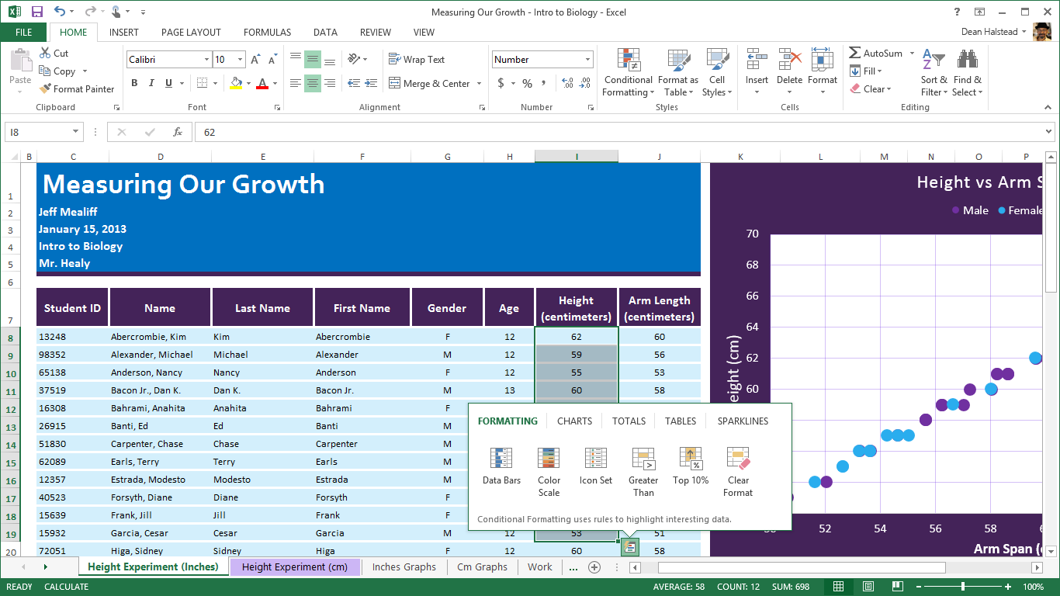
Recommended Charts: Find the best ways to visualize your data in charts. Excel recommends the most suitable charts based on patterns in your data. Quickly look at your data in different charts and graphs, and pick the view that shows what you want.
Chart Formatting Control: Fine-tune your charts quickly and easily. Change the title, layout, or other elements of your charts from a new and interactive interface.
Chart Animations: Watch every change in a chart as you adjust the numbers or add new data points. With animations, you can clearly see the changes applied to your charts and better understand movement in your data.
Timeline Slicer: Quickly see your data over different periods. Now you can apply a visual time filter on your data, charts, or PivotTables or move through rolling month-to-month performance with a click.
Get started quickly: Structure and format your spreadsheet instantly using professionally designed templates including budgets, calendars, forms, and reports.
Excel App animations: Enjoy working in the new Excel with smooth animations that help you focus on the changes.
Touch-enabled: Get in touch with Excel. Use your fingers to move through your charts, graphs, and tables.

Share
Work together or show off your results with the new sharing capabilities of Excel. Send a link to co-workers, and post to your social network using the free Office Web Apps.
Simplified sharing: Sharing a workbook is now much simpler. You can share and collaborate by sending a link to your workbooks saved in the cloud.
Post to social networks: Embed part of your spreadsheet on social network pages.
Present online: Share your workbook and collaborate in real time with others. You can even allow them to take control of your workbook.
Send by instant message: Share your workbook by attaching it to an instant message. Each recipient will get a separate copy of your workbook.

For information about Excel, visit the Get started with Excel 2013 website.
PowerPoint

Design and deliver beautiful presentations with ease and confidence
Easily work with others and design beautiful presentations. Intuitive design tools make it easy to start from a theme, apply variants, align text and media, and even build customized icons. When collaborating, co-authoring and replying comments make it easy to work with one version and keep all important conversations in context. Sharing online is simple: Even if your audience doesn't have PowerPoint, you can project to their browser. When you present, you are in complete control behind the scenes, keeping track of your notes, zooming in on specific slides, and easily navigating among them.

Design
Get started on your presentation, and making it look great has never been easier.
Start screen: Get started with ease. When opening PowerPoint, you are presented with a collection of compelling, widescreen themes to use in creating your presentation.
Alignment guides: Enhanced alignment guides make it easy and intuitive to line up shapes, text boxes, and other graphics, so your presentations look as if they were polished by a designer.
Smart guides: See in real time how your graphics line up and intuitively drop objects into the right place.
Master-level guides: Set fixed guides for specific slides from the master, making it easy to achieve visual consistency across slides.
Theme variants: Change the look and feel of your presentation with one click, and make your presentation unique.

Merge Shapes: Select two or more shapes on your slide, and easily create new, custom shapes with union, combine, fragment, intersect, or subtract tools. Create amazing new shapes for diagrams and icons.
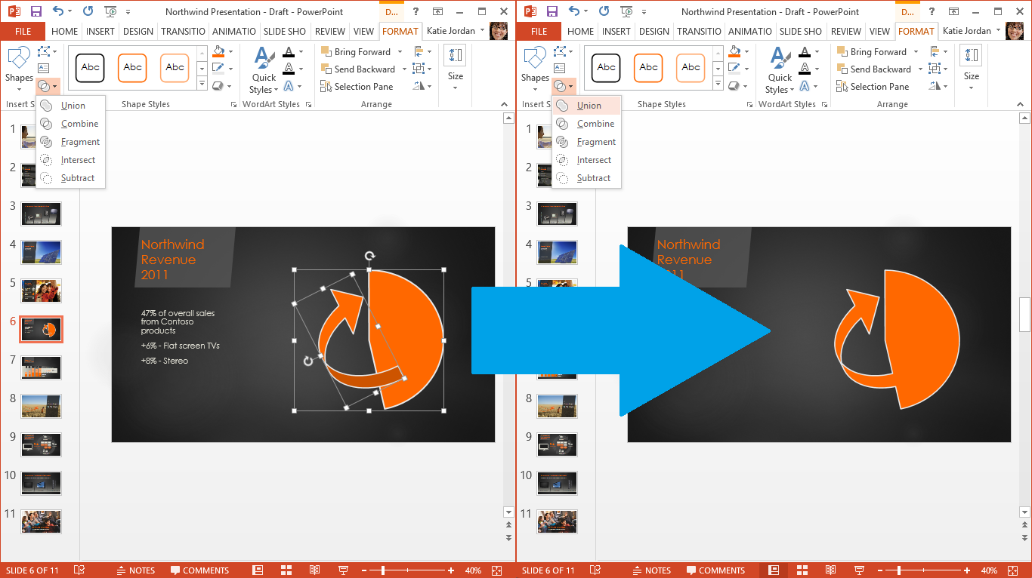
Eyedropper: Grab the exact color you need to make your slides great. Match the color of a title to an accompanying picture, or ensure that you are using your exact logo color with three clicks.
Online pictures: When online, you can use PowerPoint to search your albums on Facebook, Flickr, and other online services, and add pictures directly to the document without having to first save them to your desktop, laptop, or tablet.
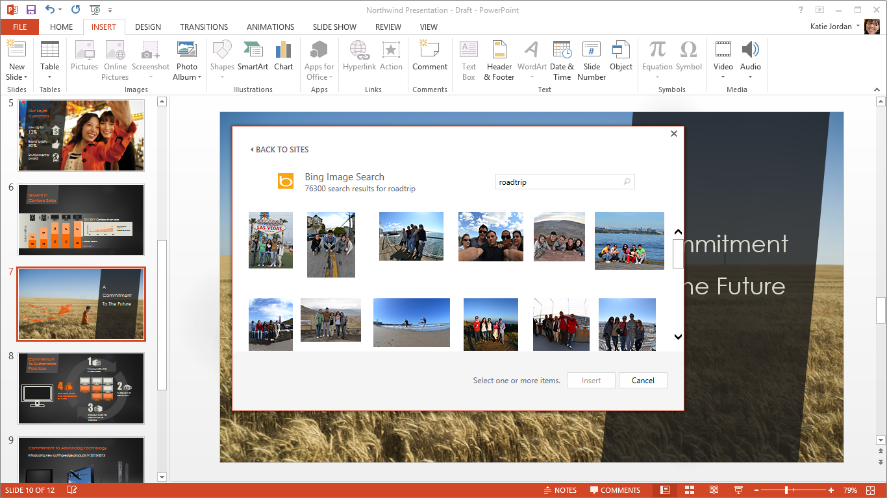
Insert pictures from online sources without saving them to your desktop first.

Media support: Add life to your presentations with videos, and enjoy support for even more formats.
Play in Background: Have music and sound play across several slides or your whole presentation.
Format Object task pane: A new pane holds all the shape, picture, and text design decisions for you. Easily navigate among formatting options, and see their immediate effect.
Modify Data Layout: Fine-tune your charts quickly and easily without affecting the underlying data. Filter the data presented using a new, intuitive menu.

Impress
Stay in control so you can focus on your audience, not your slides.
Presenter View: When presenting with a second screen (such as with a projector), new behind-the-scenes tools keep you in control and allow you to focus on and connect with your audience.
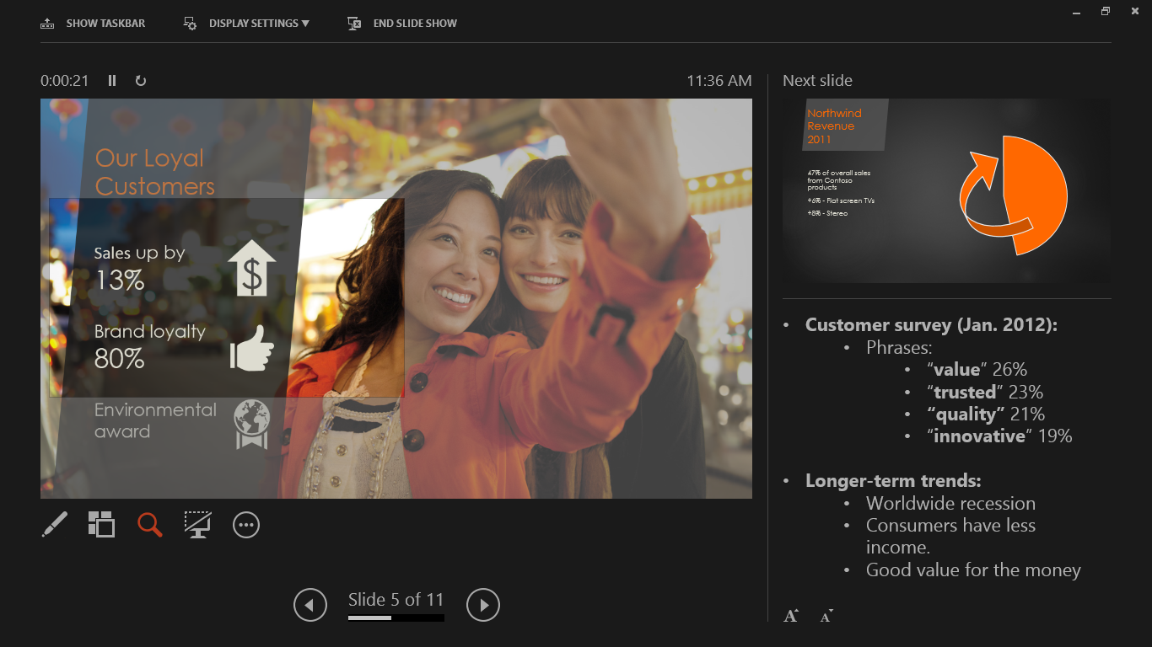
Effortlessly control your presentation with the improved Presenter View.
Slide zoom: Help your audience focus on your ideas. Click to zoom in and out on a specific diagram, chart, or graphic.
Navigation grid: Easily navigate between slides using a visual grid to show your slides at a glance; your audience sees only the slide you're presenting.
Auto-extend: When you connect to a second screen, PowerPoint applies the settings to enable Presenter View and ensure that it is projected on the correct screen.
Swap displays: Move Presenter View and Audience View to opposite screens with one click.

Work together
Create and edit presentations with others in real time, and share online easily.
Simplified Sharing: When you are online and signed in with your Microsoft account or an organization or school ID, your presentations are saved to the cloud by default. You can share and collaborate by sending a link, which also grants read or edit permissions. With online sharing, you can easily manage a single version of your presentation.
Reply comment: Debate and easily track comments next to the relevant text or graphics. You can see who replied to whom and when, so you have helpful conversations where they matter.
Comments pane: The new comments pane makes it easier to review all the comments and conversations in a given slide.
PowerPoint Web App Co-authoring: Co-authoring comes to the free PowerPoint Web App. When you're online, you and your team can work together on a presentation at the same time from the desktop and in the browser with the PowerPoint Web App on SkyDrive.
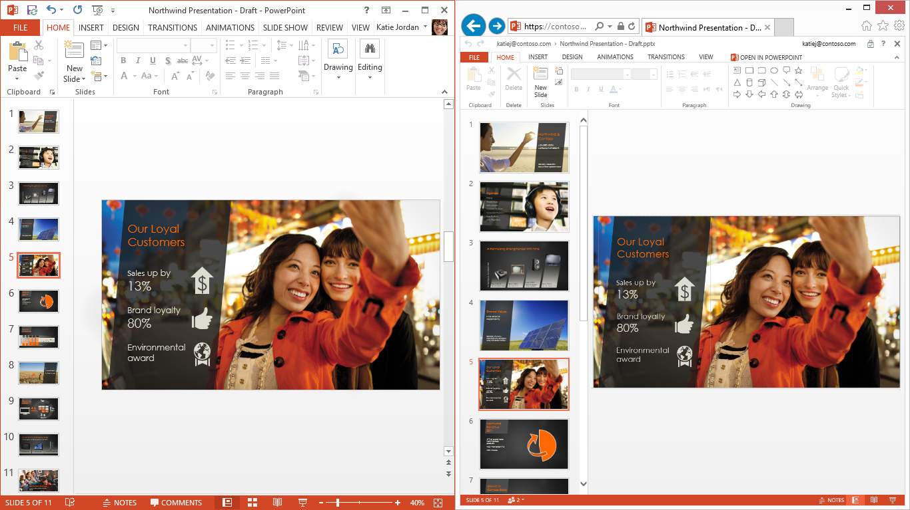
Present Online: You can share your presentation with others, even if they don't have PowerPoint. Send them a link, and when you are online, they can follow you in their browser as you advance through the presentation on your screen.

For information about PowerPoint, visit the Get started with PowerPoint 2013 website.

Outlook

Manage your email, schedules, contacts,
and to-do lists
Outlook helps you manage your busy life more easily and efficiently. You get new and improved ways to find information quickly, handle email, coordinate schedules, keep current with contacts and social networks, and tame your unruly to-do lists.

Communicate
Quickly connect and share files with the people and groups that matter most.
Inline replies: Reply to email with one click, and check replies off your list so that you can focus on important tasks.
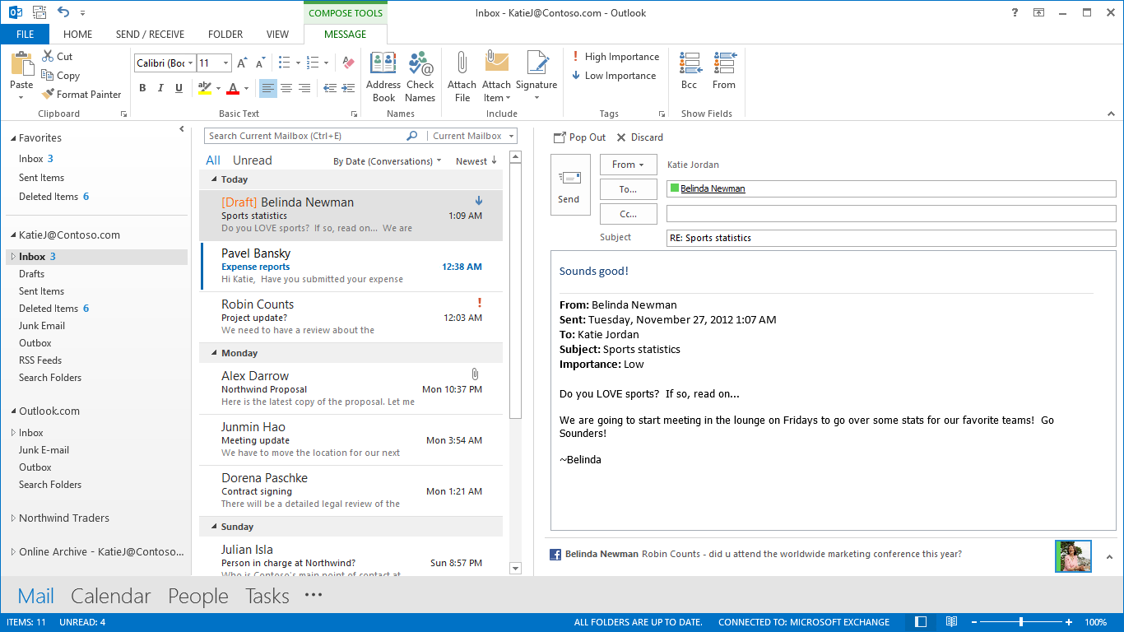
Animation: Smooth transitions between email, calendar, and tasks intuitively help you understand context.
Navigation bar: Get easy access to email, calendar, people, and tasks with a navigation bar that takes up less space.
Ribbon: See the ribbon when you need it, and hide it when you don't.
Social connectors: See social updates from the people you're in contact with. LinkedIn, Facebook, and other updates are incorporated automatically, so you have the right context to start, add to, or change the conversation.
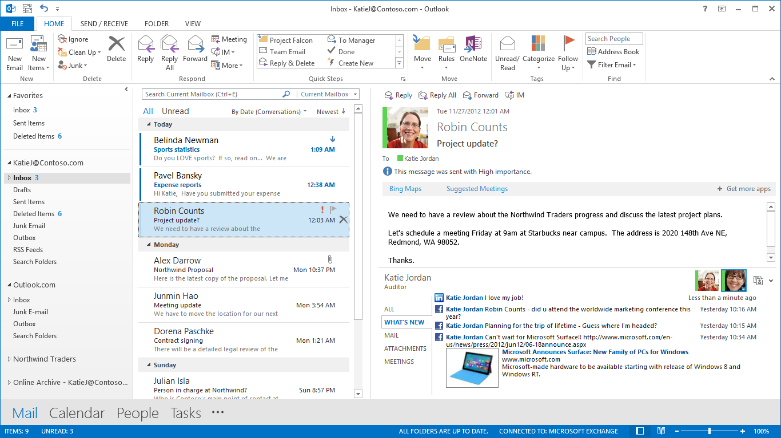
Exchange ActiveSync support: Connect Outlook using Exchange ActiveSync, and access push-based email, appointments, and contacts across many popular email servers and services.

Manage
Take control of your email and schedule with tools that help you organize your life.
Peeks: Take a peek at your schedule, a specific appointment, or details about the person you're emailing without moving screens or losing context.
People card: Multiple contacts are transparently joined into one view, reducing distracting duplicates and offering social context.
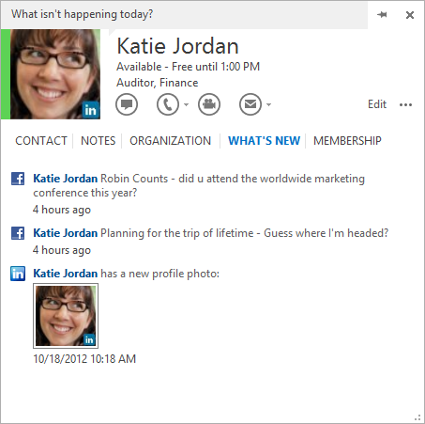
Multiple email accounts: See, create, and respond to all your email in one place just like you do on your phone, including Hotmail and third-party webmail. You don't have to download anything or install add-ons; Outlook can now connect directly with your other email and calendars.
Share your calendar: Make your calendar available for others to see so scheduling meetings becomes a snap.

Find
Find the important information that you need so you can make the right decision fast.
Search: Find the information you need fast. Search is available for email, attachments, calendar appointments, and contacts so you can quickly find the information you need.
Fast filters and context commands: Get one-click context, and instantly see what's happening today, next week, or next year. View email messages by who sent them or whether or not you've responded, or go straight to what you haven't read. Easily file, flag, or delete email.
Clear view: See more of your information with a clean, clear viewing area.
Weather bar: See the weather while you ponder your calendar, for easy planning of your day or next trip.
Personalize: With apps from the new Office Store, you can add capabilities to Outlook to simplify your life such as the Hertz app, which lets you rent a car without leaving Outlook. Apps are also available for Word and Excel.
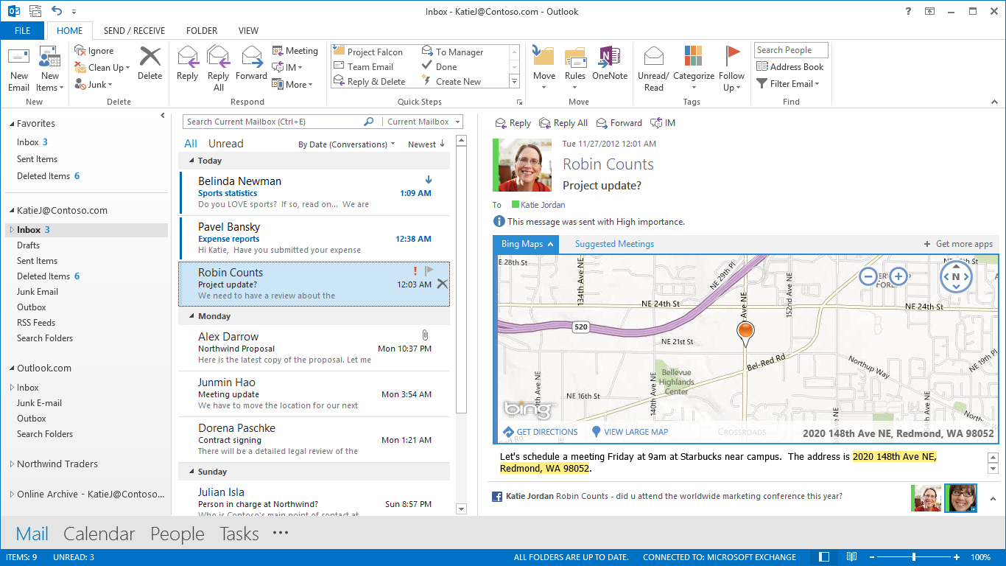

For information about Outlook, visit the Get started with Outlook 2013 website.

OneNote

Take notes, and have them where you want, when you need them
OneNote is a digital notebook that holds your notes, pictures, webpages, and media. Access your information wherever you go, using your favorite devices. Create notes, sketch a diagram, or record a lecture, and connect them to related presentation files, photos, videos, Web links, and charts in your notes. Everything you capture is saved and searchable without extra steps. With OneNote, your notes travel seamlessly with you. Download the OneNote app so you can access your latest OneNote notebooks from your favorite devices including Windows Phone 8, Windows 8, iPhone, iPad, and Android phones. OneNote is also available through your browser using the free OneNote Web App. You don't have to remember, because OneNote's got it.

Capture
Have your ideas in one spot: Keep all your notes, links, Web pages, and media together. Take notes, sketch a diagram, or record a presentation, all in OneNote.
Embed Files: Add a presentation file, document, spreadsheet, Web link, video file, or other media to your notes. You'll always have the information you need at hand.
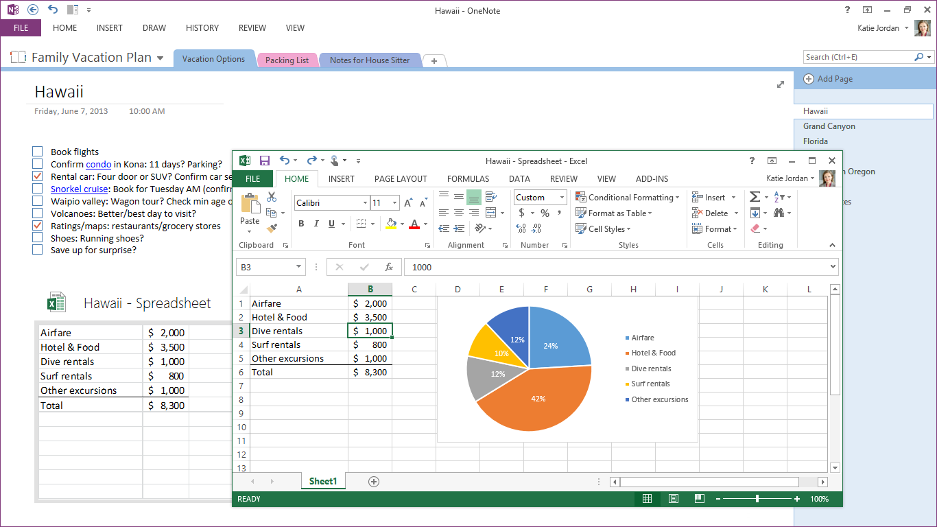
Auto-Updating File Views: When you embed Excel and Visio files, you'll be able to see content previews from within your notebook. Made a change? The preview will automatically update. You'll be able to see the information you care about next to your notes.
Tables: Do more with tables. OneNote now has powerful table tools that allow you to make headers and quickly move around rows and columns. Want to create data visualizations or do more advanced data work? With one click, you can convert tables in your notes into embedded Excel spreadsheets.
Inking: OneNote's improved inking allows you to draw, erase, and edit seamlessly whether using your finger, stylus, or mouse. Like writing instead of typing? OneNote converts handwriting into text.
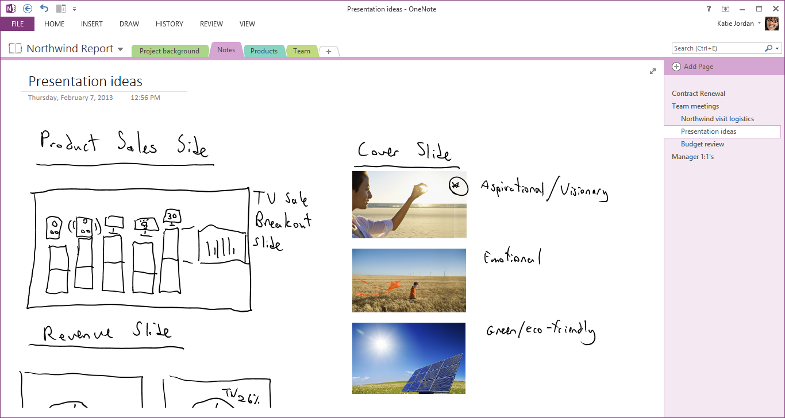
Meetings (with Outlook): Connect your notes with corresponding meetings scheduled through Outlook. Go to your meeting, and pull up the corresponding notes on the given topic. Embed a presentation for a meeting, open it during the meeting, and make your notes alongside every slide.
Linking audio: Go back and hear what was said, record audio in your notes, and type while you're recording. Your notes will link with the specific part of the audio recorded while you were typing. Find your note, hit Play, and listen to what was said.
Snip photos: Add cropped screenshot images from any type of file or image to your notes.
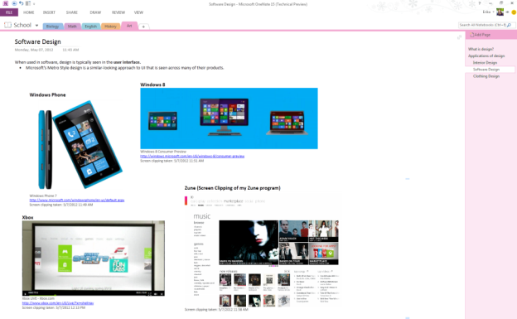
Snip anything from your screen, and add it to your notes.

Find
In OneNote, your notes are automatically saved and searchable. You can even find the words you're looking for in audio and pictures. You don't have to remember where you put anything—OneNote's got it.
Auto-save: OneNote saves as you go so you never need to remember to click Save. You can still save as a new version or under a new name.
Search: You can search the notes and files you've added to find anything you've captured—a page in a presentation, text in a picture, or a comment in an audio clip. Type in a keyword or phrase.
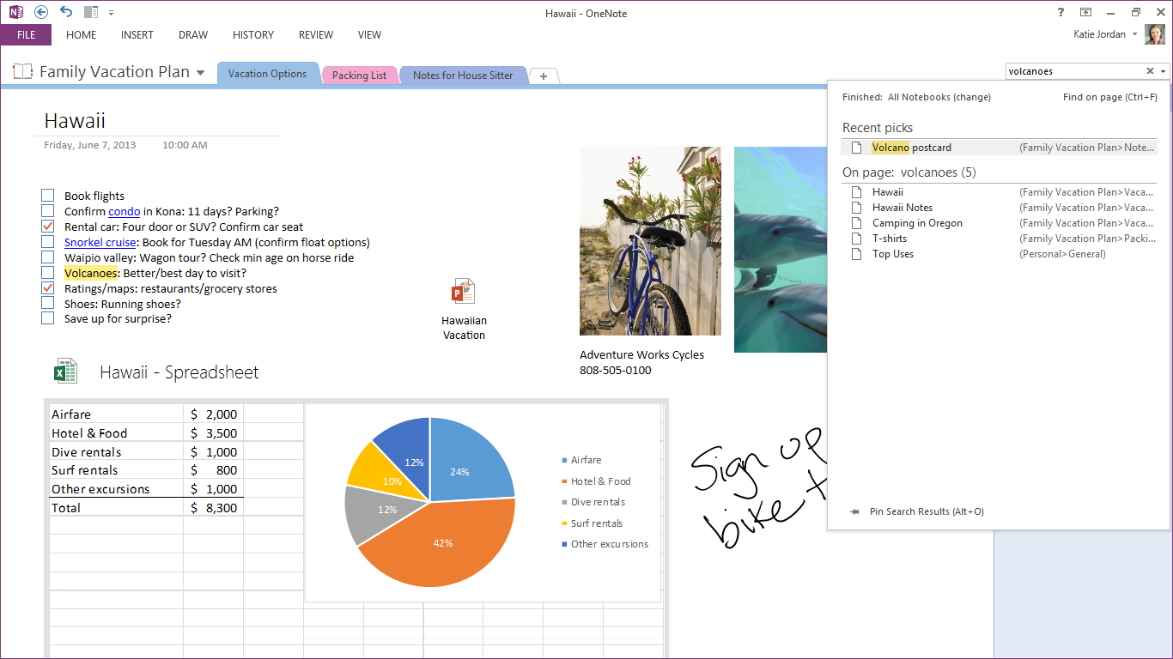
Simplified Sharing: Your notes are saved to the cloud by default when you're online. You can share and collaborate by sending a link. Manage and track only one version of your notebook, all within OneNote, and when it's in the cloud, it's backed up, so you don't have to worry about losing your work.
Full Page View: Have the tools you want when you need them. When you want just your notes, full-screen mode hides the ribbon and page navigation so you have no distractions. Need to go to a different page or access the ribbon? They're a click away.

Go
OneNote is your digital notebook that travels with you. Download the OneNote app so you can access your latest OneNote notebooks from your favorite devices, including Windows Phone 8, Windows 8, iPhone, iPad and Android phones.
The OneNote app for Windows 8: Draw, type, click, and swipe: OneNote is reimagined for Windows 8. Your notes are saved and searchable, and they sync to OneNote apps on your other devices.
Touch: Get in touch with OneNote. Use your fingers to move through your pages and notes when you don't have a keyboard.
In Sync: OneNote syncs fast with SkyDrive, so you know you always have the latest on all your devices. You can find what you need or add more from the OneNote client or from SkyDrive.

For information about OneNote, visit the Get started with OneNote 2013 website.

Publisher

Create professional and impactful publications
Use familiar, simple tools to create professional-looking publications that make an impact. With the unique layout and print capabilities of Publisher, you can easily and quickly make brochures, newsletters, calendars, posters, and fliers. Publisher makes it easy to grab your audience’s attention with personalization tools so you can customize names, photos, and links, and you can share publications in the way that best suits your audience.

Impact
Make an impact in a highly visual world overloaded with content. Publisher has simple tools that make your publication stand out and grab attention.
Swap picture: Import all your pictures to a single canvas in Publisher, and swap them in and out of your design by simply dragging. Experiment to find the right image quickly.
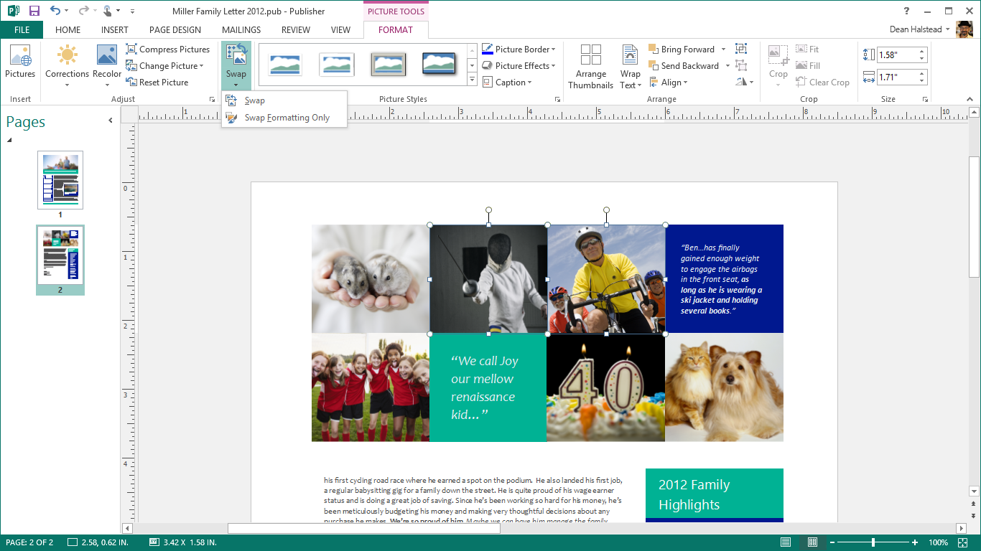
Effects: Use professional-looking effects for text, shapes, and pictures, including softer shadows, reflections, and OpenType features such as ligatures and stylistic alternates. These familiar effects work like those in other Office applications that support them.
Start: The new Start experience gives you easy access to new, compelling templates as well as a list of your recently viewed documents, so you can get back to where you were in no time.
Picture background: Use your photos as high-resolution page backgrounds, and make your publications look professional and polished.
Online pictures: When online, you can use Publisher to search your albums on Facebook, Flickr, and other online services, and add pictures directly to the document without having to first save them to your desktop, laptop, or tablet.

Personalize
Make your publications personal for your audience through text, photos, and links. It's simple to customize with Publisher using familiar tools such as mail merge.
Mail merge: Include photos and links in the familiar mail merge tools, and personalize your newsletters, cards, and email.
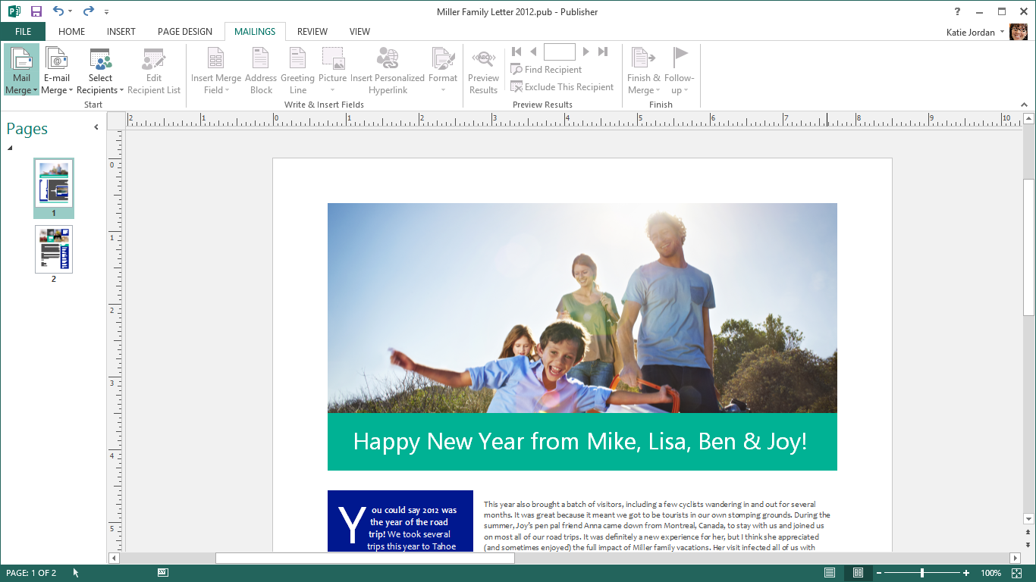
Mailings tab: All your personalization needs are in one place in the ribbon.

Share
Share and work easily with others. Email, PDF, XPS, or high-quality prints—publish in the way that suits your audience best.
Simplified sharing: Your documents are saved to the cloud by default when you're online and signed in with your Microsoft account or organizational or school ID. You can share and collaborate by sending a link.
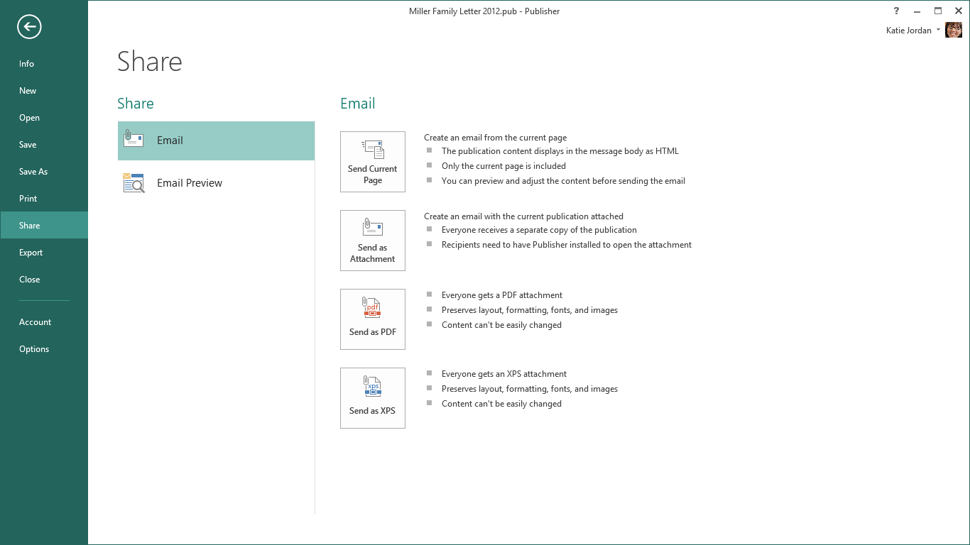
Photo Printing: It's now easier to print great-looking publications or photo albums at any print shop. You can save all of your pages to a common picture format such as JPG.
Email: Share a page as an email, or send the entire publication in the email message as HTML. All the pages will be combined into one message for you.
PDF and XPS: Save your publications as PDF and XPS, or send them directly as PDF or XPS attachments without first saving them.
Print: The Print tab in the backstage view makes it easier to preview your publications and ensure that they come out perfect.

For information about Publisher, visit the Get started with Publisher 2013 website.
Access

Organize data in your life and business

Create
Build and share custom databases that run on your computer—no software development knowledge needed.
Welcome screen lift-off: Start creating a custom database from the Welcome screen, or get inspired by one of the new and professionally-designed database templates.
Table templates: Simply type what you need to track and Access will use table templates to deliver a database that does the job. Access handles the complexities of fields, relationships, and rules so you can concentrate on your project. You’ll have a new database with a natural UI up-and-running before you know it.
Create and run legacy databases: Enjoy support for your existing desktop databases (ACCDB/MDB).
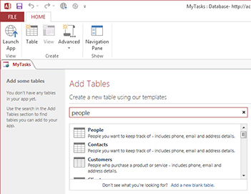

Experience
Use a standardized app framework that makes navigating databases familiar and easy. Your database will remain professional-looking as it grows with your business.
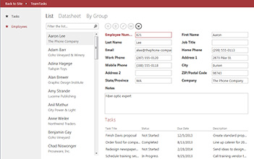
Gorgeous simplicity: Never again get "lost in the data." Databases you rely on every day remain easy-to-use even as data volume and complexity grow.
Related items control: Take a peek at additional relevant information in the database without changing screens. You always have the right context when reviewing or entering information.
Autocomplete control: Entering data accurately is a “breeze" with drop-down menus and recommendations that appear when you begin typing.
Drill-through: Simply click to view a pop-up and dig into the details of a record.

For information about Access, visit the Get started with Access 2013 website.

Get started

Get started with Office 365 Home Premium
Getting your Office 365 Home Premium up and running is simple.
Step 1  Visit office.com/setup.  Arrive at POSA Redemption Site and enter Product Key found on packaging |  | 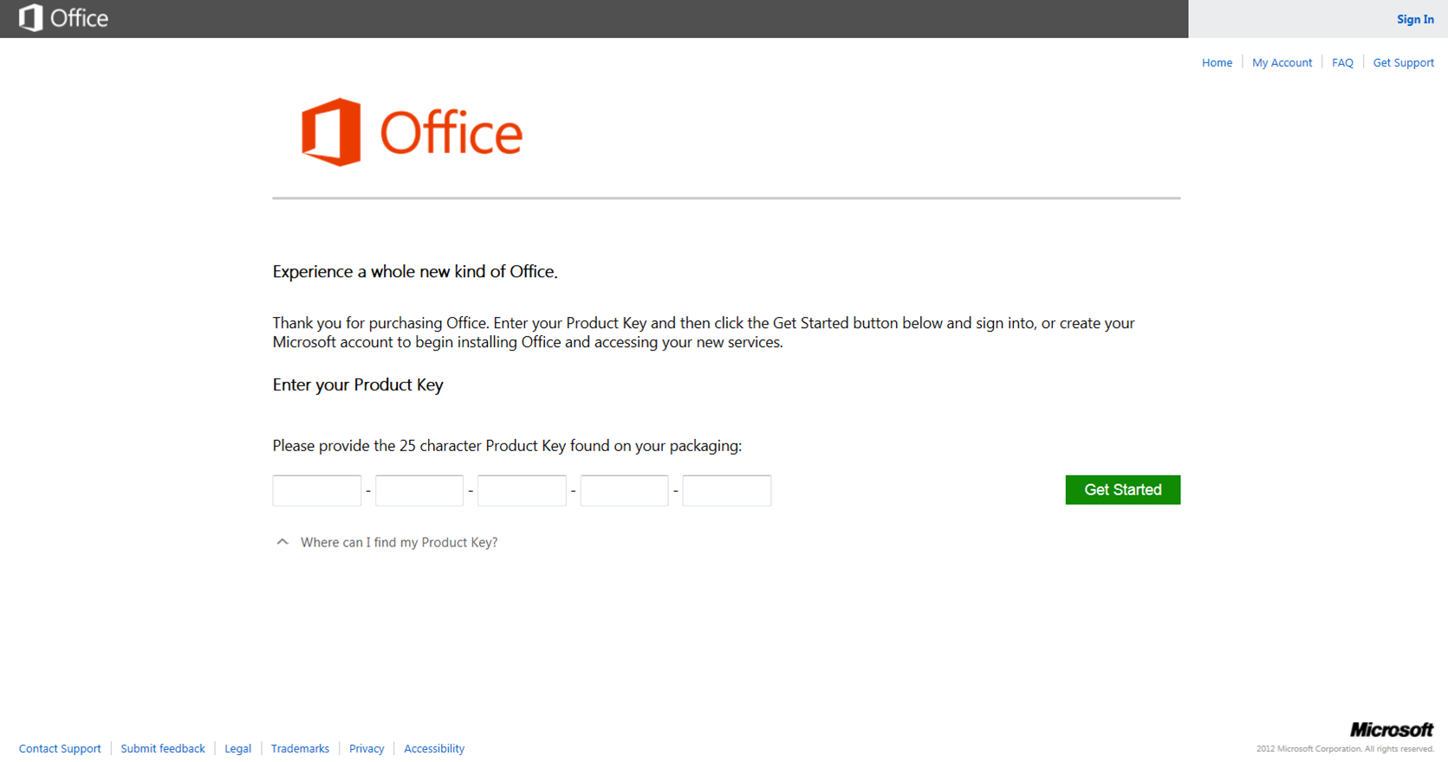
Step 2  Log in with existing Microsoft account, or create a new account. |  | 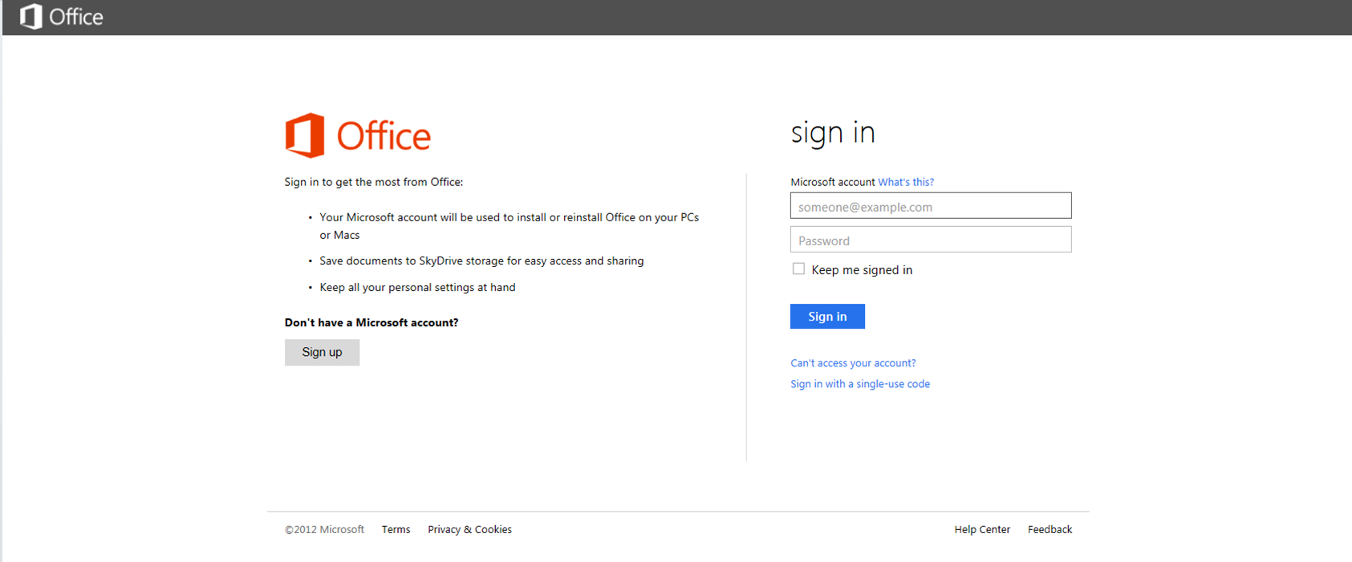
Step 3  Choose country and language and privacy settings. |  | 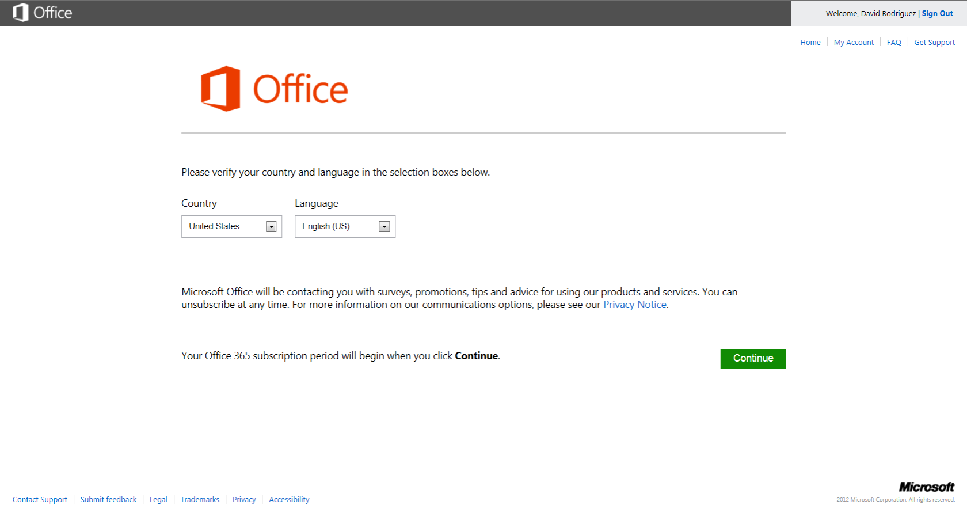
Step 4  Subscription is being provisioned … |  | 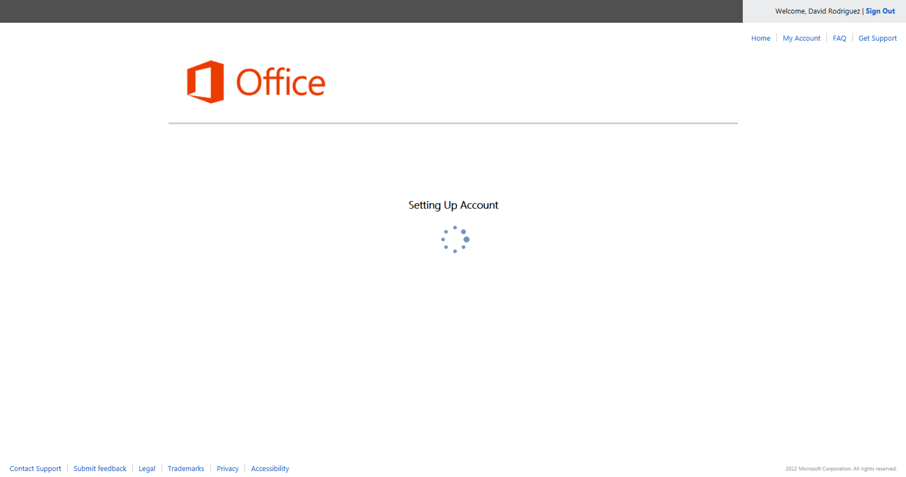
Step 5  User lands on MyAccount to install and manage subscription. |  | 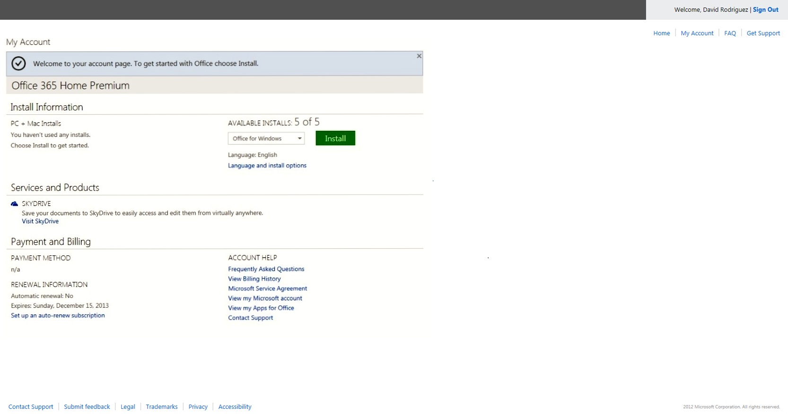

Managing your Office 365 subscription: Frequently Asked Questions
How do I install Office 365 on PCs?
If you install any of the Office 365 Preview plans, you can install Office on up to five PCs. For Office 365 Home Premium, go to office.com/myaccount and click on Install Office.

How can I change which devices have Office 365 installed?
Office 365 Home Premium can be installed on up to five PCs or Macs. If you have already installed Office on five PCs or Macs and want to use Office on another a different PC or Mac, you can deactivate a computer from your subscription by logging on to office.com/myaccount.
From the My Account page, you can install Office on a new PC or Mac. The copy of Office on the PC or Mac that was removed from the subscription will revert to reduced functionality mode, but you will not lose the documents that are saved locally on the original PC.
How do I manage my Office 365 Home Premium Account?
You can install Office on additional PCs, remove existing PCs, or cancel your subscription at any time. Go to office.com/myaccount and follow the on-screen instructions.

What is my Microsoft account, and why do I need it for my Office software?

A “Microsoft account" is the new name for what used to be called "Windows Live ID." Your Microsoft account is the combination of an email address and a password that you use to sign in to services like Hotmail, Messenger, SkyDrive, Windows Phone, Xbox LIVE, or Outlook.com. If you use an email address and password to sign in to these or other services, you already have a Microsoft account, but you can sign up for a new one at any time.

With this release of Office, you use a Microsoft account to start an Office subscription and to install and manage your Office software. You may also need to sign in with a Microsoft account when you install the latest Office 2013 suites.

The Microsoft account you use to sign up for your Office 365 subscription or install your Office suite will be the one you sign in with every time you want to manage your account. For example, you will need to sign in when you install Office on a new computer in your household or change your subscription billing details.

Any time you want to install Office on another PC or Mac, choose a new language for an installation, or make other changes to your account, return to office.com/myaccount, and sign in with your Microsoft account.
How do I enable my Skype minutes?
If you have a Skype account, sign in at office.com/myaccount with your Microsoft account, and click the link to activate your Skype world minutes. If you don't have a Skype account, sign up for one, and follow the steps above to activate the minutes. You will see a confirmation at office.com/myaccount when the minutes have been activated.
What happens when my subscription ends? How can I continue to work with my documents?
As the expiration date approaches, you will receive notifications in the Office applications and via email that alert you to the upcoming expiration. Once your Office 365 subscription expires, the Office software applications enter read-only reduced
functionality mode, which means that you can view or print documents but will not be able to create new documents or edit existing documents.
To return to full Office functionality, you can purchase a new subscription from Office.com or any participating retailer. You can also return to using an older version of Office or use the free Office Web Apps on SkyDrive for basic editing.
What happens to the documents I have stored in SkyDrive when my subscription expires?
Your documents will remain accessible to download. If you have reached your free 7GB storage limit, you won’t be able to add or edit documents until you reduce your SkyDrive storage below your quota. You will have the option to access your documents saved on SkyDrive. You can save your SkyDrive documents to another computer or disk drive at any time.
If you are using the new Office 365 Home Premium subscription, which includes an additional 20 GB of storage, you will receive notice as part of your subscription expiry/renewal notifications stating that your subscription is ending.
For which devices will Office be available?
At launch, Office supports PCs running Windows 7 or higher and Macs with Mac OS X 10.5.8 or higher. Office Mobile supports Windows Phone devices running Windows Phone OS 7.5 and higher. Additional devices will be added in the future. Check office.com/information for details.
How do I know if my computer or devices can run the new Office?
You’ll need Windows 7, Windows 8, or Mac OS X version 10.6.0 or later to run Office on your PC or Mac. Other system requirements are as follows:
Computer and processor: 1 gigahertz (GHz) or greater x86/x64 processor with SSE2 instruction set (PC), Intel processor (Mac)
Memory: 1 GB RAM (32 bit or Mac), 2 GB RAM (64 bit)
Hard disk: 3 GB free disk space (PC), 2.5 GB HFS+ hard disk format (Mac)
Operating system (PC): Windows 7 or higher, 32 bit or 64 bit; Windows 2008 R2 or higher with .NET 3.5 or higher. It isn’t possible to install the new Office on a PC running Windows XP or Vista. To use the new Office with Windows 8, you must be running the Release Preview version or higher.
Operating system (Mac): Mac OS X version 10.6.0 or later. Please note, if you are not using the Office 365 Home Premium subscription, 10.5.8 is the minimum operating system.
Graphics: Graphics hardware acceleration requires DirectX 10 graphics card and 1366 x 728 resolution (PC), 1280 x 800 screen resolution (Mac)

Mac functionality excludes personal settings.
PC running Windows 7 or 8 and Internet connection required. Fees may apply. Mac functionality excludes personal settings.
See office.com for details. Skype account required. Excludes special, premium, and nongeographic numbers. Calls to mobile phones are for select countries only. Skype available in select countries only.
Visit www.office.com/information for a current list of devices.
Internet connection required. Internet and mobile telephone usage charges may apply.
App availability varies by device and country/region. See office.com/preview for details.
App availability varies by device and country/region. See office.com/preview for details.
Publisher on PC only.
Access on PC only.
Locally saved documents on original PCs can be opened and printed but not edited.
Locally saved documents on original PCs can be opened and printed but not edited

