Surface Pro 3
Fact sheet
May 2014

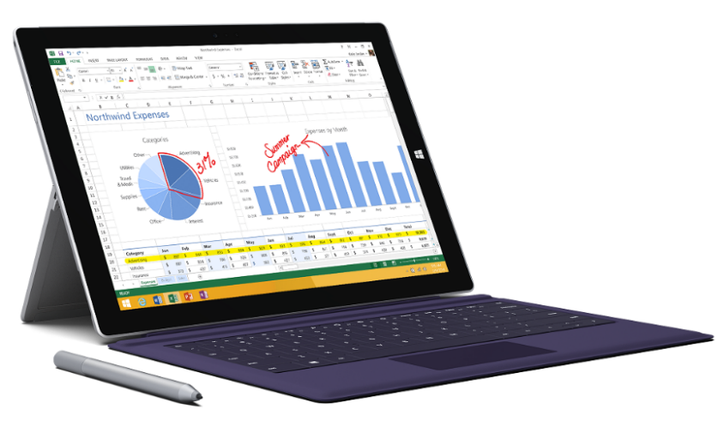
Meet Surface Pro 3, the tablet that can replace your laptop. Wrapped in magnesium and loaded with a 12-inch ClearType Full HD display, 4th-generation Intel® Core™ processor and up to 8 GB of RAM in a sleek frame — just 0.36 inches thin and 1.76 pounds — with up to nine hours of Web-browsing battery life, Surface Pro 3 has all the power, performance and mobility of a laptop in an incredibly lightweight, versatile form.

The thinnest and lightest member of the Surface Pro family, Surface Pro 3 features a large and beautiful 2160x1440 2K color-calibrated screen and 3:2 aspect ratio with multitouch input, so you can swipe, pinch and drag whenever you need. The improved optional Surface Pro Type Cover and more adjustable, continuous kickstand will transform your device experience from tablet to laptop in a snap. Surface Pro Type Cover features a double-fold hinge enabling you to magnetically lock it to the display’s lower bezel, keeping everything steady so you can work just as comfortably on your lap as you do at your desk. With a full-size USB 3.0 port, microSD card reader and Mini DisplayPort, you can quickly transfer files and easily connect peripherals like external displays. And with the optional Surface Ethernet Adapter, you can instantly connect your Surface to a wired Ethernet network with transfer rates of up to 1 Gbps.

The custom Surface Pen, crafted with a solid, polished aluminum finish, was designed to look and feel like an actual fountain pen to give you a natural writing experience. Use Surface Pen to organically mark presentations, sign documents or create art in apps like Fresh Paint. A click of Surface Pen opens OneNote, so you can capture your thoughts instantaneously — and your work is automatically saved. Double-click the back of Surface Pen to instantly capture a screenshot of whatever’s on your screen. And with our sophisticated Palm Block technology, you can rest your hand as you write without unintended inputs and marks.

When it’s time to have some fun, Surface Pro 3’s bright 12-inch ClearType Full HD display, Dolby® Audio-enhanced sound and doubled Wi-Fi speeds are up to the task. Prop up your Surface via its continuous kickstand for your perfect viewing angle, and enjoy Surface Pro 3’s front-facing speakers, now 45 percent louder for an even better audio experience. Need to quickly capture a photo or video chat with your friends? Surface Pro 3 now features two 5MP cameras capable of capturing 1080p HD video, so capturing stills or video has never been easier.

With Windows 8.1 Pro, Surface Pro 3 is capable of running all your Windows software, including Microsoft Office and Windows Store apps, including custom line-of-business apps for enterprises and business owners. Starting at just $799 ERP, Surface Pro 3 is available with an Intel® Core™ i3, i5 or i7 processor with up to 512 GB of storage and up to 8 GB of RAM.

Top features and benefits
- Replace your laptop. Surface Pro 3 takes you from tablet to laptop and back with the optional Surface Pro Type Cover and Docking Station for Surface Pro 3. Prop Surface Pro 3 and Surface Pro Type Cover up on your lap to type on the go, flip the cover back and use Surface Pro 3 like a tablet, or draw with Surface Pen. Connect Surface Pro 3 to the docking station to create a powerful desktop rig. It’s the tablet that can replace your laptop.
- Feel the power. With the option of three different 4th-generation Intel® Core™ processor models and packing up to 8 GB of RAM, Surface Pro 3 is a powerhouse providing enterprise-worthy performance, all in a thin and lightweight package.
- Write, draw and create. Surface Pro 3 includes the all-new Surface Pen that is pressure-sensitive and precise, so you can get creative with drawing and note-taking. Surface Pen makes it easy to mark presentations, PDFs and documents just like you would on paper.
- Smile for the camera. Featuring two 1080p HD video cameras, 5MP rear- and front-facing cameras, capturing image stills or video chatting is easy and beautiful.
- All the programs you need. Surface Pro 3 is compatible with virtually all your favorite and critical Windows software, including Microsoft Office. With Windows 8.1 Pro, you can download apps from the Windows Store and use them side by side with Snap View, or load custom line-of-business apps for your workforce.

Technical specs
Operating  system | Windows 8.1 Pro
Exterior | Dimensions: 7.93 in x 11.5 in x 0.36 in  Weight: 1.76 lbs  Casing: Magnesium  Color: Silver  Physical buttons: Volume, Power, Home
Storage | 64 GB, 128 GB, 256 GB, 512 GB
Display | Screen: 12-inch ClearType Full HD display  Resolution: 2160 x 1440  Aspect Ratio: 3:2  Touch: Multitouch input
Pen input | Pen input and pen (included with purchase)  Pen features 256 levels of pressure sensitivity
CPU | 4th-generation Intel® Core™ i5-4300U (1.6 GHz with Intel® Turbo Boost up to 2.90 GHz) with Intel® HD Graphics 4400  4 GB or 8 GB of RAM — dual-channel LPDDR3  TPM 2.0 (Trusted Platform Module — for BitLocker encryption)  4th-generation Intel® Core™ i3/i5/i7 Processor  System memory: 4GB or 8GB memory options  TPM 2.0 chip for enterprise security
Wireless | Wireless: Wi-Fi 802.11ac/802.11 a/b/g/n  Bluetooth 4.0 low energy technology
Battery | Up to nine hours of Web-browsing battery life
Cameras and A/V | 5MP and 1080p HD front- and rear-facing cameras  Built-in front- and rear-facing microphones  Stereo speakers with Dolby® Audio-enhanced sound
Ports | Full-size USB 3.0  microSD card reader  Headset jack  Mini DisplayPort  Cover port  Charging port
Sensors | Ambient light sensor  Accelerometer  Gyroscope  Magnetometer
Power supply | 36W power supply (including 5W USB for accessory charging)
Warranty | One-year limited hardware warranty

Pricing
Surface Pro 3 | Estimated retail price (USD)
Intel® Core™ i3, 64 GB and 4 GB of RAM | $799
Intel® Core™ i5, 128 GB⁷ and 4 GB of RAM | $999
Intel® Core™ i5, 256 GB⁷ and 8 GB of RAM | $1,299
Intel® Core™ i7, 256 GB⁷ and 8 GB of RAM | $1,549
Intel® Core™ i7, 512 GB⁷ and 8 GB of RAM | $1,949

Surface Pro 3 Accessories | Estimated retail price (USD)
Surface Pro Type Cover | $129.99
Additional Surface Pen | $49.99
Additional 36W Power Supply | $79.99
Additional Pen Loop | $4.99
Docking Station for Surface Pro 3 | $199.99
Surface Ethernet Adapter | $39.99

Contact info
For more information, press only:
Rapid Response Team, Waggener Edstrom Communications, (503) 443-7070, rrt@waggeneredstrom.com

For more product information and images:
Visit Surface Newsroom at http://www.microsoft.com/en-us/news/presskits/surface/.

For more information about Surface:
Visit Surface at http://www.microsoft.com/surface.

Capable Ethernet connection required.
Double-click feature coming with a future update.
Must be compatible with Windows 8.1.
Estimated retail price; actual prices may vary.
System software uses significant storage space. Available storage is subject to change based on system software updates and apps usage. 1 GB = 1 billion bytes. See http://www.microsoft.com/surface/storage for more details.
Office sold separately.
System software uses significant storage space. Available storage is subject to change based on system software updates and apps usage. 1 GB = 1 billion bytes. See http://www.microsoft.com/surface/storage for more details.
Battery life varies with usage and settings.
U.S. only; varies by market
System software uses significant storage space. Available storage is subject to change based on system software updates and apps usage. 1 GB = 1 billion bytes. See http://www.microsoft.com/surface/storage for more details.

