Surface 3 Accessories
Fact Sheet
March 2015

Surface 3 Type Cover  Work the way you’re used to working with Surface 3 Type Cover. Enhanced with magnetic stability to keep the keyboard steady, you can work as comfortably on your lap as at your desk. Flip the cover back, and take Surface 3 from laptop to tablet in an instant. When you add Surface 3 Type Cover, Surface 3 becomes a highly versatile laptop.  The backlit Surface 3 Type Cover lets you work or play at any hour. One of the thinnest mechanical keyboards available, Surface 3 Type Cover features a QWERTY keyboard, a full row of Function keys (F1–F12), and the most precise trackpad and responsive keyset Microsoft has ever delivered. When the cover is closed, Surface 3 Type Cover shuts down your display to preserve battery life. Choose from six colors — blue, bright blue, red, bright red, black and purple — to express your personal style.  Specs  Weight 265 grams  Compatibility Surface 3, Surface 3 (4G LTE)  Dimensions 271mm x 202mm x 5.1mm  Available colors Blue Bright blue Red Bright red Black Purple  Keys Activation: moving (mechanical) keys Full QWERTY Full row of Function keys (F1–F12)  Interface Magnetic  Sensors Accelerometer  Warranty One-year limited hardware warranty  $129.99 USD | 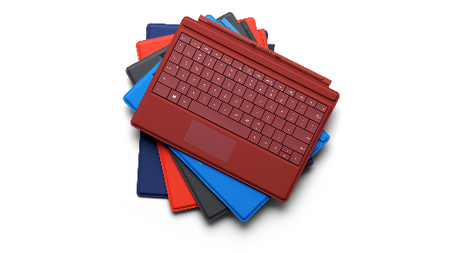
Surface Pen  Unleash your creativity and productivity with Surface Pen. Custom-crafted and cased in aluminum, Surface Pen looks and feels more like a fountain pen than a traditional stylus for a natural writing experience. With Palm Block technology and 256 levels of pressure sensitivity when paired with Surface, you can write and draw without worrying about errant doodles on the screen.  Click the button on the top of the pen once to instantly open OneNote, even if your display is locked. Notes are automatically saved. Double-click the top of Surface Pen to instantly capture and save a screenshot. Flip the pen and use the button on top to easily erase or edit notes as you work without interruption. And now, choose from four vibrant colors — blue, red, black and silver — to express your personal style.  Specs  Weight 20 grams  Compatibility Surface 3, Surface 3 (4G LTE), Surface Pro 3  Dimensions 135 mm x 9.5 mm diameter  Available colors Blue Red Black Silver  Connector type Bluetooth 4.0 low energy  Buttons Right-click and Erase (side) Top button  Battery 1 AAAA, 2 319 coin cell batteries  In the box Surface Pen Batteries  Warranty One-year limited hardware warranty  $49.99 USD | 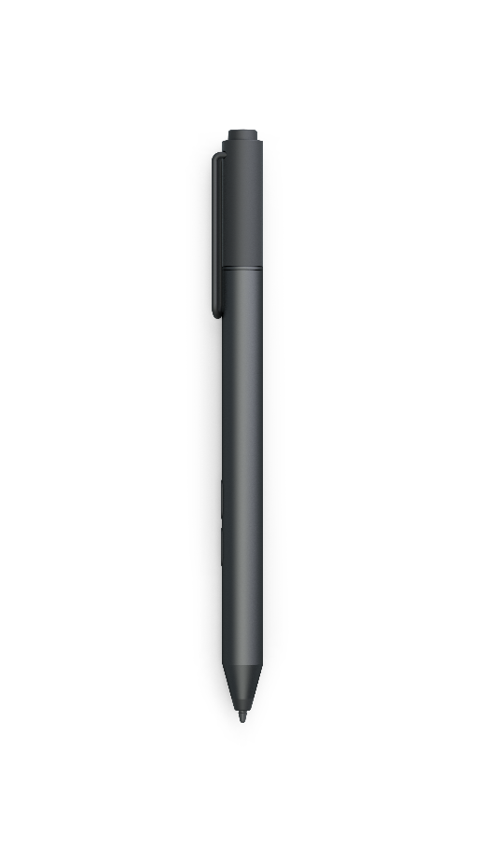
Surface 3 Docking Station  Take your productivity to the next level with Surface 3 Docking Station. It’ll instantly transform your Surface 3 into a complete desktop workstation. Create your perfect setup — connect an external monitor to the Mini DisplayPort output for HD video of up to 3840x2160 resolution, use the gigabit Ethernet port for a reliable wired network connection with speeds up to 1 Gbps, and hook up your favorite accessories using the four USB ports — two USB 3.0 ports and two USB 2.0 ports. And with a 48W charging system, you can work and charge your favorite accessories while still having ample power to charge your Surface 3.  Specs  Weight 990 grams  Compatibility Surface 3, Surface 3 (4G LTE)  Supported platforms Windows 8.1 or later  Dimensions 306.66 mm x 146.96 mm x 116.04 mm  Ports Power supply input 2 USB 3.0 ports 2 USB 2.0 ports Gigabit Ethernet port 3.5mm audio input/output Mini DisplayPort video output Security lock slot  Additional features Surface Pen storage  Warranty One-year limited hardware warranty  $199.99 USD | 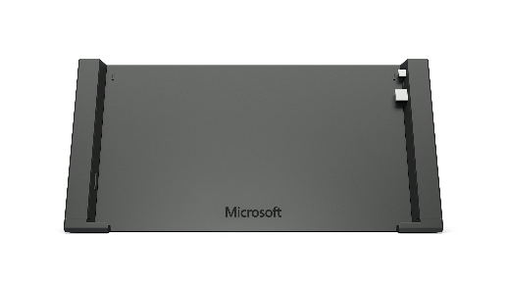
Surface 3 Screen Protector  Shield your Surface with the Surface 3 Screen Protector — a tempered glass screen protector designed for maximum clarity. With the Surface 3 Screen Protector, protect your Surface from bumps and scratches while enjoying an uncompromised Surface Pen experience.  Specs  Weight 0.1 lbs (49 grams)  Compatibility Surface 3, Surface 3 (4G LTE)  Dimensions 263.4 mm x 183.4 mm x 0.5 mm  Included in box Alcohol wipe Microfiber cloth Cleaning tape  Warranty One-year limited warranty  $49.99 USD | 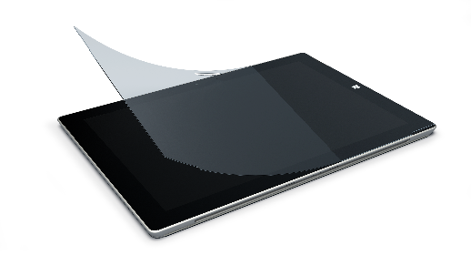
Surface 3 Power Supply  Charge your Surface 3 with the 13W power supply. Simply connect the USB cable to your Surface to recharge the battery. The standard USB to Micro USB cable can also be used to charge other devices such as a smartphone or tablet.  Specs  Weight PSU: 2.26 ounces (64 grams) USB cable: 1.59 ounces (45 grams)  Compatibility Surface 3, Surface 3 (4G LTE)  Dimensions Power supply: 57 mm x 37 mm x 28.5 mm USB cable: 59 inches (1.5 meters)  Wattage 13W AC  Warranty One-year limited warranty  $39.99 USD  Contact info  For more information, press only:  Rapid Response Team, Waggener Edstrom Communications, (503) 443-7070, rrt@waggeneredstrom.com  For more product information and images:  Visit Surface Newsroom at http://www.microsoft.com/en-us/news/presskits/surface.  For more information about Surface:  Visit Surface at http://www.microsoft.com/surface. | 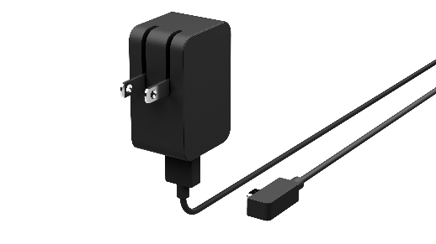

Color availability varies by market.
U.S. only; varies by market
Estimated retail price. Actual retailer prices may vary.
Color availability varies by market.
U.S. only; warranty varies by market
Estimated retail price. Actual prices may vary.
@30HZ
U.S. only; warranty varies by market.
Estimated retail price. Actual prices may vary.
U.S. only; warranty varies by market.
Estimated retail price. Actual prices may vary.
U.S. only; warranty varies by market.
Estimated retail price. Actual prices may vary.

