Surface Accessories
Fact Sheet
October 2015

Surface Pro 4 Type Cover  Transform Surface Pro 4 into a highly versatile laptop with Surface Pro 4 Type Cover —the newest keyboard cover that offers the most advanced Surface typing experience yet. Working on your lap, the plane or at your desk is easier than ever thanks to a redesigned mechanical keyboard that is thinner, lighter and includes improve d magnetic stability. The redesigned glass trackpad is 40 percent larger than the previous-generation Type Cover and packs smart controls that differentiate between unintentional contact and a deliberate click or tap.  The backlit Surface Pro 4 Type Cover also features a QWERTY integrated backlit keyboard, a full row of Function keys (F1–F12), Windows shortcut keys, and media controls. When closed, Surface Pro 4 Type Cover shuts down your display to preserve battery life. Choose from five colors — black, red, blue, bright blue and teal.  Specs  Weight 0.68 lbs (310 g)  Compatibility Surface Pro 4, Surface Pro 3  Dimensions 11.61 x 8.54 x 0.19 in (295 x 217 x 4.95 mm)  Colors Black, red, blue, bright blue, teal²  Trackpad Glass Precision trackpad (PTP), smart controls Five-point multifinger gesture support  Keys Activation: Mechanical moving keys Layout: QWERTY, full row of Function keys (F1–F12) Dedicated buttons for Windows shortcuts, media controls, screen brightness Right-click button  Interface Magnetic  Sensors Accelerometer  Warranty One-year limited hardware warranty  $129.99 USD | 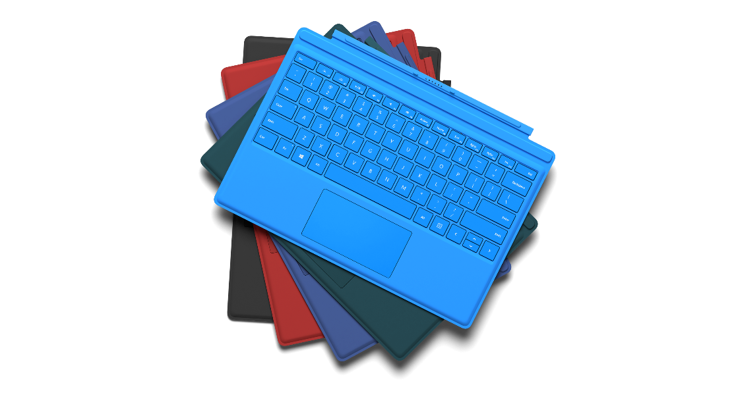
Surface Pen  Experience the ultimate modern writing experience with the new Surface Pen. Now with 1,024 levels of pressure sensitivity and reduced latency, Surface Pen lets you write, draw or mark documents digitally while still feeling as natural as pen on paper with precision ink on one end and an eraser on the other.  Take notes to quickly capture your thoughts and instantly convert to text for sharing and searching with ease. Click once to open OneNote, double click to screen capture, or click and hold to instantly access your personal digital assistant, Cortana. The Microsoft Surface Pen Tip Kit enables you to choose the tip that feels most natural. Stick with the preinstalled HB tip for writing and sketching, or swap to a B tip for sketching and illustrations, an H tip for drawing, or the 2H tip for drafting and fast strokes. And now, simply attach your Surface Pen magnetically to the side of your Surface, so you never leave it behind. Choose from five vibrant colors2 — charcoal, blue, red, silver and gold — to express your personal style.  Specs  Weight 0.046 lbs (21 g)  Compatibility Surface Book, Surface Pro 4, Surface Pro 3, Surface 3  Dimensions (L/W/H) 5.67 x 0.37 x 0.40 in (144 x 9.5 x 10.2 mm)  Available colors Charcoal, blue, red, silver, gold9  Connector type Bluetooth 4.0  Buttons Right click Back button: Erase, click for OneNote, double-click for screen capture, and click-and-hold for Cortana  Battery 1 AAAA Up to one-year battery life  In the box Surface Pen with HB tip installed Battery Microsoft Surface Pen Tip Kit10 (tip holder, removal tool, four tips: 2H, H, HB, B)  Warranty One-year limited hardware warranty4  $59.99 USD2 | 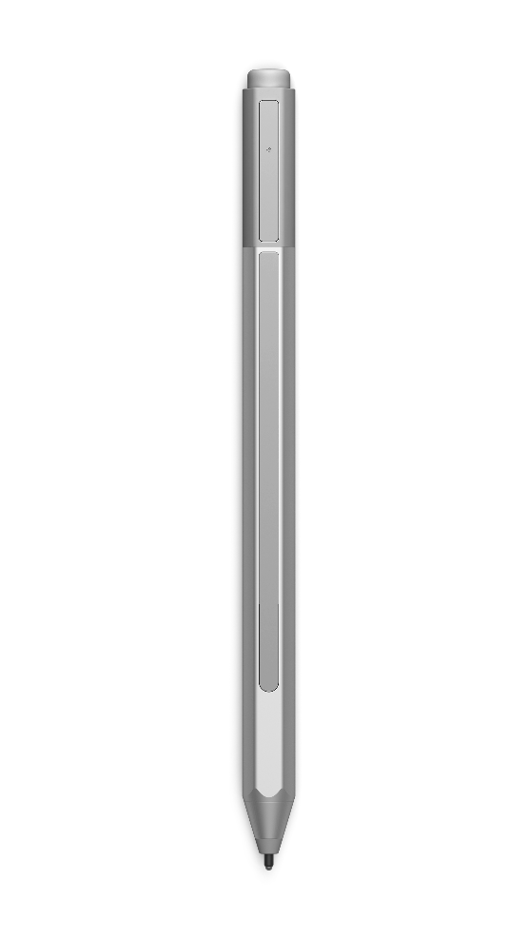

Surface Dock
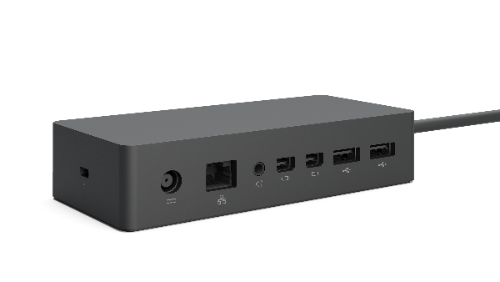
Transform your Surface into a desktop PC instantly with Surface Dock. Featuring Surface Connect technology — which enables high-speed transfer of video, audio and data over a single cable — Surface Dock keeps your desk clutter-free. Simply plug in your Surface Connect cable to charge your device and access external monitors, a keyboard, mouse, and more. And with two high-definition video ports, a gigabit Ethernet port, four high-speed USB 3.0 ports, and an audio output, you’ve got all the connections you need in a sleek, compact design so you can do your best work.

Specs
Weight | 1.21 lbs (550 g)
Compatibility | Surface Book, Surface Pro 4, Surface Pro 3
Dimensions | 5.12 x 2.36 x 1.18 in (130 x 60 x 28.4 mm)
Ports | 2 Mini DisplayPort  1 Gigabit Ethernet  4 USB 3.0  1 audio out  Surface Connect cable  External power supply
Warranty | One-year limited hardware warranty4

$199.99 USD2

¹ Sold separately; availability varies by market.
² Color availability varies by market.
³ U.S. only; varies by market.
⁴ Estimated retail price. Actual retailer prices may vary.
⁵ Cortana available in select markets at launch. Cortana experience may vary by region and device.
⁶ Included in retail pack; retail pack sold separately.
⁷ Surface Book and Surface Pro 4 only.
⁸ Gold available at a later date.
⁹ Included in retail pack; retail pack sold separately.

Contact Information
For more information, press only:
Rapid Response Team, WE Communications, (503) 443-7070, rrt@we-worldwide.com

For more product information and images:
Visit Surface Newsroom at http://www.microsoft.com/en-us/news/presskits/surface.

For more information about Surface:
Visit Surface at http://www.microsoft.com/surface.

