Background
The objective of the “Cloud Computing as an Engine of Growth Study” is to better understand IT decision-makers across multiple industries, and their current and planned adoptions of cloud-based technology solutions to grow revenue, launch new lines of business, hire staff and innovate. The survey measured:
- Use of cloud computing-based services within two segments – SMB and Enterprise – across multiple industries and markets
- Perceived value of cloud based computing in terms of business value, innovation, and importance to critical business functions
- The benefits most likely to lead to adoption of cloud services, such as saving money, creating new lines of business and more
- Which cities were furthest along – the greatest concentration of companies – in adoption and embrace of cloud computing

Methodology
An online survey of IT decision-makers (ITDMs) conducted by 7th Sense Research and funded by Microsoft Corp. was conducted during October 2010 among 2,211 ITDMs across 10 markets, including New York, Los Angeles, Chicago, Philadelphia, Dallas, San Francisco, Boston, Atlanta, Washington D.C., and Detroit. Each market had a minimum of 200 ITDMs across small (1-249 employees) and Enterprise (250+ employees) firms, and was representative of multiple industries.

Microsoft then ranked those cities most “cloud-friendly” based on a number of factors. The city rankings are based on the ITDMs opinions and attitudes toward cloud based services in these markets. For example, while Enterprise companies in New York City rank among the highest cities aligned with cloud computing, small businesses here are the most resistant. Rankings were created from a combination of responses at specific attitudinal and usage questions, including having an opinion, having a positive opinion, a non-cynical attitude about cloud computing, number of projects in the works and current use for projects/applications.

Summary Findings
- 54% of national respondents say that they are hiring as a result of cloud services.
- 41% of Enterprise companies surveyed have at least one cloud project planned or underway compared to 16% of SMBs.
- While larger organizations appear to be using and enjoying the benefits of clouds, SMBs have not fully embraced the business opportunity – yet.
- Despite beliefs to the contrary, there is positive agreement among ITDMs about the value of cloud, agreeing it will be a strategic engine in the coming years and not a passing trend or a threat to IT.
- 52% of Enterprise respondents say cloud computing is an opportunity for IT to be more strategic.
- Nearly a third (30%) of SMB and 44% of Enterprise respondents view companies embracing the cloud as innovative.
- Businesses of any size or type are highly reliant on partners to bring cloud into their organizations.
- Among enterprise-sized companies, Boston ranks as the top cloud-friendly city, while Washington, D.C. ranks first among small-to-midsized companies.
- Enterprise-sized companies are more likely to be working on multiple cloud computing projects, while the majority of small companies are not working on any (84%).

Enterprise-size Company Ranking |  |  |  | SMB Company Ranking
Rank | City | Index |  | Rank | City | Index
1 | Boston | 128.1 |  | 1 | Washington D.C. | 94.6
2 | New York | 127.2 |  | 2 | San Francisco | 93.7
3 | Dallas | 122.7 |  | 3 | Philadelphia | 88.4
4 | San Francisco | 121.5 |  | 4 | Los Angeles/ Orange County | 83.6
5 | Atlanta | 120.9 |  | 5 | Boston | 82.2
6 | Washington D.C. | 120.8 |  | 6 | Dallas | 81.8
7 | Philadelphia | 116.8 |  | 7 | Atlanta | 80.9
8 | Los Angeles/Orange County | 112.8 |  | 8 | Detroit | 80.4
9 | Chicago | 108.9 |  | 9 | Chicago | 75.2
10 | Detroit | 108.1 |  | 10 | New York | 69.9
Rankings were created from a combination of responses at specific attitudinal and usage questions, including having an opinion, having a positive opinion, a non-cynical attitude about cloud computing, number of projects in the works and current use for projects/applications.

Firmographics
Fifty-five percent of SMB IT Decision Makers claim to be the primary decision maker versus Enterprise companies where responsibility appears distributed. SMBs are more likely to work in a distribution & services. The average number of years SMBs have been in business is 16.3 years, while Enterprise companies reporting having been in operations for 27.5 years on average. More than half of SMBs (59%) have only one business location, though 29% operate two or more. Eighty-one percent of Enterprise companies report 6 or more locations. IT Decision makers in small to midsize businesses are slightly older than ITDMs at Enterprise businesses. Most SMBs deploy broadband or wireless internet, and far fewer (25%) than Enterprise businesses (74%) deploy a T-1 line.
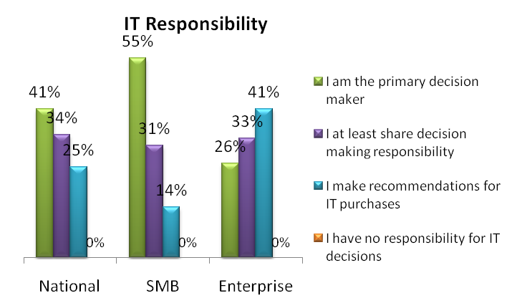

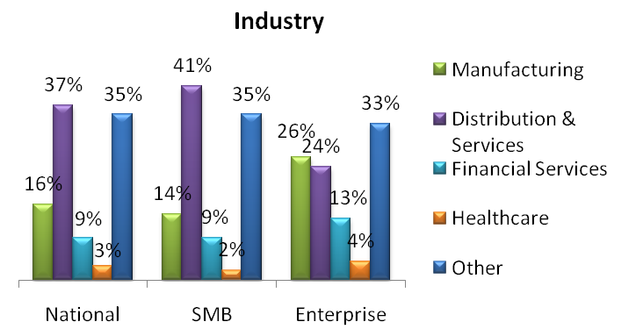

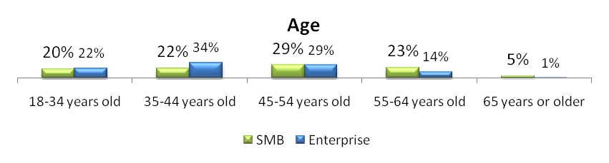

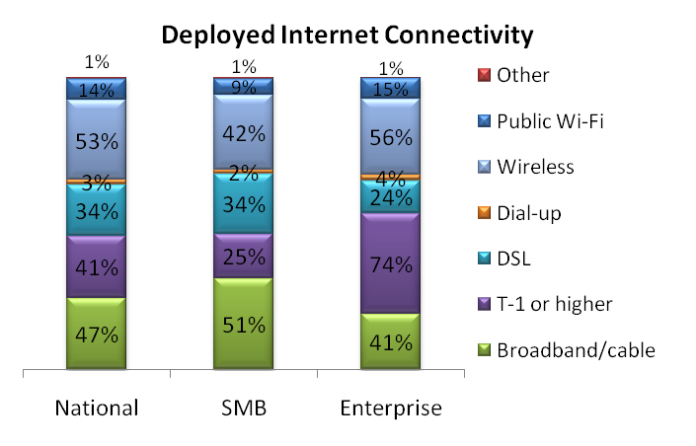

Investing in IT Promotes Profitability
More than one-third of SMBs and more than half of Enterprise companies surved agree that investing in IT increased profitability.
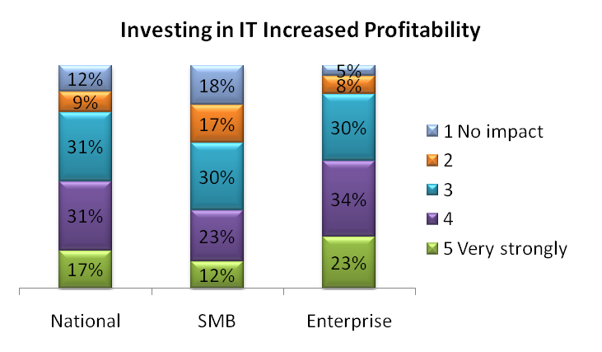

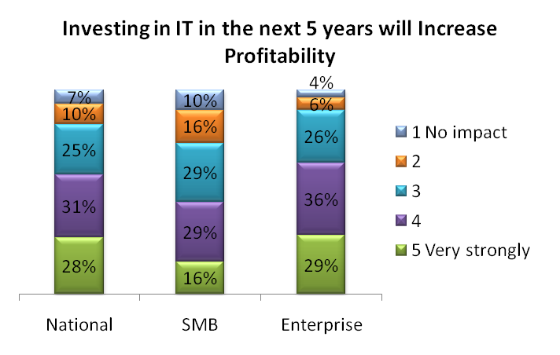
SMBS agree that the IT department must present an opportunity for the company to grow in revenue
(68%) and address the requirement to work anywhere at any time (66%), while Enterprise companies are
more concerned with addressing internal clients' needs (82%) and business process issues (82%).

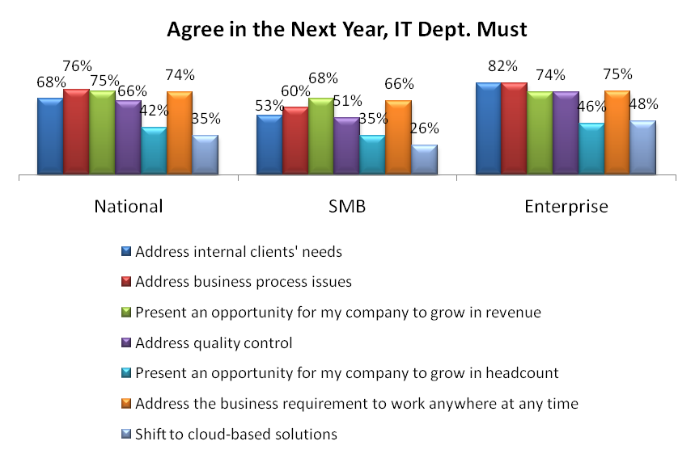

SMBs are less familiar with cloud computing, compared to ITDMs working with Enterprise-sized companies. Only 20% of SMBs claim to know cloud computing very well or a fair amount compared to 41% of ITDMs at Enterprises claiming the same.

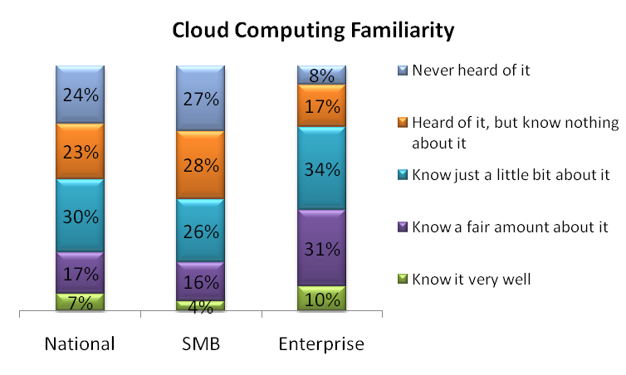
Cloud Computing is a Strategic IT Imperative
More than half of ITDMs at Enterprise businesses (52%) endorse cloud as a strategic opportunity for IT.
Though more than half of SMBs do not have an opinion of cloud computing (57%), nearly one-third (29%) agree that cloud is an opportunity for IT to be more strategic (29%).
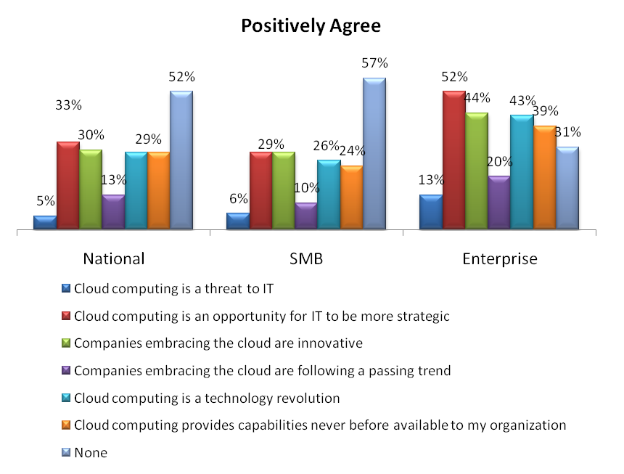

41% of Enterprise companies surveyed have at least one cloud project planned or underway compared to 16% of SMBs.

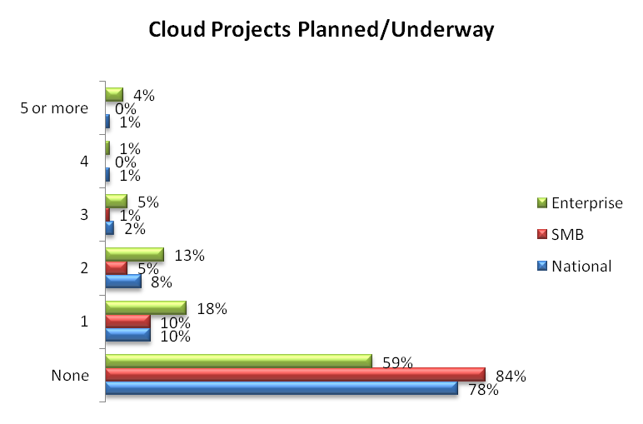

Cloud-based Tools are Used for Communication and Collaboration
SMBs are most likely to be employing or planning to implement email and communication tools (20%) or cloud based backup and storage (18%). Enterprise companies are employing or planning to implement cloud-based collaboration tools.

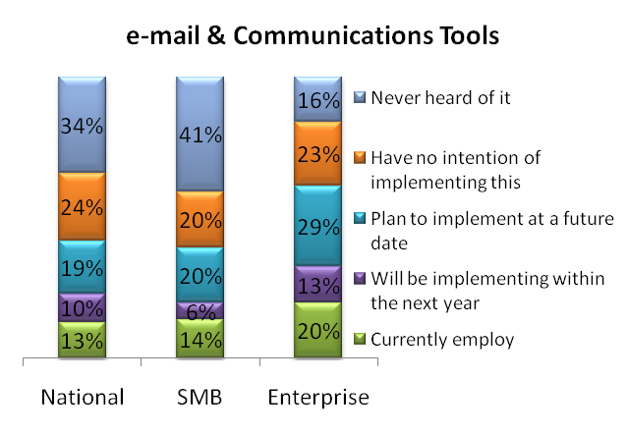
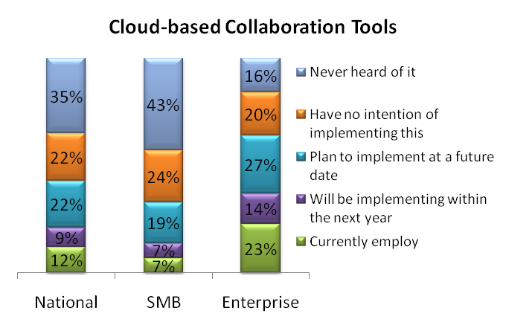
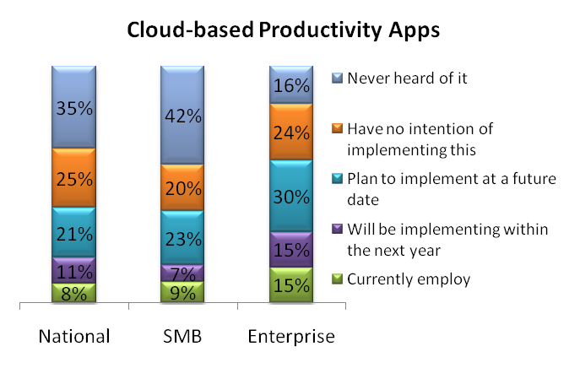

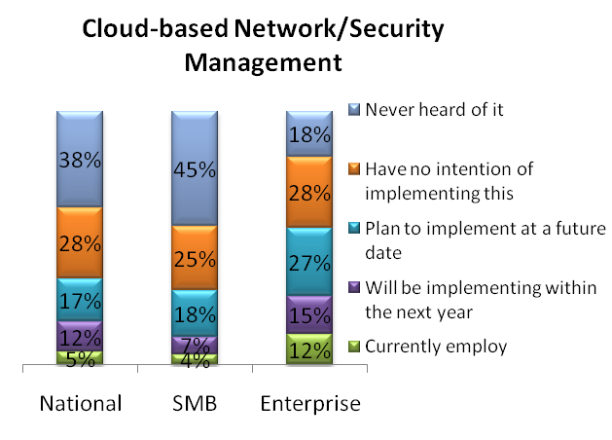
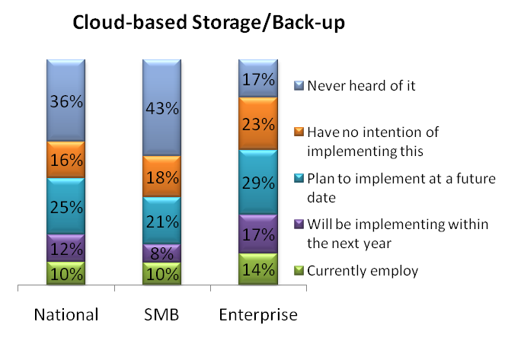
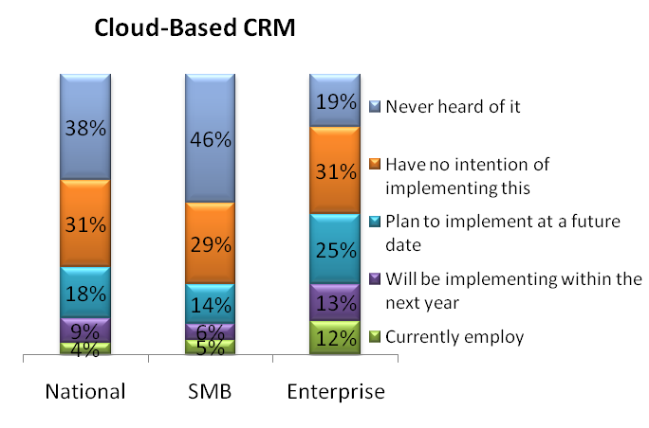
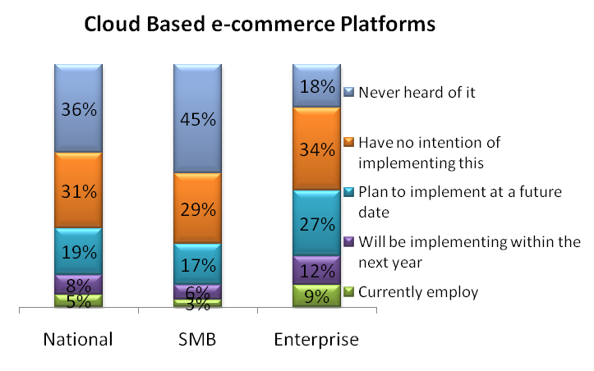
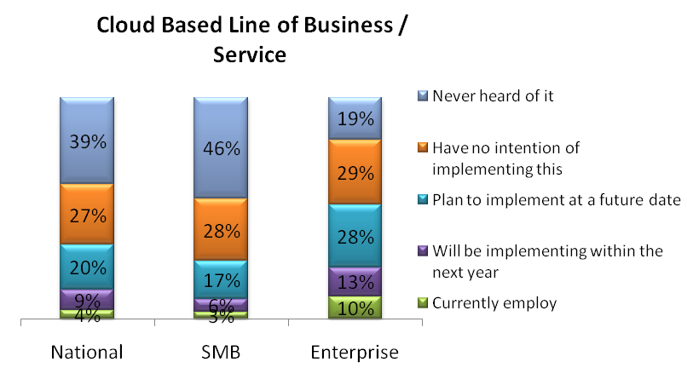

Reliance on Vendors is Key to Implementation
Close to half of Enterprise companies and more than one-quarter (27%) of SMBs surveyed say they would be more likely to purchase a cloud solution if they could work with a certified vendor.
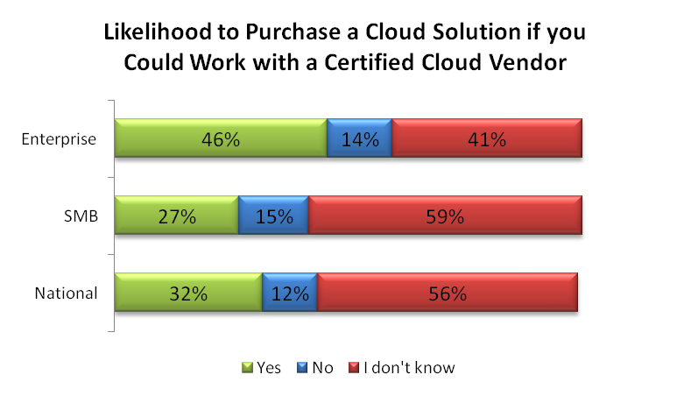
Cloud is Considered an Engine of Innovation and a has the Potential to Grow into a Business Imperative
Slightly more than one-third of SMB ITDMs believe cloud is an engine of innovation, but that percentage is far fewer than that of the Enterprise, with nearly half agreeing. While low cost of total ownership motivates the ITDMs nationally, SMBs appear a reason to buy into cloud services is because it's free. Enterprise companies show more concern for total cost of ownership.
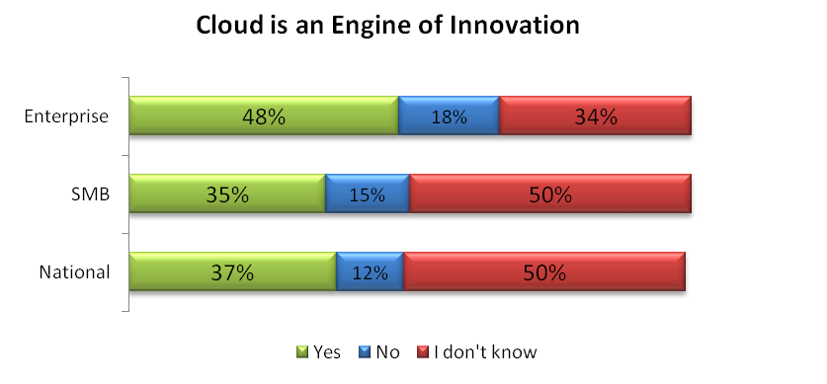
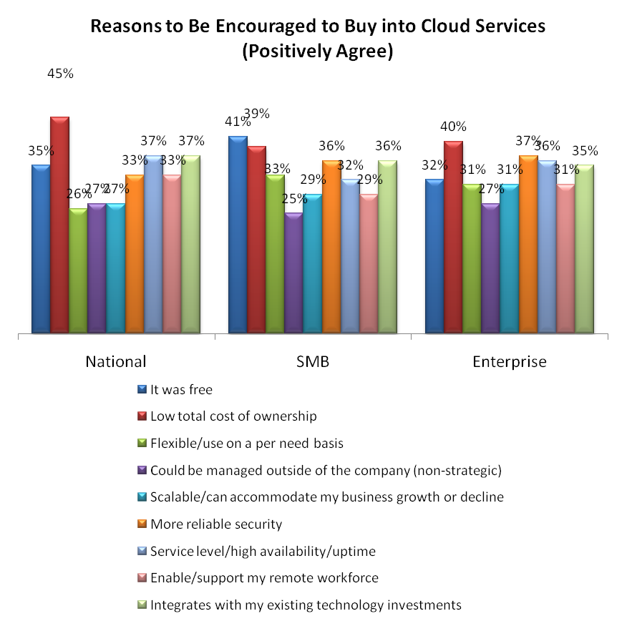
For those SMBs that already bought into cloud more than two-fifths (44%) say they did so because it was free. Total cost of ownership (42%) is also mentioned as a reason to buy cloud services. Flexibility and usage on a per need basis is cited by SMBs and Enterprises in equal percentages, however, this reason is selected most often by ITDMs at Enterprise businesses.
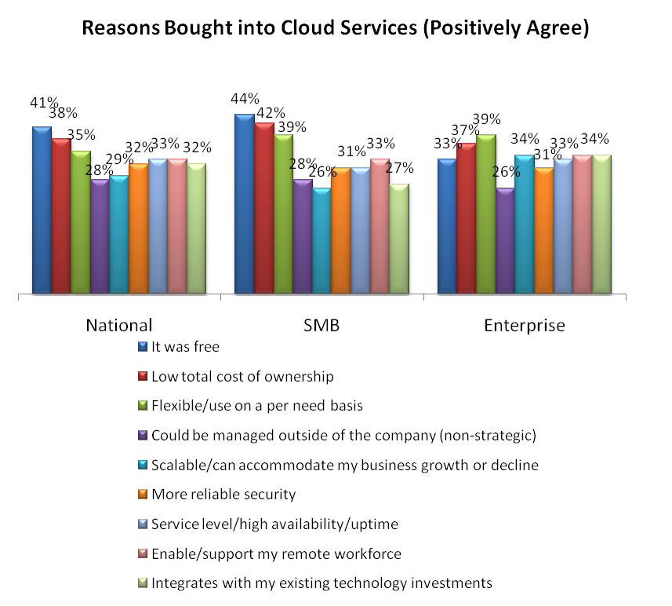
Regardless of size of company, only around 10% of ITDMs say they've used cloud services to help start a new business. A high percentage (approximately three-quarters) of respondents have not.
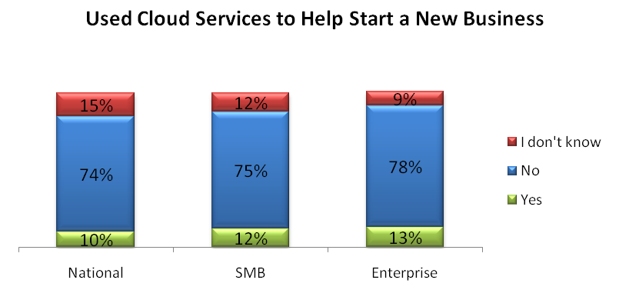
On average, the majority of respondents have not realized the potential of starting a new line of business using cloud services as only 15% of SMBs and 22% of Enterprise businesses have done so. Approximately the same percent claim to have used cloud services to level the playing field. Of those implementing cloud services, ITDMs at SMBs claim their company has saved money versus requiring more budget.
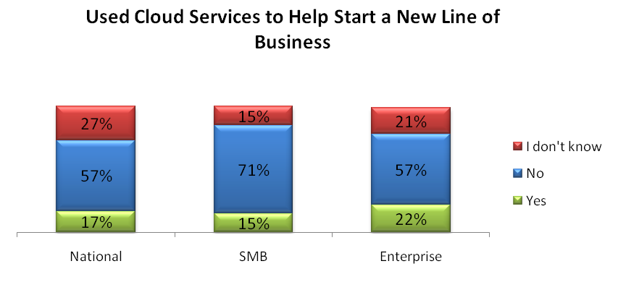
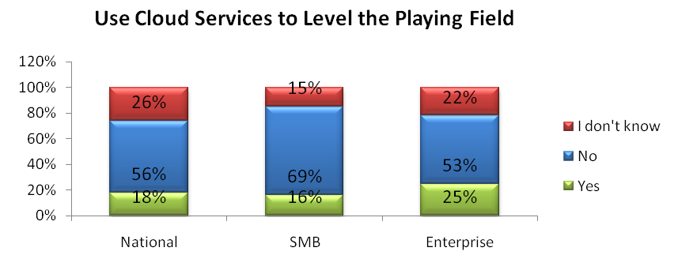
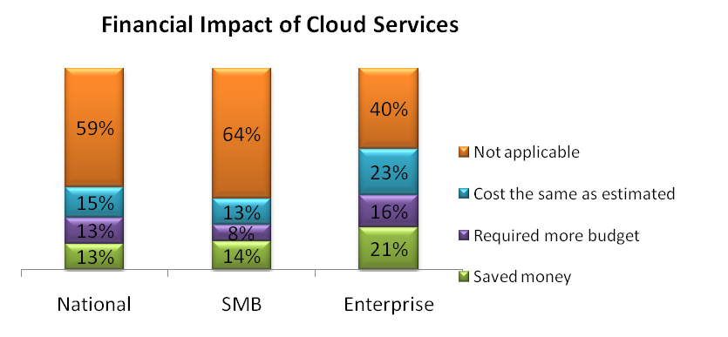
Cloud Services will Impact Hiring Practices
Vendors have a strong opportunity to assist in the deployment of cloud projects, but internal staff will also be required to have cloud computing experience as a pre-requisite, especially for SMBs.
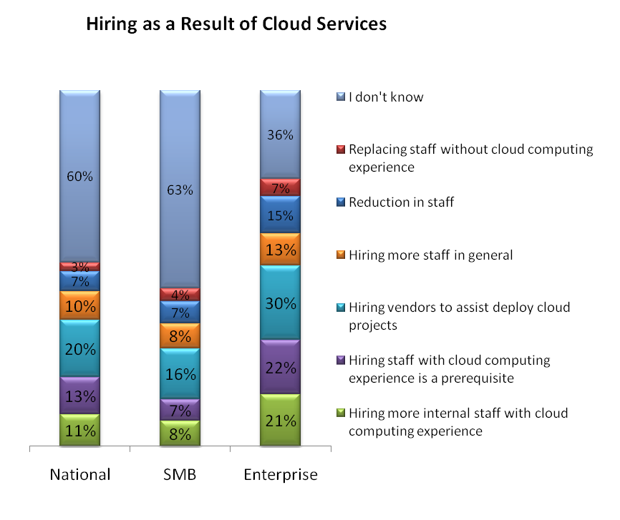
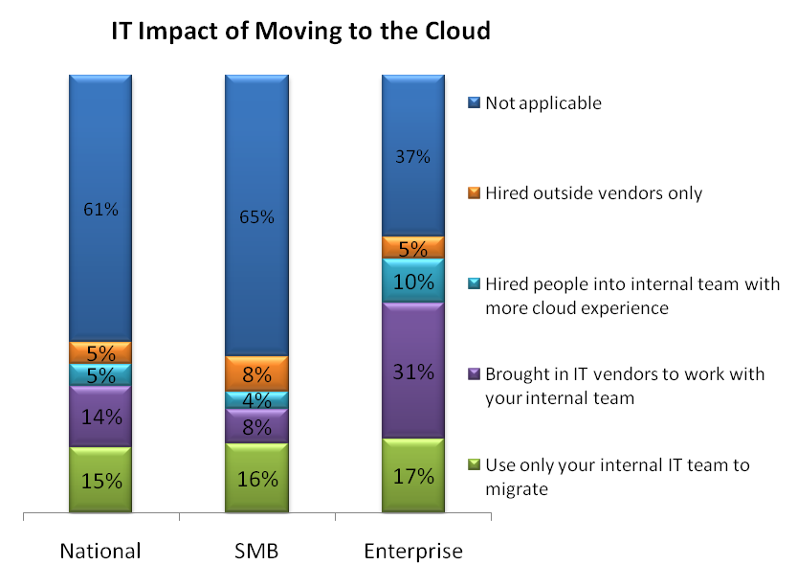
Investing in Cloud Has the Potential to Save
For some cloud can be an investment. While nearly one-third of ITDMs at Enterprise organizations claim to have spent $100,000 or more to move to the cloud, 14% of SMBs have spent less than $1,000. Slightly more than one-third of SMB ITDMs believe cloud is an engine of innovation, but that percentage is far fewer than that of Enterprise companies. For those that have invested in cloud services, 14% of SMBs report having saved less than $1,000, while 9% of the Enterprise reports savings of $1 million or more.
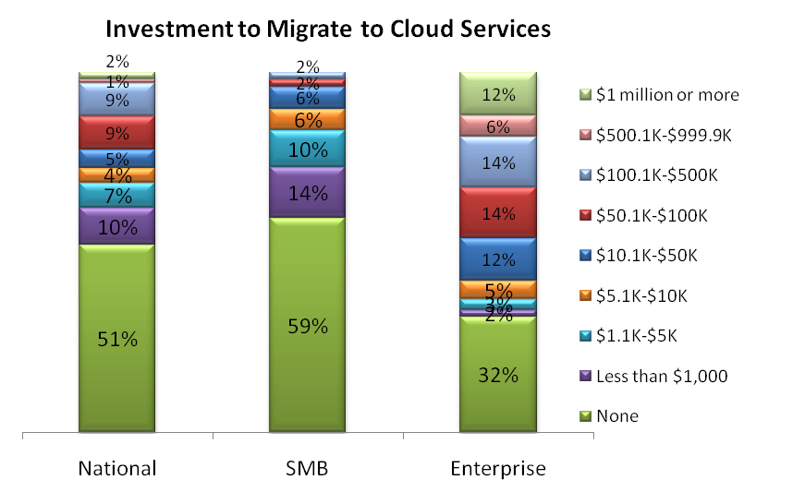
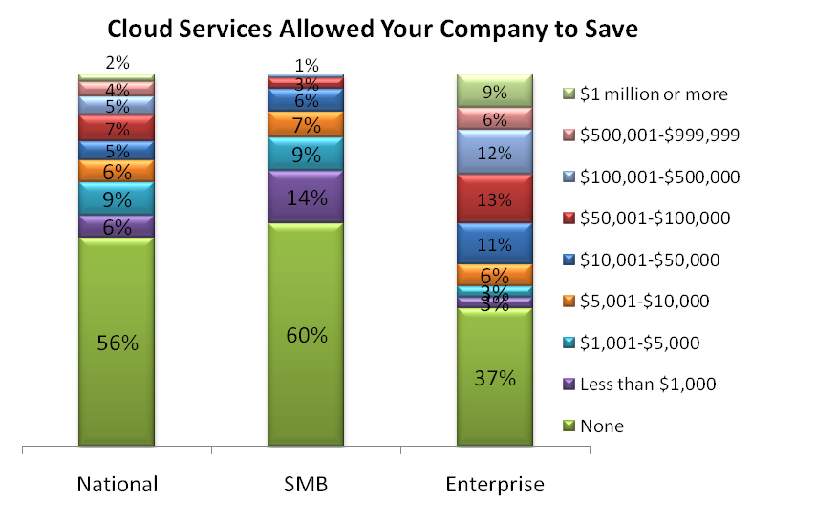
Cloud Enables Business Results
While both company-size segments agree that the IT workload was reduced, the bottom line saved and faster deployments were achieved, SMB ITDMs say cloud services provided increased security (45%) and ensure the latest versions of technology (41%). Enterprise ITDMs were able to abandon legacy systems (41%) and scale technology with the business (36%).
