Microsoft’s Cloud Infrastructure
Datacenters and Network Fact Sheet
October 2013

Who we are
Microsoft Corp. delivers more than 200 cloud services, including Bing, MSN, Outlook.com, Office 365, SkyDrive, Skype, Xbox Live and the Windows Azure platform. Today, more than 1 billion customers and 20 million businesses in 88 global marketplaces use our cloud services. These services are hosted in Microsoft’s cloud infrastructure composed of globally distributed datacenters, edge computing nodes, service operations centers and a massive fiber optic network that connects them all. The cloud infrastructure is managed by the company’s Global Foundation Services (GFS) team.

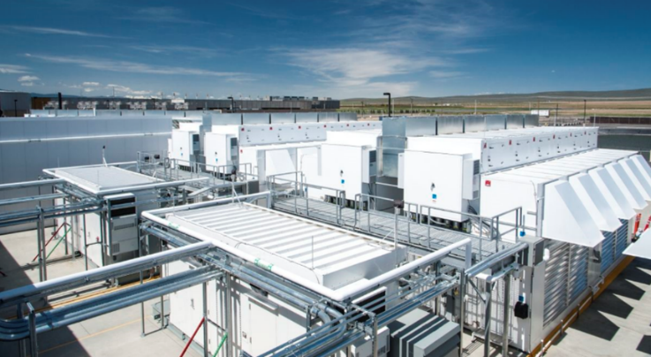
What we do
Microsoft provides cloud services to customers 24x7x365, and the GFS team designs, builds, operates and helps secure every facet of the infrastructure. Since opening our first datacenter in 1989, we have invested more than $15 billion on our infrastructure and remain focused on delivering reliable, scalable and security-enhanced online services, while efficiently managing operations and costs as we grow.

Microsoft’s cloud infrastructure strategies
- Reliability. Delivering services at huge scale requires a radically different approach to designing, building, deploying and operating datacenters. When software applications are built as distributed systems, every aspect of the physical environment — from the server design to the building itself — creates an opportunity to drive systems integration for greater reliability, scalability, efficiency and sustainability. For more information on Microsoft’s resilient software strategy and how cloud workloads have changed the way we design and operate datacenters, please read the Cloud-Scale Datacenter strategy brief and listen to our cloud engineer’s presentation.
- Security and compliance. Microsoft is committed to helping keep customer data secure, maintain privacy and meet compliance regulations, while providing high service availability. We have risk-based information security and privacy controls and a compliance framework to ensure that our infrastructure meets our commitments while helping customers meet their complex compliance requirements. For more on Microsoft’s security and compliance efforts, please read the Securing the Cloud Infrastructure strategy brief and listen to our cloud security expert’s presentation.
- Environmental sustainability. Microsoft is investing in the development of software and technology innovations to help people and organizations improve the environment and reduce their impact upon it. We continue to evolve our datacenter operations and build technologies to improve our efficiency, while sharing sustainability best practices with the industry. For more information on Microsoft’s sustainability efforts, please read the Datacenter Sustainability strategy brief and listen to our cloud energy strategist’s presentation.

Microsoft’s cloud infrastructure by the numbers
- 1989: The year Microsoft opened its first datacenter on its Redmond, Wash., campus.
- 1 billion customers, 20 million businesses: The number of customers and businesses in more than 88 countries that use the Microsoft cloud.
- 200-plus: The number of online services delivered by Microsoft’s datacenters 24x7x365.
- $15 billion-plus: Microsoft’s investment in building our huge cloud infrastructure.
- 1 million-plus: The number of servers hosted in our datacenters.
- 2.5 billion-plus: Our infrastructure storage capacity in megabytes.
- 1.125: Microsoft’s average PUE for its new datacenters. Power usage effectiveness (PUE) is a metric of datacenter energy efficiency and is the ratio of the power and cooling overhead required to support our server load. The industry average is 1.8.
- 2.3 billion kWh: The amount of green power purchased by Microsoft as part of our carbon-neutral goal — ranking as the third most purchased by any U.S. company, according to the U.S. Environmental Protection Agency.
- 3: The number of times Microsoft’s fiber optic network, one of North America’s largest, could stretch to the moon and back.
- 15: The number of carbon offset projects Microsoft has invested in, including projects in Brazil, Cambodia, China, Guatemala, India, Kenya, Mongolia, Peru, Turkey and the United States.
- 100: The percentage of our servers and electronic equipment that we send to a third-party vendor for recycling and/or reselling after it has been securely decommissioned.
- 2007: The year Microsoft began sharing its best practices for cloud infrastructure with the industry. Download our latest Top Ten Best Business Practices for Environmentally Sustainable Datacenters white paper.

Microsoft’s datacenters
Microsoft has both owned and leased datacenter capacity to support customers in regions throughout the world. Although we do not share the total number of datacenters or their specific locations to protect the security of our cloud services, the following locations represent a portion of our global portfolio: Amsterdam; Boydton, Va.; Cheyenne, Wyo.; China; Chicago; Des Moines, Iowa; Dublin; Hong Kong; Japan; Quincy, Wash.; and San Antonio.

For more information:
Visit www.microsoft.com/datacenters and our team blog.
Join the datacenter team’s blog site RSS feed.
Watch our datacenter tour video.

For more information, press only:
Rapid Response Team, Waggener Edstrom Worldwide, (503) 443-7070, rrt@waggeneredstrom.com

