MICROSOFT NATURAL ERGONOMIC DESKTOP 7000
Fact Sheet
April 2012
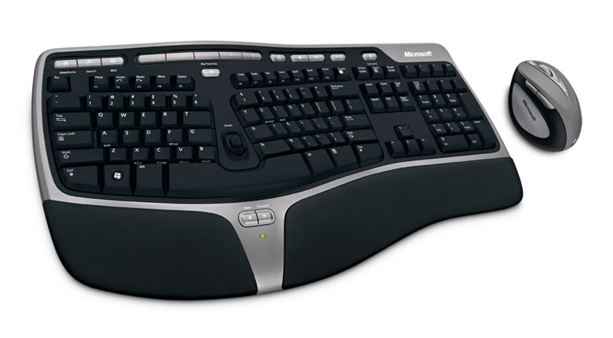

The Microsoft Natural Ergonomic Desktop 7000 provides superior comfort and productivity, borrowing from the designs of the best-selling¹ Natural Ergonomic Keyboard 4000 and award-winning Natural Wireless Laser Mouse 6000. The desktop features 2.4 GHz wireless technology, which provides a confident connection with virtually no interference and an easy setup.

This peripheral combination offers ergonomic designs for a keyboard and mouse, promoting a more natural position for your arms, wrists and hands.

Top Features and Benefits
- 2.4 GHz wireless technology gives consumers a confident wireless connection and a range of up to 30 feet, even in crowded wireless environments.
- Battery life indicator on both the mouse and keyboard warns users when it’s time to replace the batteries.
Natural Ergonomic Keyboard 7000
      - The design addresses the fact that fingers all have different lengths by adding a gentle, gullwing-like curvature to the key layout. This not only helps the keyboard better match the hand, but it also helps reduce the reach required for the most distant keys.
- Zoom feature provides effortless control of digital photos and documents with just the touch of a finger, delivering a seamless experience. Simply push the slider, located in the middle of the keyboard, to zoom in and out when navigating large documents or images.
- Customizable Hot Keys provide instant access to email, Web, home page and search, allowing users to quickly launch important programs with the touch of a button.

Natural Wireless Laser Mouse 7000
      - Ergonomic curvature gives the mouse a pronounced elevated surface and rounded shape, allowing fingers to relax and curl naturally to help reduce finger extension.
      - Five easily customizable buttons enables users to perform popular commands with a single touch.
      - High-definition laser technology puts ultimate performance in the palm of each user’s hand. The Microsoft Intelligent Tracking System provides smoother tracking, 1,000 dots per inch for more responsiveness and 6,000 frames per second for better precision.
Read on for more information about the following:
Top-Line System Requirements / Availability and Pricing / Contact Info
Top-Line System Requirements

To use the Microsoft Natural Ergonomic Desktop 7000, consumers need the following:
For a Windows-based PC | For Macintosh
- Windows 7, Windows Vista, Windows XP with Service Pack 4 (SP4) or later  - At least 60 MB available hard disk space  - An available USB port  - 4 AA batteries (included)  - Internet access required for certain features; connect time charges apply | - Mac OS X v.10.2–10.4.x  - At least 30 MB available hard disk space  - An available USB port  - 4 AA batteries (included)  - Internet access required for certain features; connect time charges apply

Availability and Pricing

The Manufacturer’s Recommended Retail Price for the Microsoft Natural Ergonomic Desktop 7000 is $119.95 (U.S.).³

The Natural Ergonomic Desktop 7000 is backed by a worldwide three-year limited hardware warranty. The limited warranty and license agreement are available at http://www.microsoft.com/hardware/warranty.

¹ Source: The NPD Group, U.S. Retail & Commercial Tracking Service, January 2006 to March 2007
² Microsoft high definition laser technology provides 6,000 frames per second for precision, 1,000 dots per inch for responsiveness and Microsoft Intelligent Tracking System for tracking.
³ Actual retail price may vary.

Contact Info

For more information, press only:
Rapid Response Team, Waggener Edstrom Worldwide, +1 (503) 443-7070, rrt@waggeneredstrom.com

For more product information and images:
Visit the Microsoft News Center at http://www.microsoft.com/en-us/news/presskits/hardware.

For more information about Microsoft Hardware:
Visit the Microsoft Hardware blog at http://www.microsofthardwareblog.com.

