Exec Bios for Windows 8 GA
Last updated Oct. 23, 2012

Bios included in this document:
- Steve Ballmer
- Steven Sinofsky
- Tami Reller
- Antoine Leblond
- Dean Hachamovitch
- Julie Larson-Green
- Michael Angiulo
- Panos Panay
- Erwin Visser
- Samuel Moreau

Steve Ballmer |  | 
Chief Executive Officer

Steven A. Ballmer is CEO of Microsoft Corp., the world's leading manufacturer of software for personal and business computing. Ballmer joined Microsoft in 1980 and was the first business manager hired by Bill Gates. Since then, Ballmer's leadership and passion have become hallmarks of his tenure at the company.

Ballmer and the company's business and technical leaders are focused on continuing Microsoft's innovation and leadership across the company's core businesses. Microsoft's goal is to provide an integrated platform to enable a seamless experience across a wide range of computing and non-PC devices and services.

Variously described as ebullient, focused, funny, passionate, sincere, hard-charging and dynamic, Ballmer has infused Microsoft with his own brand of energetic leadership, vision and spirit over the years.

Ballmer was born in March 1956 and grew up near Detroit, where his father worked as a manager at Ford Motor Co. He graduated from Harvard University with a bachelor's degree in mathematics and economics.

While in college, Ballmer managed the football team, worked on the Harvard Crimson newspaper, as well as the university literary magazine, and lived down the hall from fellow sophomore Bill Gates. After college, he worked for two years at Procter & Gamble Co. as an assistant product manager and, before joining Microsoft, attended Stanford Graduate School of Business.

Photos

Steven Sinofsky |  | 
President, Windows Division

As president of the Windows Division, Steven Sinofsky has accountability for the development and business of the overall Windows client OS and related technologies, including user interface, device support, graphics and media, as well as Internet Explorer. He also oversees Windows Services including Outlook.com and SkyDrive.

Sinofsky has held several positions on product teams at Microsoft Corp. His most recent position was senior vice president of the Windows and Windows Live engineering group. Before Windows, he oversaw the development of the Microsoft Office system of programs, servers and services and was responsible for the product development of the 2007 Microsoft Office system, Microsoft Office 2003, Microsoft Office XP and Microsoft Office 2000.

In 1994, when the Office Product Unit was formed, Sinofsky joined the team as the director of program management and led the design of the shared technologies in Microsoft Office 95 and Microsoft Office 97. He spent four years as a software design engineer and project lead in the Development Tools group, where he helped lead the development of the first versions of the Microsoft Foundation Classes Library for Windows and Visual C++. He joined Microsoft in July 1989 as a software design engineer.

Sinofsky has a master’s degree in computer science from the University of Massachusetts Amherst and an undergraduate degree with honors from Cornell University In 1998, Sinofsky served as a visiting scholar at Harvard Business School. He spent fall 2004 living in Beijing working on projects in sales, marketing, and research and development.

Sinofsky is the co-author of the book “One Strategy,” along with Marco Iansiti of Harvard Business School. He shares his thoughts on business and software development via the Building Windows 8 blog and communicates on Twitter via @buildwindows8 and @stevesi.
Photos

Tami Reller |  | 
Chief Financial Officer and Chief Marketing Officer, Windows Division

As chief financial officer and chief marketing officer of the Windows Division, Tami Reller is responsible for the financial performance and global marketing of Windows.

Over the course of her career, Tami Reller has held a variety of leadership roles in marketing, finance, sales and general management. Before joining Windows in 2007, Reller held leadership positions within the Microsoft Dynamics Division.

Reller began her career in technology at Great Plains Software in 1984, while still in college. She had a number of leadership positions within the company, including chief financial officer, a position she held at the time of the successful acquisition of Great Plains Software by Microsoft Corp. in 2001.

A native of Grand Forks, N.D., Reller earned a bachelor’s degree in mathematics from Minnesota State University Moorhead and an MBA from St. Mary's College in Moraga, Calif.

Photos
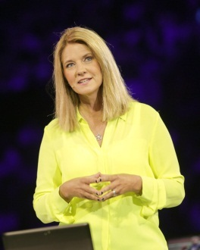

Antoine Leblond |  | 
Corporate Vice President, Windows Web Services

As corporate vice president of the Windows Web Services team at Microsoft Corp., Antoine Leblond is responsible for overseeing the group that manages integral Windows services, which today deliver updates, solutions, community and a depth of information for the Windows consumer and include the Windows Store.

Since joining Microsoft as a software design engineer in 1989, Leblond has worked on the design and development of many components of the Microsoft Office system. During his time in the Office Division, he led the development efforts for Microsoft Word 97 and Microsoft Word 2000 and held roles as director of Office development and corporate vice president of Office Program Management. Most recently, Leblond was senior vice president of the Office Productivity Applications Group, overseeing the design, development and testing of the Microsoft Office suite of productivity applications and services.

In 2000, Leblond received the title of distinguished engineer in recognition of his technical contributions to the success of Microsoft. He currently moderates the Windows Store for Developers Blog, dedicated to informing developers both on the progress of the Windows Store as a service and on the platform and economic opportunity it represents.

A native of Quebec City, Leblond has a bachelor of science in mathematics from McGill University in Montreal. He lives with his wife and two daughters in Washington state.

Photos


Dean Hachamovitch |  | 
Corporate Vice President, Internet Explorer

As corporate vice president for Internet Explorer, Dean Hachamovitch is responsible for the team that designs, develops and releases Internet Explorer. The team is also responsible for security, privacy and customer response for the currently supported versions of Internet Explorer.

Since joining Microsoft Corp. in 1990, he has helped lead the development and release of several versions of Microsoft Word and Microsoft Office on both Windows and Macintosh. His primary focus was user-interface innovations, such as AutoCorrect, automatic spelling checking and formatting, and integration across the product suite. He also led the Internet Explorer 7, 8, 9 and 10 efforts and ran Microsoft's online games business.

Hachamovitch's passion is shipping useful, desirable and trustworthy software that matters for people and enables developers to do more.

Hachamovitch has a bachelor's degree in mathematics from Harvard College. He lives with his wife and kids in Washington state.

Photos


Julie Larson-Green |  | 
Corporate Vice President, Windows

As corporate vice president of program management for Windows at Microsoft Corp., Julie Larson-Green oversees the design and delivery of the Windows operating system. Leading a team of technical engineers, her responsibilities include program management, design research and development of all international releases for Windows 8.

Larson-Green joined Microsoft in 1993 and has focused on technical design and development throughout her career. As a program manager in Development Tools and Languages, she was instrumental in several releases of Visual C++ for 32-bit operating systems and led the development of Microsoft's first customizable integrated development environment for Windows. Moving to the Windows team, she was responsible for the Internet Explorer 3.0 and Internet Explorer 4.0 user experiences, including features related to the Web-integrated Windows desktop.

Continuing her focus on end-user software, Larson-Green joined the Office team in 1997 and led program management for Microsoft SharePoint and Microsoft FrontPage, including the early work in information worker servers. More recently, she has been responsible for leading the user interface design for Microsoft Office XP, Microsoft Office 2003 and the 2007 Microsoft Office system, which was lauded for its innovative reinvention of the user experience for productivity software. Before Windows 8, Larson-Green served as corporate vice president of Windows Experience for Windows 7, charged with leading the design and development of the Windows 7 OS.

Before joining Microsoft, Larson-Green was a senior development engineer at a Seattle-based company that created leading desktop publishing software. She has a master's degree in software engineering from Seattle University and a bachelor's degree in business administration from Western Washington University. A native of Washington state, she lives there with her husband, who is a university professor, and her two children.
Photos
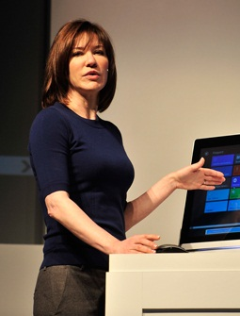

Michael Angiulo |  | 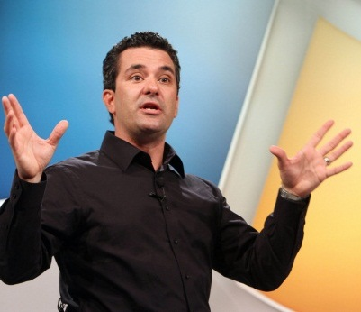
Corporate Vice President,
Windows Hardware and PC Ecosystem

As corporate vice president of the Windows Hardware and PC Ecosystem team at Microsoft Corp., Michael Angiulo leads the engineering teams working with OEM, IHV and ISV partners on future Windows technologies. He is also responsible for Microsoft Surface and Microsoft Hardware.

Before this role, Angiulo was the general manager of the Project Business Unit for four years. Angiulo has been with Microsoft for more than 18 years and, before being the first group product planner for the Information Worker Division, held program management roles in Microsoft Research, as well as on the Microsoft Excel, Microsoft FrontPage and core Microsoft Office product teams. He has been awarded seven patents.

Angiulo earned an undergraduate engineering degree from Harvey Mudd College in Claremont, Calif., and a master of science in mechanical engineering from the University of Washington.

Photos
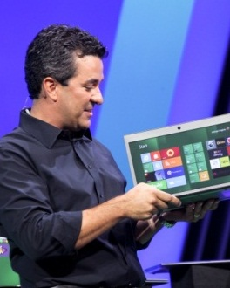

Panos Panay |  | 
General Manager, Microsoft Surface

Panos Panay is the general manager for Surface Computing at Microsoft Corp. He is responsible for the overall direction and strategy for this innovative business, focused on delivering on the vision that is now Microsoft Surface. He is also responsible for the Microsoft Hardware Division, where he manages user experience and development for all mice, keyboards, webcams and headsets.

Before joining Microsoft in 2004, Panay was a group program manager at NMBT Electrical Mechanical Division, responsible for end-to-end development and manufacturing of products such as keyboards, speakers and other electromechanical devices.

Panay has an MBA from Pepperdine University and a bachelor of science from California State University, Northridge. He and his wife have four children and live in Washington state.

Photos
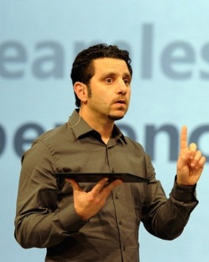

Erwin Visser |  | 
Senior Director, Windows Commercial Business Group

Erwin Visser is senior director within the Windows Division, responsible for the worldwide commercial marketing strategy of Windows 7, Windows Intune and Microsoft Desktop Optimization Pack. Visser’s focus includes both marketing to small and midsize business and enterprise customers and commercial partner channels.

In 2005, Visser transitioned from Microsoft BV in the Netherlands, where he headed up the Microsoft subsidiary marketing organization as a member of the Dutch leadership team, to Microsoft Corp. in Redmond, Wash. Before leading the marketing team, he worked in different sales, marketing and technical presales roles at Microsoft. He began his career working for a Dutch system integrator in various software development projects.

Visser has a master’s degree in computer science and a minor in mathematics from the University of Amsterdam. He frequently authors guest posts on the Windows for your Business Blog.

Photos


Samuel Moreau |  | 
User Experience Director,
Windows and Internet Explorer

Samuel Moreau is the principal director of User Experience Design and Research for Windows and Internet Explorer. In this role, Moreau has spent the past six years driving user experience and design decisions to re-imagine the Windows 8 operating system.

Moreau has been at Microsoft Corp. since 2006 and previously worked on Windows 7. Before joining Microsoft, he served in a similar capacity as director of User Experience Design at Yahoo and, before that, worked at a number of Web companies in Silicon Valley.

Moreau has a psychology degree from Montana State University. He lives in Washington state with his wife and two children.

Photos
