Surface 2 (AT&T 4G LTE)
Fact sheet
March 2014
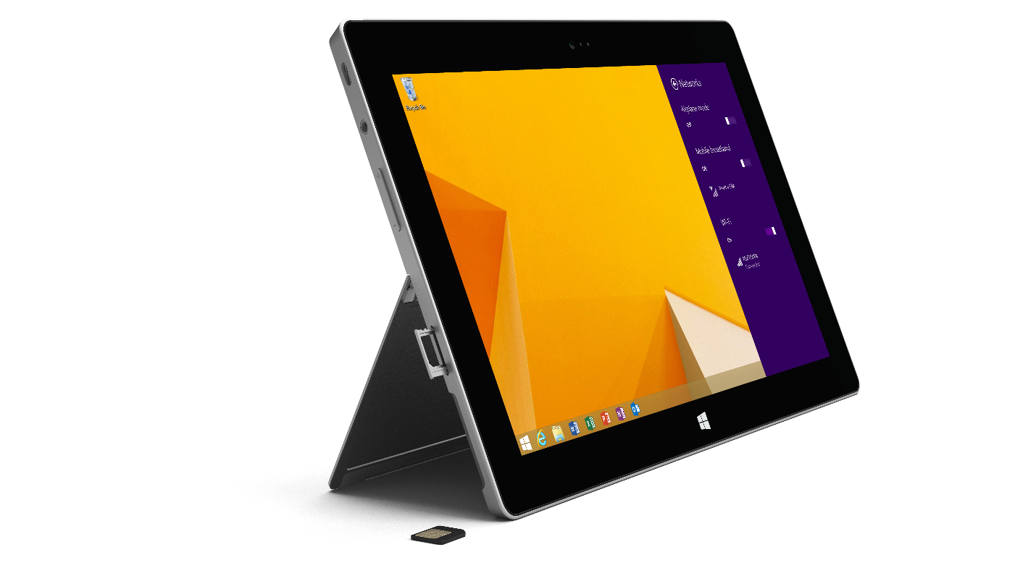

Surface 2 (AT&T 4G LTE¹) is the next generation of Surface 2, the most productive tablet for personal use. It offers all the entertainment and gaming capabilities you expect from a tablet, along with the ability to get work done on the go. Like Surface 2, Surface 2 (AT&T 4G LTE) has great battery life and is powered by an NVIDIA Tegra 4 processor, making apps run fast and smooth. The 10.6-inch ClearType Full HD display renders 1080p video for enjoying shows and movies, and the USB 3.0 transfers files up to four times faster than the original Surface RT. It comes with a 3.5-megapixel front camera and 5-megapixel rear camera, both capable of capturing 1080p video and featuring improved low-light performance from the first generation of Surface, making face-to-face conversation with your favorite people crisper and clearer. Surface 2 (AT&T 4G LTE) is a portable, flexible, powerful tablet for people who want to do more, in more places.

Surface 2 (AT&T 4G LTE) ships with Windows RT 8.1, bringing personalization, search, multitasking and built-in apps. Xbox Music allows you to stream millions of songs for free², and an assortment of apps and games from the Windows Store will ensure you never run out of ways to play. When it’s time to get serious, Surface 2 (AT&T 4G LTE) is pre-loaded with Office Home & Student 2013 RT and Outlook 2013 RT³; simply click in a Touch or Type Cover 2, and get to work, virtually wherever you are.

To help people get the most out of Surface 2 (AT&T 4G LTE), new customers purchasing the device will receive free Skype⁴ calling to landlines in more than 60 countries for one year, unlimited Skype Wi-Fi available at more than 2 million hot spots worldwide for one year, and 200 GB of free OneDrive (formerly known as SkyDrive) storage for two years.⁵

Top features and benefits
- Mobile broadband. Surface 2 (AT&T 4G LTE) is an unlocked tablet ready for AT&T’s cellular network.¹
- Personal productivity. Open, edit and create files with touch-optimized versions of Outlook, Word, Excel, PowerPoint and OneNote included. With 200 GB of free OneDrive (formerly known as SkyDrive) storage for two years, you can keep your pictures and movies with you wherever you go.
- More than a tablet. Unlike other tablets, you can knock out longer emails by clicking in an optional Touch Cover or Type Cover. Its sturdy kickstand features two positions, and its full-size USB 3.0 port makes transferring files and connecting to other devices simple.
- Windows 8.1. With Windows RT 8.1 you can personalize your Surface and set up multiple accounts for your family. Discover new apps in the Windows Store and snap apps side by side, so you can get more done.
- Ready to go wherever you go. Surface 2 (AT&T 4G LTE) has great battery life and is powered by an NVIDIA Tegra 4 processor, making apps run fast and smooth.
- Picture perfect. The 10.6-inch touchscreen, with its 16:9 aspect ratio and ClearType Full HD display (1080p resolution, 1920x1080), is perfect for watching HD movies, browsing the Web and using Office.
- Smile for the camera. The 3.5-megapixel camera on the front and 5-megapixel camera on the back combine with great low-light performance to make face-to-face conversations with your favorite people crisp and clear.

Specs
Operating  system | Windows RT 8.1 with Microsoft Office 2013 RT versions of Word, Excel, PowerPoint, OneNote and Outlook. Works exclusively with apps available in the Windows Store.
Exterior | 10.81” x 6.79” x 0.35”  Less than 1.51 lbs  VaporMg  Magnesium (Silver)  Volume up/down and power buttons
Storage | 64 GB⁶
Display | 10.6-inch ClearType Full HD display  1920 x 1080p  16:9 (widescreen)  5-point multitouch
CPU | NVIDIA Tegra 4 (T40) 1.7GHz quad core  2 GB of RAM
Cellular | Unlocked tablet ready for AT&T’s cellular network; capable of accepting any GSM micro-SIM card but will only work with the following cellular network bands:  - 2G GSM (Quadband: 850/900/1800/1900)  - 3G UMTS (Bands 1, 2, 5)  - 4G LTE (Bands 4, 7, 17)
Wireless | Wi-Fi (802.11a/b/g/n)  Bluetooth 4.0 low energy technology
Battery | Up to 10 hours of video playback  7–15 days idle life
Cameras and A/V | 3.5MP front-facing camera  5MP rear-facing camera  1080p video capture  Stereo speakers (digitally enhanced for fuller sound)  Two microphones (with noise cancellation)
Ports | Full-size USB 3.0  MicroSDXC card reader  Headset jack  HD video out port  Cover port
Sensors | Ambient light sensor  Accelerometer  Gyroscope  Magnetometer
Power supply | 24W power supply
Warranty | One-year limited hardware warranty
Apps (included) | Mail, Calendar, People, Internet Explorer 11, Photos, Music, Video, Games, Skype, Fresh Paint, Calculator, Reading List, Reader, Scan, News, Weather, Sports, Travel, Finance, Health & Fitness, Food & Drink, Help, Camera, OneDrive (formerly known as SkyDrive), Sound Recorder, and more

Availability and pricing
Available for $679 (ERP), Surface 2 (AT&T 4G LTE) will be available for purchase starting March 11, 2014, at Microsoft retail stores, www.MicrosoftStore.com and Best Buy in the United States.
Surface 2 (AT&T 4G LTE) | Estimated retail price
64 GB | $679

Contact info
For more information, press only:
Rapid Response Team, Waggener Edstrom Communications, (503) 443-7070, rrt@waggeneredstrom.com

For more product information and images:
Visit the Surface Newsroom at http://www.microsoft.com/en-us/news/presskits/surface.

For more information about Surface:
Visit Surface at http://www.microsoft.com/surface.

AT&T service activation on qualifying plan required; additional fees apply. Coverage not available everywhere. Contact AT&T for details.
2 Data rates apply. Free streaming limited to 10 hours per month after six months; unlimited with paid subscription. Limit one per person; prior Zune Pass trial users not eligible.
3 Some functionality may be limited. See Office.com/OfficeRT.
4 Internet access fees may apply. Skype offer excludes calls to special, premium and nongeographic numbers. A fair usage policy and Skype’s Terms of Use apply; see http://www.skype.com/surface for details. For OneDrive (formerly known as SkyDrive) offer terms and conditions; see http://www.skydrive.com/surface.
5 System software uses significant storage space. Available storage is subject to change based on system software updates and apps usage. 1 GB = 1 billion bytes. See http://www.microsoft.com/surface/en-us/support/storage for more details.
6 Beyond AT&T’s network, we do not test or make particular claims about Surface 2 (AT&T 4G LTE)’s carrier performance.

