Surface 2
Fact sheet
September 2013

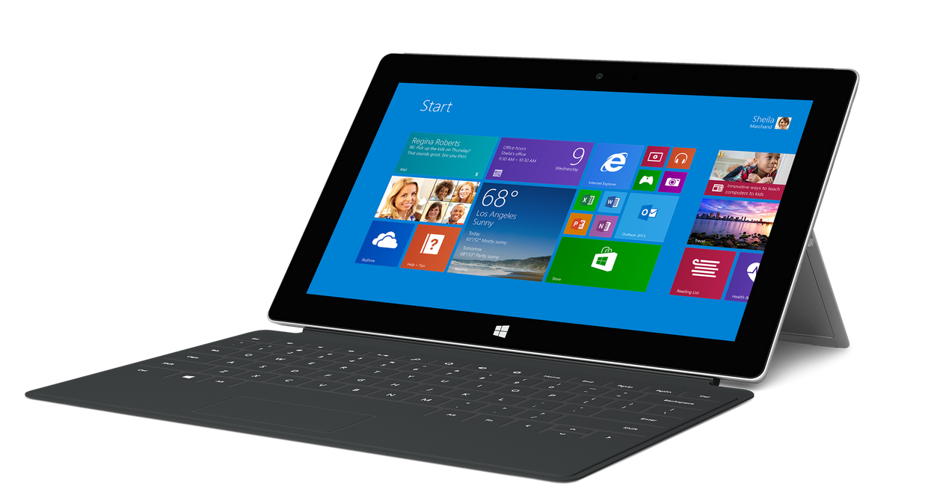

Surface 2 is the most productive tablet for personal use. It offers all the entertainment and gaming capabilities you expect from a tablet, along with the ability to get work done. Surface 2 is powered by an NVIDIA Tegra 4 processor, making apps run faster and smoother and increasing battery life to up to 10 hours of video playback. The 10.6-inch ClearType Full HD display now renders 1080p video for enjoying shows and movies, and its full-size USB port has been upgraded to USB 3.0 for up to four times faster file transfers. Camera resolution has also increased, with a 3.5-megapixel front camera and 5-megapixel rear camera, both capable of capturing 1080p video and featuring improved low-light performance, making face-to-face conversation with your favorite people crisp and clear. Even with these and other upgrades, Surface 2 is slightly thinner and lighter than its predecessor.

Surface 2 will ship with Windows RT 8.1, bringing improvements in key areas such as personalization, search, multitasking, built-in apps, the Windows Store experience and cloud connectivity. The new Xbox Music allows you to stream millions of songs for free, and an updated Video app and great games from the Windows Store such as “Halo: Spartan Assault” will ensure that you never run out of ways to play. When it’s time to get serious, Surface 2 is pre-loaded with Microsoft Office 2013 RT — including Outlook 2013 RT; simply click in a Touch or Type Cover and get to work.

To help people get the most out of Surface 2, customers purchasing the device will receive free Skype calling to landlines in more than 60 countries for one year, unlimited Skype WiFi on their Surface 2 at more than 2 million hot spots worldwide for one year and 200 GB of free SkyDrive storage for two years.

Top features and benefits

- Personal productivity. Open, edit and create files with touch-optimized versions of Outlook, Word, Excel, PowerPoint and OneNote included. With 200 GB of SkyDrive storage included for two years, you can keep your pictures and movies with you wherever you go.
- More than a tablet. Unlike other tablets, you can knock out longer emails by clicking in a Touch Cover or Type Cover. Its sturdy Kickstand now features two positions, and its full-size USB 3.0 port makes transferring files and connecting to other devices simple.
- Windows 8.1. With Windows RT 8.1 you can personalize your Surface and set up multiple accounts for your family. Discover new apps in the Windows Store and snap apps side by side so you can get more done.
- Ready to go wherever you go. Surface 2 is powered by an NVIDIA Tegra 4 processor, making apps run faster and smoother and increasing battery life to up to 10 hours of video playback, helping you power through your day wherever you are.
- Picture perfect. The 10.6-inch touchscreen, with its 16:9 aspect ratio and ClearType Full HD display (1080p resolution, 1920x1080), is perfect for watching HD movies, browsing the Web and using Office.
- Smile for the camera. With 1080p video cameras and one year of Unlimited World calling and Skype WiFi, Skype gets even better on Surface 2. The 3.5-megapixel camera on the front and 5-megapixel camera on the back combine with improved low-light performance to make face-to-face conversations with your favorite people crisp and clear.

Specs
Operating  system | Windows RT 8.1 with Microsoft Office 2013 RT versions of Word, Excel, PowerPoint, OneNote and Outlook. Works exclusively with apps available in the Windows Store.
Exterior | 10.81” x 6.79” x 0.35”  Less than 1.49 lbs  VaporMg  Magnesium (Silver)  Volume up/down and power buttons
Storage | 32 GB; 64 GB¹
Display | 10.6" ClearType Full HD display  1920 x 1080p  16:9 (widescreen)  5-point multitouch
CPU | NVIDIA Tegra 4 (T40) 1.7GHz quad core  2 GB of RAM
Wireless | Wi-Fi (802.11a/b/g/n)  Bluetooth 4.0 low energy technology
Battery | Up to 10 hours of video playback  7–15 days idle life
Cameras and A/V | 3.5MP front-facing camera  5MP rear-facing camera  1080p video capture  Stereo speakers (digitally enhanced for fuller sound)  Two microphones (with noise cancellation)
Ports | Full-size USB 3.0  MicroSDXC card reader  Headset jack  HD video out port  Cover port
Sensors | Ambient light sensor  Accelerometer  Gyroscope  Magnetometer
Power supply | 24W power supply
Warranty | One-year limited hardware warranty
Apps (included) | Mail, Calendar, People, Internet Explorer 11, Photos, Music, Video, Games, Skype, Fresh Paint, Calculator, Reading List, Reader, Scan, News, Weather, Sports, Travel, Finance, Health & Fitness, Food & Drink, Help, Camera, SkyDrive, Sound Recorder and more

Availability and pricing
Starting at $449 (ERP), Surface 2 will be available online at http://www.surface.com and at Microsoft Stores and select retail locations starting Oct. 22.

Surface 2 | Estimated retail price
32 GB | $449
64 GB | $549

¹ System software uses significant storage space. Available storage is subject to change based on system software updates and apps usage. 1 GB = 1 billion bytes. See Surface.com/storage for more details.

Contact info

For more information, press only:
Rapid Response Team, Waggener Edstrom Worldwide, +1 (503) 443-7070, rrt@waggeneredstrom.com

For more product information and images:
Visit the Microsoft News Center at http://www.microsoft.com/en-us/news/presskits/surface.

For more information about Surface:
Visit Surface at http://www.surface.com.

