Surface Pro 2
Fact sheet
September 2013
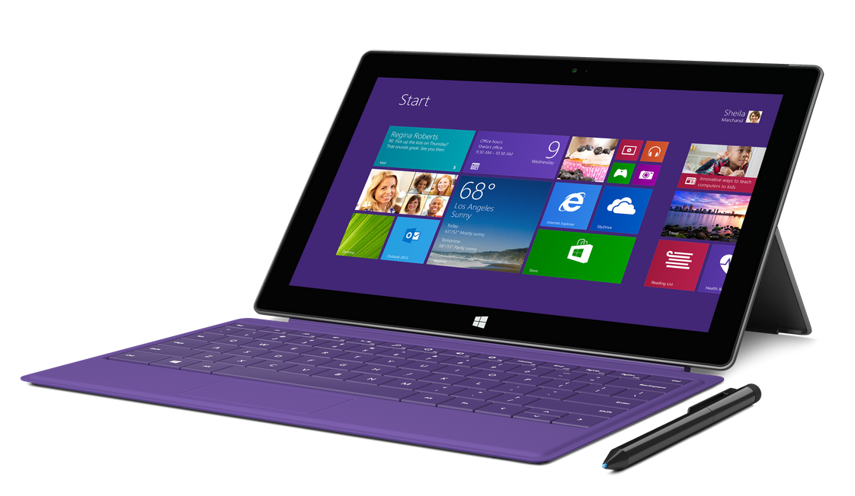

Surface Pro 2 is the successor to Surface Pro and, like its predecessor, is a true laptop replacement, capable of running all your Windows software including the full Microsoft Office suite, as well as apps from the Windows Store. Surface Pro 2 offers the portability and simplicity of a tablet when you want it and the power and flexibility of a laptop when you need it. It is powered by a fourth-generation Intel Core i5 processor which, combined with other improvements, delivers increased performance and up to 75 percent longer battery life than Surface Pro.

Starting at $899, Surface Pro 2 will be offered in 64GB and 128GB configurations with 4 GB of RAM and 256GB and 512GB configurations with 8 GB of RAM.¹

To help people get the most out of Surface Pro 2, customers purchasing the device will receive free Skype calling to landlines in more than 60 countries for one year, unlimited Skype WiFi on their Surface Pro 2 at more than 2 million hot spots worldwide for one year and 200 GB of free SkyDrive storage for two years.

Top features and benefits
- More than a tablet. Unlike other tablets, you can knock out longer emails by clicking in a Touch Cover or Type Cover. The sturdy Kickstand now features two positions, making Surface Pro 2 comfortable to use on your lap or at a desk. With a full-size USB port, it’s easy to transfer pictures or connect to other devices.
- Performance of a laptop. With a fourth-generation Intel Core i5 processor, Surface Pro 2 provides incredibly fast performance and up to 75 percent more battery life, so you can do more on a single charge.
- All the programs you need. Surface Pro 2 is compatible with virtually all your favorite Windows software, including the entire Microsoft Office suite.² With Windows 8.1 Pro, you can download apps from the Windows Store and use them side by side with snap view.
- Write, draw and create. Surface Pro 2 includes the Surface pen that is pressure-sensitive and precise so you can get creative with drawing and note-taking. The pen makes it easy to mark up your presentations, PDFs and documents just like you would on paper.
- Use Skype everywhere. With front- and rear-facing 720p cameras, you can take photos and have crystal-clear video chat. Surface Pro 2 now comes with unlimited worldwide calling to landlines in more than 60 countries around the world and unlimited Skype Wi-Fi for one year.

Specs
Operating  system | Windows 8.1 Pro with one-month trial for new Microsoft Office 365 customers
Exterior | 10.81” x 6.81” x 0.53”  2 lbs  VaporMg casing  Dark Titanium color  Volume and power buttons
Storage | 64 GB, 128 GB, 256 GB, 512 GB³
Display | 10.6" ClearType Full HD display  1920 x 1080p  16:9 (widescreen)  10-point multitouch
Pen input | Pen input and pen (included with purchase)  Pen digitizer features 1,024 levels of pressure sensitivity
CPU | Fourth-generation Intel Core i5-4200U (1.6 GHz with Intel Turbo Boost up to 2.6 GHz) with Intel HD Graphics 4400  4 GB or 8 GB of RAM — dual-channel LPDDR3  TPM 1.2 (Trusted Platform Module – for Bitlocker Encryption)
Wireless | Wi-Fi (802.11a/b/g/n)  Bluetooth 4.0 low energy technology
Battery | 42 W-h
Cameras and A/V | 720p HD front- and rear-facing cameras  Built-in microphone  Stereo speakers with enhanced signal processing
Ports | Full-size USB 3.0  MicroSDXC card slot  Headset jack  Mini DisplayPort  Cover port
Sensors | Ambient light sensor  Accelerometer  Gyroscope  Magnetometer
Power supply | 48W power supply (including 5W USB for accessory charging)
Warranty | One-year limited hardware warranty
Apps (included) | Mail, Calendar, People, Internet Explorer 11, Photos, Music, Video, Games, Skype, Fresh Paint, Calculator, Reading List, Reader, Scan, News, Weather, Sports, Travel, Finance, Health & Fitness, Food & Drink, Help, Camera, SkyDrive, Sound Recorder and more

Availability and pricing
Starting at $899 (ERP), Surface Pro will be available online at http://www.surface.com and at Microsoft Stores and select retail locations starting Oct. 22.

Surface Pro | Estimated retail price
64 GB + Surface pen | $899
128 GB + Surface pen | $999
256 GB + Surface pen | $1,299
512 GB + Surface pen¹ | $1,799

¹ Initial quantities of Surface Pro 2 with 512 GB will be limited.
² Office sold separately.
³ System software uses significant storage space. Available storage is subject to change based on system software updates and apps usage. 1 GB = 1 billion bytes. See Surface.com/storage for more details.

Contact info

For more information, press only:
Rapid Response Team, Waggener Edstrom Worldwide, +1 (503) 443-7070, rrt@waggeneredstrom.com

For more product information and images:
Visit the Microsoft News Center at http://www.microsoft.com/en-us/news/presskits/surface.

For more information about Surface:
Visit Surface at http://www.surface.com.

