Surface 3 and Surface 3 (4G LTE)
Fact Sheet
March 2015
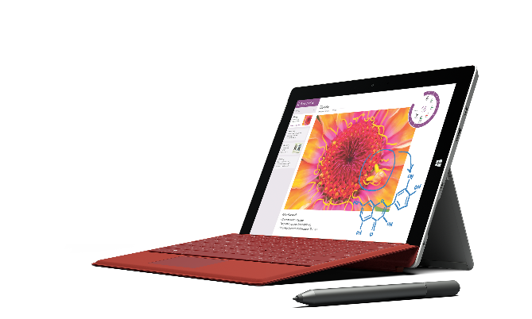

Meet Surface 3, the best of a tablet that works like a laptop. Equipped with the full Windows experience for maximum functionality and productivity, Surface 3 is ideal for students, schools and professionals on the go. It starts at just $499.

Top features and benefits
- The best of a tablet. With a fanless design and up to 10 hours of video-playback battery life, along with a beautiful screen, integrated kickstand and stereo speakers with Dolby® Audio-enhanced sound, Surface 3 offers hands-free entertainment wherever you go.
- Works like a laptop. Full Windows, multiple ports and the ability to run desktop software and click in a Surface 3 Type Cover make Surface 3 an ideal productivity device for school, work, home and on the move. You can also enhance your productivity with the Surface 3 Docking Station.
- The programs you want. With full Windows 8.1 and a free upgrade to Windows 10 when it’s available, Surface 3 is compatible with virtually all your favorite software and lets you run apps and desktop software side-by-side. It also includes a one-year Office 365 Personal subscription and OneDrive storage, so you can create, share, edit and present the way you’re used to.
- The performance you need. With the new quad-core Intel® Atom™ x7 processor — the highest-performing processor within the Intel Atom processor family — for outstanding performance and long battery life, Surface 3 runs everything from apps for Windows to desktop software and offers the perfect balance of power and mobility in a lightweight, versatile form.
- Write, draw and create. Note-taking is just a click away with the optional Surface Pen. Mark presentations, PDFs, term papers or proposals just like you would on paper, or easily convert your handwritten notes to text in OneNote.
- Full HD screen. With a 10.8-inch 1920x1280 resolution multi-touch display and 3:2 aspect ratio for comfortable viewing, Surface 3’s screen builds on the innovative design of the Surface Pro 3 display and is the brightest and most accurate Surface has ever made.
- High-definition cameras. Two 1080p HD cameras, including a rear-facing 8 megapixel auto-focus camera and a 3.5 megapixel front-facing camera, capture beautiful images and videos of what’s important to you — everything from people to documents.
- Constant connectivity. The addition of Surface 3 (4G LTE), a 4G LTE-ready model, offers added flexibility and usability. Perfect for on-the-go professionals or people who desire constant connectivity, it enables even greater access where there may not be Wi-Fi.

Technical specs
Operating  system | Windows 8.1
Exterior | Dimensions: 10.51 x 7.36 x 0.34 inches (267 x 187 x 8.7 millimeters)  Weight: 1.37 pounds (622 grams)  Casing: Magnesium  Color: Silver  Physical buttons: Volume, Power, Home
Storage | 64 GB, 128 GB
Display | Screen: 10.8-inch ClearType Full HD Plus Display  Resolution: 1920 x 1280  Aspect ratio: 3:2  Touch: 10-point multi-touch
Pen input | Surface Pen (sold separately)
CPU | Quad-core Intel® Atom™ x7-Z8700 processor  (2MB cache, 1.6 GHz with Intel Burst™ technology up to 2.4 GHz)
Network | Wi-Fi (802.11 a/b/g/n/ac)  Bluetooth 4.0 low energy
Battery | Up to 10 hours of video-playback battery life
Cameras and A/V | 3.5 megapixel 1080p front-facing camera  8.0 megapixel 1080p rear-facing camera with auto-focus  Microphone  Stereo speakers with Dolby® Audio-enhanced sound
Ports | Full-size USB 3.0  Mini DisplayPort  microSD™ card reader  Micro USB charging port (passes power and USB 2.0 data)  Headset jack  Cover port  Surface 3 (4G LTE) only: Nano-SIM card slot
Sensors | Ambient light sensor  Proximity sensor  Accelerometer  Gyroscope  Magnetometer  Digital compass
Power supply | 13W Micro USB power supply
Location | Surface 3 (4G LTE):  GPS  Assisted GPS  GLONASS
In the box | Surface 3 Power Supply  Quick Start Guide  Safety and warranty documents
Pre-loaded | One-year subscription to Office 365 Personal, including Outlook, Word, Excel, PowerPoint and OneNote  OneDrive cloud storage
Warranty | One-year limited hardware warranty

Pricing
Suggested Retail Pricing
Surface 3 | Estimated retail price
2 GB of RAM, 64 GB of storage | $499
4 GB of RAM, 128 GB of storage | $599
Surface 3 (4G LTE) | Estimated retail price
2 GB of RAM, 64 GB of storage | $599
4 GB of RAM, 128 GB of storage | $699

Contact info
For more information, press only:
Rapid Response Team, Waggener Edstrom Communications, (503) 443-7070, rrt@waggeneredstrom.com

For more product information and images:
Visit Surface Newsroom at http://www.microsoft.com/en-us/news/presskits/surface.

For more information about Surface:
Visit Surface at http://www.microsoft.com/surface.

Estimated retail price. Actual retailer prices may vary.
Testing conducted by Microsoft in March 2015 using 128GB and 64GB units with 4 GB of RAM. Testing consisted of full battery discharge during video playback. All settings were default except Wi-Fi was associated with a network and Auto-Brightness was disabled. Battery life varies significantly with settings, usage and other factors.
Surface 3 Type Cover sold separately.
Surface 3 Docking Station sold separately.
Free upgrade to Windows 10 for qualified Windows 8.1 devices that upgrade in the first year. More information and additional offer terms available in the coming months. See http://windows.microsoft.com/en-us/windows-10/about?ocid=WIN10_0_WOL_Hero_Home_Windows-10_Null_01 for more information.
Available on Surface 3 with Windows 8.1 purchased prior to Dec. 31, 2015. While supplies last. Office activation required within six months of Windows activation date.
Intel, Intel Atom and the Intel logo are trademarks of Intel Corporation in the United States and other countries.
Surface Pen sold separately.
Service availability and performance subject to service provider’s network. Contact your service provider for details, compatibility, pricing, SIM card and activation.
Upgradable to Windows 8.1 Pro immediately and Windows 10 once available
System software uses significant storage space. Available storage is subject to change based on system software updates and apps usage. 1 GB = 1 billion bytes. See http://www.microsoft.com/surface/storage for more details.
Testing conducted by Microsoft in March 2015 using 128GB and 64GB units with 4 GB of RAM. Testing consisted of full battery discharge during video playback. All settings were default except Wi-Fi was associated with a network and Auto-Brightness was disabled. Battery life varies significantly with settings, usage and other factors.
Available on Surface 3 with Windows 8.1 purchased prior to Dec. 31, 2015. While supplies last. Office activation required within six months of Windows activation date.
Available on Surface 3 with Windows 8.1 purchased prior to Dec. 31, 2015. While supplies last. Office activation required within six months of Windows activation date.
In the U.S.; warranty terms vary by market.
Estimated retail price. Actual prices may vary.

