Surface Pro with Windows 8 Pro
Fact Sheet
February 2013
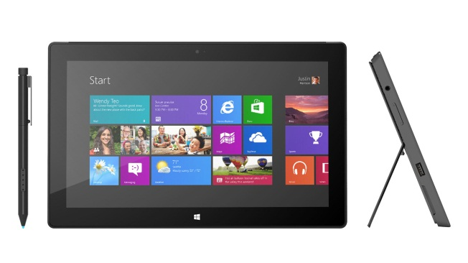
Surface Pro is all new, and yet you can do everything on it that you’ve ever done on your PC. Touch-enhanced applications run as smoothly as your favorite desktop software, so you can work the way you want. It’s got the power and apps you want, looks amazing and is light and easy to carry.¹ You’ll enjoy taking Surface wherever you go to deliver your best.

Surface Pro is a 64-bit tablet PC that combines beauty, power and mobility. Available in 64GB and 128GB storage configurations² and powered by an Intel Core i5 processor, Surface Pro is a powerful machine. Weighing less than two pounds and measuring just 13.5 millimeters thin, it’s the perfect way to do more.

Top Features and Benefits
- Windows 8 Pro. Tablet meets laptop in an intelligently constructed machine with the power and legacy of Microsoft applications and security features — all in one beautiful place.
- Surface pen. Surface Pro includes a pen that lets you jot down ideas anytime, anywhere. Distinctively crafted to work with Surface, the pen is a stylish way to edit, collaborate and do your signature work.
- Click in, and do more. Two ways to click in and do more — Touch Cover and Type Cover. Revolutionary design marries a light, thin form with comfort and speed. Doubling as a protective screen cover, both keyboards offer productivity with style and convenience.
- Kickstand. Surface was designed with an integrated kickstand that makes work instant and easy. Just flip out the kickstand and you’re ready to get busy.
- Security. Surface Pro combines the security and manageability that you expect from Microsoft. Microsoft BitLocker encrypts your hard drive’s data, helping keep your stuff safe. Install applications and connect with accessories and printers, just like you always have.
- Connectivity. When your creations need to be shared with others, connect to projectors, big screens or displays by plugging into the Mini DisplayPort.³ This HD connection lets presentations, videos and documents take center stage.

Specs
Operating  System | Runs current Windows 7 desktop applications and integrates with your existing enterprise management infrastructure. Uses the programs and the apps available in the Windows Store.
Exterior | 10.81 x 6.81 x 0.53”  Less than 2 lbs.  VaporMg casing  Dark Titanium color  Volume and power buttons
Storage | 64 GB;¹ 128 GB
Display | 10.6" ClearType Full HD Display  1920x1080 pixels  16:9 (widescreen)  10-point multitouch
Pen Input | Pen input and pen (included with purchase)
CPU | 3rd Generation Intel Core i5 Processor with Intel HD Graphics 4000  4 GB of RAM — dual channel memory
Wireless | Wi-Fi (802.11a/b/g/n)  Bluetooth 4.0 low-energy technology
Battery | 42 W-h
Cameras and A/V | Two 720p HD LifeCams, front- and rear-facing with TrueColor Technology  Microphone,  Stereo speakers
Ports | Full-size USB 3.0  microSDXC card slot  Headset jack  Mini DisplayPort  Cover port
Sensors | Ambient light sensor  Accelerometer  Gyroscope  Compass
Power Supply | 48W power supply (including 5W USB for accessory charging)
Warranty | One-year limited hardware warranty
Apps (included) | Windows Mail and Messaging; SkyDrive; Internet Explorer 10; Bing; Xbox Music, Video and Games.

Availability and Pricing
Starting at $899 (ERP), Surface Pro will be available online at http://www.surface.com and at Microsoft Stores and select retail locations worldwide.

Surface Pro | Estimated Retail Price
64GB + Surface pen | $899
128GB + Surface pen | $999

¹ Some apps from Windows Store. Internet required; fees apply.
² System software uses significant storage space; your storage capacity will be less. Available storage is subject to change based on system software updates and apps usage. See surface.com/storage. 1 GB = 1 billion bytes.
³ May require a separate cable and adapter (each sold separately).

Contact Info

For more information, press only:
Rapid Response Team, Waggener Edstrom Worldwide, +1 (503) 443-7070, rrt@waggeneredstrom.com

For more product information and images:
Visit the Microsoft News Center at http://www.microsoft.com/en-us/news

For more information about Surface:
Visit Surface at http://www.surface.com

