Microsoft Classic IntelliMouse
Fact Sheet
October 2017
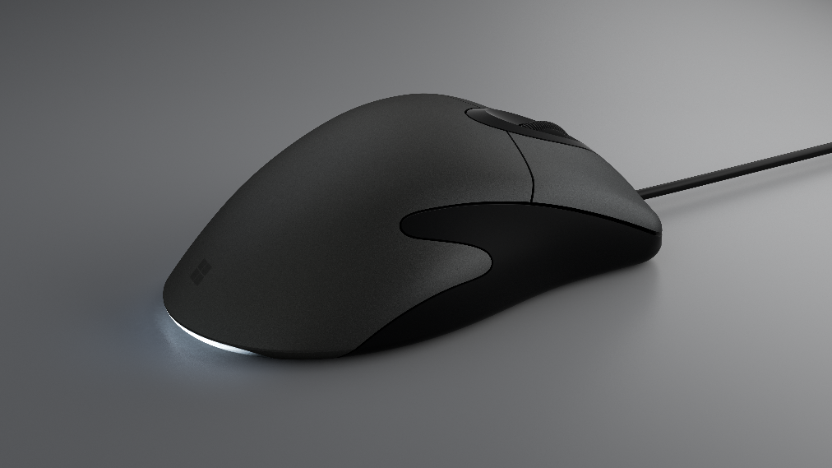

Inspired by the Microsoft IntelliMouse 3.0, the new Microsoft Classic IntelliMouse makes improvements to a fan favorite. The popular features from the original are still here, including customizable* buttons, the classic ergonomic look and feel, and wired USB connection. We introduced several new improvements to help give the mouse a more contemporary feel, including more precise tracking, buttons that feel more reliable, and the taillight in a distinctive, modern white.

Top Features and Benefits
- Works how you want it to. Work exactly the way you want with the new Microsoft Classic IntelliMouse. Plug in the fast, wired USB connector and immediately get into your flow without waiting for Bluetooth to pair or searching for a dongle.
- Designed for comfort. The ergonomic design of the new Microsoft Classic IntelliMouse remains comfortable, even after hours of use. Fluidly handle every maneuver for your most detailed projects with carefully calculated weight, stability and control.
- Packed with modern upgrades. The new Microsoft Classic IntelliMouse improvements make tracking more precise with four DPI settings from 400 up to 3200 (default 1600), and buttons feel more responsive than ever before. The red taillight that made the Microsoft IntelliMouse 3.0 so distinctive is now a clean, modern white.

Technical Specifications
Product Design | Length: 132 mm  Width: 69 mm  Depth/Height: 43 mm  Weight: 129 g  Cable length: 1800 millimeters  USB 2.0 full speed compatible  Two customizable* thumb buttons, customizable middle click  Ergonomic design
Compatibility | Microsoft Classic IntelliMouse is compatible with:  - Windows 10, Windows 8.1, Windows 8. Mouse and Keyboard center not available in Windows 10 S.*  - Windows 7 (limited customization).  - Apple Mac OS X v10.12+ (basic functionality, Mouse and Keyboard center not available*)  - Android 5.0+ (basic functionality, Mouse and Keyboard center not available*)  *Customization of buttons only available using Mouse and Keyboard center software. Requires 150 MB of available space.
Connection | USB 2.0
Power supply | Direct USB Connection
Tracking | Microsoft BlueTrack Technology, plus track on glass
In the box | Microsoft Classic IntelliMouse  Quick Start Guide  Safety and warranty documents
Warranty | One-year limited hardware warranty¹
¹ In the U.S.; warranty terms vary by market.

For more information, press only:
Microsoft Media Relations, WE Communications, (425) 638-7777, rrt@we-worldwide.com

For more PC Accessories information:
Visit the Microsoft Accessories Newsroom at https://news.microsoft.com/presskits/accessories.

For more information about PC Accessories:
Visit https://www.microsoft.com/accessories/en-us/mice.

