Surface Precision Mouse
Fact Sheet
October 2017

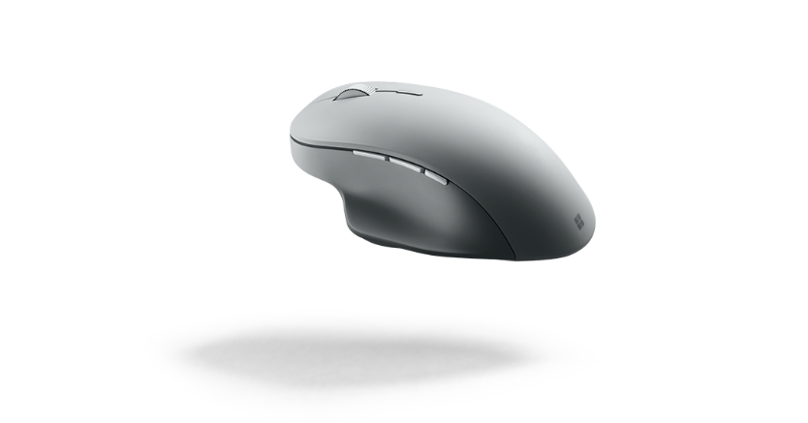

Designed for exceptional accuracy and an unprecedented level of control, Surface Precision Mouse helps you stay in your creative flow with flawless detent or smooth scrolling, three customizable thumb buttons, and the ability to use it with up to three computers at the same time. Built to last, Surface Precision Mouse is crafted with premium materials and thoughtful ergonomic details, including side grips and thumb rest for added comfort. Supports both Bluetooth and USB wired connections. This mouse is the perfect partner to Surface Book 2 or Surface Studio as it was designed with the same customer in mind — especially STEM professionals and creatives who use advanced or professional software to get things done. The customizability, ergonomic design and performance of Surface Precision Mouse help these individuals get more done quickly, accurately and comfortably.

Top Features and Benefits
- Customized to fit your needs. Surface Precision Mouse has multiple customizable features, including the three buttons on the left side that can be programmed to do tasks such as launch a program, execute a complex macro or save a document. Surface Precision Mouse is capable of pairing with up to three PCs, allowing you to seamlessly work across all your devices.
- Designed with comfort in mind. Surface Precision Mouse was crafted based on ergonomic principles that make it perfect for long hours of work .We selected materials to ensure durability and comfort for intense daily use, from the side grips to the machined aluminum buttons and scroll wheel.
- It’s all about the control. We carefully calculated Surface Precision Mouse’s weight, stability and precision for easy manipulation. Depending on how you like to work, Surface Precision Mouse can connect to your computer wirelessly via Bluetooth or through a wired connection.

Technical Specifications
Product Design | Length: 122.6 mm  Width: 77.6 mm  Depth/Height: 43.3 mm  Weight: 135 g  Three customizable buttons  Medium-profile arch  Ergonomic design  Machined aluminum  Molded TPE side grip and thumb rest
Compatibility | Surface Precision Mouse is compatible with:  - Windows 10, Windows 8.1, Windows 7* (USB mode only). Customizable and multidevice support not available on Windows 10 S. Mouse and Keyboard center not available in Windows 10 S.  - Macintosh Mac OS X v10.12+ (USB mode only, Mouse and Keyboard center not available)  - Android 5.0+ (Bluetooth mode only, Mouse and Keyboard center not available)  Customization of buttons and Smart Switching only available using Mouse and Keyboard center software
Network | USB 2.1  Bluetooth® Low Energy 4.0/4.1/4.2 compatible*
Wireless range | At least 16 feet (5 meters) in office environments.
Power supply | Rechargeable USB cable provided
Battery | 3 months
In the box | Surface Precision Mouse  USB cable  Quick Start Guide  Safety and warranty documents
Warranty | One-year limited hardware warranty²
² In the U.S.; warranty terms vary by market.

For more information, press only:
Microsoft Media Relations, WE Communications, (425) 638-7777, rrt@we-worldwide.com

For more product information and images:
Visit the Surface Newsroom at http://www.microsoft.com/en-us/news/presskits/surface.

For more information about Surface:
Visit Surface at http://www.microsoft.com/surface.

