Surface Go Signature Type Cover
Fact Sheet
July 2018
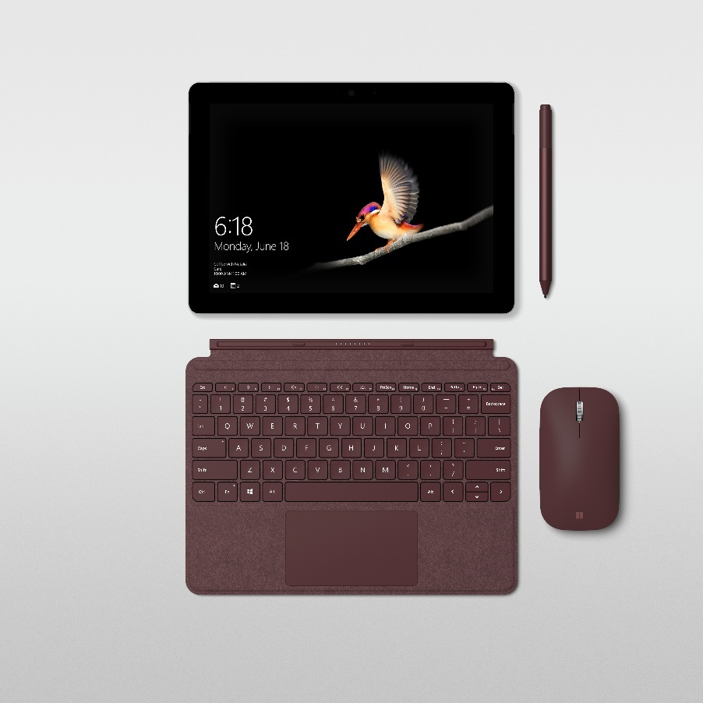
Add a touch of luxury to your Surface Go with the redesigned Surface Go Signature Type Cover. Offering a fast, comfortable typing experience and constructed with Alcantara®, a luxury material sourced in Italy, your Surface Go Signature Type Cover is elegant, durable and easy to care for.

Top Features and Benefits
- Laptop-class typing. The Surface Go Signature Type Cover features the proven scissor key mechanism to provide 1.0 mm of mechanical and stable key travel for an easier, more consistent and more accurate typing experience.
- Best of Microsoft technology. The Surface Go Signature Type Cover has LED backlighting, optimal key spacing for fast, fluid typing, and a large glass precision trackpad with support for multi-finger gestures — giving you a premium laptop experience on the go. With enhanced magnetic stability, the Surface Go Signature Type Cover clicks easily into place for additional stability. Adjust Surface Go’s kickstand to virtually any angle so you can work comfortably at your desk, on a plane or at a coffee shop.
- Beautiful and personal. In addition to a traditional black, the Surface Go Signature Type Cover is wrapped in luxurious Alcantara^{®1} material for an even more comfortable typing experience. Choose from three rich tone-on-tone colors, including Platinum, Burgundy and Cobalt Blue.

Technical Specifications
Weight | 243g (0.54 lbs.)
Compatibility | Surface Go
Dimensions | 248 mm (L) x 190 mm (W) x 4.6 mm (H)
Materials and Colors | Material: Alcantara®, polyurethane  Colors: Platinum, Burgundy, Cobalt Blue  Material: Polyurethane  Colors: Black
Trackpad | Large glass trackpad  Five-finger multi-touch gesture support
Keys | Activation: Moving (mechanical) keys with 1.0mm of key travel  Layout: QWERTY, full row of function keys (F1-F12)  4 directional keys, Windows, brightness and media control keys, LED backlighting
Interface | Magnetic
Sensors | Accelerometer
Warranty | One-year limited hardware warranty

1. EASY TO CARE FOR: Alcantara®-covered keyboard is treated with a polyurethane coat to maintain its premium aesthetic while also making it easy to clean and durable. Material is water-resistant and should be treated as you would treat your favorite or jacket or couch — simply wipe with a clean cloth.
2. WARRANTY: U.S. only; varies by market.

Contact Information
For more information, press only:
Rapid Response Team, WE Communications, (503) 443-7070, rrt@we-worldwide.com

For more product information and images:
Visit Surface Newsroom at https://news.microsoft.com/presskits/surface/.

For more information about Surface:
Visit Surface at http://www.microsoft.com/surface.

