Surface Mobile Mouse
Fact Sheet
July 2018
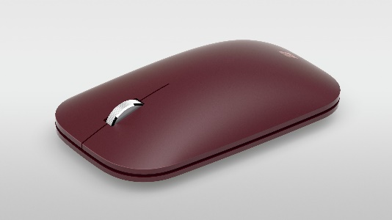
Slim, light and ready to travel, the Surface Mobile Mouse is designed to conform to either hand and fits easily in your bag.

The Surface Mobile Mouse is stylish, ultra-thin and affordable, and complements your style. Surface Mobile Mouse is an ideal, ultra-portable companion for your Surface. Choose one in a matching color — or mix and match.

Top Features and Benefits
- Compact design. The slim design of Surface Mobile Mouse is perfect for travel and optimized for comfort and a natural feel under the palm.
- Portable. Its stylish, ultra-thin profile goes anywhere without the bulk of a traditional mouse and matches your style when you pull it out of your bag.
- Fast pairing. Surface Mobile Mouse is dongle-free, with seamless Bluetooth pairing, and works on virtually any surface. The optimized metallic wheel provides more precise and comfortable scrolling.
- Colors. Choose from three rich tone-on-tone colors, including Platinum, Burgundy and Cobalt Blue.

Technical Specifications
Weight | 78g including 2 AAA alkaline batteries
Compatibility | Windows 10/8.1¹
Dimensions | 107.2mm x 60.3mm x 25.8mm
Materials and Colors | Platinum, Burgundy, Cobalt Blue
Features | - 4 Buttons: Left button, Right button, Wheel button, Power button (Pairing button by long press)  - Metal wheel for vertical scrolling and wheel button clicking  - Swift Pair to pair mouse to your computer easily, supported by Windows 10 April 2018 Release or later  - Customization: X-Y resolution adjusting, wheel button reassignment, wheel customization, and battery reporting²
Battery Life | Up to 12 months with 2 AAA batteries (included)³
Tracking | Microsoft-proprietary BlueTrack Technology, dynamically adaptable to 4000 frames per second and tracking speed up to 30 inches per second
Wireless | Bluetooth® 4.2 Low Energy, 2.4GHz frequency range with range up to 33 feet (10 meters) in open air and up to 16 feet (5 meters) in typical office environment
Warranty | 1 year

1. Device must support Bluetooth 4.0 or higher.
2. Requires Mouse and Keyboard Center (MKC) software installed on host that meets the requirements: 1) Operating system is Microsoft Windows 10 or Windows 8.1/8 (not available on Windows 10 in S mode) and 2) 150MB hard disk space is available. You must accept license terms for software download at microsoft.com/accessories/downloads. Internet is required, and associated charges may apply.
3. Battery life may vary based on user and computing conditions.

Contact Information
For more information, press only:
Rapid Response Team, WE Communications, (503) 443-7070, rrt@we-worldwide.com

For more product information and images:
Visit Surface Newsroom at https://news.microsoft.com/presskits/surface/.

For more information about Surface:
Visit Surface at http://www.microsoft.com/surface.

