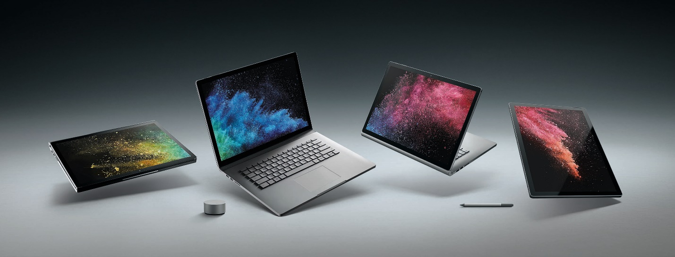

Surface Book 2
Fact Sheet
October 2017

Introducing Surface Book 2, the most powerful Surface yet. It’s designed to deliver the ultimate in performance and versatility without compromise, featuring the latest Intel® Dual-Core™ or Quad-Core™ processors, NVIDIA® GeForce® GPUs, and up to 17 hours of battery life.¹ Now available in 13.5-inch and new 15-inch models, Surface Book 2 has up to five times more graphics performance than the original and is twice as powerful as the MacBook Pro.² With a stunning PixelSense™ Display, Surface Book 2 gives you the power of a laptop, the versatility of a tablet and the freedom of a portable studio all in one beautifully styled device. Move seamlessly between professional apps from companies such as Adobe, Autodesk, Dassault and Unity, play popular PC games or immerse yourself in Windows Mixed Reality. Every detail of the iconic Surface Book design has been refined, from the dynamic fulcrum hinge for a more stable touch experience, to the improved, backlit keyboard and flexibility of both USB Type-A and USB Type-C ports.

Starting at US $1,499, Surface Book 2 is a portable powerhouse that provides the performance you need to tackle any task, with enough battery life to last all day.

Top Features and Benefits
- Built for performance. With Surface Book 2, you can seamlessly transition between professional-grade software and the latest PC games. Breeze through any task with lightning-fast storage and the latest dual- or quad-core Intel® Core™ i5 and i7 processors, and experience the best graphics performance yet with the latest NVIDIA® GeForce® GPUs. Surface Book 2 delivers up to 17 hours of battery life¹ with the 15” version delivering up to 5 times more graphics performance than the original Surface Book.

- Adapts to the ways you create. Surface Book 2 is a robust laptop, powerful tablet and portable studio that adapts to the ways you work and create best. Whether you’re designing 3-D models with CAD, sketching with Surface Pen, or editing 4K video on an external monitor, Surface Book 2 has four versatile modes of use to help you find your breakthrough. The versatility doesn’t stop there — Surface Book 2 connects to all your devices: hook up to USB Type-C and USB Type-A ports, as well as your full-size SD card, Surface Dial and Surface Dock.

- Designed with innovation in every detail. Surface Book 2 balances performance with premium, lightweight materials for unprecedented power in a laptop its size. Choose from a 13.5- or 15-inch touchscreen and immerse yourself in experiences that look and feel like real life on a stunning PixelSense™ Display. The backlit keyboard lets you get your ideas down faster and more confidently with the fastest, most comfortable Surface Book typing experience yet.

- Powers the best of Microsoft. Surface Book 2 lets you work, play and create without limits. Work seamlessly with your favorite Microsoft Office apps and add 3-D content to increase the impact of your content. Play the latest PC games and pair your Xbox Wireless controller and compatible headset, no dongle required (15” models only). Get immersed in VR games and content with Windows Mixed Reality Ultra experiences. When only a pen will help you express your idea, grab Surface Pen to naturally sketch, paint and draw, and use Surface Dial for easy, on-screen access to tools.

Technical Specifications

 | Surface Book 2 13“ |  | Surface Book 2 15“
Display | 13.5” PixelSense™ Display  3000 x 2000 (267 PPI)  1600:1 contrast ratio  10 point multitouch  Compatible with next-generation Surface Pen and Surface Dial on-screen interaction |  | 15” PixelSense™ Display  3240 x 2160 (260 PPI)  1600:1 contrast ratio  10 point multitouch  Compatible with next-generation Surface Pen and Surface Dial on-screen interaction
Available Models | 8th gen Intel® Quad-Core™ processor  Intel® Core™ i7-8650U w/ 4.2GHz Max Turbo, 8GB RAM and 256GB PCIe SSD  Intel® Core™ i7-8650U w/ 4.2GHz Max Turbo, 16GB RAM and 512GB PCIe SSD  Intel® Core™ i7-8650U w/ 4.2GHz Max Turbo, 16GB RAM and 1TB PCIe SSD  7th gen Intel® Dual Core™ processor  Intel® Core™ i5-7300U w/ 3.2GHz Max Turbo, 8GB RAM and 256GB PCIe SSD |  | 8th gen Intel® Quad-Core™ processor:  Intel® Core™ i7-8650U w/ 4.2GHz Max Turbo, 16GB RAM and 256GB PCIe SSD  Intel® Core™ i7-8650U w/ 4.2GHz Max Turbo, 16GB RAM and 512GB PCIe SSD  Intel® Core™ i7-8650U w/ 4.2GHz Max Turbo, 16GB RAM and 1TB PCIe SSD
Graphics | Intel Core™ i5  Intel® HD Graphics 620 integrated GPU  Intel Core™ i7  Intel® UHD Graphics 620 integrated GPU and NVIDIA® GeForce® GTX 1050 discrete GPU w/ 2GB GDDR5 graphics memory |  | Intel Core™ i7  Intel® UHD Graphics 620 integrated GPU and NVIDIA® GeForce® GTX 1060 discrete GPU w/ 6GB GDDR5 graphics memory
Windows OS | Ships with 64-bit Windows 10 Pro (Windows Creators Update)
Dimensions | Intel Core™ i5  312mm x 232mm x 13mm–23mm  12.3” (L) x 9.14” (W) x 0.51–0.90” (D)  Intel Core™ i7  312mm x 232mm x 15mm–23mm  12.3” (L) x 9.14” (W) x 0.59–0.90” (D) |  | Intel Core™ i7  343mm x 251mm x 15mm–23mm  13.5” (L) x 9.87” (W) x 0.57–0.90” (D)
Weight | Intel Core™ i5  Total – 1533 g (3.38 lbs)  Tablet – 719 g (1.59 lbs)  Intel Core™ i7  Total – 1642 g (3.62 lbs)  Tablet – 719 g (1.59 lbs) |  | Intel Core™ i7  Total – 1905 g (4.20 lbs)  Tablet – 817 g (1.80 lbs)
Battery¹ | Up to 17 hours of battery life  Up to 5 hours of battery life in Tablet Mode |  | Up to 17 hours of battery life  Up to 5 hours of battery life in Tablet Mode
Wireless | Wi-Fi: IEEE 802.11 a/b/g/n/ac compatible  Bluetooth Wireless 4.1 technology  Xbox Wireless built in (15” only)
Ports | 2x USB Type-A 3.1 (Gen1)  1x USB Type-C w/ video, power in/out and USB 3.1 (Gen1) data  Full-size SDXC card reader (UHS-II)  Headphone jack (3.5mm)  2x Surface Connect ports (1 in tablet, 1 in keyboard base)
Security | TPM 2.0 hardware chip for enterprise security, Common Criteria (CC) EAL4+, FIPS 140-2 Level 2  Windows Hello face sign in
Sensors | Ambient light sensor  Accelerometer  Gyroscope  Magnetometer
Cameras | 5.0MP 1080p video @30FPS (front)  8.0MP 1080p video @30FPS with auto-focus (rear)
Audio | Stereo speakers w/ Dolby® Audio™ Premium  Windows Sonic for Headphones included  Dolby® Atmos™ for headphones compatible
Keyboard and  Trackpad | Full-size, backlit keyboard with 1.55mm of full key travel  Glass track pad with antifingerprint coating and improved multifinger gestures
Modes | Laptop Mode, Tablet Mode, View Mode or Studio Mode
In the Box | 39W (Intel Core™ i5) or 95W (Intel Core™ i7) Surface Power Supply w/ USB Type-A charging port (5W) | 95W Surface Power Supply w/ USB Type-A charging port (7.5W)

¹ Up to 17 hours of video playback. Testing conducted by Microsoft in October 2017 using preproduction Intel Core i5, 256GB, 8GB RAM and Intel Core i7, 512GB, 16GB RAM dGPU devices. Testing consisted of full battery discharge during video playback. All settings were default except: Wi-Fi was associated with a network and Auto-Brightness disabled. Battery life varies significantly with settings, usage and other factors.

² Microsoft Test Lab 3DMark 11 Graphics and LuxMark 3.1 CPU+GPU score comparison, Surface Book 15” [Intel i7-8650U with NVIDIA GeForce GTX 1060] vs. MacBook Pro 15-inch [Intel i7-7567U with AMD Radeon Pro 560], and Surface Book 13” [Intel i7-8650U with NVIDIA GeForce GTX 1050] vs. MacBook Pro 13-inch [Intel i7-7567U], October 2017.

Contact Information
For more information, press only:
Microsoft Media Relations, WE Communications, (425) 638-7777, rrt@we-worldwide.com

For more product information and images:
Visit the Surface Newsroom at http://www.microsoft.com/en-us/news/presskits/surface.

For more information about Surface:
Visit Surface at http://www.microsoft.com/surface.

