Surface Go

Fact Sheet
July 2018

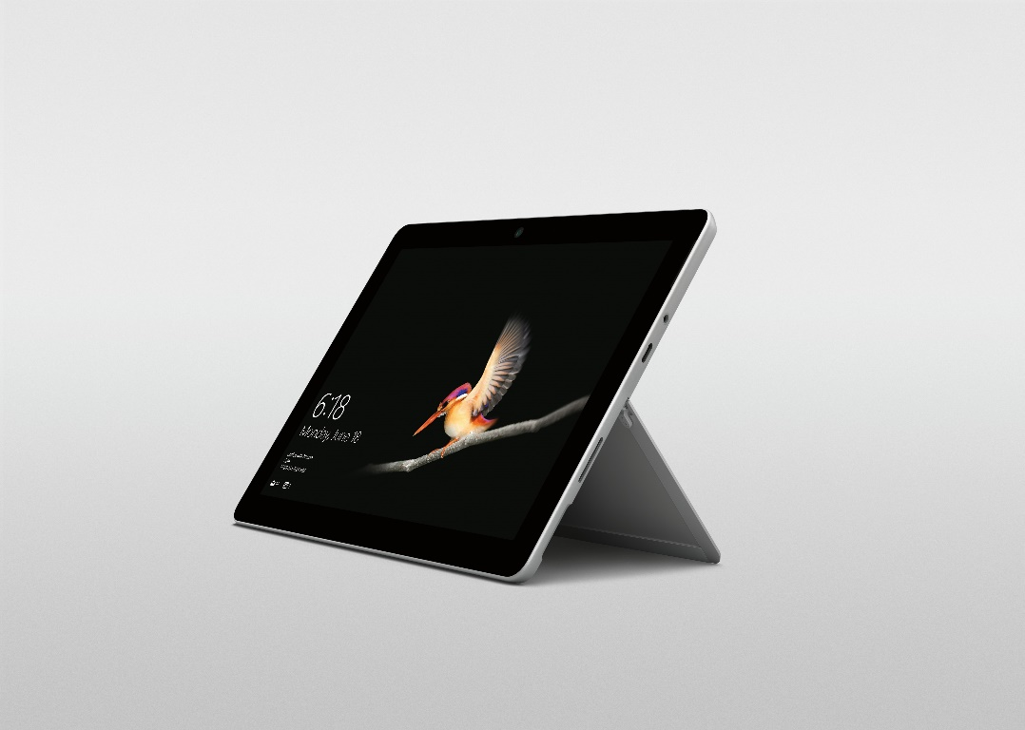

We started by looking at the world we live in. It’s filled with spectrums and different perspectives. We see this rich diversity through the different roles we play in our lives. You are a parent, sister, brother, friend, employee, athlete, artist, etc. There are some people who believe you must stay in one place, but we believe in celebrating all these roles by embracing the word AND.

You can be a parent AND an entrepreneurial titan. You can be a student AND a social justice warrior. You shouldn’t have to make binary choices that force unnecessary compromise. Surface believes in empowering users to be the most productive in their personal AND professional lives. We are thrilled to introduce our newest, smallest and lightest Surface yet — Surface Go.

Packing a punch in 1.15 pounds and a 10-inch PixelSense Display, Surface Go moves with you throughout your day — from the road to your couch. A device that is small AND strong. That can run desktop apps like Office AND casual apps like Spotify and Netflix. You can work the way you want with ink AND touch AND a trackpad. It’s the premium qualities that Surface is known for AND our most accessible price yet.

With Surface Go, we made the device smaller while remaining true to what makes Surface unique: versatility, design and performance.

Surface Go is the best of Microsoft with the Windows you know and love, and the iconic Surface design with no compromise in premium quality. It’s your notebook for imagination, your best friend on the plane and your family’s trusted confidant. We love this device and hope you do too.

--------------------------------------------------------------------------------------------------------------------

Top Features and Benefits
Most Versatile.
- Surface Go is our lightest, thinnest and most accessible Surface yet. With laptop performance and tablet portability, Surface Go helps you stay connected while on the move or at home. With Surface Go you have Office at your fingertips: You can glance and edit in Word and PowerPoint or take notes in OneNote from anywhere. Surface Go features Surface Connect, allowing you to magnetically charge and easily create a desktop experience with the Surface Dock.¹ Surface Go also includes a USB-C port for data, video and charging.²
- Experience more versatility when paired with the Surface Go Type Cover, the new Surface Mobile Mouse and Surface Pen.¹ The Surface Go Type Cover offers a fantastic typing experience with a backlit mechanical keyset. The Surface Go Type Cover is available in standard black or the Signature Type Cover with Alcantara® in three rich colors — Burgundy, Cobalt Blue and Platinum. It also features a full-size Precision Trackpad that is made of glass and has five-finger multiple touch support. It’s the perfect balance of sophisticated style and comfort. Complete the full-laptop capabilities with Surface Mobile Mouse, which features Bluetooth pairing and elegant design. For a natural inking experience, the Surface Pen provides low latency, tilt sensitivity and 4,096 levels of pressure.
- The new Surface Go comes equipped with built-in Wi-Fi and will also be offered as an LTE option (coming soon), providing hassle-free, secured connectivity wherever you go.
Innovative Design.
- With a slim, sleek design, the new Surface Go is ideal for everyday tasks when you are on the move. Its high-resolution 10-inch PixelSense Display with 10-point touch support is designed to be touched, viewed, and written on for work or play. Equipped with a 3:2 aspect ratio optimized for superior scrolling and browsing, Surface Go delivers a bigger, better reading and viewing experience by showing more content on the screen. Capture your favorite moments with family and friends by taking photos and making crisp, clear video calls with dual microphones, a front-facing 5.0-megapixel HD camera and rear auto-focus 8.0-megapixel HD camera. The built-in kickstand with full friction hinge extends to 165 degrees and helps you stay in your flow from tablet to Studio mode. The hinge design helps you find the perfect angle for any task: from adjusting the device angle on the plane to pushing the kickstand down to ink on a photo to share with your friends.
Portable Performance.
- Your Surface Go will run smoothly throughout the day, powered by an Intel® Pentium® Gold Processor 4415Y. Seamlessly launch an application like OneNote or stream video with Netflix while tasks like downloading email or listening to music run in the background. Optimized for mainstream productivity and chosen to manage performance, battery life and thinness, the 7th Generation Intel® Pentium® Gold Processor 4415Y gives you the portable power you need to get stuff done. With up to 9 hours of battery life,³ Surface Go has plenty of unplugged power, taking you from work or family projects to relaxing with your favorite TV shows, all on a single charge. A microSDXC card reader under the kickstand makes it easy to add more storage so you’ll never run out of space for photos, videos and music.
Best of Microsoft.
- Surface Go is the best of Microsoft in a 10-inch device. Start by signing in with a smile: Windows Hello face recognition uses biometrics to deliver quick and secure sign-in. Built on the manageability and security features of Windows 10 that your IT team knows and trusts, Surface Go comes equipped with Microsoft-verified security, Windows Defender Antivirus, multitasking capabilities and world-class support.

Technical Specifications
Operating System | Consumer Channels: Windows 10 Home in S mode⁴  Commercial Channels: Windows 10 Pro configurable to S mode*
Exterior | Dimensions: 9.6 inches x 6.9 inches x .33 inches (245mm x 175mm x 8.3mm)  Mechanical features: Magnesium body, kickstand with full-friction multi-position hinge to 165 degrees, magnetic attach for keyboard fold stability  Color: Platinum  Physical buttons: volume, power  Weight: 1.15 lbs.
Display | Screen: 10-inch PixelSense Display  Resolution: 1800x1200 (217 PPI)  Aspect Ratio: 3:2  Touch: 10-point multi-touch
Processor | Intel® Pentium® Gold Processor 4415Y
Graphics | Intel® HD Graphics 615
Memory | 4GB/8GB RAM 1866Mhz LPDDR3
Storage | 64GB eMMC  128GB Solid State Drive (SSD)⁵
Security | Enterprise-grade protection with Windows Hello face sign-in  TPM 2.0 for enterprise security
Network | Wi-Fi: IEEE 802.11 a/b/g/n/ac compatible, Bluetooth Wireless 4.1 technology  LTE Optional
Battery | Up to 9 hours of battery life³
Cameras, Video and Audio | Windows Hello face sign-in camera (front-facing)  5.0MP front-facing camera with 1080p HD video  8.0MP rear-facing autofocus camera with 1080p HD video  One microphone  Stereo speakers with Dolby® Audio™ Premium
Ports | USB Type C  Surface Connect  MicroSDXC card reader  3.5mm headphone jack
Sensors | Ambient light sensor  Accelerometer  Gyroscope
Power supply | 24 W power supply
In the box | Surface Go  Power supply  Quick Start Guide  Safety and warranty documents
Warranty | One-year limited hardware warranty⁶

1. Sold separately.
2. Charge times will vary.
3. Up to 9 hours for local video playback. Testing conducted by Microsoft in June 2018 using preproduction Intel Pentium Gold 4415Y Processor, 128GB, 8 GB RAM device. Testing consisted of full battery discharge during video playback. All settings were default except: Wi-Fi was associated with a network and Auto-Brightness disabled. Battery life varies significantly with settings, usage and other factors.
4. Windows 10 in S mode works exclusively with apps from the Microsoft Store within Windows and accessories that are compatible with Windows 10 in S mode. A one-way switch out of S mode is available. Learn more at Windows.com/SmodeFAQ.
5. System software uses significant storage space. Available storage is subject to change based on system software updates and apps usage. 1 GB= 1 billion bytes. See Surface.com/Storage for more details.
6. WARRANTY: U.S. only; varies by market.

Contact Information
For more information, press only:
Rapid Response Team, WE Communications, (503) 443-7070, rrt@we-worldwide.com

For more product information and images:
Visit the Surface Newsroom at https://news.microsoft.com/presskits/surface/.

For more information about Surface:
Visit Surface at http://www.microsoft.com/surface.

