Microsoft Modern USB-C Speaker
Fact Sheet
April 2021
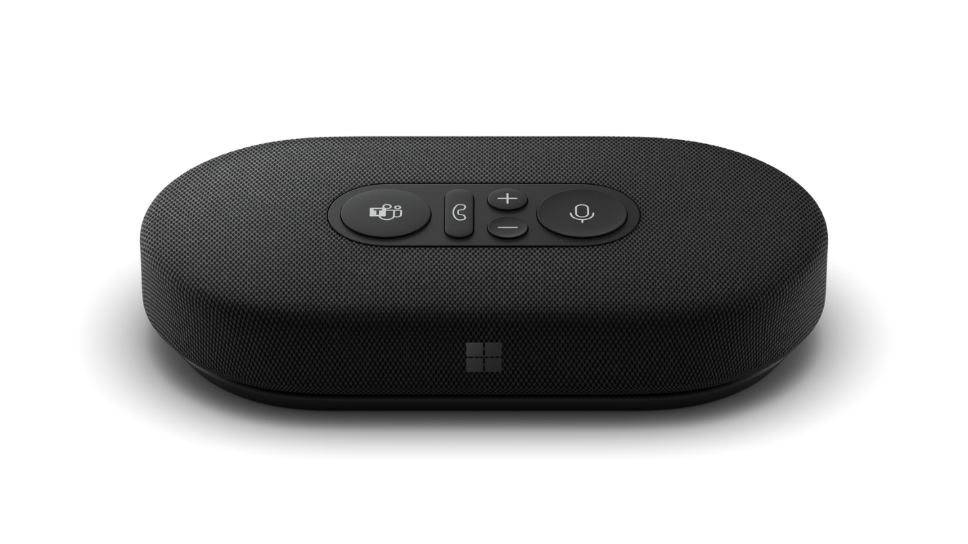
Introducing Microsoft Modern USB-C Speaker, your workday audio companion that provides high-quality audio for meetings, calls, and casual music listening. Certified for Microsoft Teams, Microsoft Modern USB-C Speaker offers intuitive, physical controls to manage your meeting experience. Its compact design with integrated cord storage makes it portable and easily placed in any workspace setup.

Top Features and Benefits
- Intuitive meeting controls, with simple, easy-to-use buttons, including mute control with status light to easily see whether you can be heard.
- Omni-directional, background noise-reducing microphones captures your voice better than your PC alone.
- High-quality speaker with voice optimization, is great for meetings and listening to music.
- Premium, compact design with cable storage and carrying case doesn’t crowd your workspace or bag and is out of the way on calls.
- Certified for Microsoft Teams, seamlessly integrates with your Surface or other Windows 10 PC. With quick-access control panel for Microsoft Teams calls.
- USB-C® connection, so you can plug-and-play with ease.

Technical Specifications
Exterior | Color: Matte Black  Materials: Fabric + Silicone
Dimensions | Length: 138 mm (5.43”)’  Width: 70 mm (2.756”)  Depth: 29 mm (1.142”)
Weight | Approximately 191 g (0.426 lbs)
Frequency response | 200Hz – 20kHz for music playback  300Hz-10KHz for conference
Microphone | Two omni-directional microphones
Speaker | 50 mm full range driver
Sound Pressure Level Output | Up to 83 dB SPL (1kHz@0.5m via cable connector with power on)
Cable Length | 680 mm (26.9”)
Inputs | USB-C® connector
Compatibility | Windows 10  Windows 8/8.1  Mac OS X 10.15  Mac OS 11.0
Microsoft Teams Certification | Pass 1.5 m conference room Spec
Buttons/Controls | Microsoft Teams button, Mute button, Volume up button, Volume down button, Hook Switch button
What’s In the box | Microsoft Modern USB-C Speaker  Carrying case  Quick start guide  Safety and warranty documents
Warranty | One-year limited hardware warranty
Best-in-class support from Microsoft Store | Microsoft Store Promise:  Fast and free shipping  30-day return policy  Free virtual workshops and training

Contact Information
For more information, press only:
Rapid Response Team, WE Communications, (425) 638-7777, rrt@we-worldwide.com

For more product information and images:
Visit the Surface Newsroom at https://news.microsoft.com/presskits/surface.

For more information about Surface:
Visit Surface at http://www.microsoft.com/surface.

Some software, hardware, and accessories sold separately.
Microsoft’s Limited Warranty is in addition to your consumer law rights.

