Microsoft Modern USB Headset:
Fact Sheet
April 2021
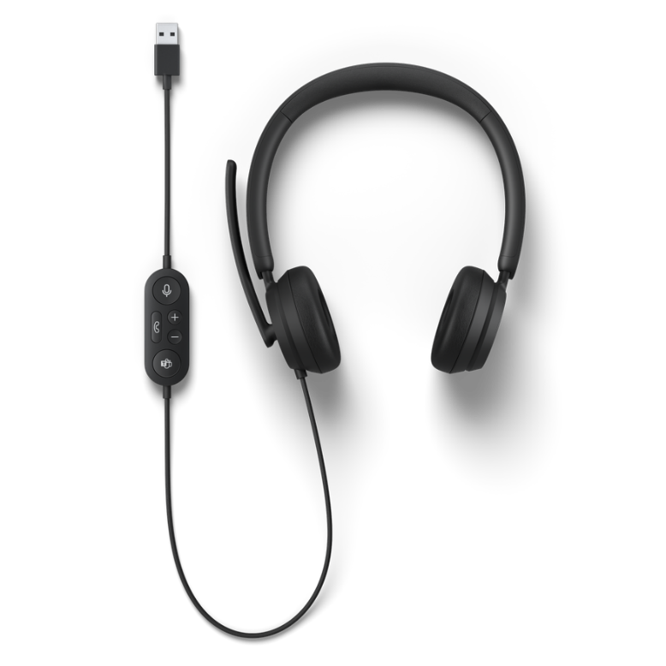
Introducing Microsoft Modern USB Headset, certified for Microsoft Teams. Microsoft Modern USB Headset connects and helps you stay focused on Microsoft Teams calls with high-quality audio and voice, noise-reducing microphone, and intuitive call controls. Be ready for everyday workday conversations with all-day comfort, physical mute controls and clear LED mute indications.

Top Features and Benefits
- Comfortable on-ear design with lightweight, padded earcups for all-day wear.
- High-quality stereo speakers optimized for voice and background noise-reducing microphone make sure you are heard loud and clear.
- Mute control with status light. See whether you can be heard or not. Controls including mute, volume, and the Microsoft Teams button, are in-line and easy to reach.
- Certified for Microsoft Teams. Join meetings at the touch of a button and enjoy high-quality audio with easy setup. Microsoft Modern USB Headset integrates seamlessly with your Surface computer and other Windows 10 PCs.
Technical Specifications
Exterior | Dimensions: Length: 6.81” (173 mm)  Width: 6.57” (167mm)  Depth: 2.36” (60 mm)  Mechanical features:  Color: Black  Buttons/Controls: Microsoft Teams button, Hook button, Mute button, Volume up/down button  Weight: 0.31 lbs (142 g)
Frequency Response | Microphone: 100Hz-10KHz  Speaker: 100Hz-20KHz
Noise Cancellation | Noise reduction mic boom
Speaker | 28 mm moving-coil speaker driver
Sound Pressure Level Output | Up to 91 dB
Cord Length | 39.4” (1.5 m)
Audio Cable Length | 29.5” (0.75 m)
Inputs | USB-A connection
Compatibility | Windows 10 / 8.1 / 8  Mac OS 11.0/10.15
Audio Codec | PCM
Microsoft Teams Certification | Microsoft Teams/Hook/Mute LED indicator
Buttons/Controls | Microsoft Teams button, Hook button, Mute button, Volume up/down button
In the box | Microsoft Modern USB Headset  Quick start guide  Safety and warranty documents
Warranty | 1-year limited hardware warranty
Best-in-class support from Microsoft Store | Microsoft Store Promise:  Fast and free shipping  30-day return policy  Free virtual workshops and training

Contact Information
For more information, press only:
Rapid Response Team, WE Communications, (425) 638-7777, rrt@we-worldwide.com

For more product information and images:
Visit the Surface Newsroom at https://news.microsoft.com/presskits/surface.

For more information about Surface:
Visit Surface at http://www.microsoft.com/surface

Sold separately.
Microsoft’s Limited Warranty is in addition to your consumer law rights.

