Microsoft Modern Webcam
Fact Sheet
April 2021
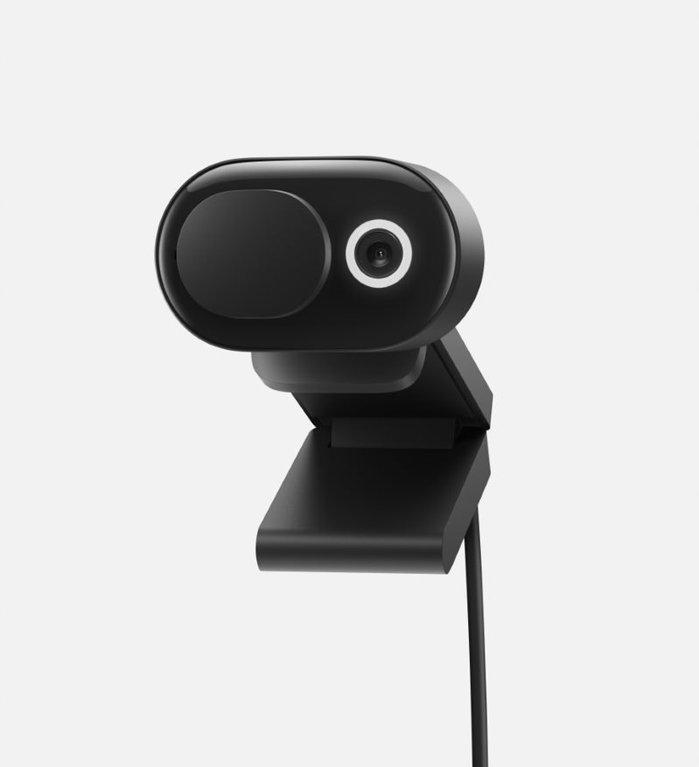
Introducing Microsoft Modern Webcam, built for you to look your best on face-to-face calls and Microsoft Teams meetings. The 1080p HD camera paired with a versatile, easy-to-mount system attaches to your monitor, laptop, desk or tripod and adds reliable, high-quality video to your laptop workspace. High-quality video with HDR and True Look deliver facial retouch and auto light adjustment. Microsoft Modern Webcam delivers exceptional 1080p video, HDR, and a 78° field of view optimized for your desk. Easily open and close the integrated privacy shutter and know you are only sharing when you want.

Top Features and Benefits
- High-quality video with HDR and True Look that deliver facial retouch, fixed light adjustment, and auto focus to help you look your best.
- Integrated privacy shutter you can easily slide open and close over the camera lens. Plus, LED status light lets you quickly see if your camera is on.
- Versatile mounting system, you can secure to your monitor, laptop, desk, or tripod.
- Certified for Microsoft Teams, with up to 1080p video and expansive 78° field of view.
- USB-A connection, for convenient plug-and-play design.

Technical Specifications
Exterior | Dimensions:  Length: 1.99” (50.53 mm )  Width: 1.42” (36.05 mm)  Depth: 2.94” (74.58 mm)  Mechanical features:  Front window: glass, polished black  Tripod mount: copper, glossy silver  Other components: plastic/TPE/rubber, matte black  Buttons: Integrated privacy shutter to turn video stream on/off  Weight: 0.21 lbs (88.3 g)
Video | Up to 1080p 30fps video output  HDR  Auto exposure  Auto white balance  Auto anti-flicker  Expansive 78° field of view
USB Cord Length | 59.1” (1.5 m)
Inputs | USB-A connection
Sensors | 1920 x 1080, 30fps  Pixel size: 1.4um x 1.4um
Compatibility | Windows 10  MacOS 11.0/10.15  Windows 8.1/8  Some features, and microphone, require software download (storage required); not supported on MacOS
Audio Codec | PCM, 16bit, 16KHz sampling
Buttons/Controls | Integrated privacy shutter to turn video stream on/off
In the box | Microsoft Modern Webcam  Quick start guide  Safety and warranty documents
Microsoft Teams Certification | DOF: 0.4-1.5m
Warranty | One-year limited hardware warranty
Best-in-class support from Microsoft Store | Microsoft Store Promise:  Fast and free shipping  30-day return policy  Free virtual workshops and training

Contact Information
For more information, press only:
Rapid Response Team, WE Communications, (425) 638-7777, rrt@we-worldwide.com

For more product information and images:
Visit the Surface Newsroom at https://news.microsoft.com/presskits/surface.

For more information about Surface:
Visit Surface at http://www.microsoft.com/surface.

Sold separately.
Microsoft’s Limited Warranty is in addition to your consumer law rights

