Microsoft Modern Wireless Headset
Fact Sheet
April 2021
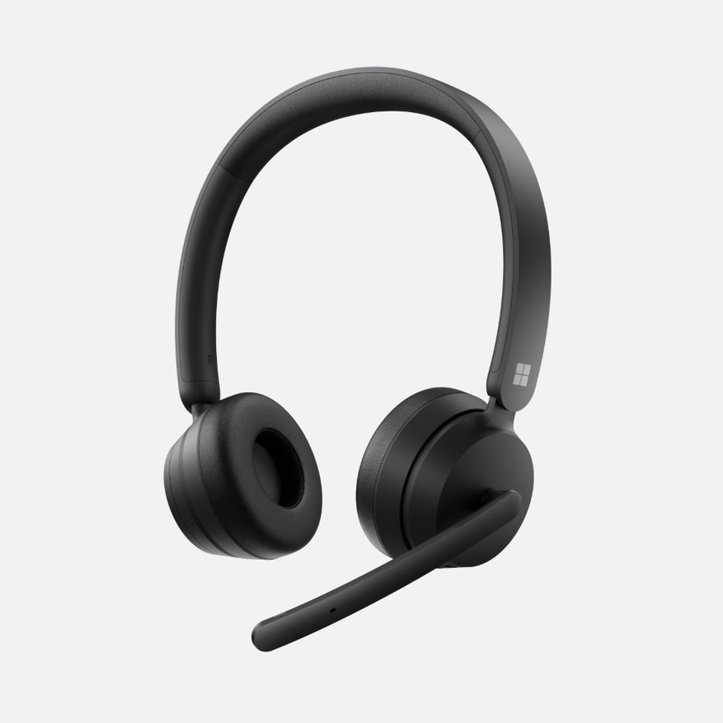
Introducing Microsoft Modern Wireless Headset. Make sure you stay connected to your Surface or other Windows 10 PC wherever you are with the wireless, Certified for Microsoft Teams headset. Make calls seamlessly with a comfortable and reliable headset.

Top Features and Benefits
- Comfortable on-ear design with lightweight, padded earcups for all-day wear.
- High-quality stereo speakers optimized for voice and background noise-reducing microphone make sure you are heard loud and clear.
- Flip-to-mute microphone with status light. Muting or unmuting your microphone is effortless by simply flipping the boom microphone up to mute and lowering to unmute.
- Convenient on-ear controls including mute, volume, and the Microsoft Teams button, are always at your fingertips.
- Certified for Microsoft Teams. Join meetings at a touch of a button and enjoy high-quality audio, plus easy setup, and management. Integrates seamlessly with your Surface computer and other Windows 10 PCs.* Microsoft Teams Certification requires the included USB dongle to connect.
- Wireless connectivity: Enjoy the freedom to move about your workspace while on calls and meetings.
- Never worry about losing your flow. Up to 50 hours of music listening time or up to 30 hours of voice calling on Microsoft Teams.
- Volume control: Intuitively adjust the volume during your calls by rotating the dial on the outside of the right earcup.

Technical Specifications
Dimensions | Length: 6.77” (172 mm)  Width: 6.46” (164 mm)  Depth: 2.36” (60 mm)
Exterior | Colors: Black
Weight | 0.30 lbs (136 g)
Frequency response | Microphone: 100Hz-10KHz  Speaker: 100Hz-20KHz
Noise Cancellation | Beamforming with 2 mems microphone
Speaker | 28 mm moving-coil speaker driver
Sound Pressure Level Output | Up to 91 dB
Charging | Full charge in 2.5 hours
Battery | Up to 50 hours^{i} of music listening time or up to 30 hours of talk time on a Microsoft Teams call^{ii}
Simultaneous Connection | Up to 2
Audio Codec | SBC
Inputs | USB A dongle and Bluetooth
Compatibility | - Bluetooth compatibility  - Windows 10: 20H1, 19H1, RS5  - Windows 8, Windows 7  - Mac OS, Android, iOS  - Microsoft Teams Certification compatible with Windows 10 and Mac OS  Some features require software download (storage required); not supported on MacOS.
Microsoft Teams Certification | Microsoft Teams and Mute LED
Buttons/Controls | Buttons:  - Power Slide button  - Pairing button  - Microsoft Teams button  - Mute button  - Hook button  Controls:  - Flip-to-mute  - Volume control dial
In the box | Microsoft Modern Wireless Headset  Charging cable  USB dongle  Quick start guide  Safety and warranty documents
Warranty | One-year limited hardware warranty
Best-in-class support from Microsoft Store | Microsoft Store Promise:  Fast and free shipping  30-day return policy  Free virtual workshops and training

Contact Information
For more information, press only:
Rapid Response Team, WE Communications, (425) 638-7777, rrt@we-worldwide.com

For more product information and images:
Visit the Surface Newsroom at https://news.microsoft.com/presskits/surface.

For more information about Surface:
Visit Surface at http://www.microsoft.com/surface.

* Sold separately. Music: Testing conducted by Microsoft on March 2021 using the Microsoft Modern Wireless Headset with firmware update 1.37.129 paired with Surface Pro 3. Playlist consisted of 44 songs transmitted using SBC encoding. Volume was set to 50%. Bluetooth A2DP profile was used. Testing consisted of full Microsoft Modern Wireless Headset battery discharge while playing audio until the Microsoft Modern Wireless Headset disconnected from the host device. Battery life depends on device settings, environment, usage, and many other factors.
Voice: Testing conducted by Microsoft on March 2021 using the Microsoft Modern Wireless Headset at peak power consumption (mA) conditions on a Microsoft Teams call. These conditions for the Microsoft Modern Wireless Headset are when 100% of usage is muted, and both the red and white LEDs are lit at the same time.
Microsoft’s Limited Warranty is in addition to your consumer law rights.

