Surface Headphones 2+ for Business
Fact Sheet
April 2021
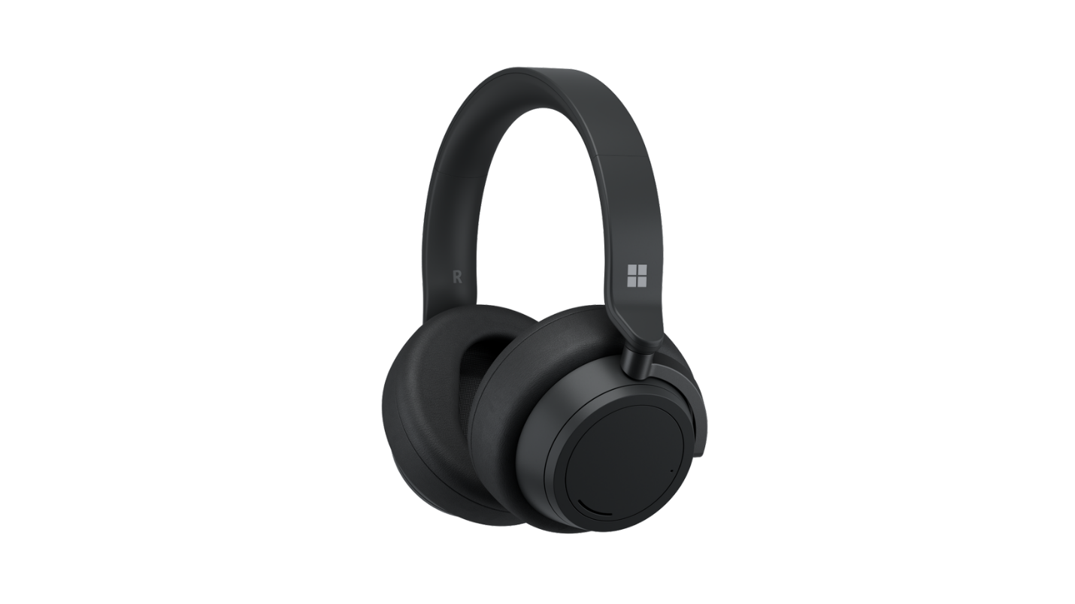
Introducing Surface Headphones 2+ for Business, Microsoft’s premium headphones designed for quality, comfort and control. Surface Headphones 2+ offers improvements for business and education customers by adding Microsoft Teams certification and functionality. Power through your day with up to 18.5 hours of music listening time or up to 15 hours of voice calling time on Microsoft Teams. Tune in or out of your surroundings with 13 levels of active noise cancellation so that you can focus on the go, at home, or in the office.

Top Features and Benefits
- Certified for Microsoft Teams for the best meeting experience. Empower employees with high-quality Microsoft Teams calls, a rock-solid connection with plug and play functionality, a dedicated Teams button, synchronized call controls to avoid the “you’re on mute,” and light states on the included dongle.
- Turn it up, tune it out. Experience your calls, music, and shows like never before with rich, immersive Omnisonic sound and 13 levels of adjustable noise cancellation. Use the on-ear dials to easily turn up the volume or tune out background noise. Advanced microphones ensure you are heard loud and clear on calls. Enjoy music, podcasts, exceptional call quality, or peace and quiet all day.
- Power through an entire day of meetings in comfort and control with up to 15 hours of voice calling time² and up to 18.5 hours of music listening time¹. Intuitively change volume and noise-cancellation levels with touch controls and dials on the soft, breathable, lightweight earcups that make our headphones a joy to wear.
- Amplify your productivity with the power of voice in Microsoft 365 apps like Word, Outlook, and PowerPoint. Voice controls vary by operating system. Be more productive using your voice to talk rather than type and enabling live captions and translation in PowerPoint. Find out more about Surface Headphones 2+ voice controls with Microsoft 365 apps.

Technical Specifications
Exterior | Dimensions:  8.03” (204 mm) x 7.68” (195 mm) x 1.89” (48 mm)  Mechanical features:  Colors: Matte Black  Buttons/Controls: Power button, Microsoft Teams button, Volume dial (right ear), Noise Cancellation dial (left ear), Single earcup tap (Mute)  Weight: 0.64 lbs (290 g)
Frequency Response | 20–20kHz
Noise Cancellation | Up to 30 dB for active noise cancellation  Up to 40 dB for passive noise cancellation
Speaker | 40mm Free Edge driver
Sound Pressure Level Output | Up to 115 dB (1kHz, 1Vrms via cable connector with power on)  Up to 115 dB (1kHz, 0dBFS over Bluetooth® connection)
Charging | Full charge in less than 2 hours
Battery | Up to 18.5 hours of music listening time¹ or up to 15 hours of voice calling on Microsoft Teams²
USB Cord Length | 1.5 m
Audio Cable Length | 1.2 m
Inputs | Headphones: USB C® connector, 3.5 mm audio connector  Union: USB-A
Compatibility | Windows 10, iOS, Android, MacOS
Buttons/Controls | Power button, Microsoft Teams button, Volume dial (right ear), Noise Cancellation dial (left ear), Single earcup tap (Mute)
In the box | - Surface Headphones 2+  - Carrying case  - USB cable  - Audio cable  - Union (USB-A)  - Quick Start Guide  - Safety and warranty documents
Warranty | One-year limited hardware warranty

Contact Information
For more information, press only:
Rapid Response Team, WE Communications, (425) 638-7777, rrt@we-worldwide.com
For more product information and images:
Visit the Surface Newsroom at https://news.microsoft.com/presskits/surface.
For more information about Surface:
Visit Surface at http://www.microsoft.com/surface.

Music listening testing conducted by Microsoft in Feb 2021 using prerelease Surface Headphones+ Dongle package with prerelease software. The dongle was plugged into Surface Laptop 3 and/or Surface Pro 7. Playlist consisted of 44 songs transmitted using SBC encoding. Volume was set to 46% with maximum noise cancellation. Bluetooth A2DP profile was used. Testing consisted of full Surface Headphones battery discharge while playing audio until the Surface Headphones disconnected from the host device. Battery life depends on device settings, environment, usage, and many other factors.
Voice calling testing conducted by Microsoft in Feb 2021 using prerelease Surface Headphones+ Dongle package with prerelease software. The dongle was plugged into Surface Laptop 3 and/or Surface Pro 7. Volume was set to 52% with maximum noise cancellation. Bluetooth Hands-Free profile was used. Testing consisted of full Surface Headphones battery discharge with a Microsoft Teams call until the Surface Headphones disconnected from the host device. Battery life depends on device settings, environment, usage, and many other factors.
Included USB dongle required for Teams Certification, available on Windows and macOS.
Sold separately.
USB-A to USB-C® adapter should work for a C-capable source. Performance varies based on the quality of the adapter and the cable length.
Included USB dongle required for Teams Certification, available on Windows and macOS.
AptX™ only works with Surface Headphones 2+ when not using Union.
Microsoft’s Limited Warranty is in addition to your consumer law rights.

