Surface Laptop 4
Fact Sheet
April 2021

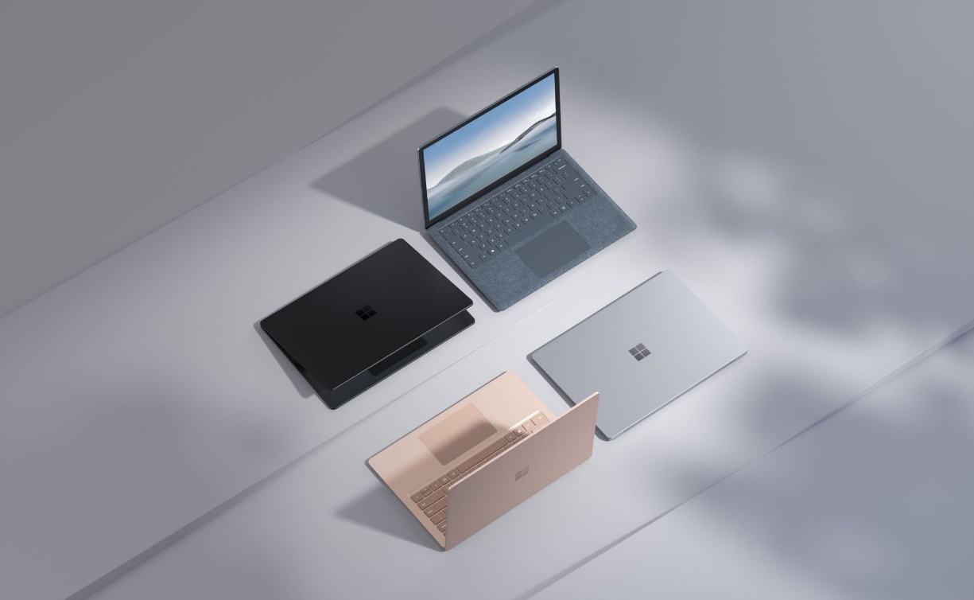

Introducing Surface Laptop 4 the most elegant and powerful Surface Laptop 4 ever. Surface Laptop 4 retains its iconic design and accomplishes tasks with style, performance, and speed. Be confident you’ll show up clearly with an HD front-facing camera and studio mics or immerse yourself in a cinematic experience with Dolby Atmos® audio. Surface Laptop 4 now has more choice than ever with two keyboard finishes, rich colors, and your choice of an 11th Gen Intel® Core™ or an exclusive AMD Ryzen™ Microsoft Surface® Edition processor in either 13.5” or 15” sizes. From the kitchen table to the office, the coffee shop and to the classroom, Surface Laptop 4 brings you the perfect balance of style, multitasking speed, and up to 19 hours of battery life.

Top Features and Benefits
- Sleek, elegant, and quiet. Open effortlessly with one finger and do your best work on the brilliant PixelSense™ touchscreen. Personalize with choice of two sizes and sophisticated keyboard finishes — warm Alcantara® or cool metal — plus rich colors.
- Next-gen performance for multitasking, video chats, and entertainment. Breeze through busy days with Microsoft’s most powerful Laptop ever that’s up 70% faster than Surface Laptop 3 with more multitasking power than before. Look and sound your best on video calls and enjoy immersive Dolby Atmos® audio, all backed by serious power from your choice of an 11th Gen Intel® Core™ or AMD™ Ryzen™ Microsoft Surface Edition processor.
- Comfort, convenience, and all the connections. Power your creativity anywhere thanks to all-day battery life, Fast Charging with 80% charge in one hour, and industry-leading typing comfort. Connect easily with both USB-C® and USB-A ports.
- The best of Microsoft, all in one place. Protect your files and photos in the cloud with OneDrive storage within Windows File Explorer. Work seamlessly across devices with Microsoft 365. And, get started right away with the Windows you know.

Technical Specifications
 | 13.5” | 15”
Operating system | Windows 10 Home 20H2 (Consumer)  Windows 10 Pro (Commercial)  Microsoft 365 Family 30-day trial
Exterior | Dimensions: 12.1” x 8.8” x 0.57” (308 mm x 223 mm x 14.5 mm)  Weight: Platinum and Ice Blue Alcantara 2.79 lbs (1,265 g)  Weight: Matte Black and Sandstone metal 2.84 lbs (1,288 g)  Mechanical features: Aluminum body  Colors: Platinum, Ice Blue (Alcantara version only)  Matte Black, Sandstone (metal version only) | Dimensions: 13.4” x 9.6” x 0.58” (339.5 mm x 244 mm x 14.7 mm)  Weight: Platinum and Matte Black metal 3.40 lbs (1,542 g)  Mechanical features: Aluminum body  Colors: Matte Black, Platinum
Display | Screen: 13.5” PixelSense™ Display  Resolution: 2256 x 1504 (201 PPI)  Aspect ratio: 3:2  Surface Pen* enabled  Touch: 10 point multi-touch | Screen: 15” PixelSense™ Display  Resolution: 2496 x 1664 (201 PPI)  Aspect ratio: 3:2  Surface Pen* enabled  Touch: 10 point multi-touch
CPU | Quad Core 11th Gen Intel® Core™ i5-1135G7 processor  Quad Core 11th Gen Intel® Core™ i5-1145G7 processor (Commercial only)  Quad Core 11th Intel® Core™ i7-1185G7 processor  AMD Ryzen™ 5 4680U Mobile Processor with Radeon™ Graphics Microsoft Surface® Edition (6 cores)  AMD Ryzen™ 7 4980U Mobile Processor with Radeon™ Graphics Microsoft Surface® Edition (8 cores, Commercial Only) | Quad Core 11th Intel® Core™ i7-1185G7 processor  Surface Laptop 4 15”: AMD Ryzen™ 7 4980U Mobile Processor with Radeon™ Graphics Microsoft Surface® Edition (8 cores)
Keyboard and trackpad | Precision trackpad: 115 mm x 76.66 mm, glass  Five-finger multitouch gesture  Full-size backlit keyboard with soft touch feel and full 1.3mm travel | Precision trackpad: 115 mm x 76.66 mm, glass  Five-finger multitouch gesture  Full-size backlit keyboard and full 1.3mm travel
Graphics | Surface Laptop 4 powered by Quad Core 11th Gen Intel® Core ™: Intel® Iris® Xe Graphics  Surface Laptop 4 powered by AMD RyzenTM Microsoft Surface® Edition: AMD Radeon™ Graphics | Surface Laptop 4 powered by Quad Core 11th Gen Intel® Core ™: Intel® Iris® Xe Graphics  Surface Laptop 4 powered by AMD RyzenTM Microsoft Surface® Edition: AMD Radeon™ Graphics
Memory | 8GB/16GB/32GB LPDDR4X, 3733MHz | Intel: 8GB/16GB/32GB LPDDR4X, 3733MHz  AMD: 8GB/16GB/32GB DDR4, 2400MHz
Storage | Solid state drive (SSD) 256GB/512GB/1TB  Removable  M.2 NVME SSD | Solid state drive (SSD) 256GB/512GB/1TB  Removable  M.2 NVME SSD
Security | Consumer  TPM 2.0 chip for enterprise security and BitLocker support  Enterprise-grade protection with Windows Hello face sign-in  Commercial  Hardware TPM 2.0 chip for enterprise security and BitLocker support  Enterprise-grade protection with Windows Hello face sign-in  Surface Laptop 4 powered by AMD RyzenTM Microsoft Surface Edition processors: Secured-Core PC  Surface Laptop 4 powered by 11th Gen Intel® Core™ processors: Windows enhanced hardware security
Network | Wi-Fi 6: 802.11ax compatible  Bluetooth® Wireless 5.0 technology | Wi-Fi 6: 802.11ax compatible  Bluetooth® Wireless 5.0 technology
Battery | Surface Laptop 4 Battery Life:  - Up to 19 hours on 13.5” AMD™ Ryzen™ 5  - Up to 17 hours on 13.5” Intel® Core™ i5  - Battery life varies significantly with settings, usage and other factors.  Surface Laptop 4 supports Fast Charging | Surface Laptop 4 Battery Life  - Up to 17.5 hours on 15” AMD™ Ryzen™ 7  - Up to 16.5 hours on 15” Intel® Core™ i7  - Battery life varies significantly with settings, usage and other factors.  Surface Laptop 4 supports Fast Charging
Cameras | Windows Hello face authentication camera (front-facing)  720p HD f2.0 camera (front-facing)
Audio | Dual far-field Studio Mics  Omnisonic Speakers with Dolby Atmos®9
Ports | 1 x USB-C®  1 x USB-A  3.5 mm headphone jack  1 x Surface Connect port
Sensors | Ambient light sensor
Power supply | 60W + 5W
In the box | Surface Laptop 4 13.5” or 15”:  Power Supply  Quick Start Guide  Safety and warranty documents
Warranty | One-year limited hardware warranty  Surface for Business customers: Includes Advanced Exchange, an expedited replacement service, at no additional cost
Best-in-class support from Microsoft Store | Microsoft Store Promise for Surface:  60-day return policy  Free 2-3 day shipping  90 days of free technical phone support  Free virtual workshops and training with a Microsoft Store product advisor  Surface price promise

Contact Information
For more information, press only:
Rapid Response Team, WE Communications, (425) 638-7777, rrt@we-worldwide.com

For more product information and images:
Visit the Surface Newsroom at https://news.microsoft.com/presskits/surface/.

For more information about Surface:
Visit Surface at http://www.microsoft.com/surface.

Up to 19 hours on 13.5” AMD Ryzen™ R5 Up to 17.5 hours on 15” AMD Ryzen™ R7 Up to 17 hours on 13.5” Intel® Core™ i5 Up to 16.5 hours on 15” Intel® Core™ i7
Battery life based on typical Surface device usage. Testing conducted by Microsoft in January 2021 using preproduction software and preproduction devices. Battery life varies significantly with settings, usage and other factors. See surface.com.
Sold separately.
Surface Laptop 4 for consumers comes with Windows 10 Home to bring you the powerful Windows features you use most at an exceptional value. If you need additional enterprise management and security tools for the workplace, you can switch to Windows 10 Pro for just $99 or purchase Surface Laptop 3 for Business.
System software uses significant storage space. Available storage is subject to change based on system software updates and apps usage. 1 GB = 1 billion bytes. 1 TB = 1,000 GB. See Surface.com/Storage for more details.
Advanced Exchange Service is available at no additional charge with the following Surface for Business products: Surface Pro 7, Surface Pro X, Surface Laptop 3, and Surface Laptop 4. Advanced Exchange is only available in supported markets. Restrictions apply. See Surface for Business warranty page for AES terms and conditions and list of supported markets.

