Surface Book 3
Fact Sheet
May 2020
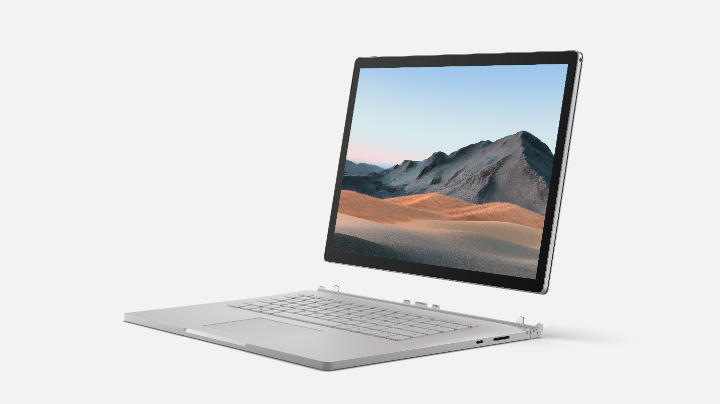

Meet Surface Book 3, the laptop that can handle your biggest demands. From intensive video and graphics files to high-octane gaming, Surface Book 3 combines speed, graphics, and long battery life with the versatility of a laptop, tablet, and portable studio. Available in 13” or 15” sizes, Surface Book 3 features quad-core powered 10th Gen Intel® Core™ processors, blazing NVIDIA® graphics, a smooth, precise trackpad, comfortable keyboard and a beautifully crisp, high-resolution PixelSense™ Display designed for Surface Pen* and touch. Surface Book 3 15” provides 50% more performance than Surface Book 2 and up to 17.5 hours of battery life, making it the most powerful Surface laptop yet. Now featuring up to 32GB of RAM and the fastest SSD we have ever shipped, Surface Book 3 is a portable powerhouse that provides the performance you need to tackle any task, with enough battery life to last all day.

Top Features and Benefits
- Powerhouse Performance. Surface Book 3 is our most powerful laptop ever, providing up to 50% more performance in the 15” model than Surface Book 2 and the longest battery life of any Surface. Get up to 17.5 hours battery life with the Surface Book 3 15”, and get back to work when you’re ready with improved standby that extends battery life when you’re away.​ Breeze through any task with lightning-fast storage and the latest dual or quad-core Intel® Core™ i5 and i7 processors, and experience the fastest graphics on any Surface laptop with a choice of NVIDIA discrete GPU and now comes with up to 32GB of RAM and the fastest SSD we have ever shipped. Enter a new world of immersive sound anywhere with Dolby Atmos®. Speed through intensive, professional desktop software like SOLIDWORKS, Autodesk Revit, Visual Studio, Adobe Premiere Pro, Adobe Photoshop®, Adobe Illustrator, Adobe Creative Cloud®*.

- Unparalleled Versatility. Surface Book 3 is a robust laptop, powerful tablet with detachable touchscreen, and portable studio that adapts to all the ways you work and create best. Whether compiling code for your latest app, sketching in Affinity,* editing video with Adobe Premiere Pro.* or getting immersed in the latest game on Xbox Game Pass, you’re able to set the perfect angle for you. For people who love to game, Surface Book 3 15” has an NVDIA GeForce GPU with enough power to play the top Xbox Game Pass for PC titles at 1080p in a smooth 60 frames per second. Get productive with a robust laptop featuring full keyboard and large, responsive trackpad, while navigating naturally on the touchscreen. Draw, write and sketch with precision using Surface Pen* with Surface Dial* and high-end graphics, at the perfect angle for you. Surface Book 3 can also connect to your devices: hook up to USB-C™ and USB-A ports, as well as your full-size SD card.

- Innovation in Every Detail. Surface Book 3 balances performance with premium, lightweight materials for unprecedented power in a laptop its size. The vibrant, PixelSense™ touchscreen display in 13” and 15” sizes breathes new life into your creations. Be heard loud and clear, whether in Teams video calls or using voice dictation in Microsoft 365 apps* with enhanced dual far-field Studio Mics and immersive Dolby Atmos® sound. Record and edit standout videos using the front-facing camera with 1080p HD and choice of graphics cards. Click and gesture at the speed of thought on Surface Book 3’s high-precision, all-glass trackpad, while typing fast and confidently on the premium backlit keyboard.
- Best of Microsoft. Dive right in with the Windows you know and the Microsoft 365 apps you rely on every day — while enjoying the best PC gaming experience on any Surface laptop. Pair your Xbox Wireless controller and compatible headset*⁴ to enjoy the latest titles with Xbox Game Pass for PC.* Bring your best ideas to life using Surface Pen, touch, dictation in Microsoft 365 and 3D content. Surface Book 3 comes with Windows 10 Home familiar features and trusted security, including Windows Hello password-free sign-in. If you need additional enterprise management and security tools for the workplace, you can purchase Windows 10 Pro or purchase Surface Book 3 for Business.

Technical Specifications

 | Surface Book 3 13.5“ |  | Surface Book 3 15“
Display | Screen: 13.5” PixelSense™ Display  Resolution: 3000 x 2000 (267 PPI)  Aspect ratio: 3:2  Contrast ratio: 1600:1  Touch: 10 point multi-touch G5 |  | Screen: 15” PixelSense™ Display  Resolution: 3240 x 2160, (260 PPI)  10 point multi-touch G5  Aspect ratio: 3:2  Contrast ratio: 1600:1
Available Models | Quad-core 10th gen Intel® Core™ processor  Quad-core 10th gen Intel® Core™ i5-1035G7 processor  Quad-core 10th gen Intel® Core™ processor  Quad-core 10th Gen Intel® Core™ i7-1065G7 Processor |  | Quad-core 10th Gen Intel® Core™ processor  Quad-core 10th Gen Intel® Core™ i7-1065G7 Processor
Graphics | Intel® i5-1035G7 models  Intel® Iris™ Plus Graphics  Intel® i7-1065G7 models  NVIDIA® GeForce® GTX 1650 with Max-Q Design w/4GB GDDR5 graphics memory |  | Intel® i7-1065G7 models  NVIDIA® GeForce® GTX 1660 Ti with Max-Q Design w/6GB GDDR6 graphics memory  NVIDIA® Quadro RTX™ 3000 with Max-Q Design w/6GB GDDR6 graphics memory
Windows OS | Ships with 64-bit Windows 10 Pro and Home
Dimensions | Intel Core™ i5  12.3” x 9.14” x 0.51”-0.90” (312 mm x 232 mm x 13 mm-23 mm)  Intel Core™ i7  12.3” x 9.14” x 0.59”-0.90” (312 mm x 232 mm x 15 mm-23 mm) |  | Intel Core™ i7  13.5” x 9.87” x 0.568-0.90” (343 mm x 251 mm x 15 mm-23 mm)
Weight | Intel Core™ i5  Total – 1534 g (3.38 lbs)  Tablet – 719 g (1.59 lbs)  Intel Core™ i7  Total – 1642 g (3.62 lbs)  Tablet – 719 g (1.59 lbs) |  | Intel Core™ i7  Total – 1905 g (4.20 lbs)  Tablet – 817 g (1.80 lbs)
Memory | 8GB, 16GB, or 32GB 3733Mhz LPDDR4x |  | 16GB or 32GB 3733Mhz LPDDR4x
Storage | Solid-state drive (SSD) options: 256GB, 512GB, or 1TB PCIe SSD |  | Solid-state drive (SSD) options: 256GB, 512GB, 1TB, or 2TB* PCIe SSD  *2TB storage available in the U.S.
Battery¹ | Connected to keyboard base: Up to 15.5 hours of typical device usage |  | Connected to keyboard base: Up to 17.5 hours of typical device usage
Wireless | Wi-Fi 6: 802.11ax compatible  Bluetooth Wireless 5.0 technology  Xbox Wireless built in (15” only)
Ports | 2 x USB-A (version 3.1 Gen 2)  1 x USB-C™ (version 3.1 Gen 2 with USB Power Delivery revision 3.0)  3.5mm headphone jack  2 x Surface Connect ports (one on keyboard base, one on tablet)  Full-size SDXC card reader  Compatible with Surface Dial* on- and off-screen interaction
Security | HW TPM 2.0 chip for enterprise security  Enterprise-grade protection with Windows Hello face sign-in
Sensors | Ambient light sensor  Proximity sensor  Accelerometer  Gyroscope  Magnetometer
Cameras | Windows Hello face authentication camera (front-facing)  5.0MP front-facing camera with 1080p HD video  8.0MP rear-facing autofocus camera with 1080p HD video
Audio | Dual far-field Studio Mics  Front-facing stereo speakers with Dolby Atmos®
Keyboard and  Trackpad | Full-size, backlit keyboard with 1.55mm of full key travel  Glass track pad with anti-fingerprint coating and improved multi-finger gestures
Modes | Laptop Mode, Tablet Mode, View Mode or Studio Mode
In the Box | Intel Core™ i5  65W Surface Power Supply w/USB-A (5W) charging port  Intel Core™ i7  102W Surface Power Supply w/USB-A (7W) charging port  Quick Start Guide  Safety and warranty documents | 127W Surface Power Supply w/USB-A (7W) charging port  Quick Start Guide

Contact Information
For more information, press only:
Microsoft Media Relations, WE Communications, (425) 638-7777, rrt@we-worldwide.com

For more product information and images:
Visit the Surface Newsroom at http://www.microsoft.com/en-us/news/presskits/surface.

For more information about Surface:
Visit Surface at http://www.microsoft.com/surface.

*Sold separately Surface Book 3 15” connected to keyboard base: Up to 17.5 hours of battery life based on typical Surface device usage. Testing conducted by Microsoft in April 2020 using preproduction software and preproduction configurations of Surface Book 3 15” Intel® Core™ i7, 256GB, 16 GB RAM. Testing consisted of full battery discharge with a mixture of active use and modern standby. The active use portion consists of (1) a web browsing test accessing 8 popular websites over multiple open tabs, (2) a productivity test utilizing Microsoft Word, PowerPoint, Excel and Outlook, and (3) a portion of time with the device in use with idle applications. All settings were default except screen brightness was set to 150nits with Auto-Brightness disabled. Wi-Fi was connected to a network. Battery life varies significantly with settings, usage and other factors.
Subscription required.
"Xbox Wireless controller pairing available on 15" model." It is not available on 13.5".
Available for commercial SKU only
US availability for Surface Book 3 15”: 2TB. Outside the US: 1TB. System software and updates use significant storage space. Available storage is subject to change based on system software and updates and apps usage. 1GB = 1 billion bytes. 1TB = 1,000GB. See Surface Storage for more details.

