Surface Earbuds
Fact Sheet
May 2020
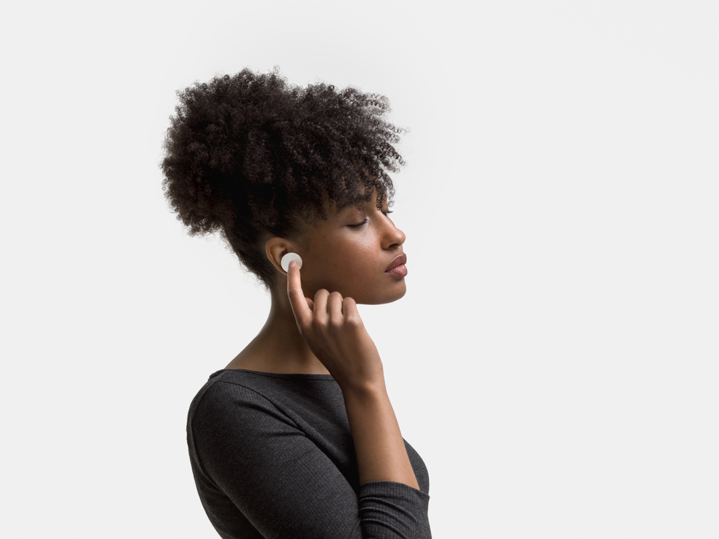

Introducing Surface Earbuds, the premium true wireless earbuds from Microsoft. Featuring an ultra-comfortable and secure design with intuitive touch controls for music, calls and more, all without a screen. Experience rich, immersive Omnisonic sound and instantly play Spotify from your Android phone4 with a simple gesture on either earbud. Enjoy all-day battery life with the included wireless charging case and access to innovative Microsoft 365* experiences that help you stay productive throughout the day. The intuitive touch controls make it effortless to control your music, calls, and more, all without a screen. Swipe, touch, and tap to adjust volume, take calls, get assistance, manage your calendar, reply to emails on iOS with the Outlook Mobile app, capture to-do's and control presentations in Windows 10 with PowerPoint. With Surface Earbuds you can leave your phone in your pocket and stay in your flow throughout the day on any of your devices.

Top Features and Benefits
- Designed for comfort and control. Surface Earbuds features an innovative design with four anchor points, so each earbud sits securely in your ear. Find your perfect size with three sets of interchangeable silicone ear tips for an ultra-comfortable and stable fit you can wear all-day. Surface Earbuds’ responsive touch surface enables intuitive gestures like tap, touch, and swipe. Swipe up or down to change volume. Swipe back or forward to change tracks. Double tap to pause music and take calls.
- Stay on top of your day and get things done. Talk rather than type with dictation in Microsoft 365* apps. Elevate your PowerPoint* skills with live captions, and subtitles on screen, including translation into one of 60+ languages (Windows 10 required). Plus, swipe to advance slides. Listen to, delete and reply to emails on the go — all with touch and voice using Play My Emails in the Outlook mobile app for iOS (in the U.S.)* Or touch and hold to activate your personal digital assistant.
- Premium sound for music and calls. Surface Earbuds feature the Surface Omnisonic sound profile with custom-designed drivers and precision tuning inspired by listening to the world’s best live music venues and most advanced audio equipment, delivering an audio experience that’s rich, immersive and crystal clear. Instantly play Spotify1 from your Android phone with a triple tap on either earbud. Be heard loud and clear with two advanced microphones in each earbud that block out background noise while amplifying your voice.
- Pairs perfectly. Surface Earbuds connects seamlessly to your Surface PC via Swift Pair. At first use, or when in pairing mode, simply position the charging case near your Surface PC or phone and click to connect. Surface Earbuds completes your Surface experience — it’s the perfect audio accessory to fuel productivity and help you stay in the flow.
- All-day battery. With up to 24 hours of battery life2 — eight hours per single charge, with additional charges in the case — you’re free to listen and get productive anywhere, any time.

Technical Specifications
Dimensions | Each earbud: 0.98” (25 mm) x 0.78” (19.9 mm)  Charging case: 2.96” (75 mm) x 1.31” (33.2 mm) x 0.98” (25 mm)
Weight | Each earbud: 7.2 g with ear tip  Charging case: 40 g without earbuds
Exterior | Color: Glacier
Frequency response | 20 –20 kHz
Microphone | Two microphones per earbud
Speaker | 13.6mm driver
Battery life | Up to 24 hours battery with included charging case⁴  (up to eight hours of continuous listening with additional charges in the case)  A 10-minute charge provides up to one hour of battery life.
Cord | USB-A to USB-C™ cord (1 meter)
Audio codecs | SBC and aptX
Waterproof rating | IPX4
Compatibility | Windows 10 or later, Android 4.4 or later, iOS 9 or later, Bluetooth 4.1/4.2
Controls | Touch, tap, swipe, voice
In the box | Two Surface Earbuds  Charging case  Three pairs of silicone ear tips  USB-C™ to USB-A cable  Quick Start Guide  Safety and warranty documents
Warranty | One-year limited hardware warranty

Contact Information
For more information, press only:
Rapid Response Team, WE Communications, (425) 638-7777, rrt@we-worldwide.com

For more product information and images:
Visit the Surface Newsroom at https://news.microsoft.com/presskits/surface/.

For more information about Surface:
Visit Surface at http://www.microsoft.com/surface.

Spotify account required
Up to 24 hours of battery life with the included charging case: 8 hours continuous listening time on a single charge, plus another two 8-hour charges with the charging case. Battery life may vary by usage.
Requires subscription to Microsoft 365 and app download (requires Microsoft account and internet connection, must accept Terms of Use microsoft.com/useterms).
Requires Android Nougat
Pairing functionality requires a Surface or other PC running Windows 10 with the latest updates. * Sold separately

