Surface Go 2
Fact Sheet
May 2020

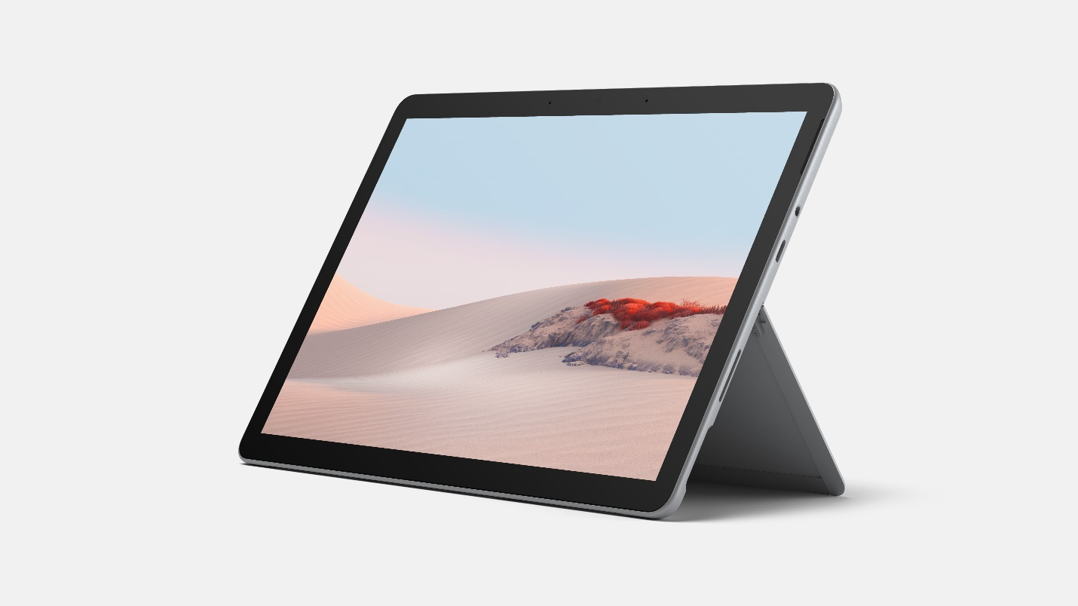

We created Surface Go to bring a more affordable and portable 2:1 to the Surface line. Businesses, schools, students and families have chosen Surface Go for its compact design, the versatility of a touchscreen, keyboard, Pen and the added connectivity of LTE Advanced. The newest Surface Go 2 was designed with those same people in in mind. Surface Go 2 keeps the same thin, lightweight design, but now offers a larger 10.5” edge-to-edge PixelSense display, improved battery life, dual Studio Mics, a 5MP front-facing camera and faster performance than the original with new Intel 8th generation processors. Surface Go 2 is perfect companion for your everyday tasks, homework, and play — delivering tablet portability with laptop versatility, all-day battery life, and Windows security for the whole family

Top Features and Benefits
- Most Versatile. Surface Go 2 gives you tablet portability and a full laptop experience with built-in Kickstand and Signature Type Cover in one compact design. Starting at just 1.2 pounds (not including Type Cover*), Surface Go 2 is our lightest and most affordable Surface yet, helping you stay connected wherever you are. Connect the Surface Go 2 Signature Type Cover* for a great typing experience when and where you need it — now in a choice of new colors for fast and accurate typing with an integrated glass trackpad for precise navigation. With Surface Go 2, you have your go-to Microsoft 365 apps at your fingertips: Glance and edit in Word and PowerPoint or take notes in OneNote from anywhere. Plug in the accessories you use today with the included USB-C™ port, Surface Connect port and headphone jack.

- High Performance. Surface Go 2 offers an option with up to 64% faster performance than the original with a new Intel 8th Generation Core M processor. With improved battery life of up to 10 hours, you can stay connected while you’re on the go. With Microsoft 3651, Surface Signature Type Cover1 and Surface Pen,1 you have a full laptop for notes, sketches, papers, and e-mail. Paired with Surface Pen, Surface Go 2 allows distance learners and remote workers to stay digital, while unlocking the power of natural ink for things like drawing diagrams, marking up documents or working through math equations. Surface Pen delivers a fast, accurate inking experience and makes on-screen note taking and sketching feel natural with virtually no lag or latency. If you need more space for photos, videos, and music, you can add up to 1TB of storage to the built-in MicroSD Card Reader. ​

- Innovative Design. Surface Go 2’s high-resolution, bigger 10.5” PixelSense™ Display and improved 220ppi resolution offers a stunning touchscreen experience. Featuring new Dolby® Audio™ offer premium sound with clear, powerful volume. Enhanced dual far-field Studio Mics increase voice clarity and reduce background noise, you’ll heard loud and clear while Teams calls or video chats. Plus, full HD 5MP front- and rear-facing cameras let you make crisp, clear calls to friends and family or take and share great photos. We’ve also added a new Camera app for the rear-facing camera to make it easy to scan documents, and whiteboards – whether you’re sharing notes from a meeting or turning in homework. Surface Go 2 comes equipped with built-in WiFi, plus optional LTE Advanced, providing hassle-free, secured connectivity wherever you go.
- Best of Microsoft. Sharing Surface Go 2 with the rest of your family is seamless, safe, and secure, with multiple-user logins via Windows Hello, parent-managed screen time limits, spending control and content filtering. With OneDrive cloud storage you have one place for your favorite pictures, videos and files. And OneDrive works across all your devices, so you’ll have recipes, photos ready to view and share from Surface Go 2 or the OneDrive mobile app anytime. ​Keep your private and confidential files secured with OneDrive Personal Vault, an extra layer of protection for documents, photos, and videos for you and your family. ​Surface Go 2 offers peace of mind with the Windows you know — comes with Windows 10 Home in S mode, including Microsoft-verified security, Windows Defender, parental controls, and world-class support.​

Technical Specifications
Operating System | Consumer Channels: Windows 10 Home in S mode6  Commercial Channels: Windows 10 Pro
Exterior | Dimensions: 9.65 inches x 6.9 inches x 0.33 inches (245mm x 175mm x 8.3mm)  Mechanical features: Magnesium body, kickstand with full-friction multi-position hinge to 165 degrees, magnetic attach for keyboard fold stability  Color: Silver  Physical buttons: volume, power  Wi-Fi: Starting at 1.2 lbs (544 g), not including Type Cover*  LTE Advanced3: Starting at 1.22 lbs (553 g), not including Type Cover*
Display | Screen: 10.5-inch PixelSense Display  Resolution: 1920 x 1280 (220 PPI)  Aspect Ratio: 3:2  Contrast Ratio 1500:1  Touch: 10-point multi-touch  Corning®Gorilla® Glass 3
Processor | Intel® Pentium® Gold Processor 4425Y  8th Gen Intel® Core m3 Processor
Graphics | Intel® UHD Graphics 615
Memory | 4GB/8GB RAM
Storage | 64GB eMMC  128GB Solid State Drive (SSD)
Security | Enterprise-grade protection with Windows Hello face sign-in  Firmware TPM 2.0
Network | Wi-Fi: IEEE 802.11 a/b/g/n/ac/ax compatible, Bluetooth Wireless 5.0 technology  LTE Advanced Qualcomm® Snapdragon™ X16 LTE Modem
Battery | WiFi: Up to 10 hours of typical device usage  LTE Advanced:3 Up to 10 hours of typical device usage
Cameras, Video and Audio | Windows Hello face sign-in camera (front-facing)  5.0MP front-facing camera with 1080p HD Skype HD video  8.0MP rear-facing autofocus camera with 1080p HD video  Dual Studio Mics  2W stereo speakers with Dolby® Audio™ Premium
Ports | 1 x USB-C  1 x Surface Connect  Surface Type Cover Port  MicroSDXC card reader  3.5mm headphone jack
Sensors | Ambient light sensor  Accelerometer  Gyroscope  Magnetometer
Power supply | 24 W power supply
In the box | Surface Go 2  Power supply  Quick Start Guide  Safety and warranty documents
Warranty | One-year limited hardware warranty

Contact Information
For more information, press only:
Rapid Response Team, WE Communications, (503) 443-7070, rrt@we-worldwide.com

For more product information and images:
Visit the Surface Newsroom at https://news.microsoft.com/presskits/surface/.

For more information about Surface:
Visit Surface at http://www.microsoft.com/surface.

Sold separately.
Available colors may vary by market.
Subscription required (sold separately).
Up to 10 hours of battery life based on typical Surface device usage. Testing conducted by Microsoft in February 2020 using preproduction software and preproduction configurations of Surface Go 2. Testing consisted of full battery discharge with a mixture of active use and modern standby. The active use portion consists of (1) a web browsing test accessing 8 popular websites over multiple open tabs, (2) a productivity test utilizing Microsoft Word, PowerPoint, Excel and Outlook, and (3) a portion of time with the device in use with idle applications. All settings were default except screen brightness was set to 150nits with Auto-Brightness disabled. Wi-Fi was connected to a network. Battery life varies significantly with settings, usage and other factors.
Service availability and performance subject to service provider’s network. Contact your service provider for details, compatibility, pricing, SIM card, and activation. See all specs and frequencies at Surface.com.
Windows 10 Home in S mode works exclusively with apps from the Microsoft Store within Windows and accessories that are compatible with Windows 10 Home in S mode. A one-way switch out of S mode is available. Learn more at Windows.com/SmodeFAQ.
System software and updates use significant storage space. Available storage is subject to change based on system software updates and apps usage. 1 GB = 1 billion bytes. 1 TB = 1,000 GB. See Surface.com/Storage for more details.

