Surface Headphones 2
Fact Sheet
May 2020

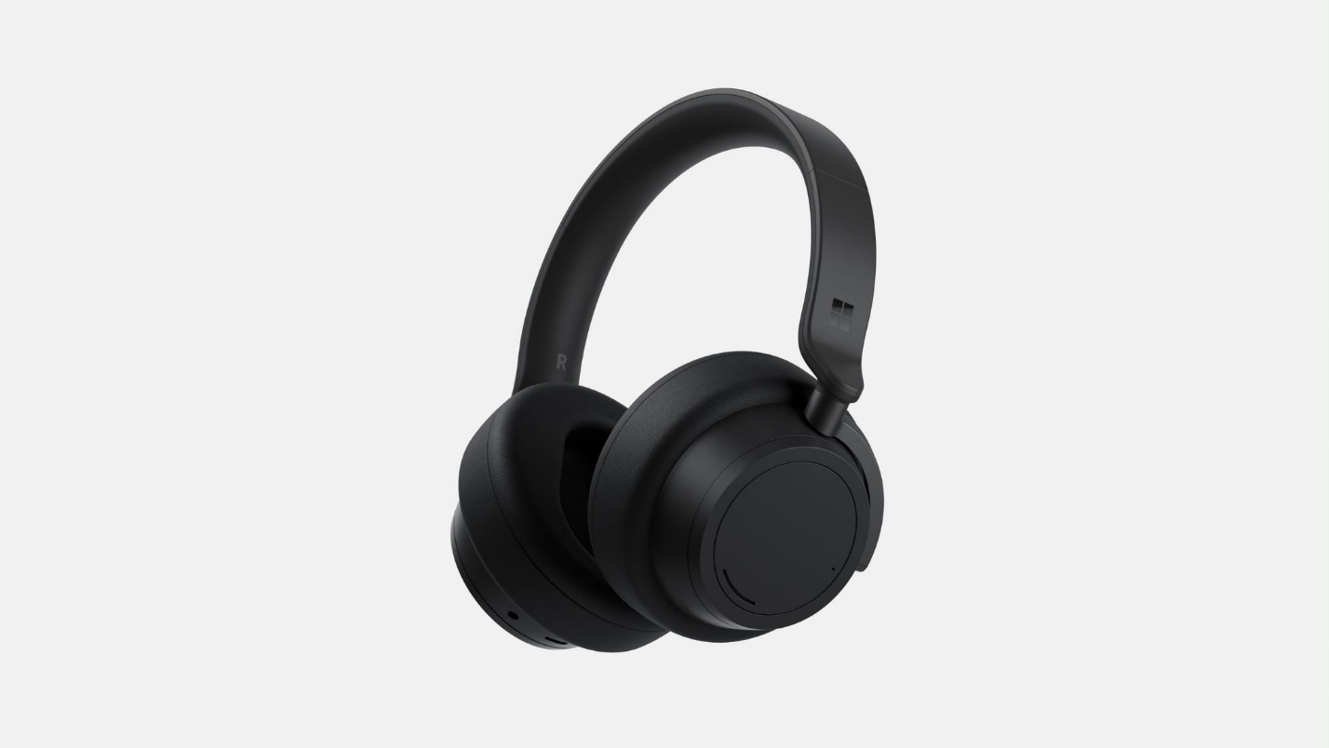

Introducing Surface Headphones 2, Microsoft’s premium headphones that offer a smarter way to listen and are now available in two colors — Light Gray and new Matte Black. Whether you’re on the go, at the office or relaxing at home, listen in comfort and style all day with Surface Headphones 2. Your music and phone calls sound spectacular with enhanced Omnisonic sound. Tune out distractions with adjustable noise cancellation. Listen to almost an hour of music with just a 5-minute charge — and listen all day with up to 20 hours of battery life. Plus, use touch to control your music, calls, get assistance, and more.

Top Features and Benefits
- Turn it up, tune it out. Experience your music, shows, and calls like never before with rich, immersive Omnisonic sound and 13 levels of adjustable noise cancellation. Use the on-ear dials to easily turn up the volume or tune out background noise. Advanced microphones ensure you are heard loud and clear on calls. Enjoy music, podcasts, exceptional call quality, or peace and quiet all day.
- Designed for comfort and control. Listen in comfort and style all day with soft, lightweight ear pads. Use touch to skip tracks, answer and end calls, and get hands-free assistance. Tap on-ear sensors or tell Surface Headphones to do it for you. What’s more, your music pauses when you slip off Surface Headphones 2 and resumes when you put them back on, so you’ll never miss a beat.
- Get ahead with your headphones. Talk rather than type with dictation in Word, Outlook, and PowerPoint*. Elevate your PowerPoint* skills with live captions, and subtitles on screen, including translation into one of 60+ languages (Windows 10 required). With Play My Emails in the Outlook mobile app for iOS, catch up on the go with what’s new in your inbox your personal productivity assistant to read out and act on emails and changes to your day — all with touch and voice (in the U.S.).*iiiiv
- A battery that lasts as long as you do. Power through your day with up to 20 hoursii of battery life. You can also listen to almost an hour of music with just a 5-minute charge.
- Hassle-free pairing. Connect Surface Headphones 2 to your Windows 10 PC right out of the box when you enable Swift Pair.

Technical Specifications
Exterior | Dimensions: 8.03” (204 mm) x 7.68” (195 mm) x 1.89” (48 mm)  Mechanical features:  Colors: Light Gray, Matte Blacki  Buttons: Power button, Mute button, Volume dial (right ear), Noise Cancellation dial (left ear)  Weight: 0.64 lbs (290.3 g)
Frequency Response | 20–20kHz
Noise Cancellation | Up to 30 dB for active noise cancellation  Up to 40 dB for passive noise cancellation
Speaker | 40mm Free Edge speaker
Sound Pressure Level Output | Up to 115 dB (1kHz, 1Vrms via cable connector with power on)  Up to 115 dB (1kHz, 0dBFS over Bluetooth connection)
Charging | Full charge in less than 2 hours
Battery | Up to 20 hours (with music playback over Bluetooth®, ANC on)ii
USB Cord Length | 1.5 m
Audio Cable Length | 1.2 m
Inputs | USB-C connector  3.5mm audio connector
Compatibility | Windows 10, iOS, Android, MacOS
Buttons/Controls | Power button, Mute button, Volume dial (right ear), Noise Cancellation dial (left ear), Touch interface on both ear cups
In the box | Surface Headphones 2  Carrying case  USB cable  Audio cable  Quick start guide  Safety and warranty documents
Warranty | One-year limited hardware warranty

Contact Information
For more information, press only:
Rapid Response Team, WE Communications, (425) 638-7777, rrt@we-worldwide.com

For more product information and images:
Visit the Surface Newsroom at https://news.microsoft.com/presskits/surface.

For more information about Surface:
Visit Surface at http://www.microsoft.com/surface.

Available colors may vary by market
Up to 20 hours of battery life when connected via Bluetooth® with active noise cancellation on. Battery life varies with usage and settings.
Subscription required
Pairing functionality requires Windows 10 with the latest updates. * Sold separately

