Surface Duo
Fact Sheet
August 2020
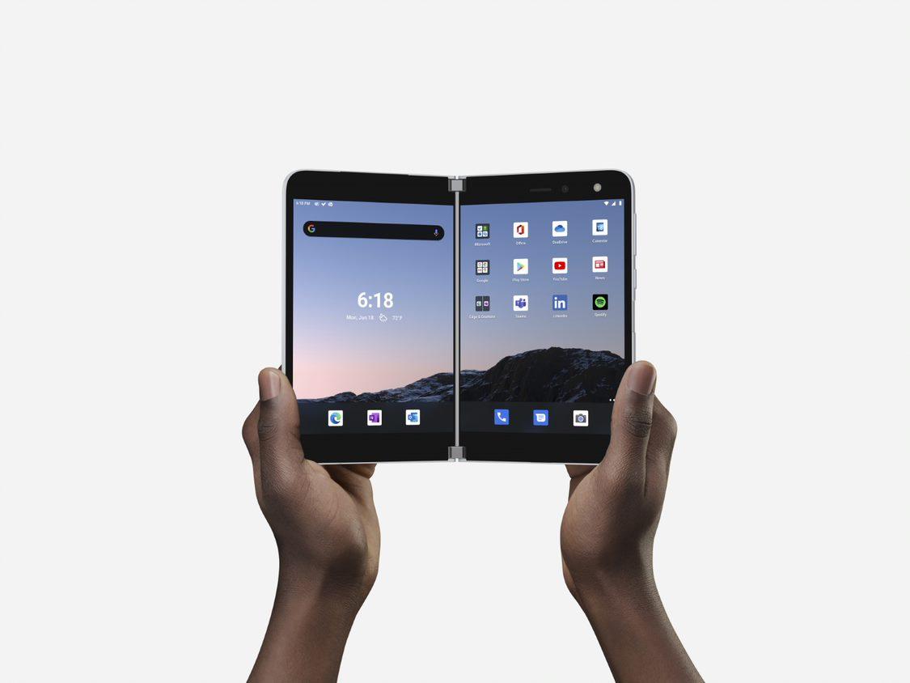

Surface Duo represents the next wave of mobile productivity, inspiring people to rethink what is possible with the device in their pocket. Surface Duo delivers the easiest way to multitask on the go, bringing together the power of Microsoft 365 experiences and the full ecosystem of Android mobile apps. Starting at $1399, Surface Duo opens into the thinnest mobile device on the market with an 8.1” PixelSense Fusion display connected by a revolutionary 360-degree hinge, allowing you to use each 5.6” display individually or together, across a variety of modes. Do more wherever you are with Surface Duo.

Top Features and Benefits
- Mobile productivity, powered by two screens. Open two screens and discover a better way to get things done. Run any two apps side by side, drag and drop between screens in supported apps, open an email attachment on the second screen without leaving Outlook, maximize one app across both screens, and say goodbye to constant app switching.
- Flexibility to do More. Surface Duo offers the flexibility to interact with your apps in more ways than ever. From Book to Compose to Tent mode, Surface Duo adapts to you - it’s a new way to be productive on the go.
The Best of Microsoft, together with Android apps. Enjoy the best of Microsoft 365 mobile experiences optimized for Surface Duo, along with every Android app in the Google Play store and seamlessly connect to your Windows 10 PC.
- Original design, created by Surface. At 4.8 mm when opened, Surface Duo is the thinnest Surface we’ve ever created. Featuring two high-resolution 5.6” PixelSense™ displays that open to an expansive 8.1” and a revolutionary 360◦ hinge – it’s Surface innovation in your pocket.
Technical Specifications
Dimensions | Open:  145.2mm (H) x 186.9mm (W) x 4.8mm (T)  Closed:  145.2mm (H) x 93.3mm (W) x 9.9mm (T at hinge) | Weight | 250 grams
Display | Dual PixelSense Fusion Displays opened: 8.1” AMOLED, 2700x1800 (3:2), 401 PPI  Single PixelSense Displays: 5.6” AMOLED, 1800x1350 (4:3), 401 PPI  Wide color gamut: 100% SRGB and 100% DCI-P3  Display Material: Corning® Gorilla® Glass | Battery life | All Day Battery Life  Up to 15.5 hours of Local Video Playback  Up to 10 days of Standby Time  Up to 27 hours of Talk Timevi
Battery Capacityiv | 3577mAh (typical) dual battery | Battery Charging | Fast Charging using 18W in-box power supply
Camera & Video Recording | Adaptive camera 11MP, f/2.0, 1.0 µm, PDAF and 84.0° diagonal FOV optimized with AI for front and rear.  Photos:  - Auto mode with low-light & HDR multi-frame photo capture and dynamic range scene detection  - Super resolution zoom, and super zoom up to 7x  - Portrait mode with adjustable depth control  - Panorama mode  - Burst mode  Video Recording:  - 4K and 1080p recording at 30 fps and 60 fps with Electronic Image Stabilization  - HEVC and H.264 video recording formats  - Video HDR mode  - Slow motion video support for 1080p at 120fps and 240fps | Video Conferencing | Microsoft Teams and Skype video conferencing up to 1080p at 30fps  High CRI LED Flash for both front and world facing photo and video scenarios
Network & Connectivity | WiFi: WiFi-5 802.11ac (2.4/5GHz)  Bluetooth: Bluetooth® 5.0  LTE:  4x4 MIMO, Cat.18 DL / Cat 5 UL, 5CA, LAA  Up to 1.2Gbps Download / Up to 150Mbps Upload  Bands Supported:  FDD-LTE: 1,2,3,4,5,7,8,12,13,14,19 20,25,26,28, 29,30,66  TD-LTE: 38,39,40,41,46,  WCDMA: 1,2,5,8  GSM/GPRS: GSM-850, E-GSM-900, DCS-1800, PCS-1900  Location: GPS, Galileo, GLONASS, BeiDou, QZSS | Countries & Carrier Compatibility | Countries: U.S.A.  Unlocked device (Gen SKU): AT&T, T-Mobile*, Verizon Wireless*  Locked device (AT&T SKU): AT&T  *T-Mobile customers coming from Sprint’s network require a T-Mobile SIM card.
Processor | Qualcomm® Snapdragon™ 855 Mobile Platform optimized for dual-screen experience | SIM | one eSIM and one Nano SIM  AT&T SKU will not support eSIM
Storage & Memory | 128GB or 256GB UFS 3.0 of internal storage  6 GB DRAM | Connections | USB-C 3.1
Software | Microsoft built-in applications:  - Microsoft Office: Word, Excel, PowerPoint, Office Lens, PDF reader and More  - Microsoft Outlook  - Microsoft Teams  - Microsoft OneDrive  - Microsoft Edge  - Microsoft OneNote  - Microsoft To Do  - Microsoft News  - Microsoft Authenticator  - Microsoft Bing Search  - Intune Company Portal  - LinkedIn  - Microsoft Solitaire Collection  - Surface Audio  Microsoft Surface Duo UI core features  - Dual screen windowing  - Adaptive modes  - App Groups  - Microsoft 365 Feed  - Dynamic dock  - Universal Search  - Adaptive Camera  - Microsoft SwiftKey Adaptive Keyboard  - Your Phone Companion - Link to Windows  Other preinstalled apps:  - Google Search  - Google Assistant  - Google Calendar  - Google Drive  - Google Duo  - Google Photos  - Google Play Movies & TV  - Google Play Store  - Google Maps  - Chrome  - Gmail  - YouTube  - YouTube Music  - Contacts  - Messages  - Phone  - Files  - Clock  - Calculator  - Sound recorder  Operating System: Android™ 10 | Audio | Mono speaker, Dual mic with noise suppression and echo cancellation optimized for productive use in all postures.  Audio formats supported: 3GP, MP3, MP4, MKV, WAV, OGG, M4A, AAC, TS, AMR, FLAC, MID, MIDI, RTTL, RTX, OTA, IMY  Qualcomm® aptX™ Adaptive
Video Playback | Video Playback Formats: MKV, MOV, MP4, H.265(HEVC), AVI, WMV, TS, 3GP, FLV, WEBM  Wireless: Chromecast support  Wired: DisplayPort over USB-C. Supports video out when connecting via HDMI Adapter | Sensors | Dual Accelerometer, Dual Gyroscope, Dual Magnetometer, Dual Ambient Light Sensor, Proximity Sensor, Hall Sensor, Fingerprint Sensor
Security & Authentication | Biometric lock type: Fingerprint reader  Lock type: Swipe, PIN, password  Security applications pre-loaded on device:  Microsoft Authenticator | Exterior | Exterior Material: Corning® Gorilla® Glass  Color: Glacier
Accessibility | Android Accessibility Suite, including screen readers, display adjustments, interaction controls, audio & on-screen text | Language support | All supported languages (Android™ 10)
What’s in the box | Surface Duo  Surface Duo Bumper (Color: Glacier)  Surface Duo USB-C® Power Supply (18w)  Quick Start Guide  Warranty and Compliance Guide  SIM Ejector tool | Pen & Inking | Supports all in-market generations of Surface Slim Pen, Surface Pen and Surface Hub 2 Pen
Warranty | 1-year limited hardware warranty | The Microsoft Store Promise for Surface | 60-day return policy  90 days of free technical phone support  Free virtual workshops and training
Your device contains magnets, which may damage objects such as credit cards, passbooks, access cards, boarding passes, or parking passes. Please keep a safe distance between your device and objects that Your device contains magnets, which may damage objects such as credit cards, passbooks, access cards, boarding passes, or parking passes. Please keep a safe distance between your device and objects that are affected by magnets. Please review [on-device safety app] and https://support.microsoft.com/en-us/help/4558037/product-safety-warnings-and-instructions for important safety information about your device.
Contact Information
For more information, press only:
Microsoft Media Relations, WE Communications, (425) 638-7777, rrt@we-worldwide.com

For more product information and images:
Visit the Surface Newsroom at http://www.microsoft.com/en-us/news/presskits/surface.

For more information about Surface:
Visit Surface at http://www.microsoft.com/surface.

Additional fees and/or subscriptions required for some apps and features. Available apps may vary by carrier and over time. Calling requires data plan; see carrier for pricing and coverage details.
Requires download of the Your Phone app from the Microsoft Store on a Windows 10 PC with the latest Windows updates and use of the phone screen feature.
Excluding Surface Duo Bumper
Testing conducted by Microsoft in August 2020 using preproduction Surface Duo units and software over Wi-Fi with LTE associated to a network. Testing consisted of full battery discharge during active use scenarios and a power drain measurement in Suspend. The active use scenarios excluded cell calls and included both single screen and dual screen scenarios, consisting of (1) a web browsing test accessing 8 popular websites over multiple open tabs, (2) productivity tests utilizing Microsoft Teams audio and video calls and Microsoft Word, PowerPoint, Excel and Outlook, (3) sending and receiving SMS text messages, and (4) streaming a video through the YouTube app. All settings were default except Adaptive Brightness was disabled, and screen was set to 150 nits. Battery life varies significantly with network and feature configuration, signal strength, settings, usage and other factors. Battery has limited recharge cycles and cannot be replaced.
Testing conducted by Microsoft in July 2020 using preproduction Surface Duo units and software. Testing consisted of full battery discharge during local video playback on a single screen. Video playback consisted of a repeated 30-minute .mp4 file in 1080p at 24 fps. All settings were default except: LTE and Wi-Fi were both associated with a network with ‘ask to join’ disabled and Adaptive Brightness was disabled, screen was set to 100 nits. Battery life varies significantly with network and feature configuration, signal strength, settings, usage, and other factors. Battery has limited recharge cycles and cannot be replaced.
Testing conducted by Microsoft in July 2020 in an AT&T Validated Lab using preproduction Surface Duo units and software. Testing conducted in accordance with AT&T requirements and test specifications. All settings were default, and network settings were: connected to LTE, and Wi-Fi was enabled but not connected. Battery life varies significantly with network and feature configuration, signal strength, settings, usage and other factors. Battery has limited recharge cycles and cannot be replaced.
Specified minimum dual battery capacity is 3462mAh
Network availability and coverage vary by carrier. See your carrier for details.
Use of eSIM requires a wireless service plan (which may include restrictions on switching service providers and roaming, even after contract expiration). Not all carriers support eSIM. AT&T locked devices will not support eSIM. Use of eSIM in Surface Duo may be disabled when purchased from some carriers. See your carrier for details.
System software uses storage space. Available storage is subject to change based on system software updates and apps usage. 1 GB = 1 billion bytes. See Surface.com/Storage for more details.
Some apps and features may require a wireless plan, additional subscriptions, or fees.
Video playback formats may require 3rd party apps from the Google Play Store; fees may apply
Sold separately

