Safer Internet Day
Discussion Guide
Age range of participants: 7 – 11 years old  Timing: 60 minutes  Preparation:  - Download and print Microsoft’s Safer Internet Day chatterbox (enough for one per student)  - Watch the Microsoft Safer Internet Day chatterbox explainer video | Resources:  - Scissors (enough for half-the-classroom)  - Large sheets of paper for recording ideas and questions  - Post-it-notes
Activity | Timing
Pair up the students  Discussion about internet safety  Making the chatterbox  Playing the chatterbox  Recap of 8 internet safety tips  Play with their parents & peers | 5 minutes  10 minutes  15 minutes  15 minutes  5 minutes  Homework
Introduction:
The online world is an incredible place. We can stay connected with family and loved ones, work remotely, and shop or play games from the comfort of our home. No matter where in the world we are or what device we use.

With research showing that youth are most vulnerable to online dangers, this guide is designed to use our paper chatterbox game to help students (individually or in groups such as a classroom) identify and avoid unsafe situations online.

Success criteria:
- To increase knowledge of Internet safety
- To help recognize dangers on the Internet
- To build critical-thinking and decision-making skills relating to internet usage
- To help protect from inappropriate behavior online

For more information, please visit:
https://aka.ms/SID2019
Pairing up:  Ask participants to get into pairs. They should be encouraged to partner with another person they normally do not speak to or sit next to.  Discussion about internet safety:  Ask each pair to think of some things they do online such as:  - Talk with friends  - Share photos  - Shop for gifts  - Play online games  - Visit websites  Record examples in your preferred method e.g. on a whiteboard, large sheets of paper or ask learners to write on a post-it notes and stick in a designated area of the room.  Questions:  - Why do people do these kinds of things online?  - How do these kinds of things make us feel?  - What would happen if we stopped doing things online?  Explain that sometimes, like the real world, the online world can be unsafe. Ask participants to think about some of the dangerous things that could happen online, and record these examples in your preferred method as above. | Making the chatterbox:  Participants shown explainer video on how to make a chatterbox, and then tasked to work in pairs to follow the instructions and create their own.  Alternatively, discussion leaders are encouraged to walk students step-by-step on how to make their chatterbox:  - Cut out the purple solid line square.  - Fold the square in half lengthways across the two middle dotted purple lines.  - Open square back out. Turnover and fold the four corners into the middle – so the animals and numbers face up.  - Turn the square back over and fold the four new corners into the middle – so the numbers face up.  - Cut the paper holding the numbers together – so each number has its own flap.  - Fold in half so the numbers face in and the animals face out.  - Put your thumb and index fingers in the pockets under the four animals and open the chatterbox!  Playing the chatterbox:  Participants are shown explainer video on how to play the chatterbox, and then tasked to play in pairs and read the tips.  To start discussion leaders are encouraged to first walk participants step-by-step on how to play the chatterbox:  - Ask a friend to pick an animal.  - Spell out the animal as you move the chatterbox back and forth (i.e. DOG, three letters, move three times).  - Have them pick a number from the inside.  - Move the chatterbox that many times.  - Have them pick a new number.  - Open the flap of the number picked, and find your tip!
Safer Internet Day
Discussion Guide
For more information, please visit:
https://aka.ms/SID2019
If someone has your house-key, they can access your home and steal everything in it. The same rule applies to passwords and online accounts. The problem with passwords is that people tend to choose ones that are easy to remember such as their name or birthday.  The easier it is for you to remember, the easier it is for cybercriminals to guess. If you use the same password for multiple accounts, then cybercriminals can – and will – access all your sensitive personal information. The key to any strong password is length and complexity; trying for at least 10 characters, mixing numbers, letters, capitalizations and special characters. | 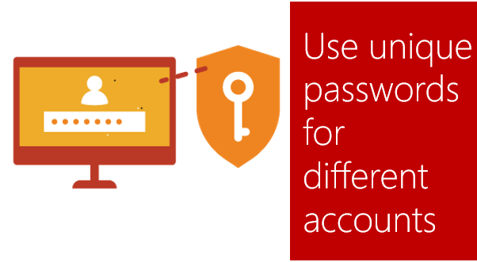
Not everyone you meet online are who they claim to be. In fact, they may not even be real. It’s common for cybercriminals to create fake social media profiles to foster relationships with unwary users and pick their cyber pockets – or much worse. The same rules apply online as they do in the real world. Don’t talk to strangers and be careful of what information you share. | 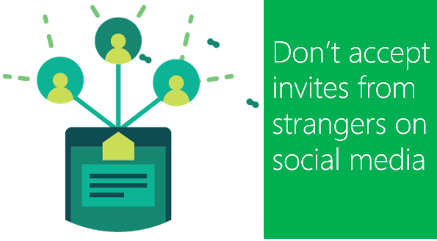
Generally, much like sidewalks or town squares, the internet is a public space. Anything published, irrespective of whether it’s directed to someone specifically, has the potential to be seen and consequently shared elsewhere without your knowledge.  If you do not want the likes of potential employers, customers or acquaintances to know certain things about you then avoid putting it online. Even things like your personal relationship status or home address, which might seem harmless, can be misused. | 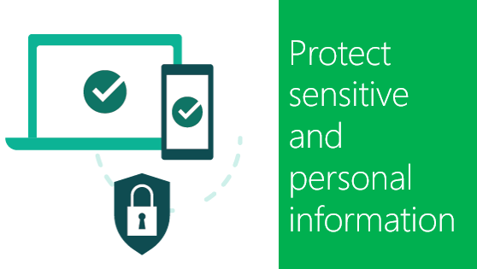
Safer Internet Day
Discussion Guide
Recap of eight internet safety tips:
Having played the chatterbox, students are then asked what each tip-means. Record examples in your preferred method and then read the below information before moving to the next tip:
For more information, please visit:
https://aka.ms/SID2019
There is no permanent delete key for the internet. Any image, comment or content you post online may remain visible, for all to see, forever. Even if you remove the original post, there is no guarantee that others have not made copies or shared across different networks. | 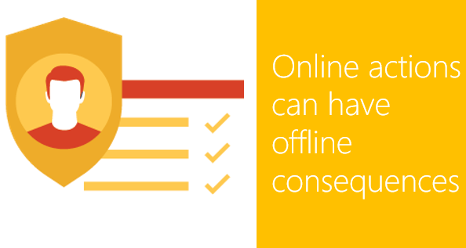
A tried-and-tested tactic by cybercriminals is to trick you into downloading malware to steal information. Do not download apps that look suspicious or come from a site you do not trust.  Does the sender have a bizarre email address? Is the greeting impersonal? Are there a lot of spelling mistakes? Is there a strange sense of urgency? Ask yourself these types of questions before clicking a suspicious link. | 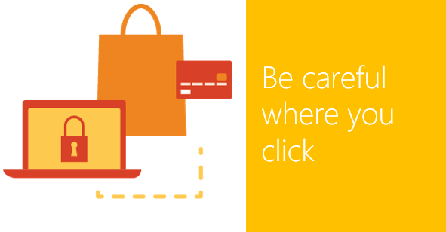
If you do not update your defences, cybercriminals will eventually come up with a way to overcome them. Be sure to stay current with your operating system's updates and make an effort to check your privacy settings on the applications browsers you use. | 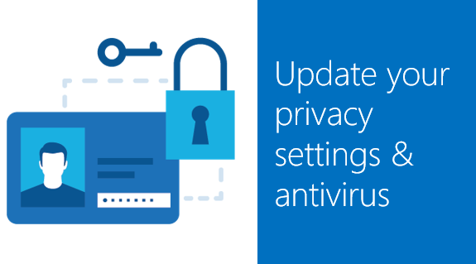
When using a public internet connection, such as Wi-Fi in a shopping center, you have no direct control over its security.  If you are unable to establish a secure connection or ensure your device is protected, then be patient and wait for a better time before sharing sensitive information. | 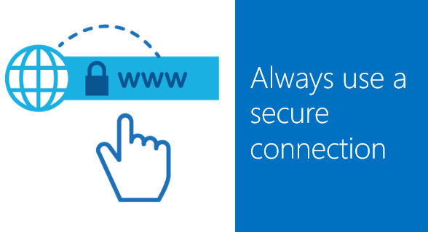
Whenever you find yourself in a situation where you are unsure or suspicious, always defer to the expertise of those you trust – whether a friend, parent, teacher or even a technology partner. Never feel rushed to click on a link or publish a post. There is nothing more urgent than our online safety. | 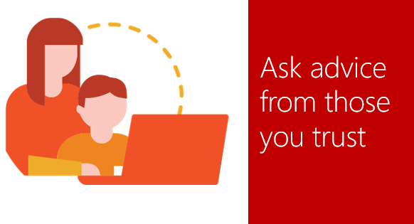
Safer Internet Day
Discussion Guide
For more information, please visit:
https://aka.ms/SID2019
Homework:
Students should take the game home, and challenge their parents/siblings/peers to test their knowledge by trying it out!

- For more information and resources visit: https://aka.ms/SID2019

Notes:

For more information, please visit:
https://aka.ms/SID2019
Safer Internet Day
Discussion Guide

