Build your own artificial intelligence powered mobile phone application to improve recycling and reduce pollution.
{no coding required }

Planet Earth has a plastic problem. And an aluminum problem. And also a paper problem. A lot of problems for one small blue planet.
We’re consuming stuff at a rate never before encountered in human history and once we’re done consuming we throw away the packaging – plastic bottles, paper/cardboard food containers, plastic bags, aluminum soda cans, glass containers, packaging boxes for various consumer goods such as TVs, PCs, smartphones and many, many others. We’re buying, we’re using and then we’re throwing away. The problem is that very soon we will run out of places to throw stuff away. We already have a huge challenge in keeping the oceans clean of plastics and other types of pollution and landfills are getting fuller by the day. At this rate we will be swimming and walking in our dumpsters in a few short years.
So how can we avoid suffocating the environment with our trash? Consuming less and more wisely is definitely a solution but with Earths’ growing population this simply won’t be enough, so we also need to seriously start sorting and recycling the stuff we’re throwing away. Which sometimes is easier said than done.
Luckily, we have technology on our side and with the right skills we can use the technology we already own to make a positive dent in our recycling efforts. The challenge we have for you today is how to use your mobile phone, backed up with artificial intelligence from Microsoft, to better sort and recycle your everyday trash.
For this to work we need to develop a mobile phone application that will take pictures of different types of trash – plastic bottles, paper bags and aluminum soda cans, analyze those pictures and provide recycling advice. The technologies we’re going to use are:
- Microsoft Azure
- Custom Vision cognitive services
- Microsoft Teams
- Microsoft PowerApps
and you know what’s the best part? We don’t need to be developers or data scientists to do all this, and we don’t need to write any code!
Clock is ticking, so let’s get started!

Pre-requisites
Azure - https://azure.microsoft.com/en-us/free/
The AI tools and resources your application will be using are part of the cloud services available on Azure – Microsofts’ cloud computing platform. Any student is eligible to receive a free 12 months Azure subscription to use such AI services and many more. Access to the subscription is granted based on educational organization e-mail address – your student e-mail address. More details on https://azure.microsoft.com/en-us/free/free-account-students-faq/

Office 365 - https://www.microsoft.com/en-us/microsoft-365/academic/compare-office-365-education-plans
Microsoft Teams, PowerApps, OneDrive, Sway and a lot of other cool cloud products & services are available for free, both for teachers and students, by registering their school information on Office 365 A1 School Sign-Up Form

1. Open up a browser and navigate to https://make.powerapps.com/
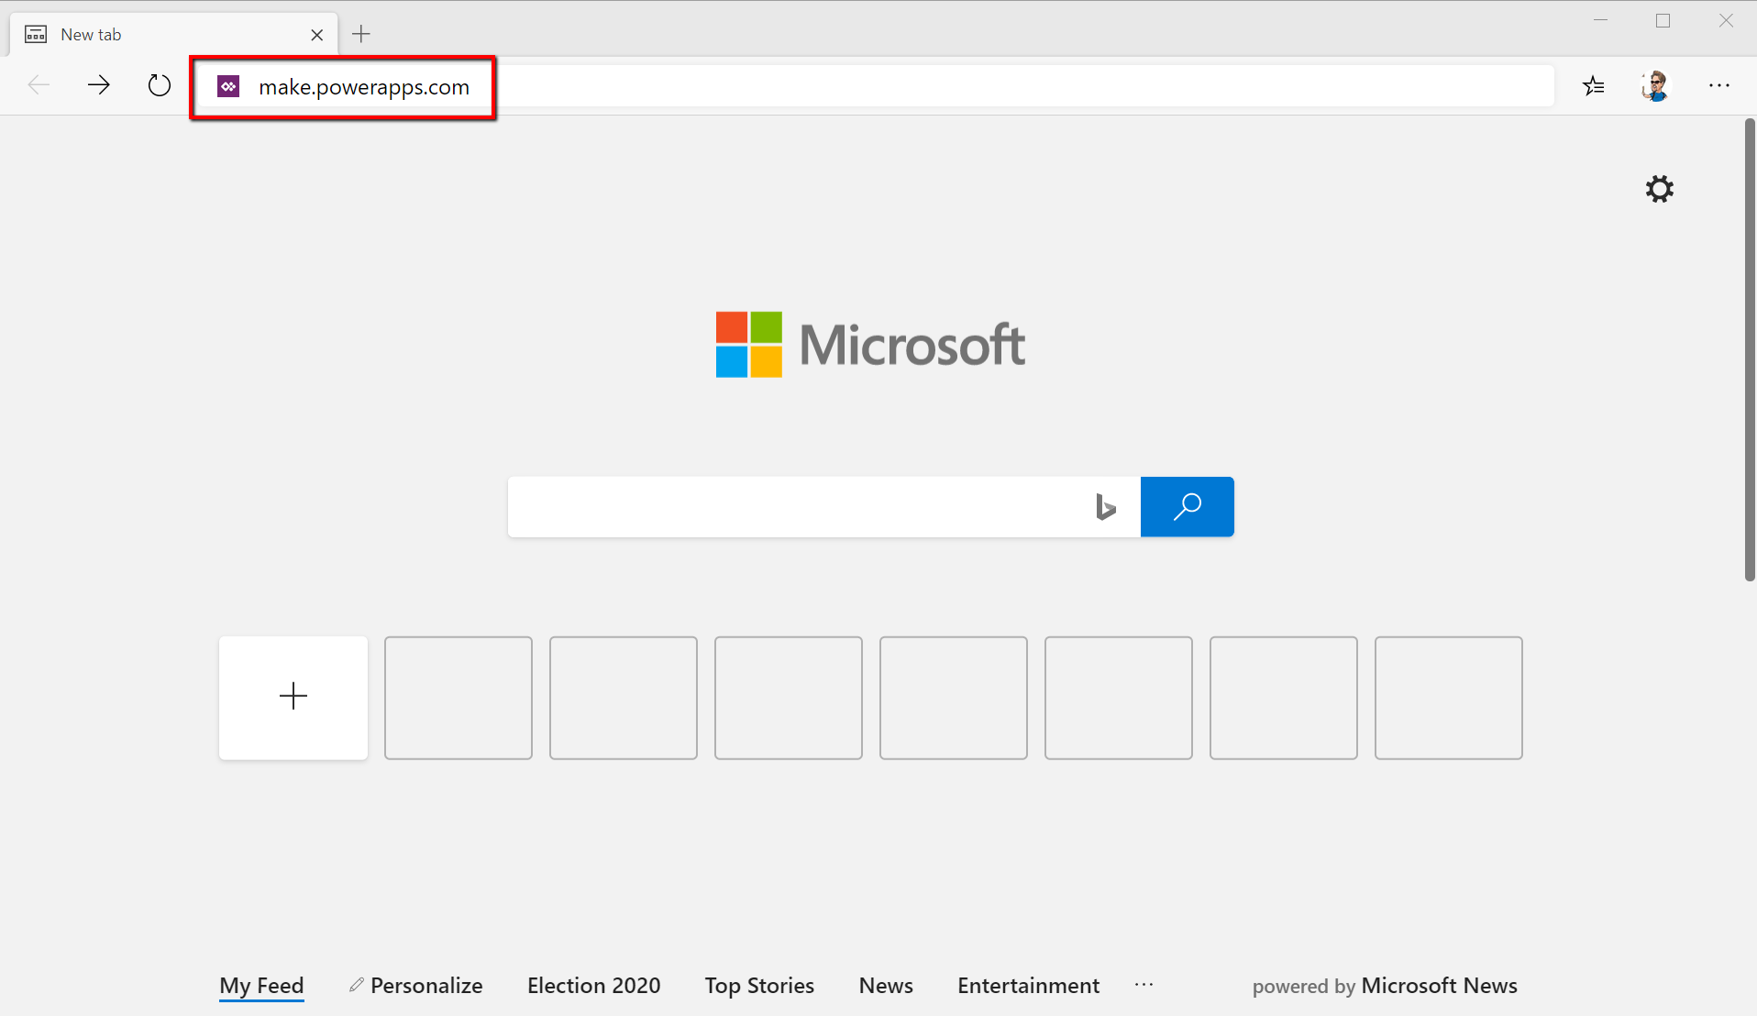

2. Sign in with your student credentials
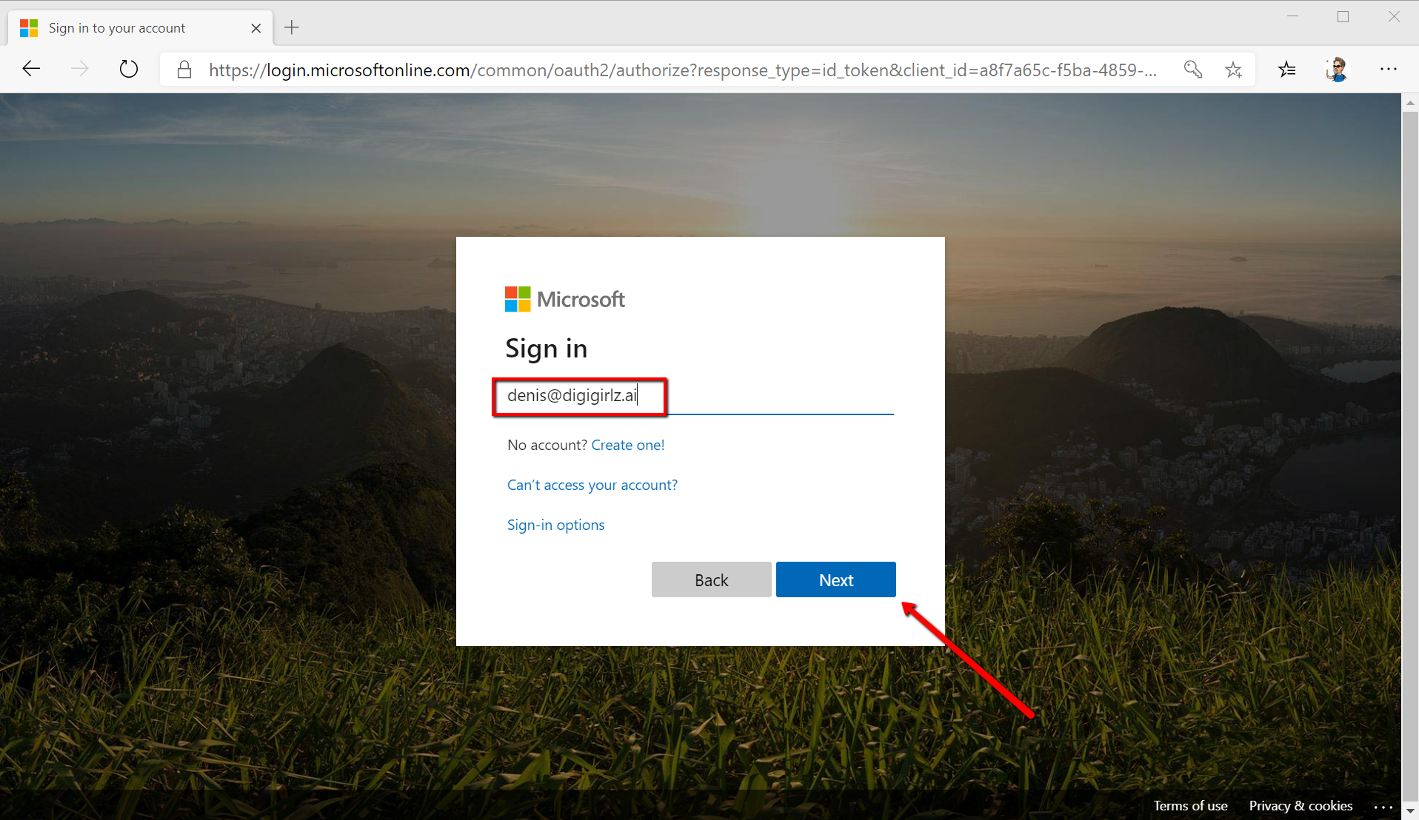

3. On the left navigation menu go to AI Builder -> Models and click on Start free trial
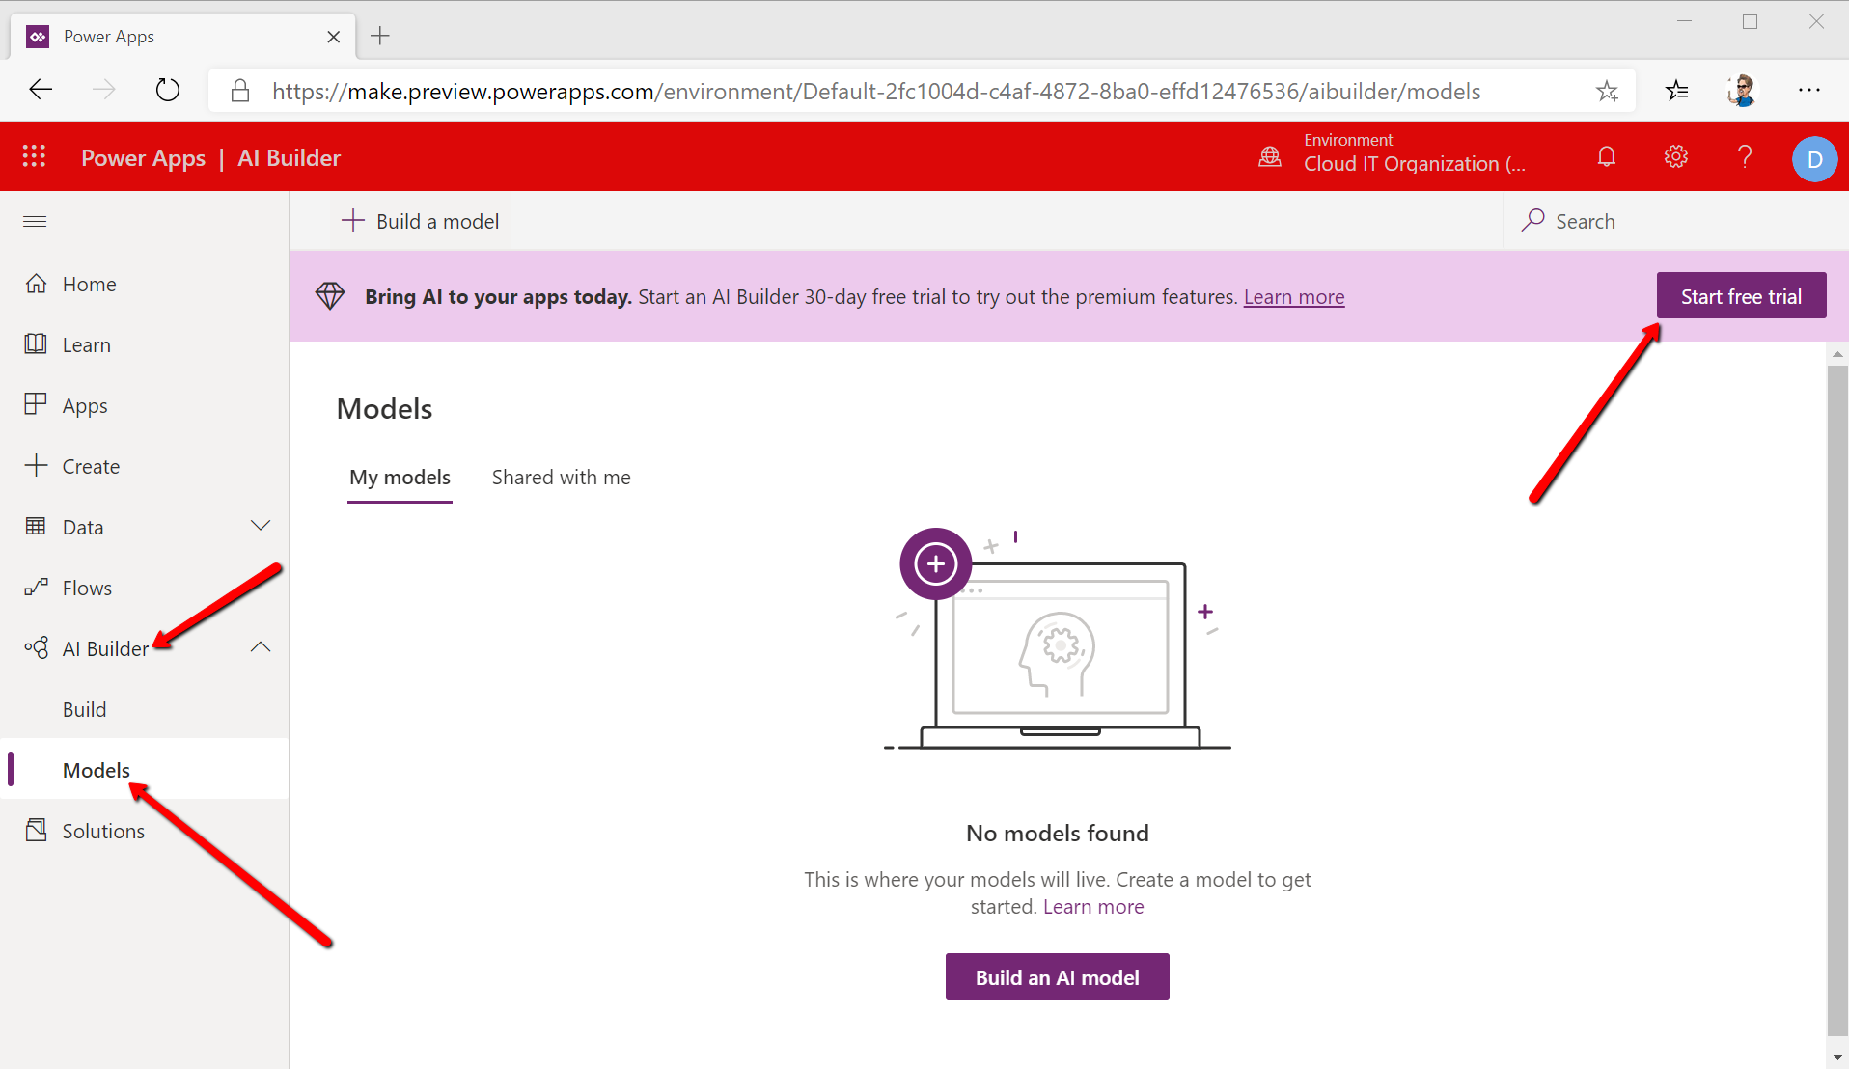

To build an app that is able to help you recycle different types of trash we first need to train an AI model to distinguish between various types of waste. In this case, we will have plastic, paper and aluminum. Feel free to add even more.
4. Creating the model - Click on Build an AI model
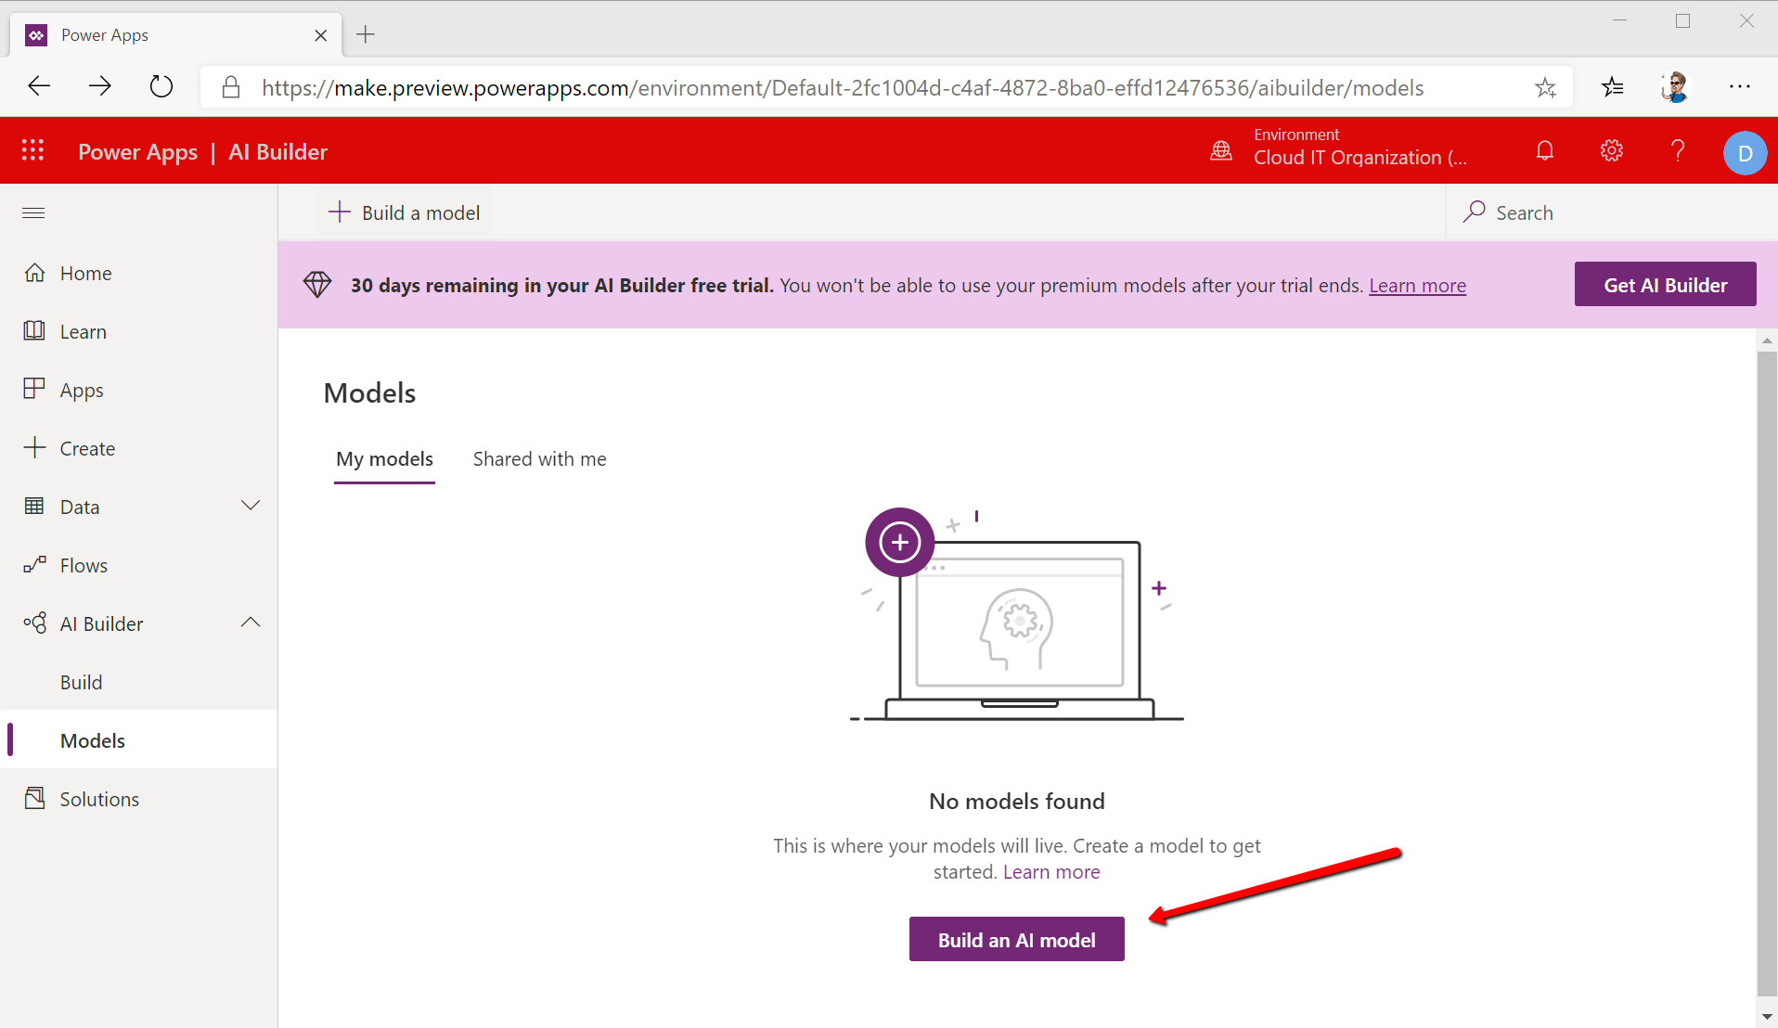

And choose Object detection because we are trying to detect various types of waste
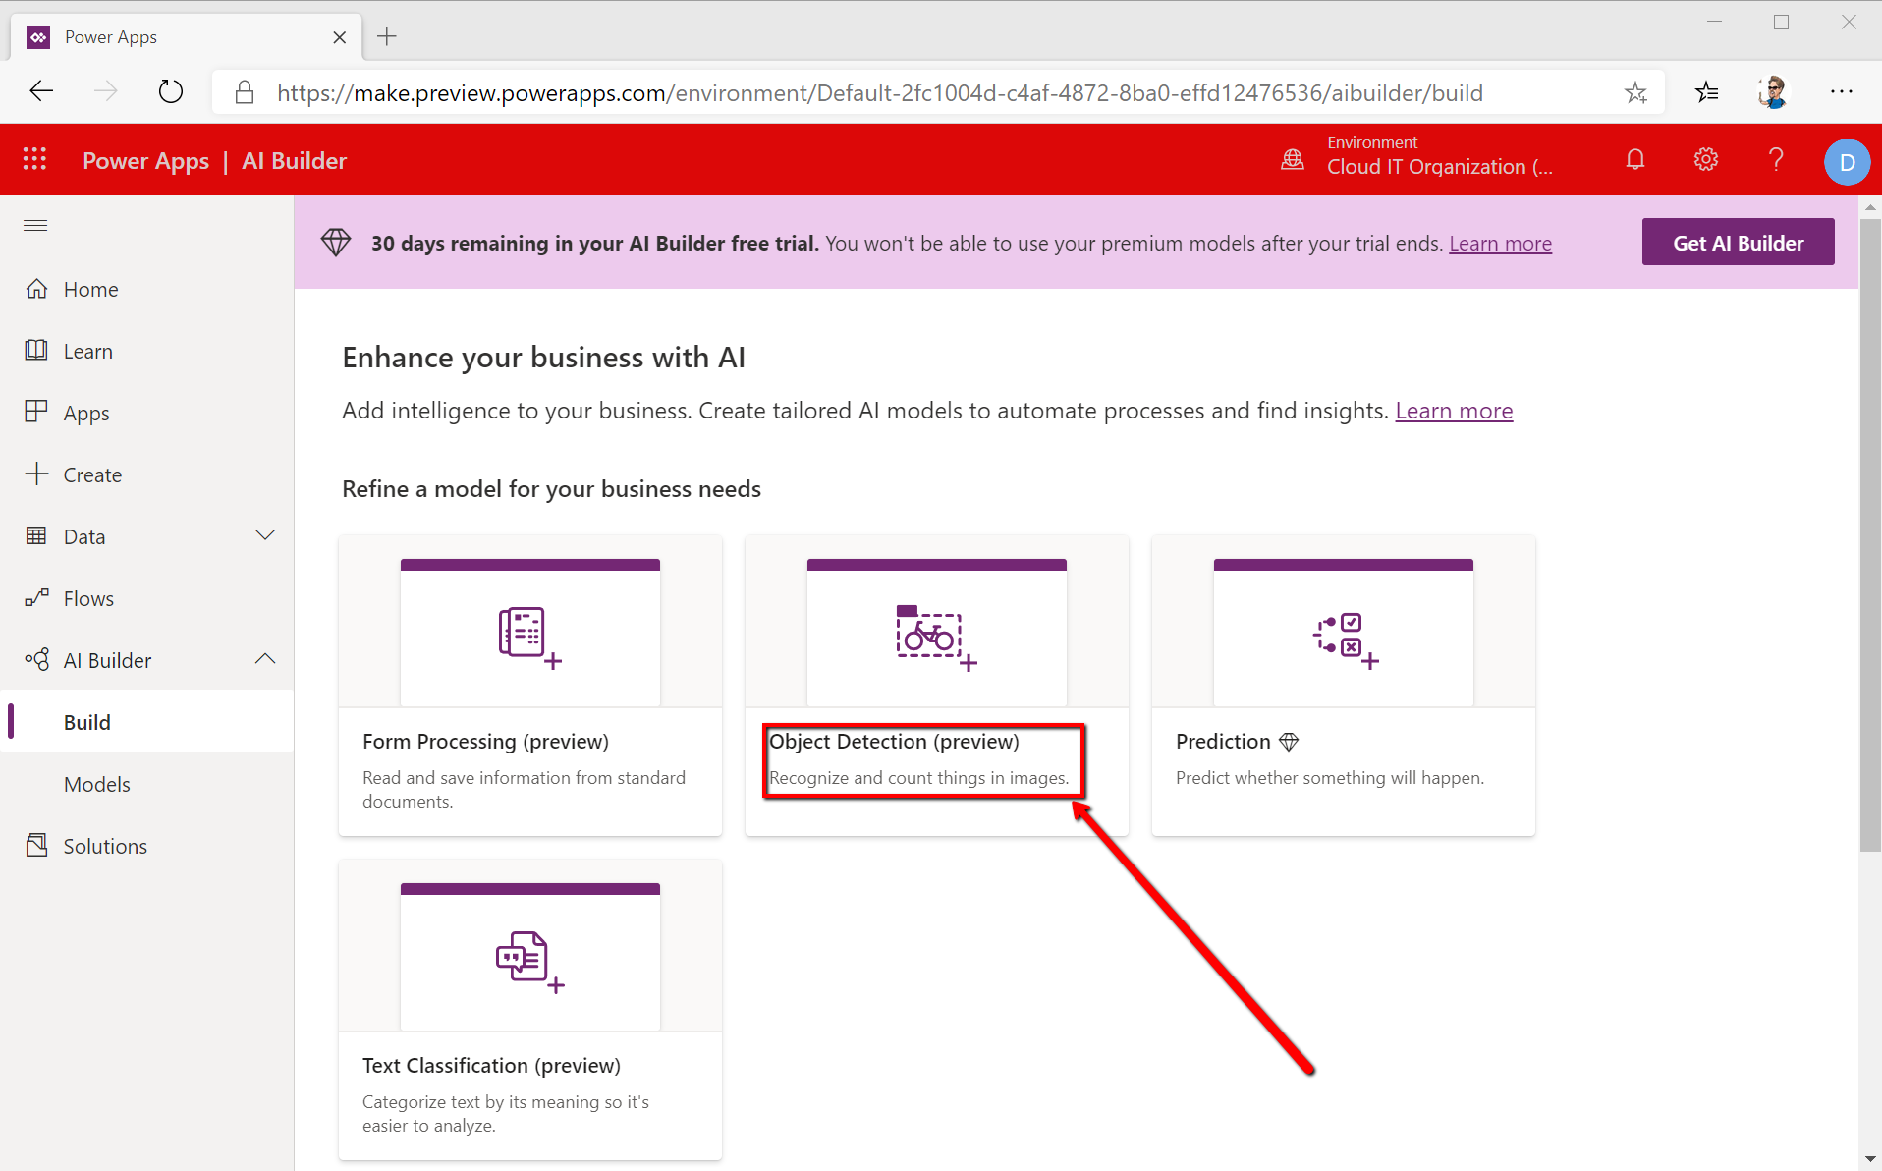
Name your model and click Create
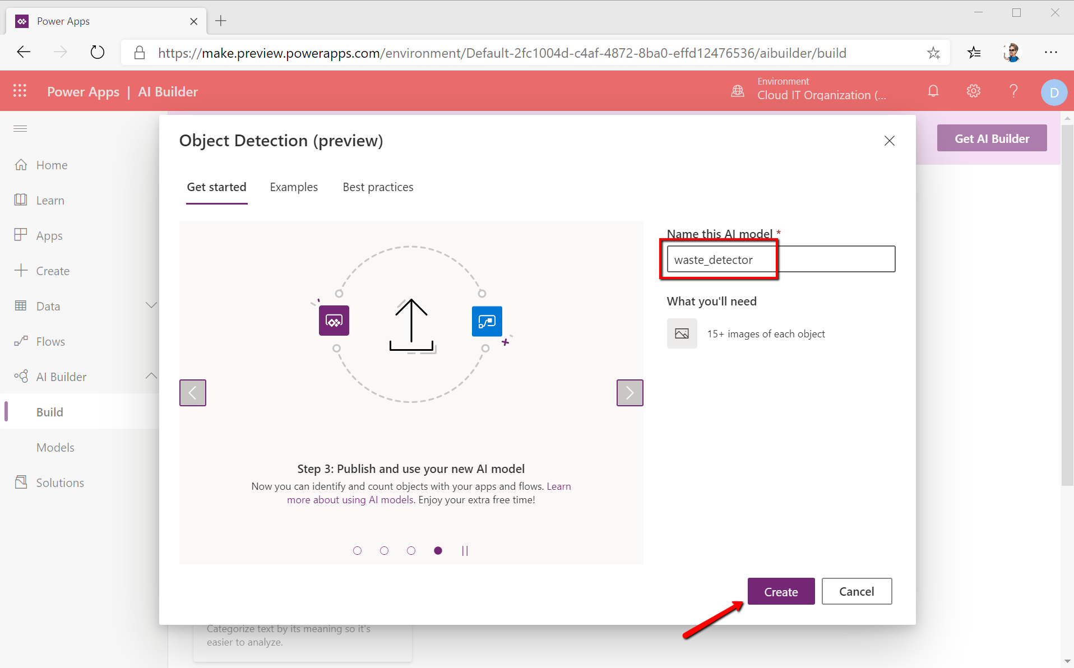
Good job! Now you have created a workspace in the cloud for your project. The next step is to teach a computer how does trash look like, and the easiest way to do it, you guessed it, is to show the computer pictures of trash. No, don’t point them at the webcam, it doesn’t work like this :D
5. Uploading images
Click on the +Add new object button create tags that you will be using to upload pictures with various types of trash. Make sure you have at least 15 photos for each type of trash – plastic bottles, paper bags and aluminum soda cans. To make the project more relevant go ahead and take pictures of these items located next to you and use those pictures in the project.

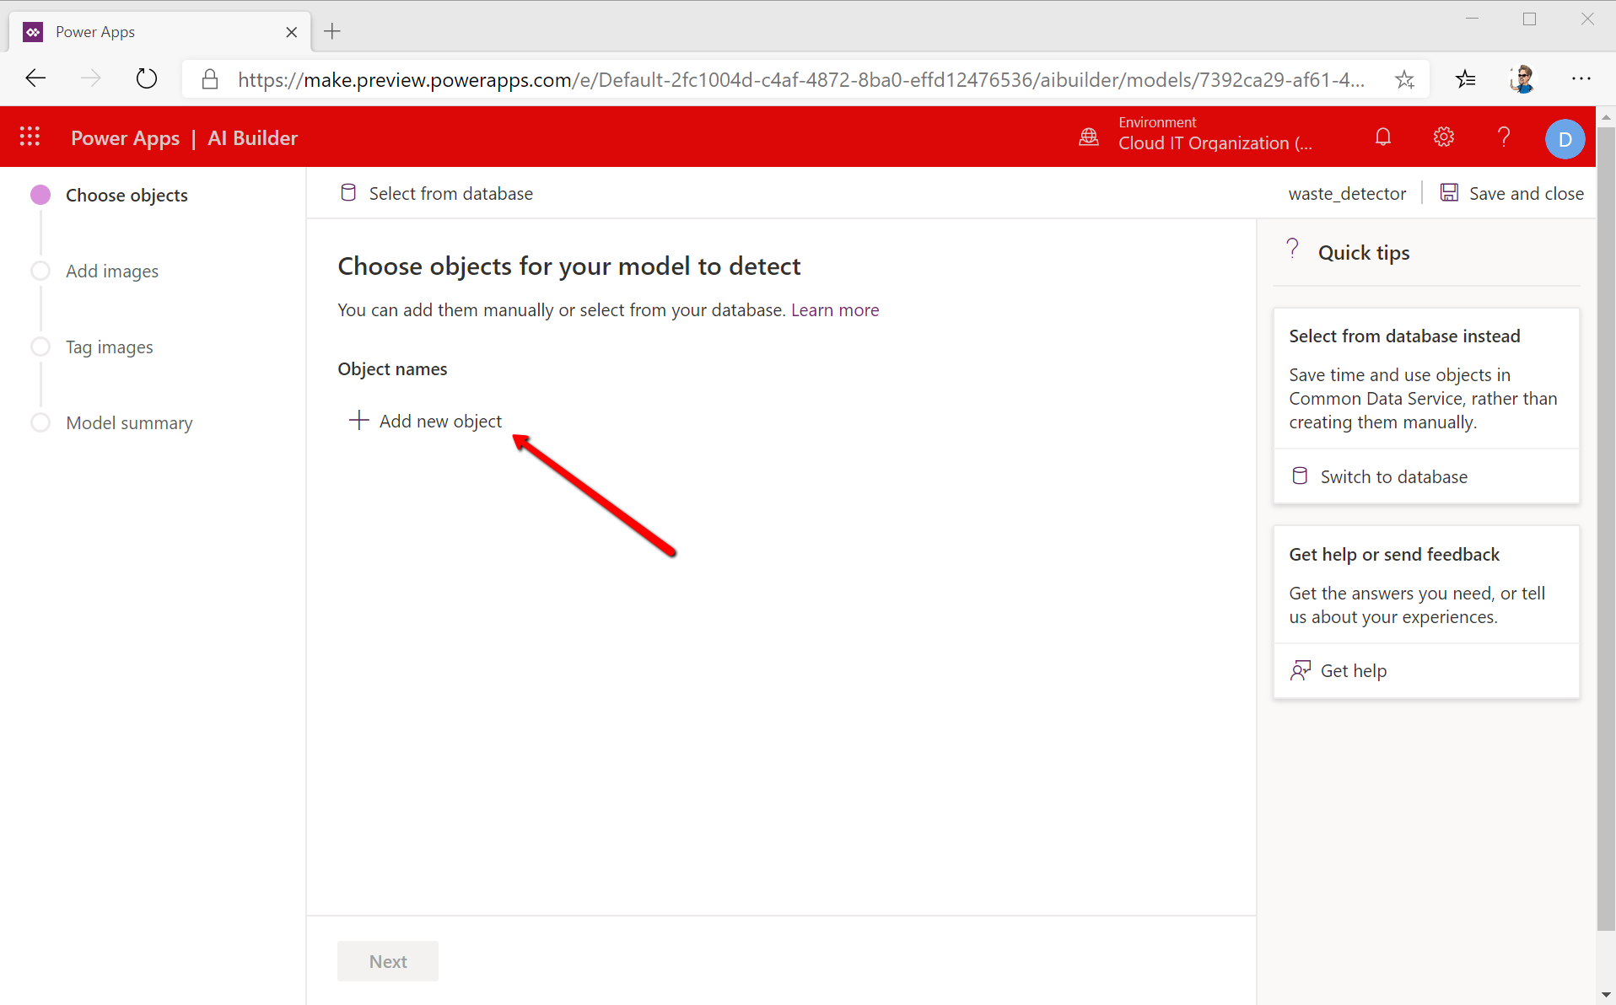

Once you’ve added the required tags (object names) click next and start uploading the images
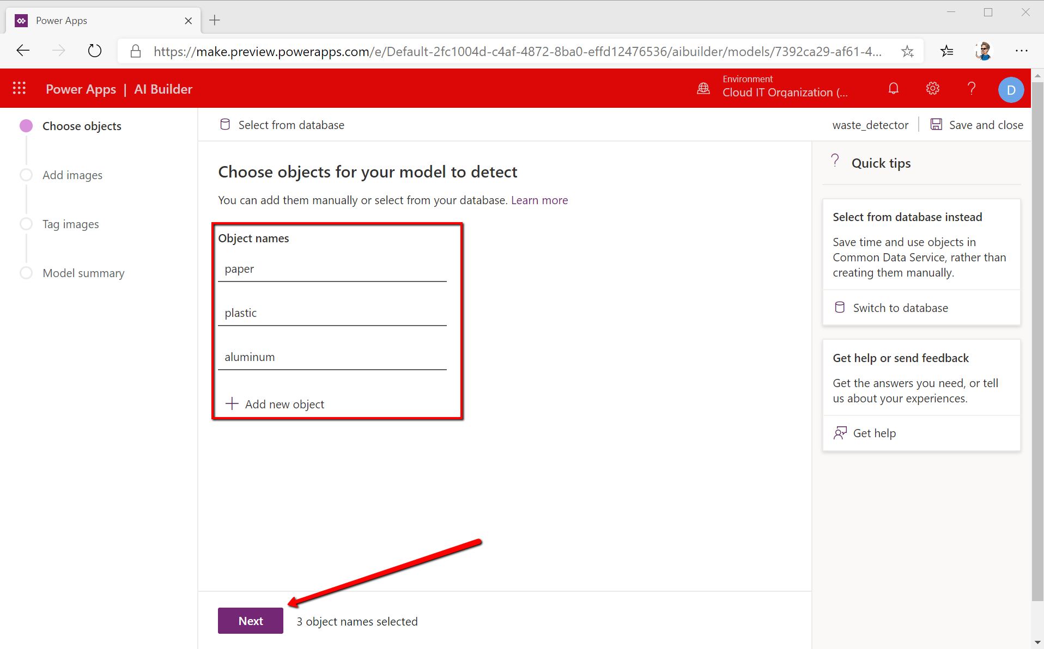

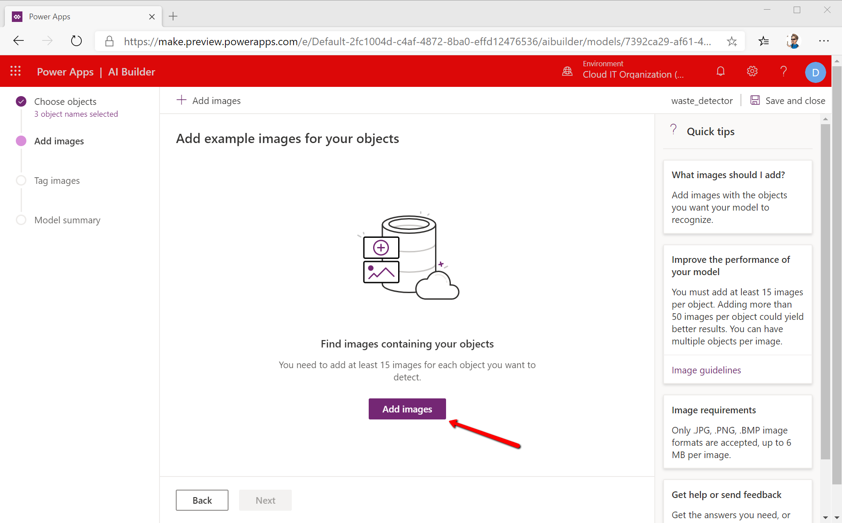
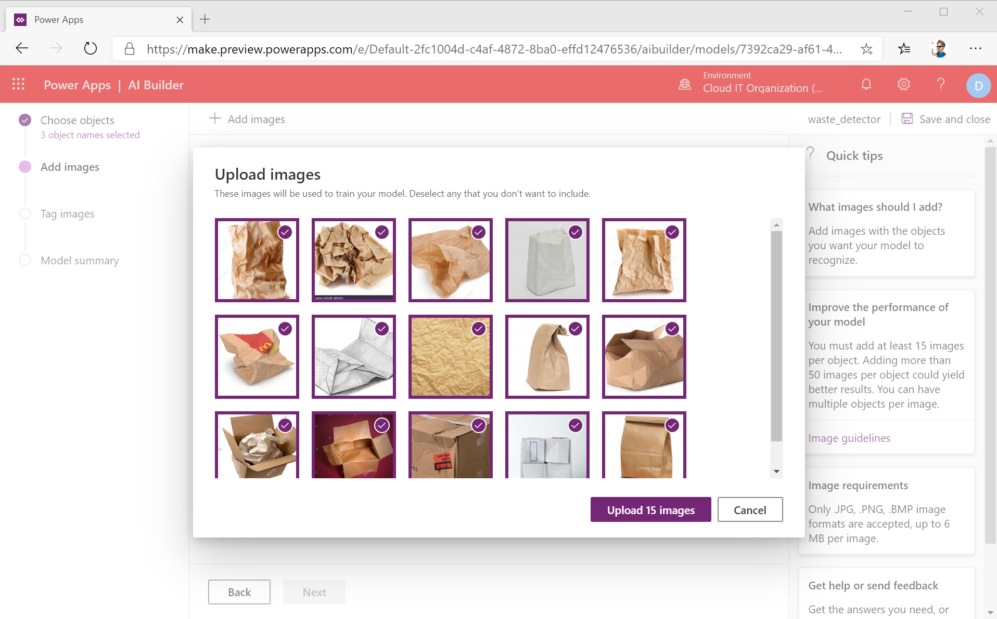

Do the same for all types of waste – plastic, paper and aluminum. Once you’ve finished you should have at least 15 images per type of waste resulting in at least 45 images for the entire project. You can go ahead and add more pictures from online sources or simply take pictures of waste from around you.
Once you’re done with adding images click Next.
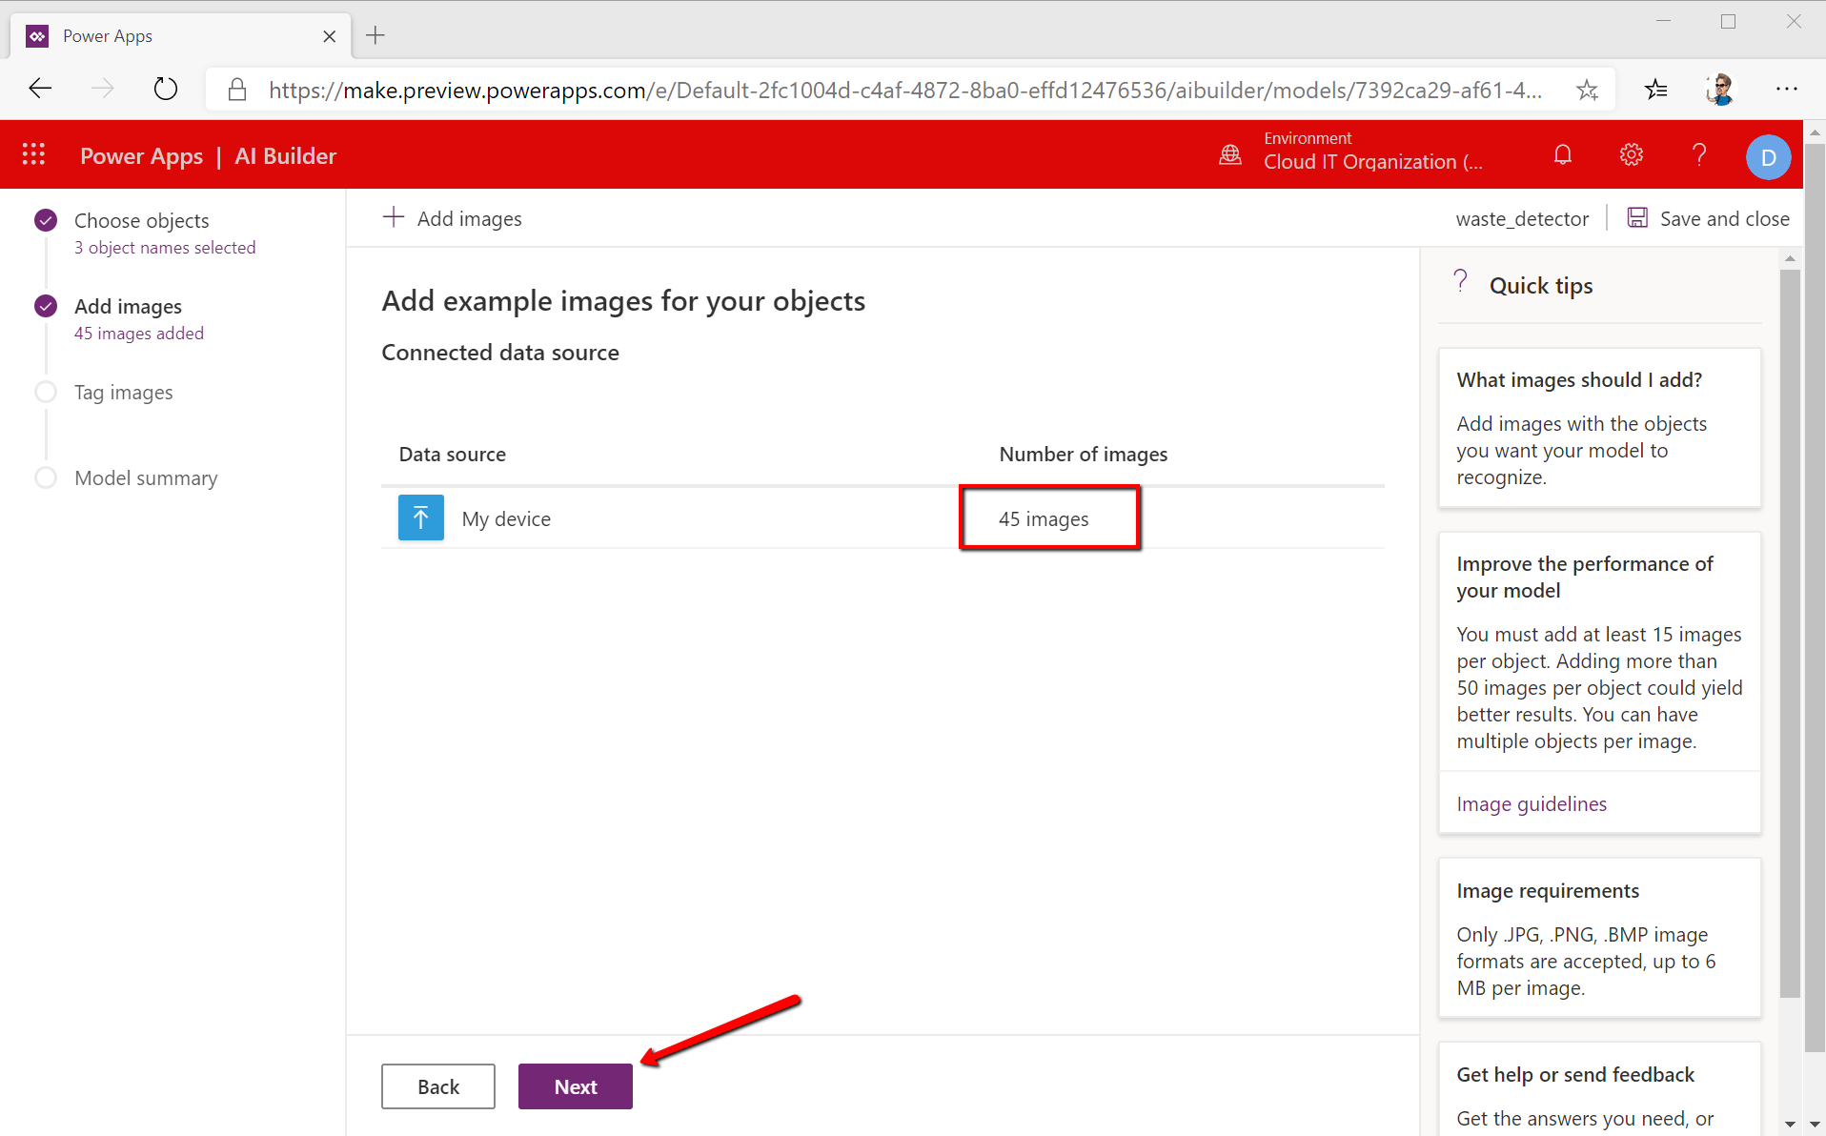

6. Training the model
At this point you have a bunch of images that don’t make any sense for a machine; a computer cannot understand what those images are describing unless we teach it. For this purpose, we need to tag in each image the object we’re looking for – in our case the paper, plastic and aluminum. So, go ahead and click the 1st picture and simply select the item using a rectangle and name it, like shown below, and tag your image with one of the tags you’ve previously created.
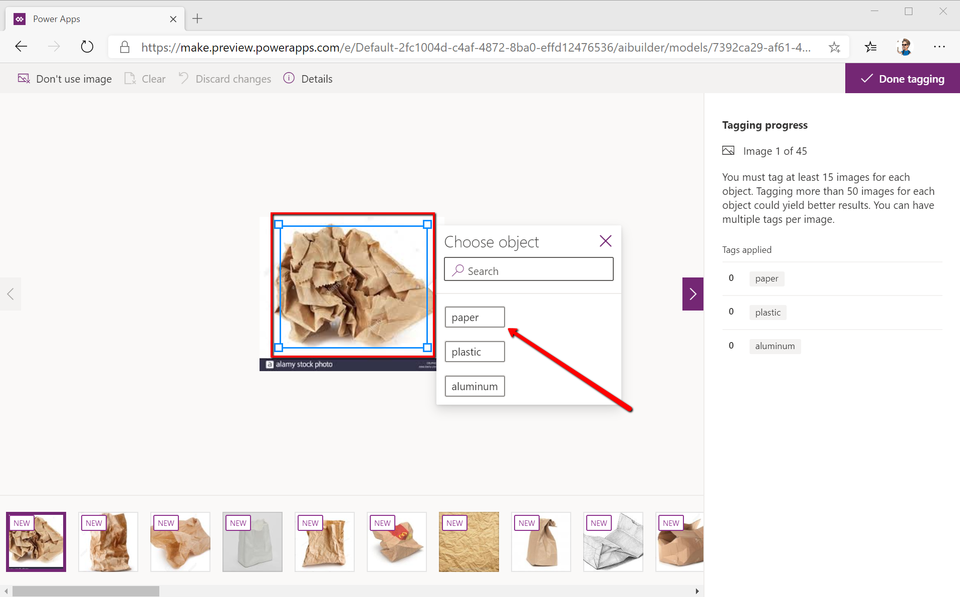

Continue doing so for all the images in your project. Remember, the more images and tags you have, and the more precise the tags are drawn around the object, the better and more precise the AI model will be. In images where you have multiple objects you can use multiple tags
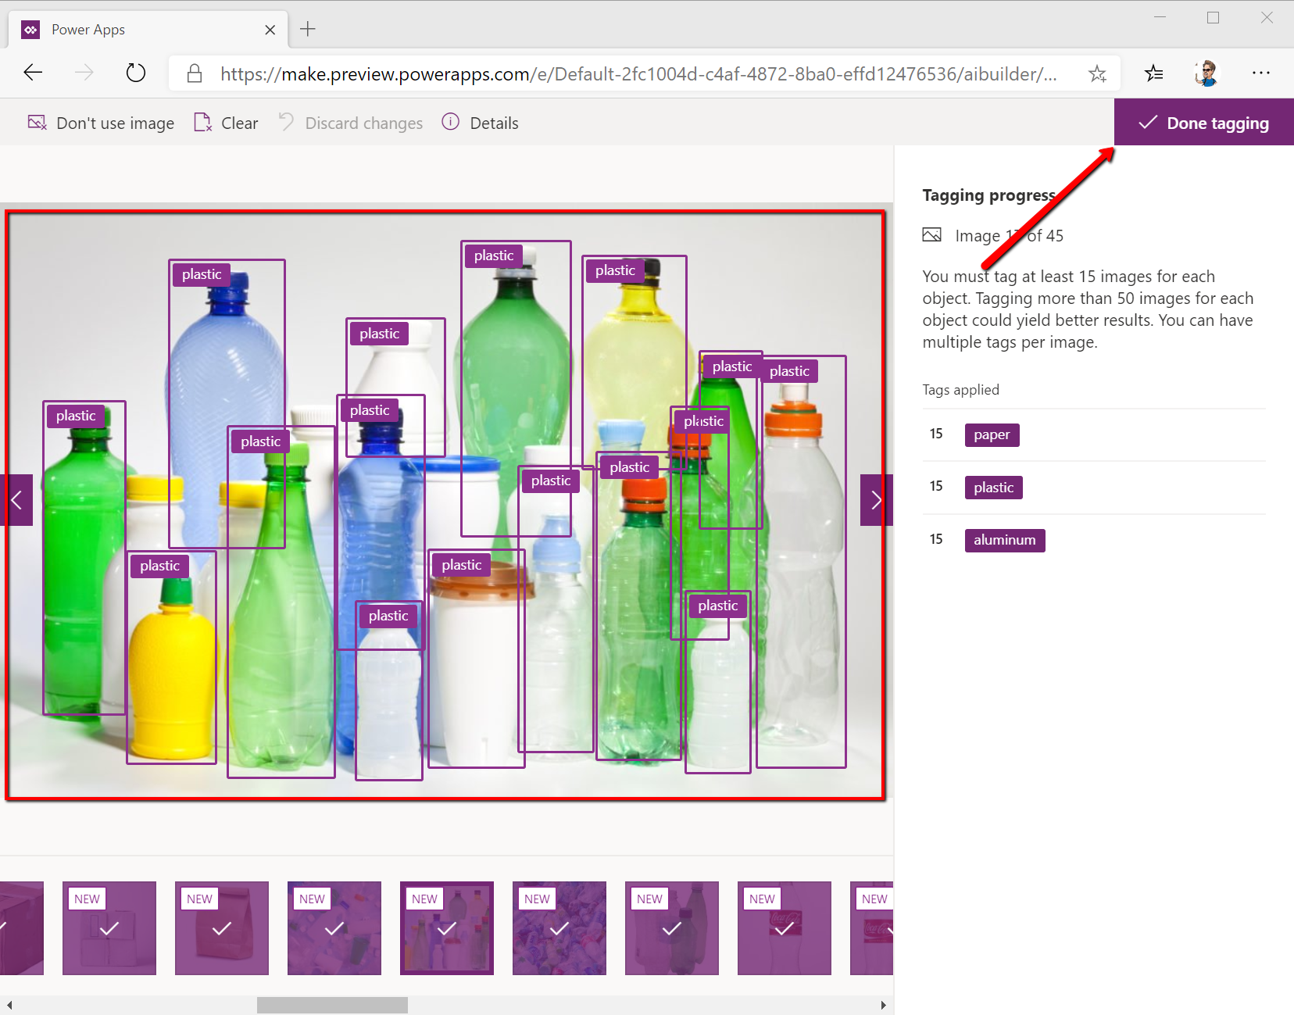
After you tagged all your images click Done tagging and Next
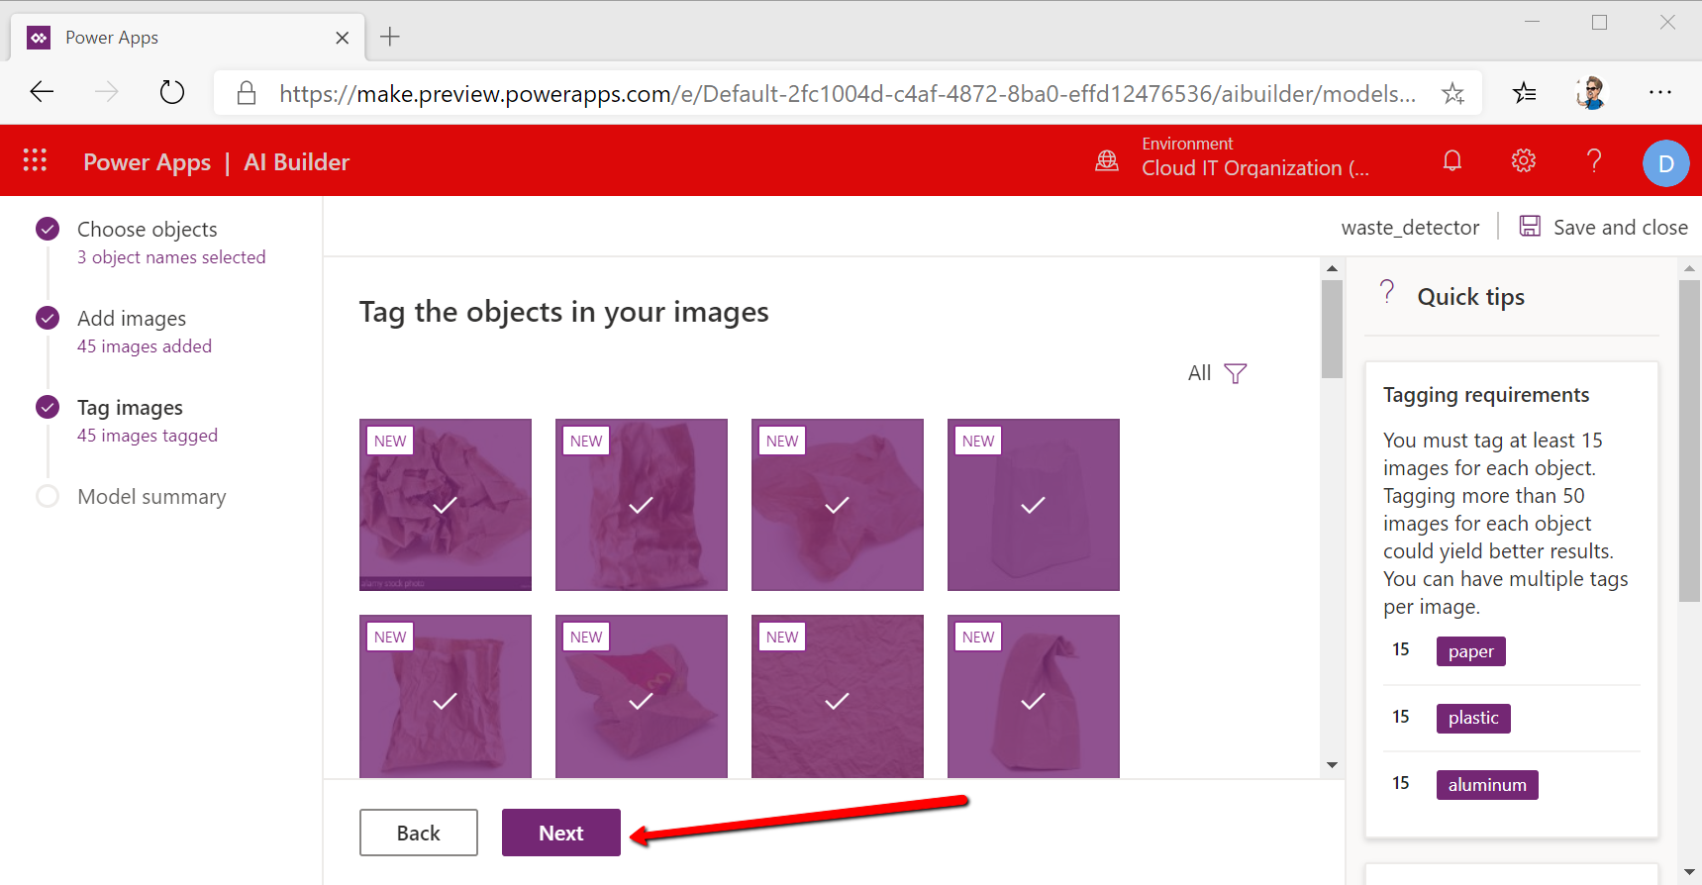
You will see that your pictures are now visible under tagged in your project. Notice you also have 3 different tags according to the type of material you want to recycle – aluminum, paper and plastic. We will be using these tags later on when we will be taking pictures with the phone camera.
After uploading the images and tagging them appropriately, it’s now time to make the computer work as well while you take a break 😊. So the next step is to actually train a machine learning model to understand, based on your rectangles tagging, how does trash look like so that the next time when it sees it, it should be able to know without you having to draw the rectangles. To do that we need to train the computer by clicking the Train button.
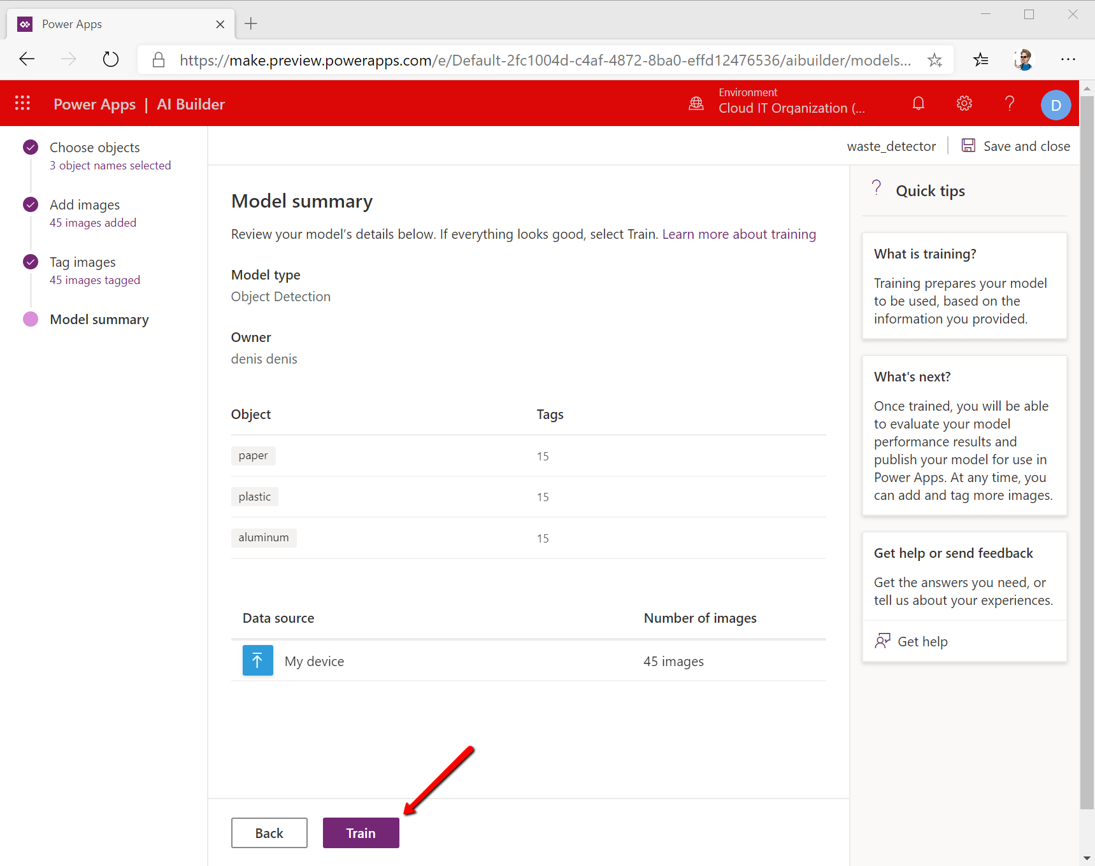

Click Go to model and wait for the AI training to finalize

After the AI model was trained, we need to publish it to make it available over the Internet. So click the model name and the click Publish
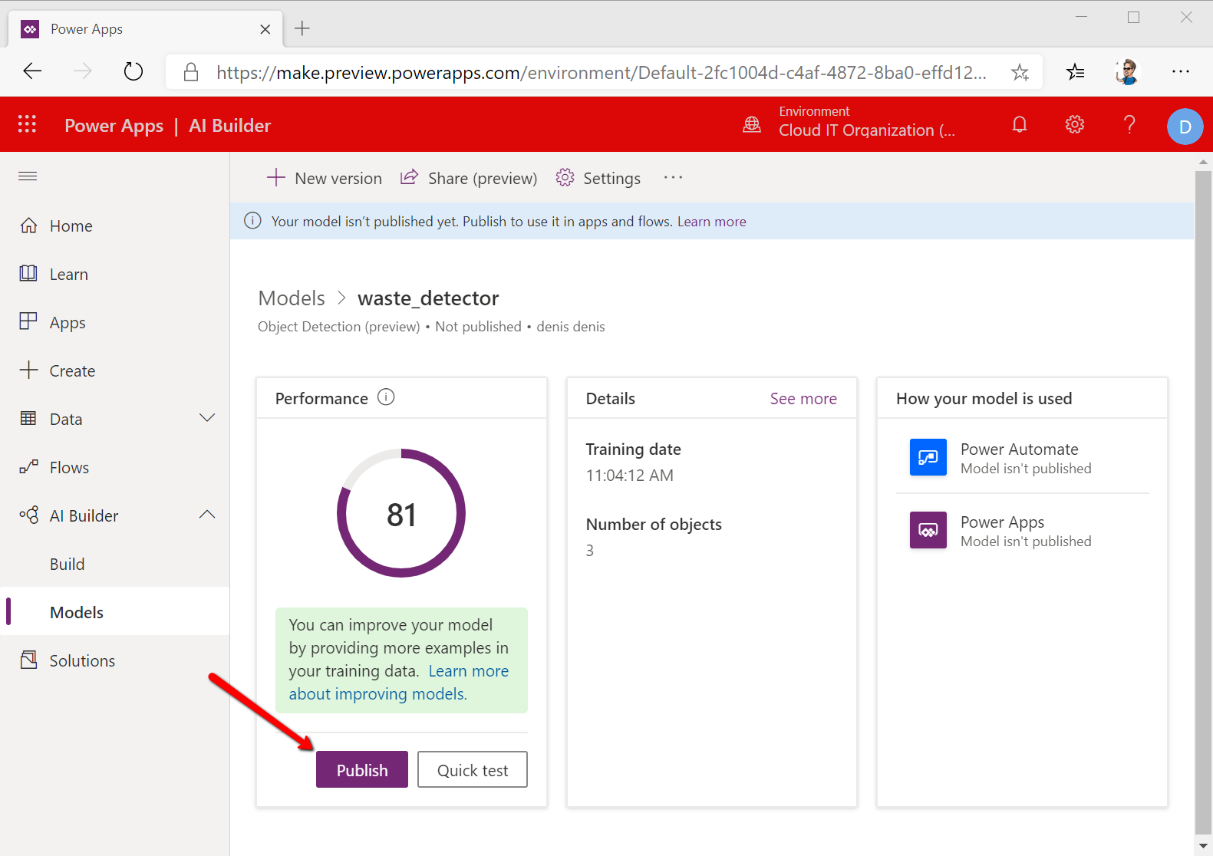
You can see that the overall performance of the model is 81%. Which means that roughly 8 out of 10 times the model will be able to correctly identify the types of trash it sees. If you are not happy with this rate, you can always go back and add more images and more tags so you will increase the models’ performance.

7. Creating the mobile application
Well done! You’ve successfully trained & published an artificial intelligence model/algorithm to make sense of the real world. This is basically the general definition of AI – programming a machine to understand, act and react to the real, external world as a human would. Nice!
The final step of this tutorial will be to embed this AI model into a mobile application so you can actually use it in the real world make it accessible to everyone. Here goes.
In the left navigation menu click on Apps then on + New app -> Canvas
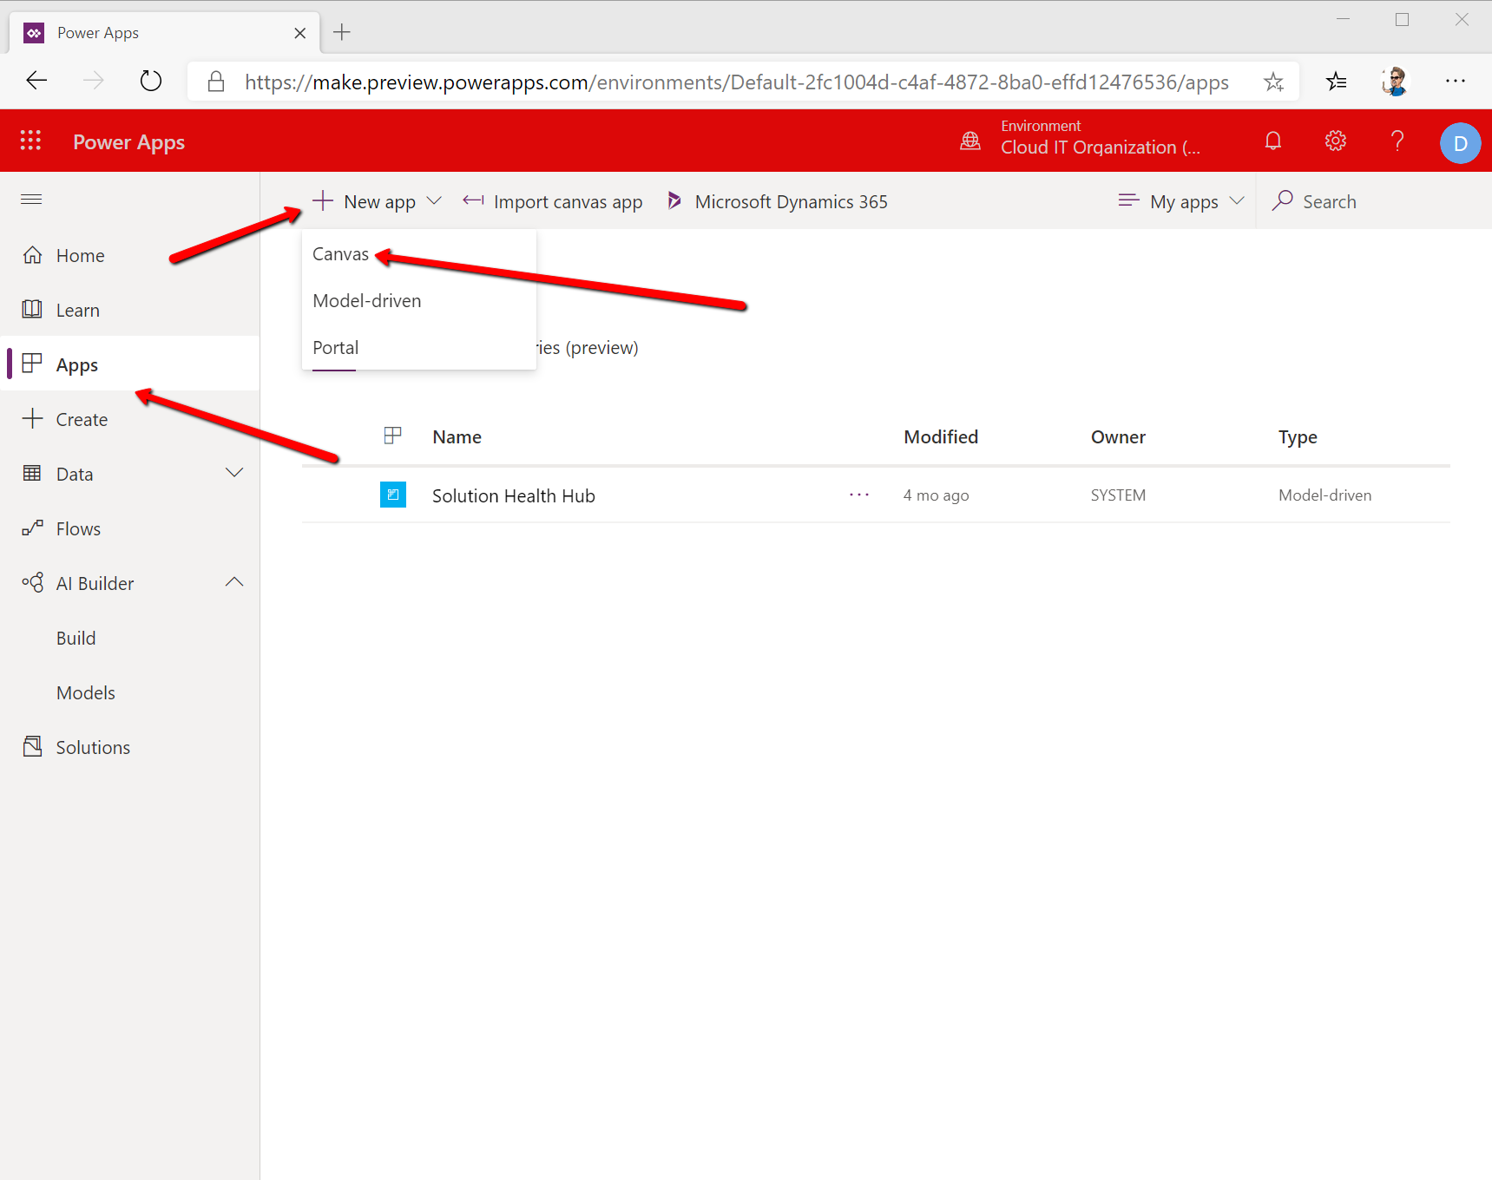

Click on Common Data Service / Phone layout because we’re creating a mobile phone application that is leveraging CDS – a framework through which we can access AI on the mobile phones
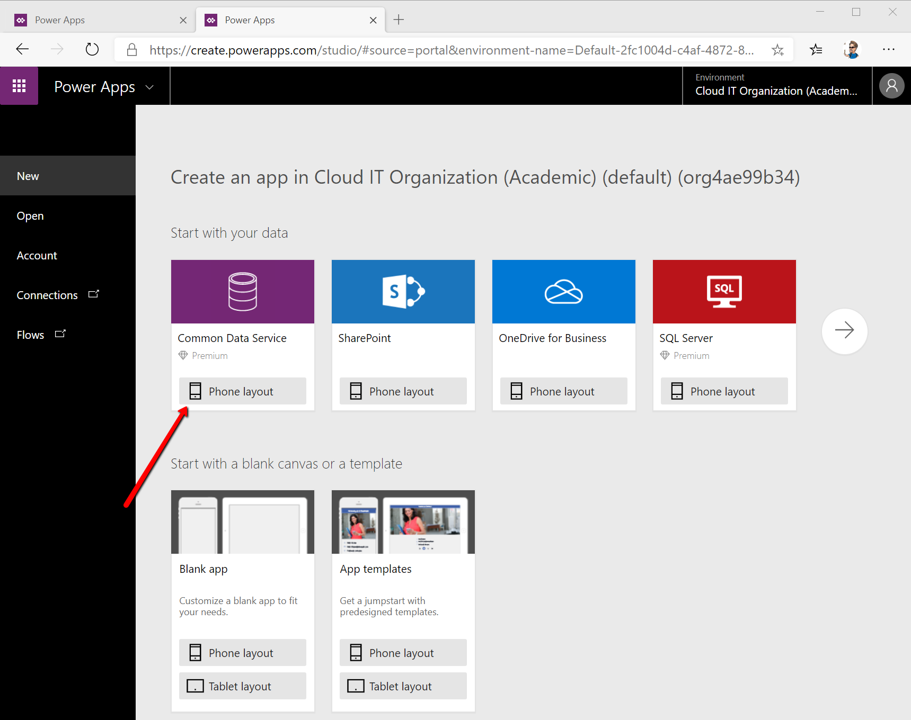

Click Create and choose Canvas Apps. Click Connect.
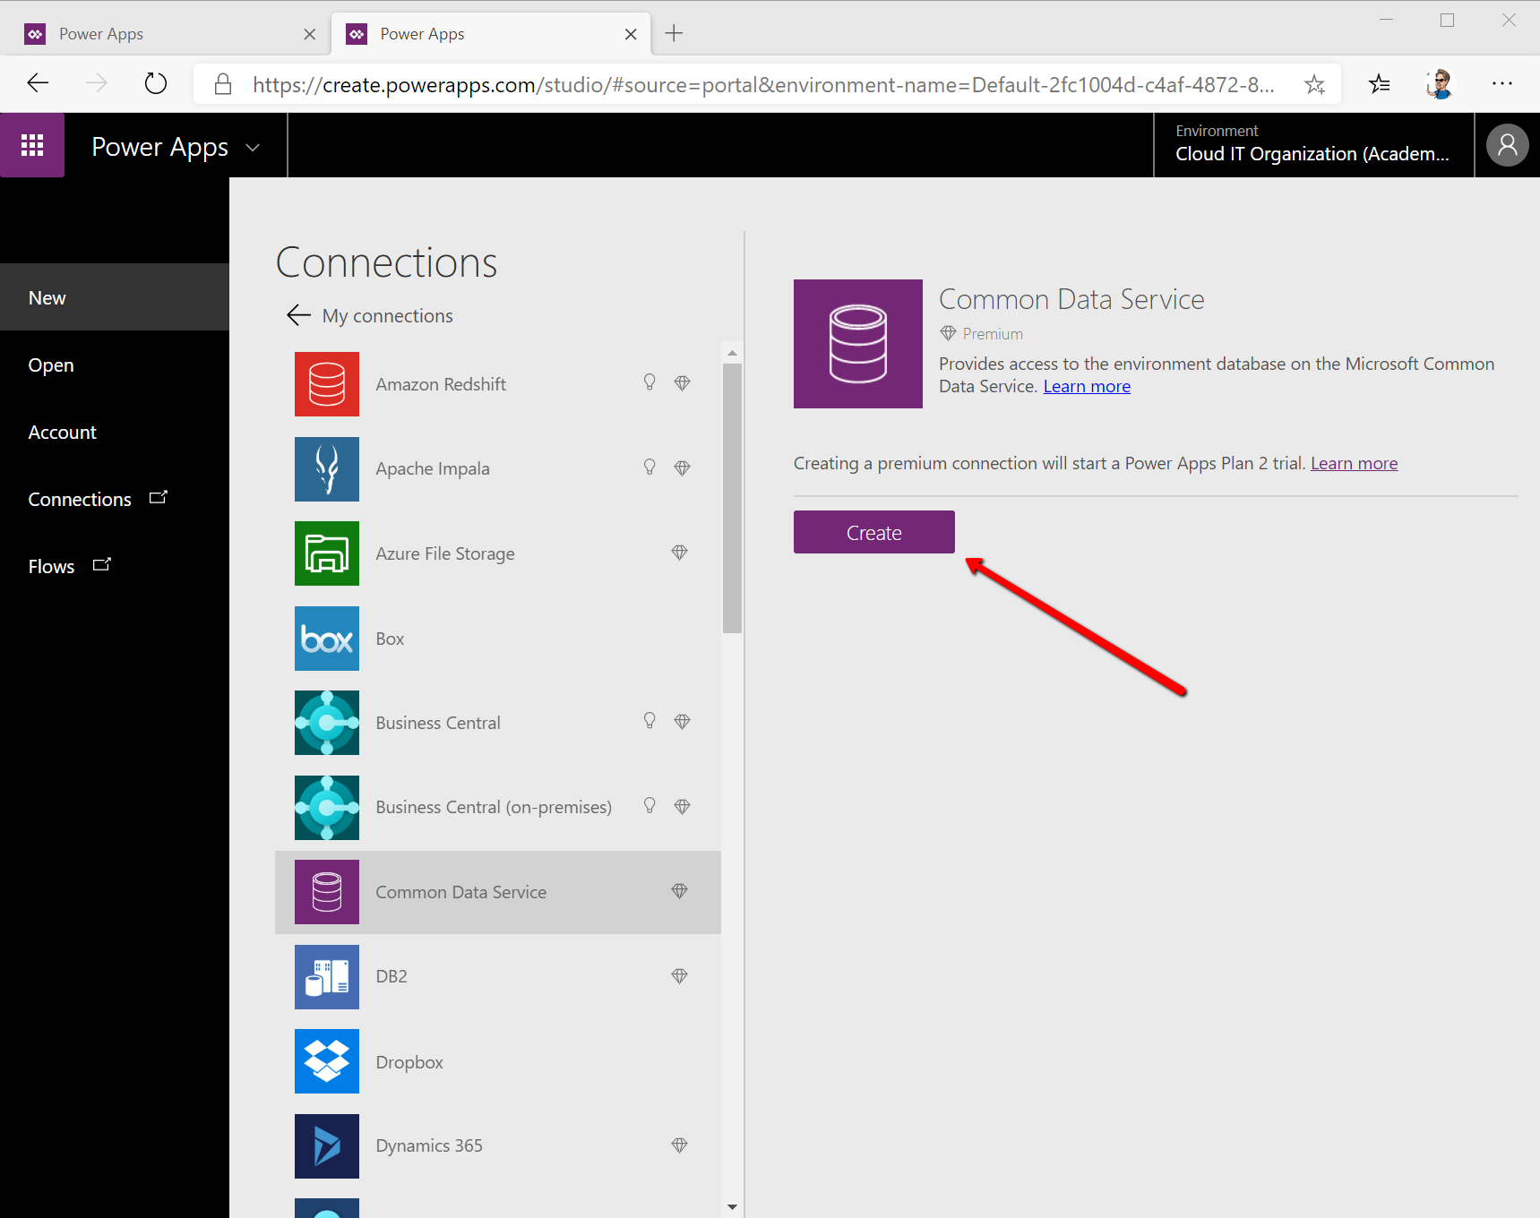
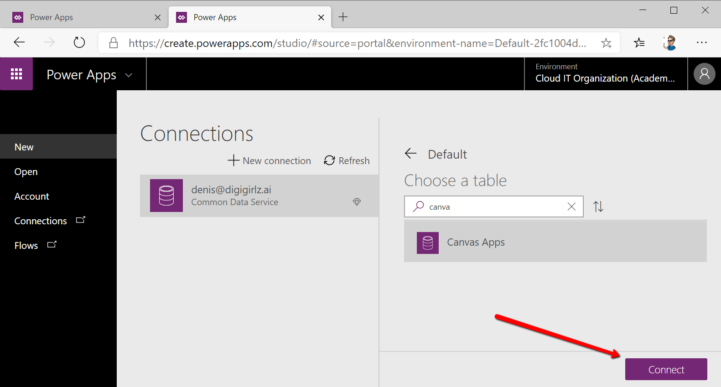

This is the dashboard that you will use to build the mobile application. Take your time, look around, explore, add buttons see what happens when you click stuff :)
Once you’re done exploring to Insert menu -> AI Builder -> Object Detection and choose the model you’ve trained & published previously.
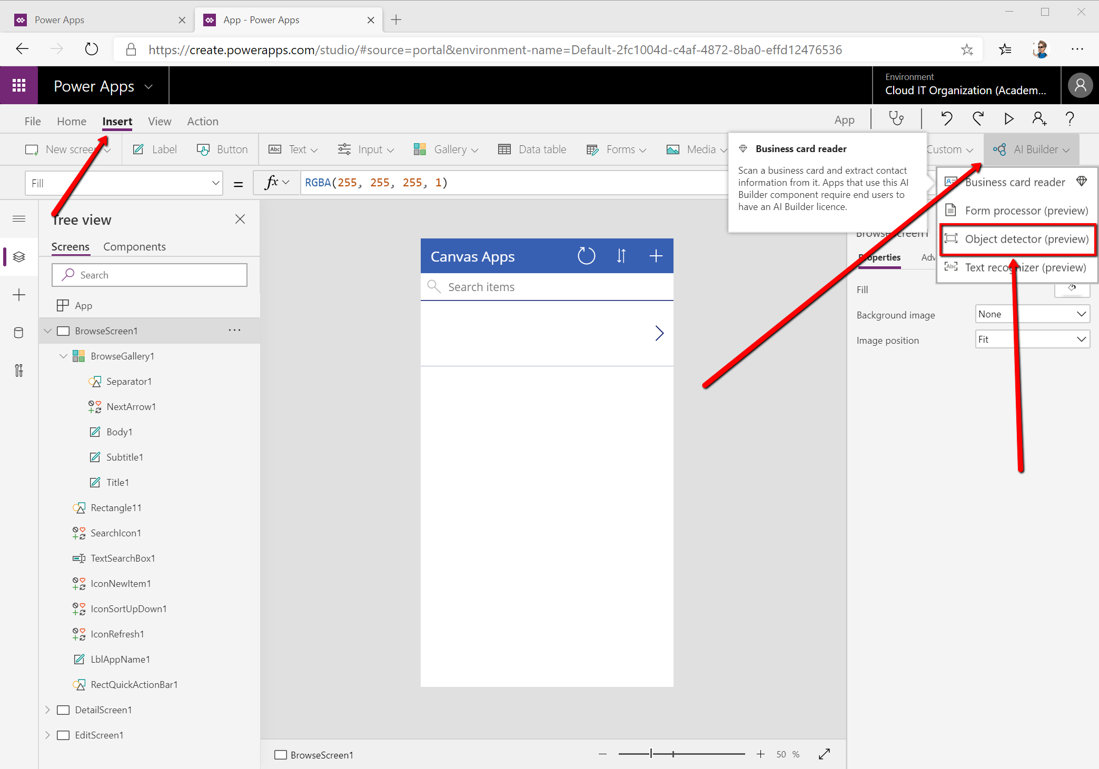
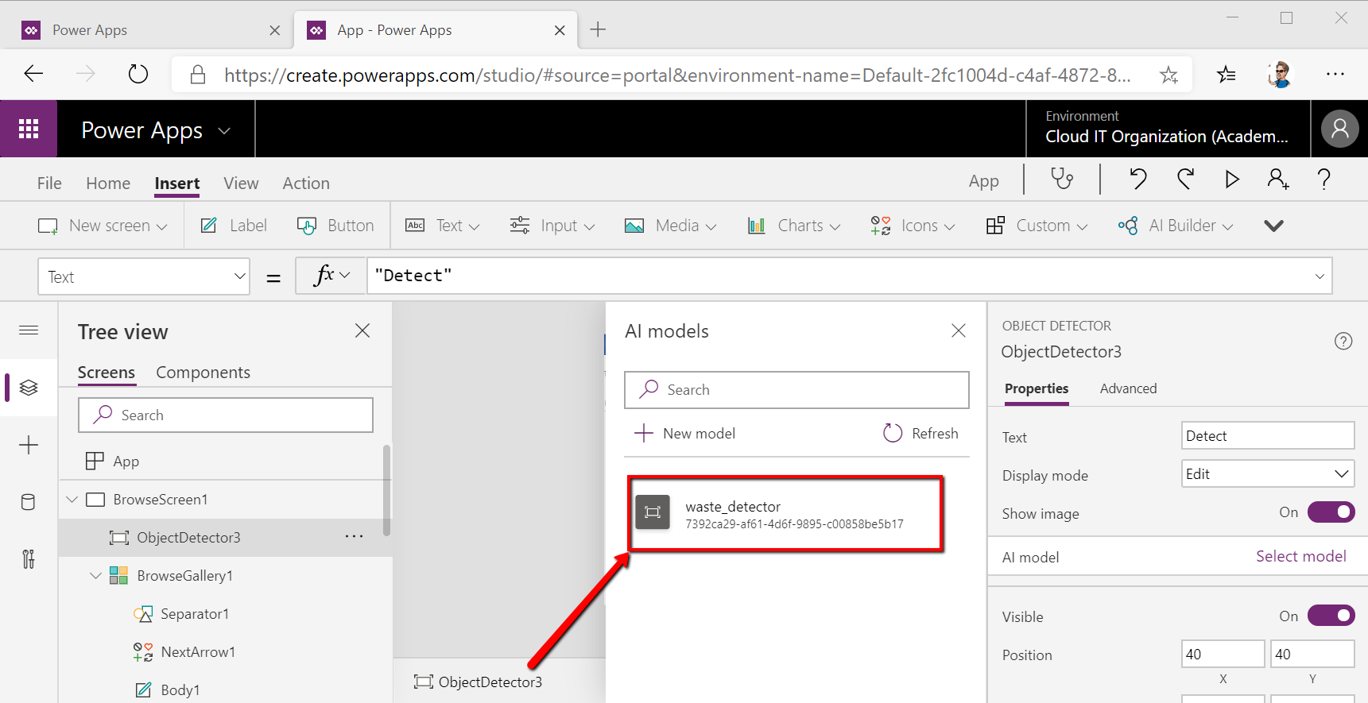

Position the AI model on the mobile phone interface & resize it as you wish. Feel free to even rename the Detect button to Take a photo or any other name you want.

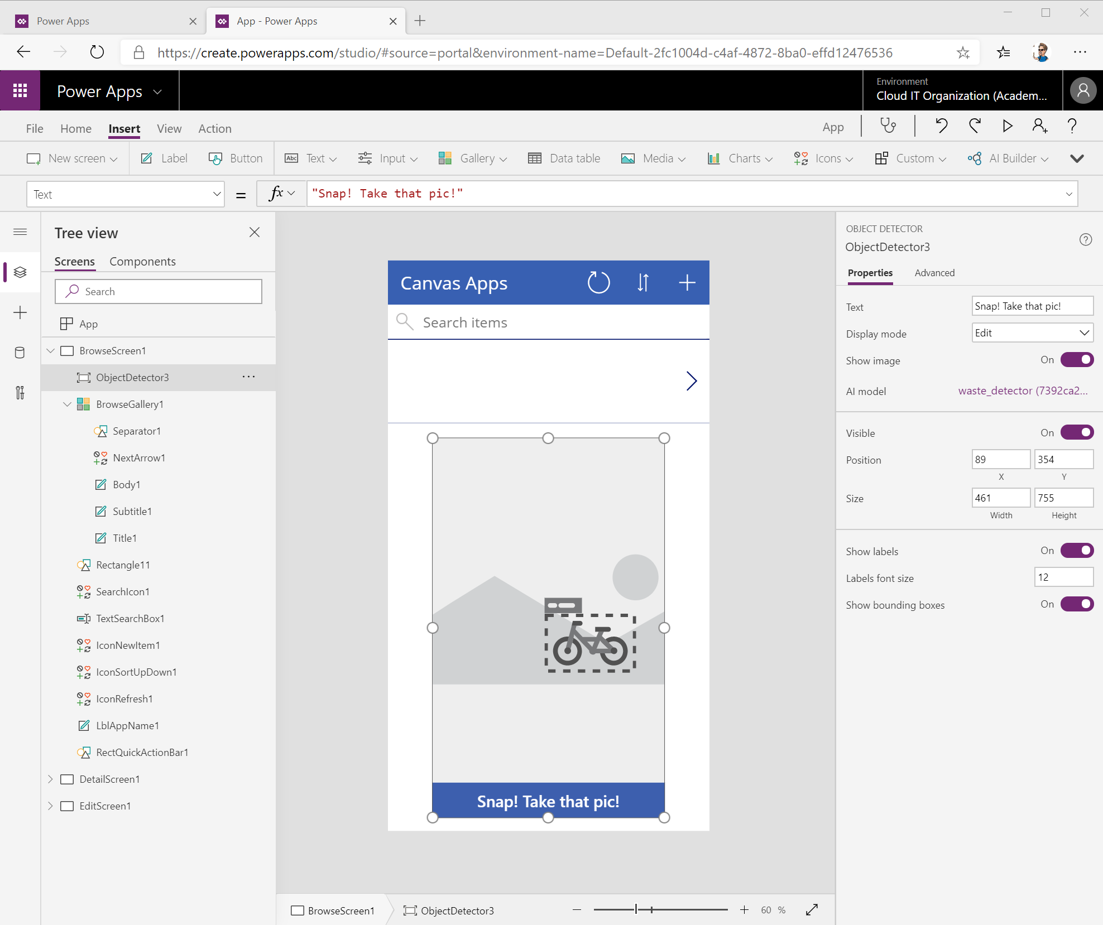
See if you can add other buttons, strings or features to your app by browsing the options available in PowerApps.

Once you’re done, click the top left File menu, name your app, choose a background color and an icon. Before you Save the application, make sure to enter a description of what it does so people understand how to use it.
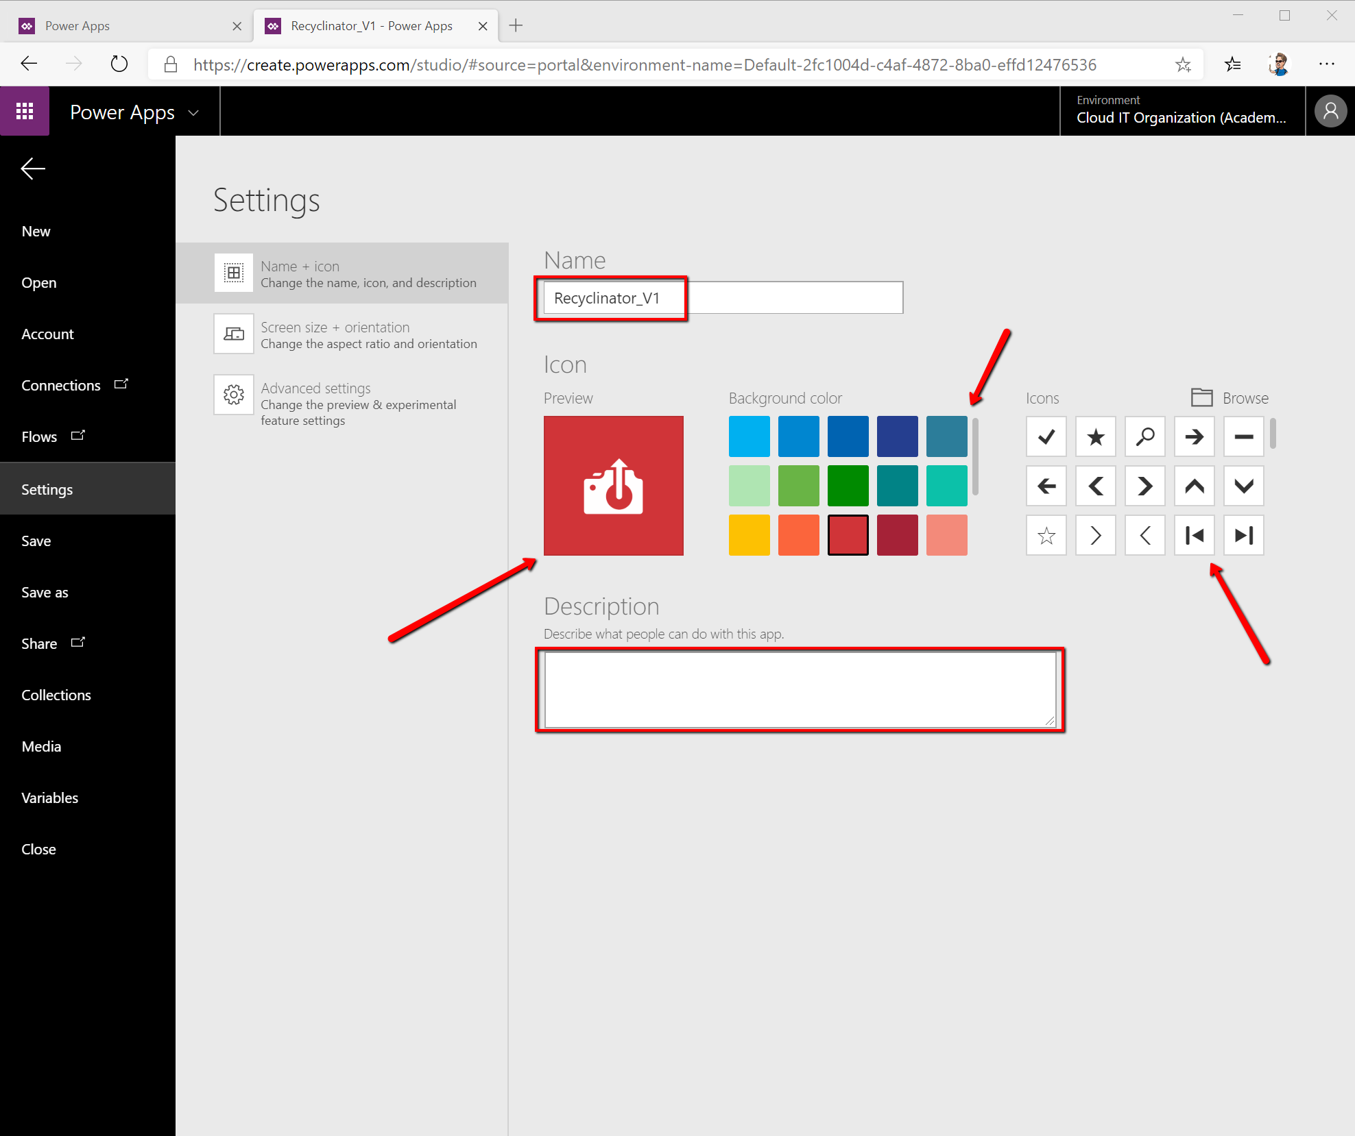
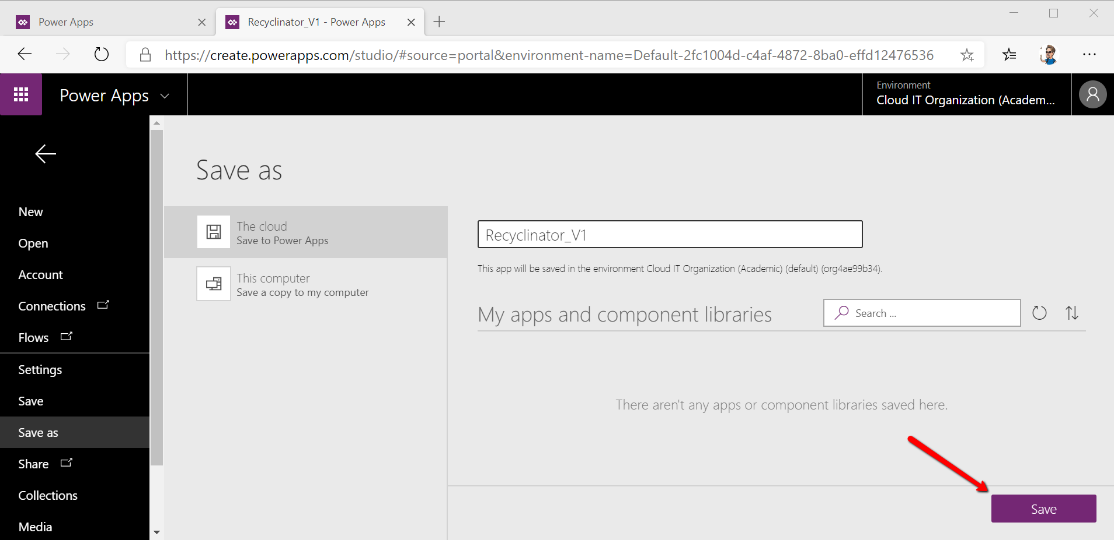
A M A Z I N G! You can give yourself a clap and install the app on your phone and test it for the 1st time!
Install PowerApps on your phone from your application store, login using the student credentials and test the application by taking pictures of the 3 types of waste. You should be able to see the app detecting the type of trash it sees through the phone camera.
Well done!
Now that you have a good understand of how this technology works, what other use cases can you find for it?

